Git HOL 5 – Clean Up and Final Push to Remote
Name : Divyansh Tiwari
SuperSet ID: 6394658
Topic : Git

Objective:
- Finalize all pending local changes
- Ensure working branch is clean
- Pull remote updates
- Push updates to the remote GitLab repository
- Confirm changes are reflected remotely

Steps Followed:
1. Ensure working branch (main) is clean
cd GitDemo
git checkout main
git status
nothing to commit, working tree clean
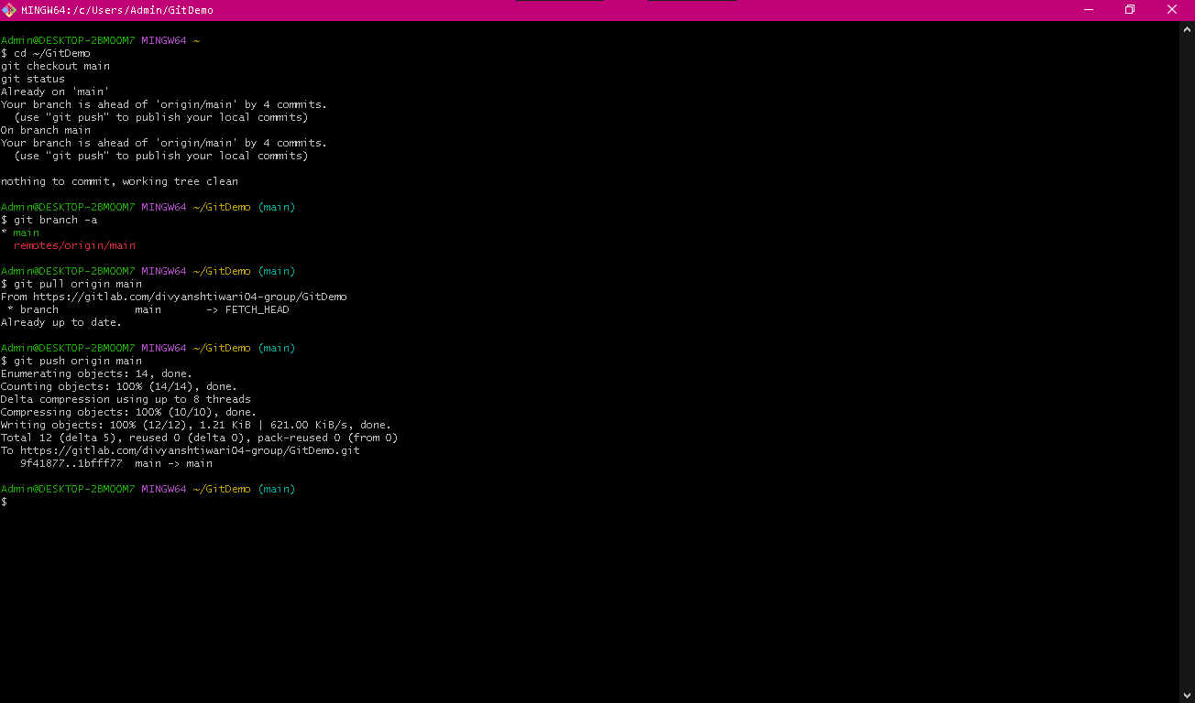
Git status showing clean working tree on main

2. List all branches
git branch -a
3. Pull latest from the remote repository
git pull origin main
4. Push pending local changes to GitLab
git push origin main

Output of local and remote branches confirmation that your local branch is up to date and successful push to remote repository

5. Verify changes on GitLab
GitLab web interface showing final changes:
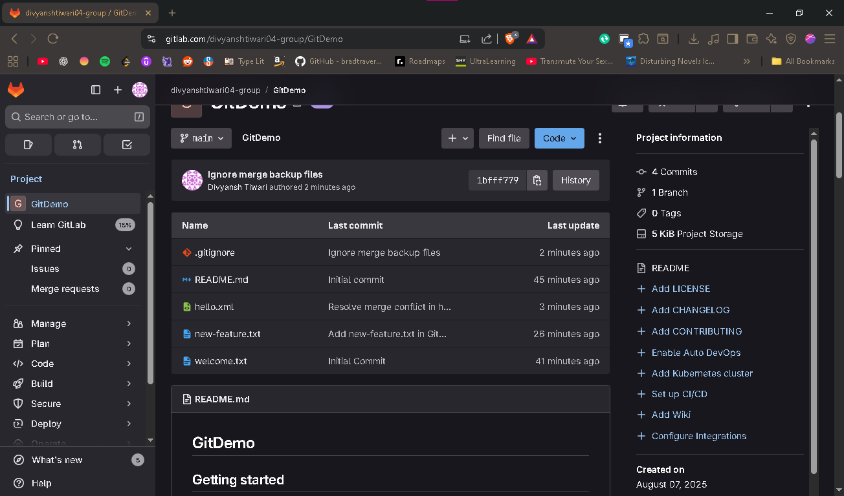
File directory on Gitlab web interface

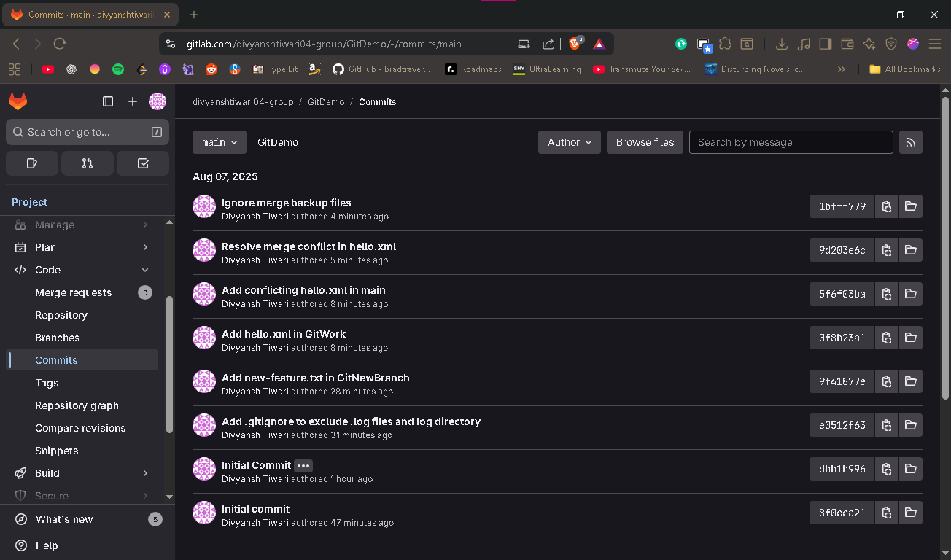
Commit history on GitLab
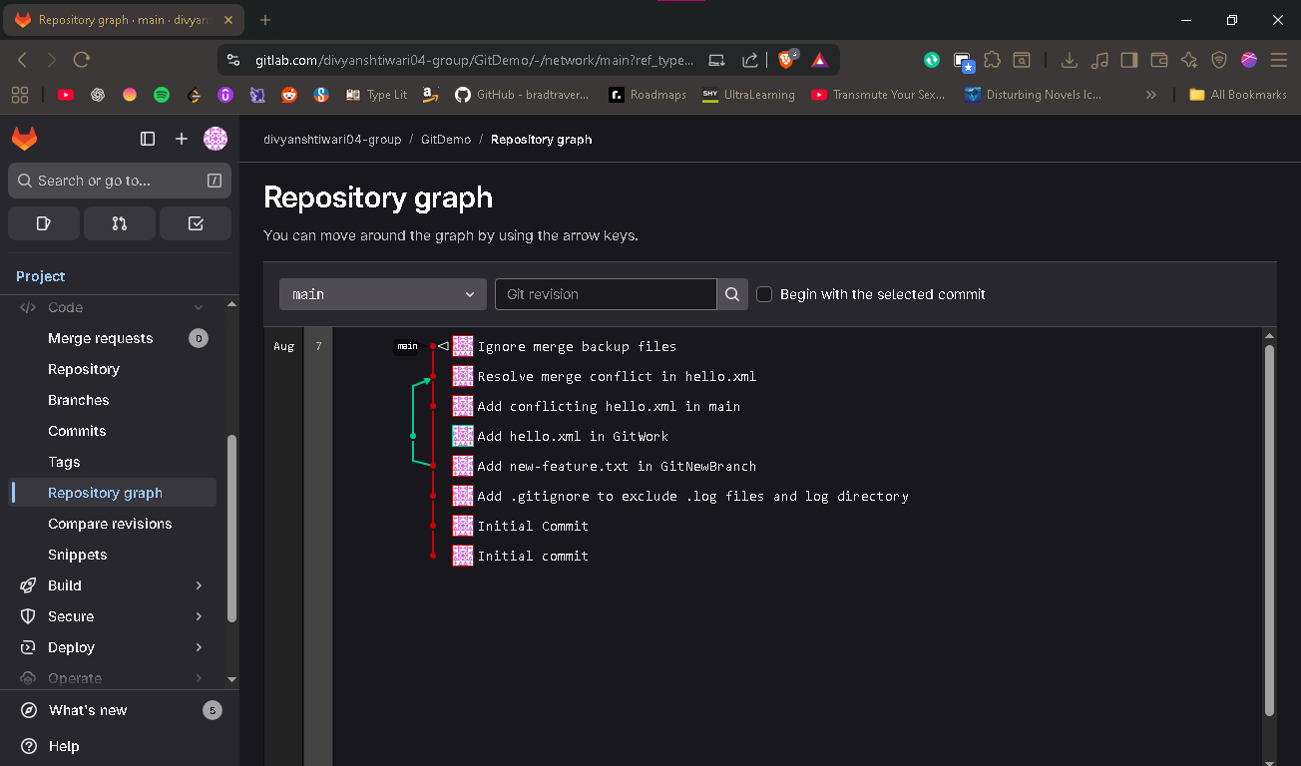
Repository Graph in GitLab visualizing merge history

