## horizontal line



CSN-361

05.10.2019

**─**

Divyanshu Salve

(17114027)

# Q1: Write a Network Simulator code to simulate a three node network with duplex links among them as shown in the figure. Show the topology using NAM. Study the variation in number of packets dropped with the variation of the queue size in the nodes and with the variation of the bandwidth of the links.

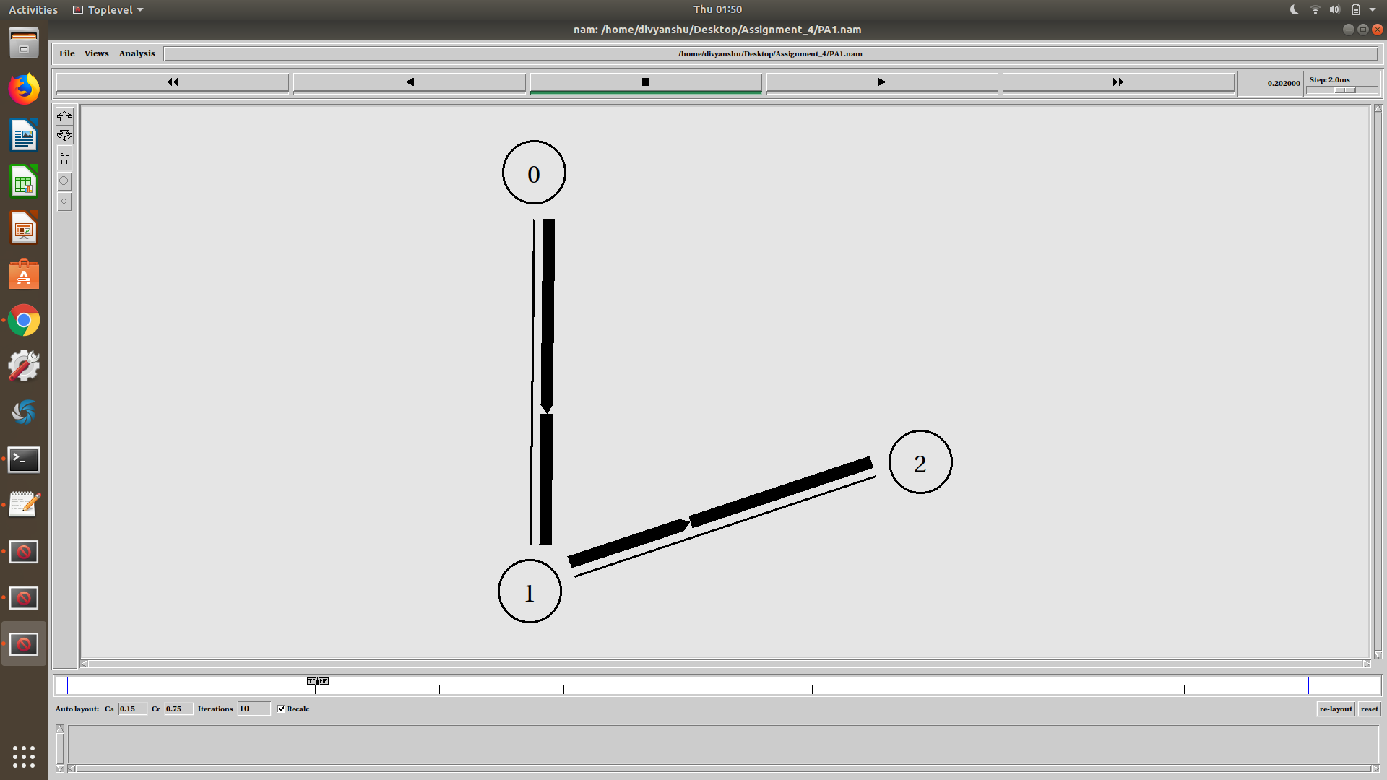

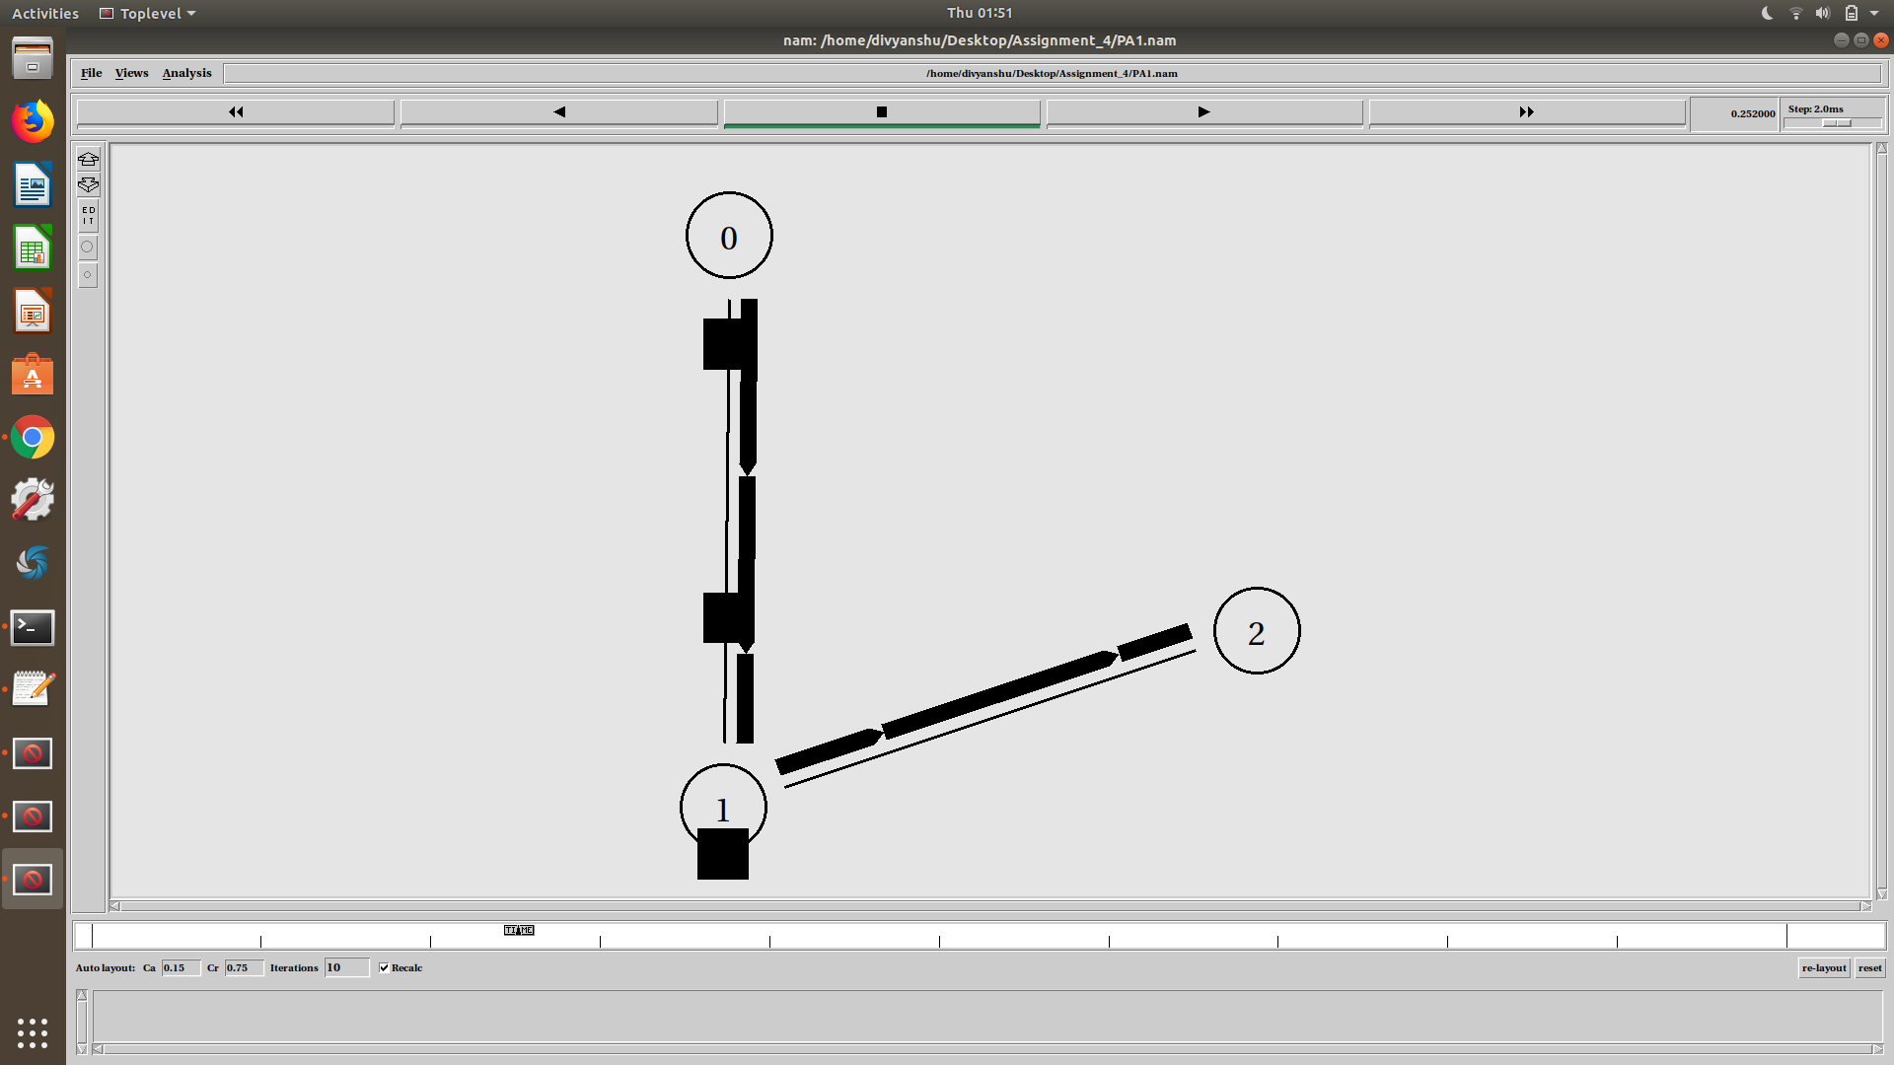

# 

# 

# 

# 

# Q2: Write a Network Simulator code to simulate the transmission of ping messages over a network topology consisting of 6 nodes and find the number of packets dropped due to congestion.

