**Final Report of the Capstone Project -The Battle of Neighborhoods**

**1.Introduction-**

The main goal behind this project is to help people in exploring better facility around there neighborhood, this will give a great choice of selecting neighborhodd surrounded them, and helps them to take decision smartly out of other members in Scarborough, Toranto.

Lots of people are moving to many different places of canada, and they need to do lots of research for house price , locality, primary health care , child care , school etc. This project is for people who are looking for better neighborhoods like better facility and ease of access.

This Project aim to create an analysis of features for a people moving to Scarborough to search a best neighborhood as a comparative analysis between neighborhoods. The features include median housing price and better school according to ratings, crime rates of that particular area, road connectivity, weather conditions, good management for emergency, water resources both freash and waste water and excrement conveyed in sewers and recreational facilities.

It will help people to get awareness of the area and neighborhood before moving to a new city, state, country or place for their work or to start a new fresh life.

**2. Data Description-**

DataSet - <https://en.wikipedia.org/wiki/List_of_postal_codes_of_Canada:_M>

with the help of above link I scrapped the data and make use of it.

***ForeSquare API***: To gain Location Information I have used this API.

ForeSquare is a location data provider with various kind of information. T

his API helpped to solve our problem statement and it woked very well to as per the expectation

After finding the list of neighborhoods, I have connect to the Foursquare API to gather information about venues inside each and every neighborhood. For each neighborhood, I have chosen the radius to be 100 meter.

Foursquare contained information of venues within a specified distance of the longitude and latitude of the postcodes.

**3. Methodology-**

**Libraries -** I have used multiple library like-

* Pandas
* Numpy
* Folium
* Geocoder
* Matplotlib
* BeutifulSoup etc.

**Cleaning –** I have scrapped the data and clean the unncessary noice of the data.

**Creating The Map –**  I used folium library to visualize the geographic area.

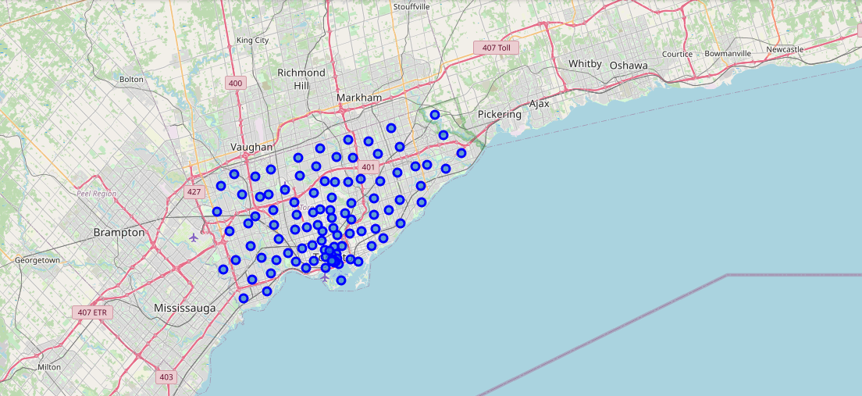

I have used Foresquare API to explore the data, Foursquare API to gather information about venues inside each and every neighborhood.

**Clustering**- I have used here K- means Algorithm ,to compare the similarities of two cities,

we have to explore neighborhoods, segment them, and group them into clusters to finding similar neighborhoods in a big city like New York and Toronto.

*Clustered Labels we can see after applying K means-*

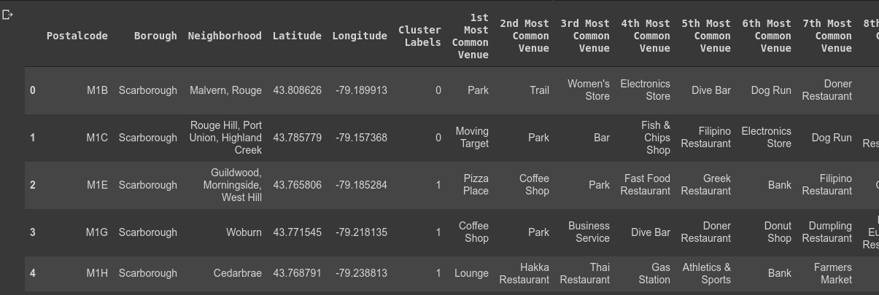

**4. Result Section -**

After aplying kmenas Clustered Map we got which is shown below-

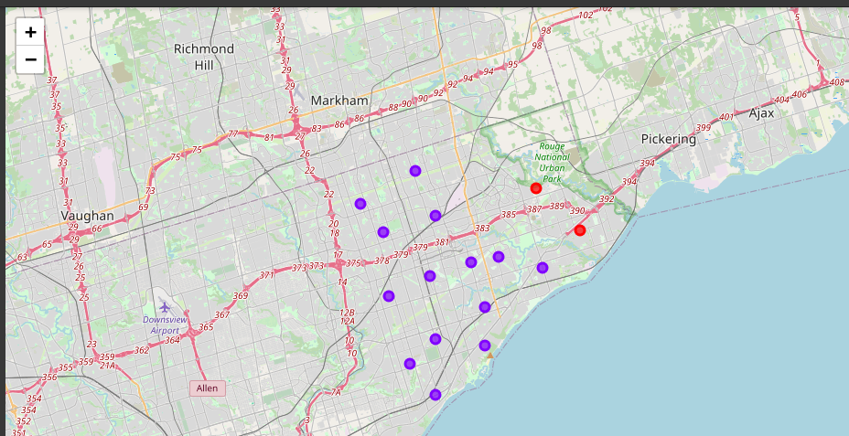

Avrage Housing price i scarborough:

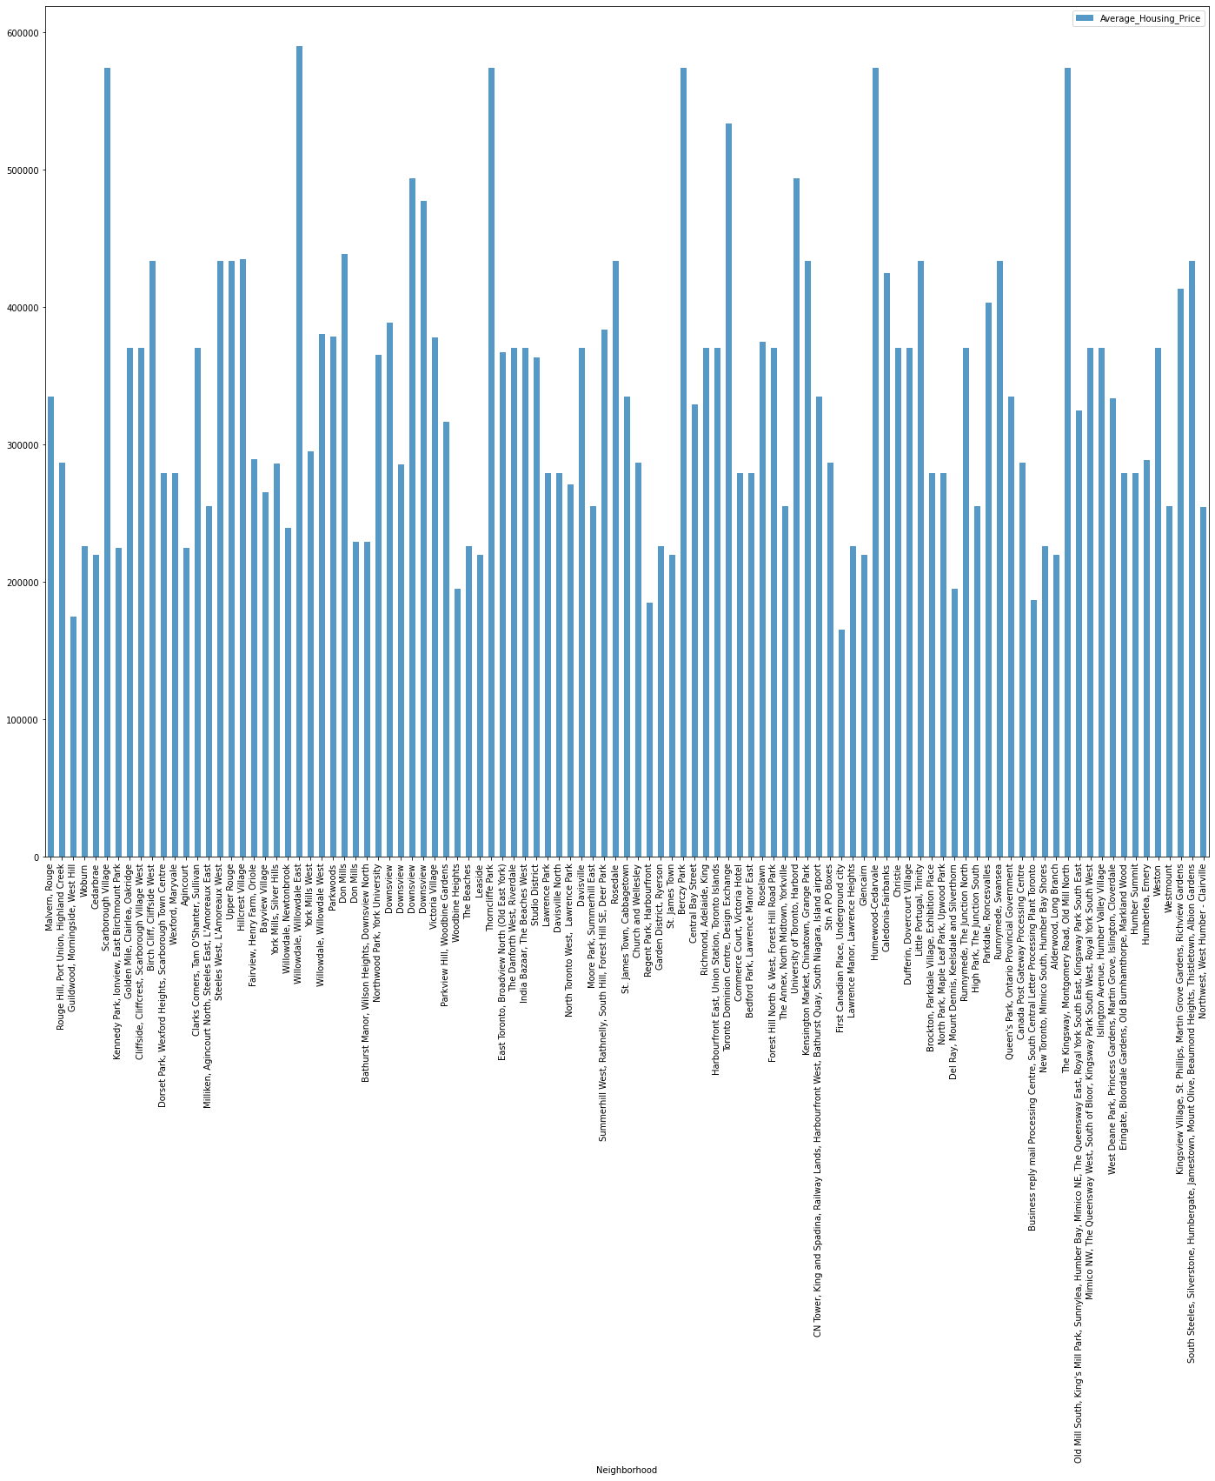

School rating plot:

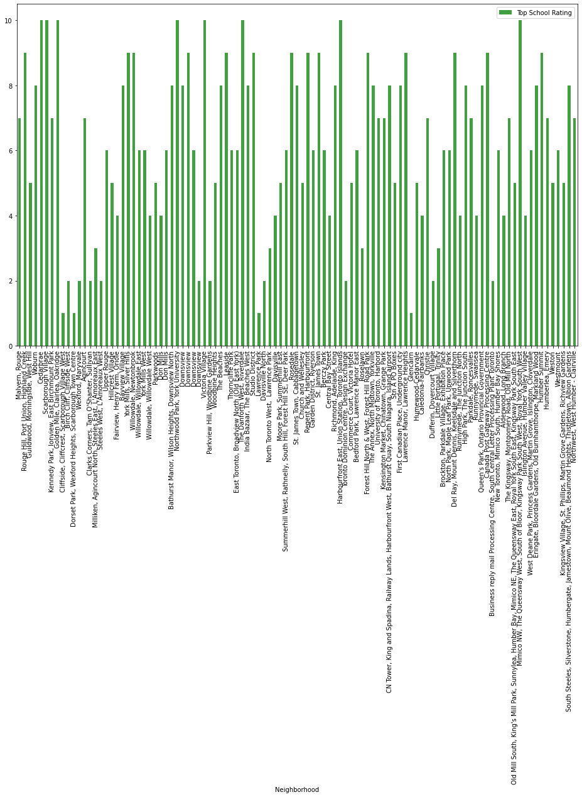

**5. Discussion-**

Here our main goal is to resolve the problem of migrants to get better facility of connectivity and daily needs.

We have sorted List of house based on average price as well sorted schools as per the rating.

Here we can do lot of improvment to get more good prediction.

**6. Conclusion-**

In this project I got very good hands on the real world problem and got very nice experience from this idea, here I have make use of K means algorithm and clustered into different segments to solve our problem statemnent, here we have generated Map to get better knowledge from the data to visualization process.