STRATEGIC DECISION-MAKING USING POWER BI

PRE-REPORT SUBMISSION

**SUBMITTED TO: DR. ARPIT YADAV**

DIVYANSHU

2023JULB01331

|  |  |
| --- | --- |
| **Section** | **Page Number** |
| Problem Statement | 1 |
| Data Requirement | 2 |
| Data Collection | 3 |
| Data Validation | 4 |
| Data Cleaning | 5 |
| Tools | 6 |
| Dashboard | 7 |
| Storytelling | 8 |

**Table of Contents**

**1. PROBLEM STATEMENT**

**Sales Performance and Forecasting for Zepto**

Zepto, a rapidly growing grocery delivery service, aims to optimize sales strategies while enhancing customer satisfaction. To achieve this, leveraging data analysis and forecasting techniques is critical for understanding sales trends, product performance, and regional preferences.

**Objective**

The primary goal is to analyze historical sales data, generate actionable insights, and forecast future sales trends to enable data-driven decision-making for growth and efficiency.

**Proposed Approach**

1. **Dashboard Creation**
   * Build a dynamic dashboard with interactive visualizations for comprehensive data exploration.
2. **Data Analysis**
   * Evaluate sales trends across key dimensions like location, outlet size, and product categories.
   * Analyze customer ratings and their correlation with sales performance.
3. **Sales Forecasting**
   * Utilize time series analysis to predict sales for the next 15 days.
4. **Actionable Insights and Recommendations**
   * Provide strategic recommendations based on data insights to improve sales and enhance operational efficiency.

**Expected Outcomes**

* Identification of top-performing outlets and categories.
* Accurate sales forecasting for inventory planning.
* Actionable strategies to enhance customer satisfaction and profitability.

**2. DATA REQUIREMENT**

The following data fields are required for analysis and forecasting:

1. **Item Fat Content** - Classification of products (e.g., Regular, Low Fat).
2. **Item Identifier** - Unique product ID.
3. **Item Type** - Product categories (e.g., Fruits, Dairy).
4. **Outlet Establishment Year** - Year the outlet was established.
5. **Outlet Identifier** - Unique outlet ID.
6. **Outlet Location Type** - Region classification (e.g., Tier 1, Tier 2).
7. **Outlet Size** - Outlet capacity (e.g., Small, Medium, Large).
8. **Outlet Type** - Store type (e.g., Supermarket Type1).
9. **Item Visibility** - Visibility percentage of the product.
10. **Item Weight** - Weight of the product.
11. **Sales** - Total sales value.
12. **Rating** - Customer ratings.

**3. DATA COLLECTION**

**Sources of Data**

1. **Sales Records** - Historical sales data for all products and outlets.
2. **Customer Feedback** - Ratings and reviews for products and services.
3. **Outlet Details** - Information on outlet type, size, and location.
4. **Market Trends** - External data on customer demand and seasonal patterns.

**4. DATA VALIDATION**

To ensure data accuracy and reliability, the following steps were taken:

1. **Missing Values**
   * Checked for and imputed missing entries in critical fields like sales and ratings.
2. **Data Consistency**
   * Verified consistent formatting for dates, outlet IDs, and location types.
3. **Duplicate Records**
   * Removed duplicates to avoid skewed analysis.
4. **Range Validation**
   * Ensured logical values for numeric fields (e.g., positive sales figures).

**5. DATA CLEANING**

**Steps Taken**

1. **Handle Missing Data**
   * Imputed missing values for ratings and sales using median values.
   * Removed irrelevant columns.
2. **Correct Data Formats**
   * Standardized date formats (e.g., YYYY-MM-DD).
   * Uniform naming conventions for categories and locations.
3. **Filter Outliers**
   * Excluded products with abnormal visibility percentages or ratings.
4. **Consolidate Data**
   * Grouped similar product categories for simplified analysis.

**6. TOOLS**

* **Power BI**: For creating interactive dashboards and visualizations.
* **Microsoft Excel**: For data cleaning and preparation.
* **Python**: For time series analysis and forecasting.

**7. DASHBOARD**

The Power BI dashboard created for Zepto includes the following components:

1. **Sales Overview**
   * Total sales, number of items sold, and average sales per product.
   * Contribution of low-fat and regular items to overall sales.
2. **Outlet Performance**
   * Sales distribution by outlet size and location type.
   * Year-on-year sales trends based on establishment years.
3. **Customer Feedback**
   * Average ratings by product category and outlet.
   * 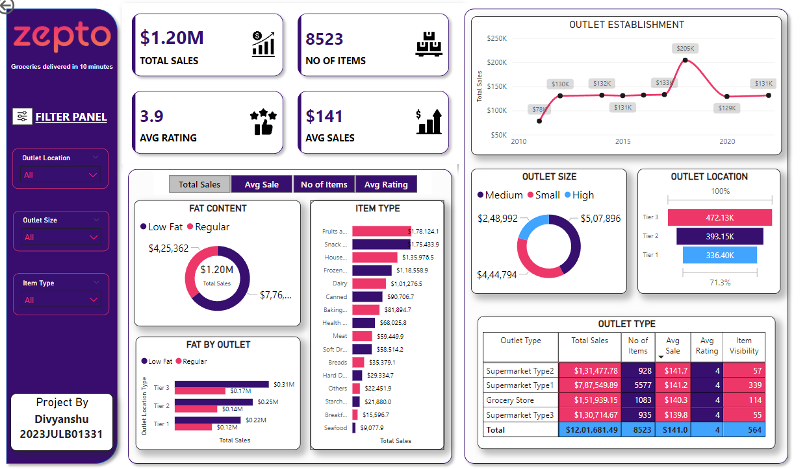Insights into customer satisfaction level

**8. STORYTELLING**

The data analysis is presented as a narrative for strategic decision-making:

**Introduction**

Zepto’s sales data was analyzed to uncover trends and provide actionable insights for growth.

**Challenges Identified**

1. **Low Sales in Specific Outlets**
   * Smaller outlets in Tier 2 cities underperform despite high demand potential.
2. **Product Visibility Issues**
   * Certain items have low visibility, affecting sales.
3. **Delivery Challenges**
   * Customer ratings indicate dissatisfaction with delayed deliveries.

**Key Insights**

1. **Top Performers**
   * Supermarket Type 1 outlets dominate sales, contributing over 40% of total revenue.
2. **Emerging Opportunities**
   * Tier 2 cities show rising demand for dairy and frozen products.
3. **Customer Preferences**
   * Regular fat items receive higher ratings and sales than low-fat items.

**Recommendations**

1. **Marketing Strategies**
   * Focus promotional campaigns on underperforming regions with high growth potential.
2. **Inventory Optimization**
   * Adjust stock levels based on sales forecasts for high-demand items.
3. **Customer Experience**
   * Partner with reliable logistics providers to ensure timely deliveries.

**Conclusion**

The analysis of Zepto's dataset revealed that $1.20M in total sales was driven primarily by regular fat content items and medium-sized outlets, with Tier-1 cities leading in demand. High-performing categories like snacks and dairy highlight consumer preferences, while an average rating of 3.9 suggests room for improvement in customer satisfaction.

Key recommendations include enhancing service quality, targeting Tier-2 and Tier-3 cities for growth, promoting top-performing items, and expanding medium-sized outlets for higher profitability. The insights and forecasts from this analysis will aid strategic decision-making and drive business growth.