**ESO207 Assignment 5**

Divyanshu Gangwar (190316)  
Atharva Umbarkar (190923)

Q1.1

|  |  |  |  |  |  |
| --- | --- | --- | --- | --- | --- |
| n | 1.00E+02 | 1.00E+03 | 1.00E+04 | 1.00E+05 | 1.00E+06 |
| Avg Comp QS | 625.272 | 10618.272 | 159483.452 | 2202636.706 | 68442518.12 |
| 2n*(loge(n)) | 921.03 | 13815.51 | 184206.807 | 23.02585.09 | 27631021.11 |
| Avg Comp MS | 557.272 | 8726.272 | 120460.162 | 1536388.43 | 18676089.7 |
| n*log2(n) | 664.4 | 9966 | 132880 | 1661000 | 19930000 |

As the value of n increases, avg compariosns by Quick Sort remain higher as compared to Merge Sort. Avg comparisons of Quick Sort are of order 2n*log(n) and that of Merge Sort are of n*log2(n).

Q1.2

|  |  |  |  |  |  |
| --- | --- | --- | --- | --- | --- |
| n | 1*1e5 | 3*1e5 | 5*1e5 | 7*1e5 | 9*1e5 |
| Avg Time QS | 12020 | 43974 | 84960 | 137070 | 193436 |

Avg running itme of Quick Sort is linear with n*log(n)

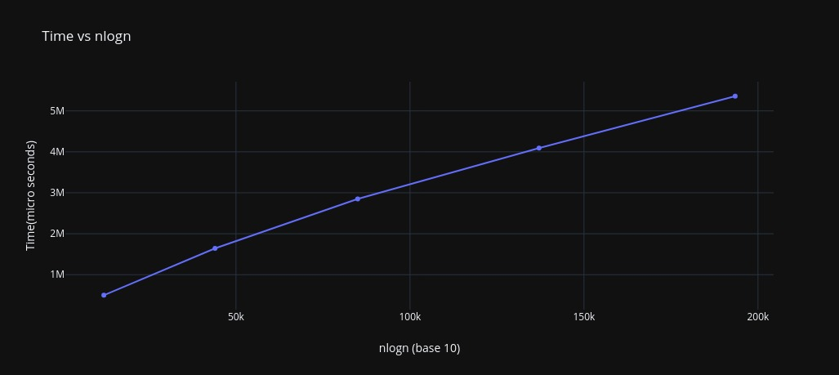

Q1.3

|  |  |  |  |  |  |
| --- | --- | --- | --- | --- | --- |
| Q3 | 1.00E+02 | 1.00E+03 | 1.00E+04 | 1.00E+05 | 1.00E+06 |
| QS Time | 4 | 72 | 1034 | 12202 | 225906 |
| MS Time | 6 | 102 | 1242 | 15892 | 173928 |
| MS outperforms QS | 1 | 32 | 150 | 500 | 500 |

On average, avg running time of Quick Sort is less than Merge Sort. It is approx. 25% faster than Merge Sort till n = 1E5.

Till n = 1E4, merge sort outperforms quicksort less than 30% of the total cased (500). After 1E4, merge sort almost always outperforms quick sort.

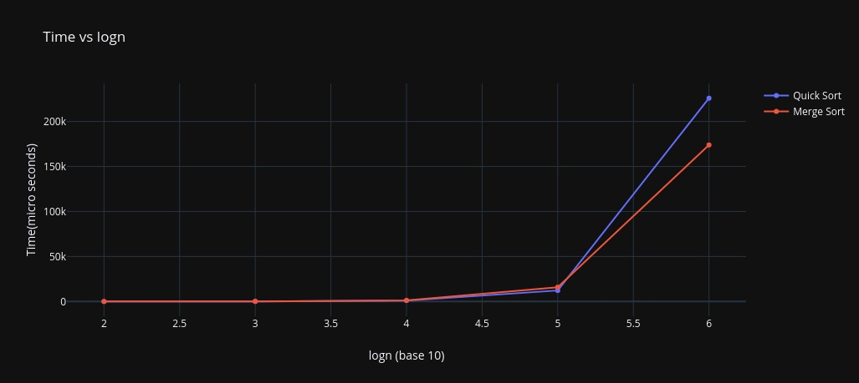

Q2

|  |  |  |  |  |  |
| --- | --- | --- | --- | --- | --- |
| Q5 | 1.00E+02 | 1.00E+03 | 1.00E+04 | 1.00E+05 | 1.00E+06 |
| Avg time of QS | 4 | 72 | 1034 | 12202 | 225906 |
| 5% | 0 | 0 | 0 | 0 | 0 |
| 10% | 0 | 0 | 0 | 15 | 0 |
| 20% | 0 | 0 | 0 | 1 | 0 |
| 30% | 0 | 0 | 0 | 0 | 0 |
| 50% | 0 | 0 | 22 | 0 | 0 |
| 100% | 3 | 37 | 0 | 0 | 0 |

As the value of m increases, the deviation of run time of quick sort is less than 5% of the avg run time over 500 cases.