**Python Beginners questions: -**

Q1: - Print the given strings as per stated format.

**Given strings**:

**"Data" "Science" "Mentorship" "Program"   
"By" "CampusX"**

**Output:**

**Data-Science-Mentorship-Program-started-By-CampusX**

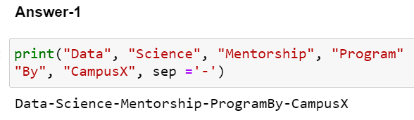

### Q2: - Write a program that will convert Celsius value to Fahrenheit.

### 

### Q3: - Take 2 numbers as input from the user. Write a program to swap the numbers without using any special python syntax.

### 

### Q4: - Write a program to find the Euclidean distance between two coordinates. Take both the coordinates from the user as input.

### 

### Q5: - Write a program to find the simple interest when the value of principle, rate of interest and time period is provided by the user.

### 

### Q6: - Write a program that will tell the number of dogs and chicken are there when the user will provide the value of total heads and legs.

**For example: Input: heads -> 4 legs -> 12  
Output: dogs -> 2 chicken -> 2**

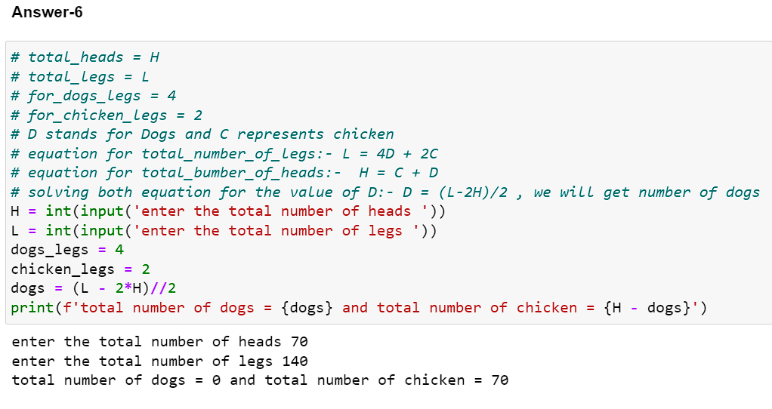

### Q7: - Write a program to find the sum of squares of first n natural numbers where n will be provided by the user.

### 

### Q8: - Given the first 2 terms of an Arithmetic Series. Find the Nth term of the series. Assume all inputs are provided by the user.

### 

### Q9: - Given 2 fractions, find the sum of those 2 fractions. Take the numerator and denominator values of the fractions from the user.

### 

### Q10: - Given the height, width and breadth of a milk tank, you have to find out how many glasses of milk can be obtained? Assume all the inputs are provided by the user.

### Input: Dimensions of the milk tank H = 20cm, L = 20cm, B = 20cm Dimensions of the glass h = 3cm, r = 1cm

### 