

Questions Link: - <https://datalemur.com/questions?category=SQL>

SQL Data Analytics Interview Solutions: -

1. Histogram of Tweets

Solution: -

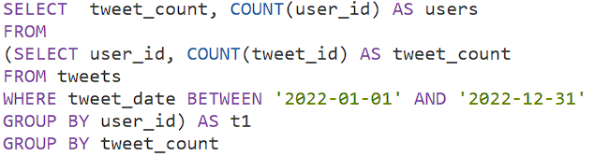

1. Data Science Skills

Solution: -

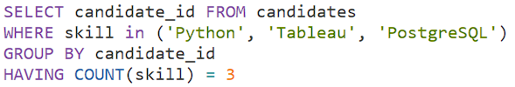

1. Page With No Likes

Solution: -

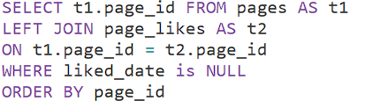

1. Unfinished Parts

Solution: -



1. Laptop vs Mobile Viewership

Solution: -

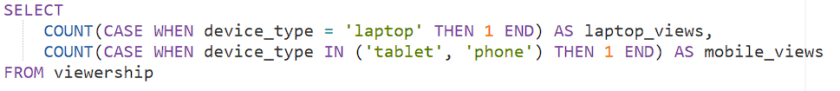

1. Average Post Hiatus (Part 1)

Solution: -

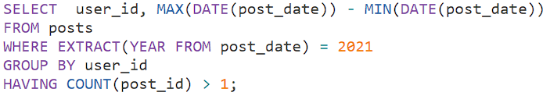

1. Teams Power Users

Solution: -

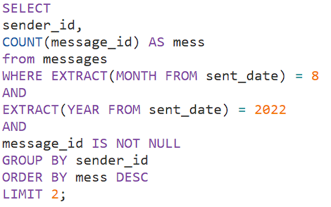

1. Duplicate Job Listings

Solution: -

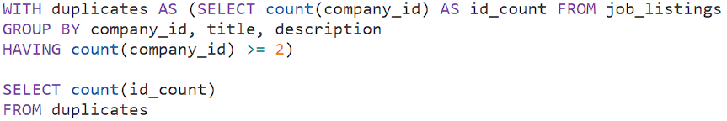

1. Cities With Completed Trades

Solution: -

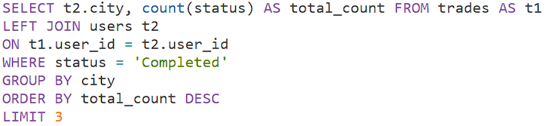

1. Average Review Ratings

Solution: -

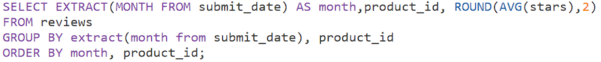

1. Apply Click-through Rate (CTR)

Solution: -

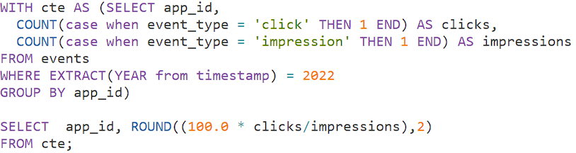

1. Second Day Confirmation

Solution: -

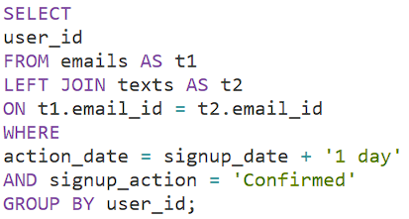

1. Cards Issued Difference

Solution: -

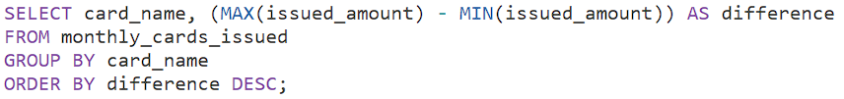

1. Compressed Mean

Solution: -



1. Pharmacy Analytics (Part 1)

Solution: -

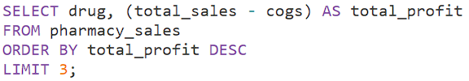

1. Pharmacy Analytics (Part 2)

Solution: -

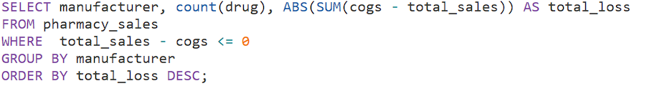

1. Pharmacy Analytics (Part 3)

Solution: -

