Financial Impacts
Discussion section — Six Sigma report: fast charging and smartphone battery degradation

Financial Impacts
Recommendation: default phone charging to a slower rate (2C) unless the user asks for a fast charge. Over a three-year ownership period, this lowers expected battery-replacement spending by $4.55 per owner (95% CI $3.37–$5.84), from $25.14 to $20.58. Slowing to 1C saves $5.84 ($4.46–$7.33). For a fleet of 10,000 company phones, that is roughly $45,500 ($33,700–$58,400) over three years at 2C. The cost is time: reaching 80% charge takes 25.6 minutes at 2C and 51.1 at 1C, instead of 17.0 at 3C.
How the costs were estimated. We combined the simulated battery lifetimes with published prices, following the bootstrap approach in Fraser (n.d.):
- Each simulated owner uses the phone for 3 years, Apple's first-owner assumption (Apple, 2024, p. 9), at 0.7 equivalent full cycles per day (Aussems, 2025): 766.5 cycles in total.
- Whenever a battery reaches 80% health, it is replaced and the new battery draws a fresh lifetime from the same strategy (a renewal process).
- Each replacement costs $99, Apple's out-of-warranty price for an iPhone 16 battery (Burkhardt, 2024), with no service fee for an in-store repair (Apple, n.d.-b). Every strategy uses the same $19 charger (Apple, n.d.-d), so charger cost cancels out.
Uncertainty. No closed-form standard error exists for this cost, so we bootstrapped it. We resampled the 1,000 simulated owners 2,000 times, with the same owners under both strategies, and took the 2.5th and 97.5th percentiles of the cost difference. Using the $119 Pro-model battery price instead raises the 2C saving to $5.47 ($4.05–$7.02).
When owners replace the whole phone at end of battery life ($799; Apple, n.d.-c), the stakes are larger. Slower 2C charging saves $36.75 per owner ($27.17–$47.14), and 1C saves $47.14 ($35.96–$59.13).
What the money depends on. Savings come from fewer owners hitting end of life within three years. At 3C, 6.2% of owners need a replacement (95% CI 4.8–7.6%); at 2C, 1.6% (0.9–2.4%); at 1C, 0.3% (0–0.7%). Most of that spending falls in year three (Figure 2).
What we cannot claim yet. The 80% charge limit and multistage charging show $0 savings only because no verified source gives their effect on battery life. These are not evidence that they don't help.
These figures are conservative for real phones. Our lifetime model, fitted to LFP cells, predicts batteries lasting five to ten times longer than Apple's 500–1,000-cycle ratings. If real phone batteries fade as fast as Apple's ratings suggest, far more owners would hit end of life within three years, and the savings from slower charging would be larger. Two inputs also deserve caution. The usage rate comes from a review site's estimate rather than a peer-reviewed study, and the battery price comes from 2024 news coverage of Apple's price list. We would ask a CTO to fund obtaining the LCO test conditions (Diao et al., 2019) and a peer-reviewed usage estimate before scaling the recommendation.
Table 1. Cost inputs and sources.
Input | Value | Source (retrieved 28 Oct 2026)
Out-of-warranty battery replacement, iPhone 16 | $99 (sensitivity: $119, Pro models) | Burkhardt (2024), citing Apple's iPhone Repair & Service page
Service fee per replacement | $0 (in-store) | Apple Support: a shipping fee applies only when the phone is mailed in
Charger (same for every strategy) | $19 | Apple Store, 20W USB-C Power Adapter (MWVV3AM/A)
Device (phone-replacement case) | $799 | Apple Store, iPhone 16 128GB
Equivalent full cycles per year | 255.5 (0.7 per day) | Aussems (2025); review-site estimate, not peer reviewed
Ownership period | 3 years | Apple (2024), iPhone 16 Product Environmental Report, p. 9
Table 2. Three-year cost per owner by charging strategy (1,000 simulated owners; bootstrap 95% CIs; 2,000 resamples).
Strategy | Owners needing a replacement in 3 yr | 3-yr cost per owner, battery replaced [95% CI] | Saving vs fast, battery replaced [95% CI] | Saving vs fast, phone replaced [95% CI]
Fast 3C (CC-CV, 100%) | 6.2% | $25.14 [23.75, 26.52] | reference | reference
80% limit (3C) | 6.2% | $25.14 [23.75, 26.52] | $0.00 [0.00, 0.00] | $0.00 [0.00, 0.00]
Multistage (3C) | 6.2% | $25.14 [23.75, 26.52] | $0.00 [0.00, 0.00] | $0.00 [0.00, 0.00]
Slower 2C | 1.6% | $20.58 [19.89, 21.38] | $4.55 [3.37, 5.84] | $36.75 [27.17, 47.14]
Slower 1C | 0.3% | $19.30 [19.00, 19.69] | $5.84 [4.45, 7.33] | $47.14 [35.95, 59.13]
80% limit and multistage: life effects not modelled, so their costs equal fast charging by construction.
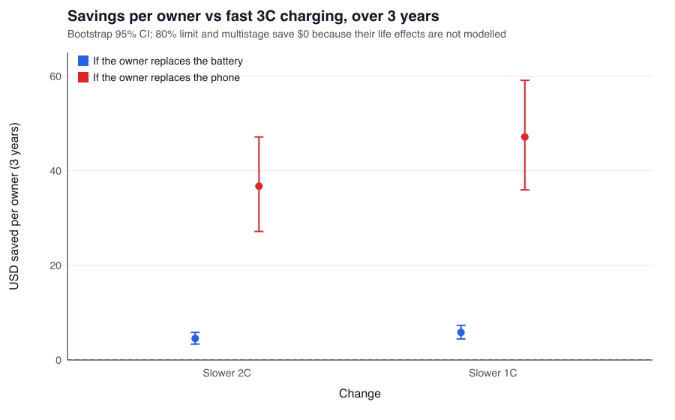
Figure 1. Savings per owner over three years from slower charging, compared with fast 3C charging, if the owner replaces the battery (blue) or the whole phone (red). Bars are bootstrap 95% CIs.
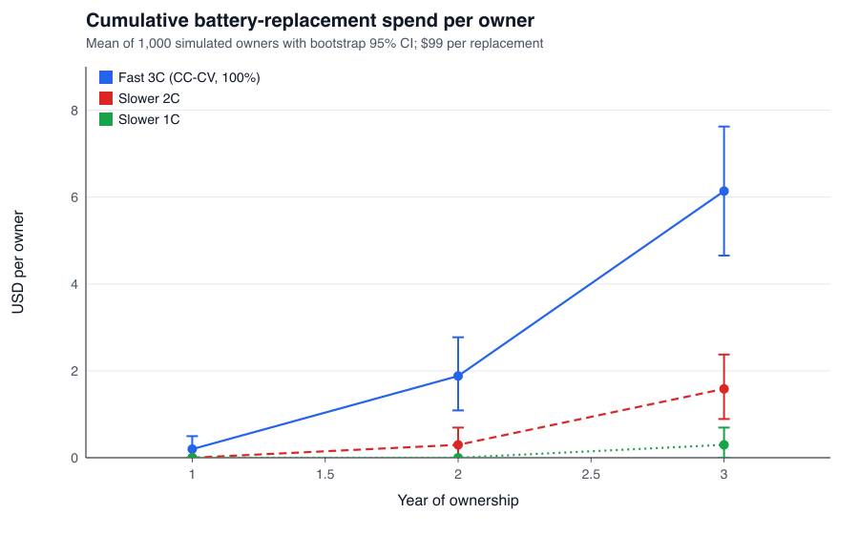
Figure 2. Cumulative battery-replacement spend per owner by year of ownership. Most of the difference appears in year three.
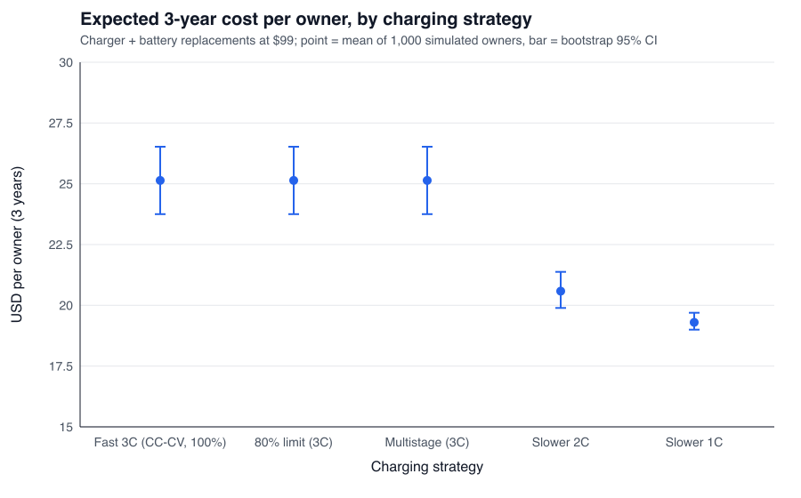
Figure 3. Expected three-year cost per owner (charger plus battery replacements) by strategy.
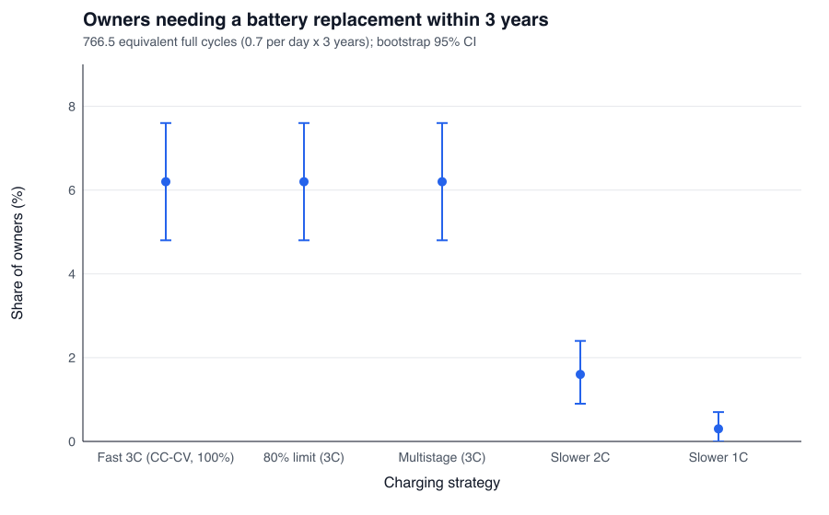
Figure 4. Share of owners needing at least one battery replacement within three years.

References
Apple Inc. (n.d.-d). 20W USB-C Power Adapter [Product listing, MWVV3AM/A]. Apple Store. Retrieved October 28, 2026, from https://www.apple.com/us/search/20W-USB-C-Power-Adapter
Apple Inc. (2024). Product environmental report: iPhone 16 and iPhone 16 Plus. https://www.apple.com/environment/pdf/products/iphone/iPhone_16_and_iPhone_16_Plus_PER_Sept2024.pdf
Apple Inc. (n.d.-c). Buy iPhone 16. Apple Store. Retrieved October 28, 2026, from https://www.apple.com/shop/buy-iphone/iphone-16
Apple Inc. (n.d.-b). iPhone battery replacement. Apple Support. Retrieved October 28, 2026, from https://support.apple.com/iphone/repair/battery-replacement
Aussems, M. (2025, July 4). iPhone battery twice as bad as Samsung: Which manufacturer performs best? ITdaily. https://itdaily.com/blogs/workplace/iphone-battery-twice-as-bad-as-samsung-which-manufacturer-performs-best/
Burkhardt, M. (2024, September 15). iPhone 16 Pro battery replacement [News article]. 9to5Mac. https://9to5mac.com/2024/09/15/iphone-16-pro-battery-replacement/
Diao, W., Saxena, S., & Pecht, M. (2019). Accelerated cycle life testing and capacity degradation modeling of LiCoO2-graphite cells. Journal of Power Sources, 435, 226830. https://doi.org/10.1016/j.jpowsour.2019.226830
Fraser, T. (n.d.). ZZ_financial_analysis [Computer code]. sysen repository, GitHub. https://github.com/timothyfraser/sysen
Severson, K. A., Attia, P. M., Jin, N., Perkins, N., Jiang, B., Yang, Z., Chen, M. H., Aykol, M., Herring, P. K., Fraggedakis, D., Bazant, M. Z., Harris, S. J., Chueh, W. C., & Braatz, R. D. (2019). Data-driven prediction of battery cycle life before capacity degradation. Nature Energy, 4(5), 383–391. https://doi.org/10.1038/s41560-019-0356-8

