Preliminary Methods and Results
Does fast charging make smartphone batteries degrade faster? — Six Sigma simulation study

Measures
The unit of observation is one simulated smartphone battery, and we record five measures for each. Cycles to 80% health counts equivalent full charge cycles until capacity falls to 80% of nominal, the end-of-life definition used by Severson et al. (2019) and by Apple's ratings (Apple, n.d.-a). Health at 500 and 1,000 cycles is capacity as a fraction of nominal at Apple's two rated cycle counts; a battery already past end of life is flagged rather than given a number. Minutes to 80% charge is the convenience measure users notice. Peak battery temperature is ambient temperature plus the charge-phase rise. Together these put the trade-off in one place: speed and heat against lifespan. Life is also summarised as Weibull reliability (β, η, MTTF and R(t)).

Assumptions
Every model number comes from a published source, a manufacturer rating, or a fit to a published dataset; anything we could not verify was left out. That rule forced four simplifications. First, life is modelled on LFP cells (Severson et al., 2019), not the LCO cells in phones, because the LCO dataset (Diao et al., 2019) cannot yet be mapped to its test conditions. Second, the charge-rate law fitted at 3.2–5.3C is applied at 1–3C. Third, ambient temperature, the 80% limit and multistage charging get no life effect, because no verified source quantifies one. Fourth, capacity fades along the median Severson curve, so batteries differ only in when they reach end of life.

Model / approach
We built a full-factorial Monte Carlo simulation in Python (numpy, pandas and scipy only) with four factors: charge rate (1C, 2C, 3C), ambient temperature (10, 25, 40 °C), charge limit (80%, 100%) and charging method (standard constant-current/constant-voltage, CC-CV, versus multistage constant current). That gives 36 scenarios with 1,000 simulated batteries each, 36,000 in total. All runs use one random seed (20261028), and battery i uses the same random draws in every scenario (common random numbers), so differences between scenarios are not sampling noise.
Life submodel. Cycles to 80% health follow a Weibull distribution whose scale depends on charge rate: η(r) = 820.2 × exp(−0.531 × (r − 4.74)), with shape β = 2.595. We estimated β, η and the rate slope together by maximum likelihood on 124 cells from Severson et al. (2019), all of which reached end of life (no censoring). The slope's 95% CI is [−0.723, −0.339]. We re-ran the whole simulation with the slope at both CI bounds to carry parameter uncertainty into the results.
Health submodel. Health at n cycles is read off the median normalised fade curve from the same 124 cells: health starts at 0.972 of nominal, is 0.958 at half of life, and 0.800 at end of life.
Charge-time submodel. Time to 80% is t₈₀ = k × 0.8 × 60 / r minutes, where k ~ Normal(1.061, 0.088) was fitted to 21 Severson cells charged at a single rate to 80%. Multistage charging multiplies t₈₀ by 0.898 at 25 °C or 0.926 at 35 °C, the measured ratios in Tahir et al. (2024, Table 11).
Temperature submodel. Peak temperature is ambient plus a charge-phase rise fitted to raw Severson temperature traces. That fit is weak (R² = 0.07) and predicts impossible negative rises below about 2C, so temperature is reported only at 3C.
Analysis. We used descriptive statistics, type III factorial ANOVA with partial η², and an ordinary-least-squares regression of log life on all factors with two-way interactions. Strategies were compared with paired bootstrap 95% confidence intervals (2,000 resamples). We fitted Weibull reliability per strategy, and applied an individuals control chart with capability indices to health at 500 cycles. This chain answers the research question directly: the ANOVA and regression isolate how much charge rate moves battery life, the bootstrap puts uncertainty on the difference between practical charging strategies, and the reliability and SPC steps translate it into the language of a warranty or a service plan.

Results
Charge rate is the dominant driver of both lifespan and charging speed. Median cycles to 80% health fall from 5,237 at 1C to 3,080 at 2C and 1,811 at 3C. In the regression of log life, the 3C coefficient is −1.062 (95% CI [−1.088, −1.035], p < 0.001) relative to 1C, which means about 65% shorter life; the 2C coefficient is −0.531 ([−0.558, −0.504], p < 0.001). The model explains R² = 0.459 of the variance in log life; the rest is battery-to-battery spread. Charge rate has a partial η² of 0.459 for log life, 0.102 for health at 500 cycles and 0.212 for health at 1,000 cycles (all p < 0.001). By 1,000 cycles, 0.9% of batteries charged at 1C are past end of life, against 3.1% at 2C and 13.2% at 3C. Mean health at 500 cycles is 0.976, 0.973 and 0.967 respectively.
Fast charging buys time. Mean minutes to 80% are 51.1 (1C), 25.6 (2C) and 17.0 (3C) with CC-CV. Rate explains almost all of the variance in charge time (partial η² = 0.963), and charging method explains a further 0.222 (both p < 0.001). Multistage charging saves 1.75 minutes per charge at 3C (paired bootstrap 95% CI [1.74, 1.76]). The ambient-temperature term is small (partial η² = 0.006) and exists only because the 40 °C scenarios borrow Tahir's 35 °C ratio.
Charge limit, ambient temperature and method show zero effect on life — by construction, not as a finding. Their F statistics for life are exactly 0 because no verified source quantified their life effects. Reliability at 3C is therefore identical for the three practical strategies: β = 2.63 [2.51, 2.76], η = 2,088 [2,037, 2,140] cycles, MTTF = 1,855 cycles, R(500) = 0.977 and R(1,000) = 0.866.
Results are sensitive to the rate slope. With the slope at its 95% CI bounds, median life at 1C ranges from 2,552 to 10,750 cycles and at 3C from 1,296 to 2,531. The baseline fails validation: at 1C and 25 °C the model predicts a median of 5,187 cycles, five to ten times Apple's ratings of 500 (iPhone 14 and earlier) and 1,000 cycles (iPhone 15 models) (Apple, n.d.-a). We did not tune the model to force a match. The most likely reason is chemistry: LFP cells last much longer than phone LCO cells. Absolute lifetimes are therefore not credible; the direction and relative size of the rate effect are the defensible results.
Control chart and capability. The individuals chart on health at 500 cycles for the multistage strategy has CL = 0.967, UCL = 0.996 and LCL = 0.938. It flags 33 points and a 16-point run, but the batteries are independent by design. The signals come from health being bounded and skewed (Shapiro–Wilk p < 0.001), not from instability. Against a lower specification of 0.80 at 500 cycles, Cpk = 5.84 and Ppk = 3.49, yet 1.8% of batteries are already past end of life at 500 cycles and cannot be charted. Capability indices overstate quality here, and the observed nonconforming fraction (1.8%) is the honest metric.

Tables and figures
Table 1. Factorial ANOVA (type III, effect coding, all interactions; n = 36,000 batteries, or fewer for health where batteries are past end of life). Terms not shown have partial η² < 0.002; the full table is in outputs/tables/p4_2_anova.csv.
Response | Term | df | F | p | Partial η²
Minutes to 80% charge | rate | 2 | 462577.8 | < 0.001 | 0.963
Minutes to 80% charge | method | 1 | 10239.8 | < 0.001 | 0.222
Minutes to 80% charge | ambient | 2 | 104.6 | < 0.001 | 0.006
Minutes to 80% charge | limit | 1 | 0.0 | 1.000 | 0.000
Minutes to 80% charge | rate:method | 2 | 1100.1 | < 0.001 | 0.058
log(cycles to 80% health) | rate | 2 | 15250.1 | < 0.001 | 0.459
log(cycles to 80% health) | method | 1 | 0.0 | 1.000 | 0.000
log(cycles to 80% health) | ambient | 2 | 0.0 | 1.000 | 0.000
log(cycles to 80% health) | limit | 1 | 0.0 | 1.000 | 0.000
log(cycles to 80% health) | rate:method | 2 | 0.0 | 1.000 | 0.000
Health at 500 cycles | rate | 2 | 2036.9 | < 0.001 | 0.102
Health at 500 cycles | method | 1 | 0.0 | 1.000 | 0.000
Health at 500 cycles | ambient | 2 | 0.0 | 1.000 | 0.000
Health at 500 cycles | limit | 1 | 0.0 | 1.000 | 0.000
Health at 500 cycles | rate:method | 2 | 0.0 | 1.000 | 0.000
Health at 1000 cycles | rate | 2 | 4573.4 | < 0.001 | 0.212
Health at 1000 cycles | method | 1 | 0.0 | 1.000 | 0.000
Health at 1000 cycles | ambient | 2 | 0.0 | 1.000 | 0.000
Health at 1000 cycles | limit | 1 | 0.0 | 1.000 | 0.000
Health at 1000 cycles | rate:method | 2 | 0.0 | 1.000 | 0.000
A term with F = 0 has no verified effect in the model and was therefore not simulated; it is not evidence of no effect.
Table 2. Regression of log(cycles to 80% health) on all factors with two-way interactions (OLS, n = 36,000; R² = 0.459, adjusted R² = 0.459, residual SD = 0.471).
Term (baseline 1C, 25 °C, 100%, CC-CV) | Estimate | SE | 95% CI | p
Intercept | 8.4903 | 0.0111 | [8.4686, 8.5121] | < 0.001
rate[2.0] | -0.5309 | 0.0136 | [-0.5575, -0.5043] | < 0.001
rate[3.0] | -1.0618 | 0.0136 | [-1.0884, -1.0352] | < 0.001
ambient[10] | 0.0000 | 0.0136 | [-0.0266, 0.0266] | 1.000
ambient[40] | 0.0000 | 0.0136 | [-0.0266, 0.0266] | 1.000
limit[80] | 0.0000 | 0.0122 | [-0.0238, 0.0238] | 1.000
method[MSCC] | 0.0000 | 0.0122 | [-0.0238, 0.0238] | 1.000
13 two-way interactions | all |b| ≤ 1.0e-14 | 0.010–0.015 | each CI contains 0 | all = 1.000
Residuals are left-skewed (skew −0.97, excess kurtosis 1.66), as expected when life is Weibull-distributed; coefficient CIs use the normal-theory standard errors.
Table 3. Practical charging strategies at 3C and 25 °C: Weibull reliability of simulated life, and the change in median minutes to 80% from a paired bootstrap (2,000 resamples).
Strategy (25 °C) | Weibull β [95% CI] | Weibull η, cycles [95% CI] | MTTF | R(500) | R(1000) | Δ median min to 80% vs normal [95% CI]
Normal fast (3C, CC-CV, 100%) | 2.63 [2.51, 2.76] | 2088 [2037, 2140] | 1855 | 0.977 | 0.866 | reference
80% limit (3C, CC-CV) | 2.63 [2.51, 2.76] | 2088 [2037, 2140] | 1855 | 0.977 | 0.866 | 0.00 [0.00, 0.00]
Multistage (3C, 100%) | 2.63 [2.51, 2.76] | 2088 [2037, 2140] | 1855 | 0.977 | 0.866 | -1.75 [-1.76, -1.74]
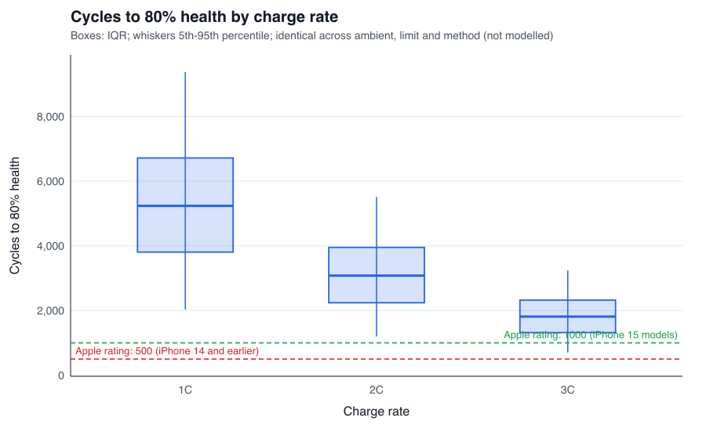
Figure 1. Cycles to 80% health by charge rate (boxes: interquartile range; whiskers: 5th–95th percentile). Dashed lines mark Apple's 500- and 1,000-cycle ratings; the simulated lives sit far above them (validation gap).
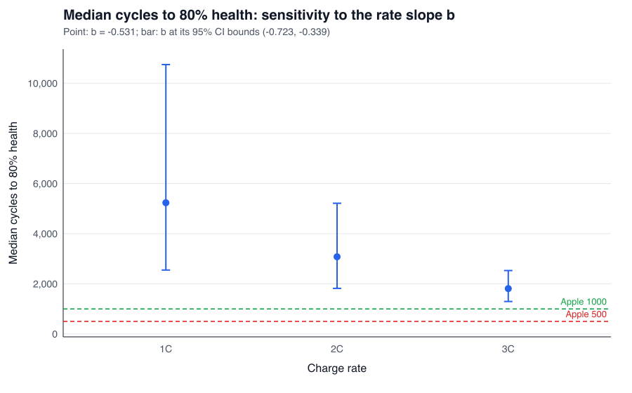
Figure 2. Median life by charge rate, with the rate slope at its point estimate (dot) and at its 95% CI bounds (bar).
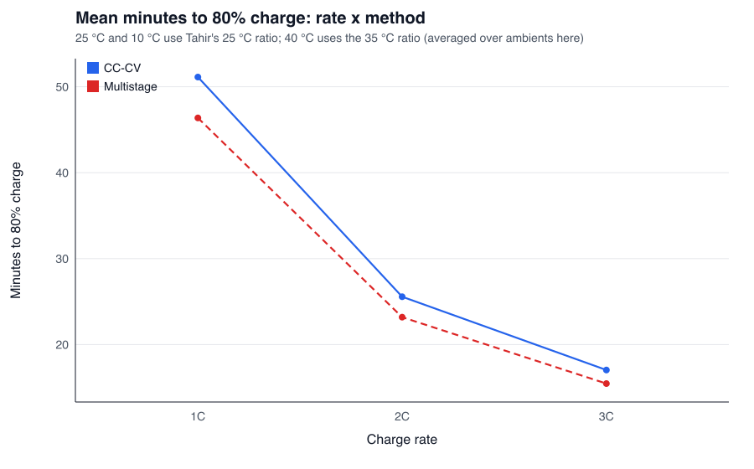
Figure 3. Mean minutes to 80% charge by rate and method.
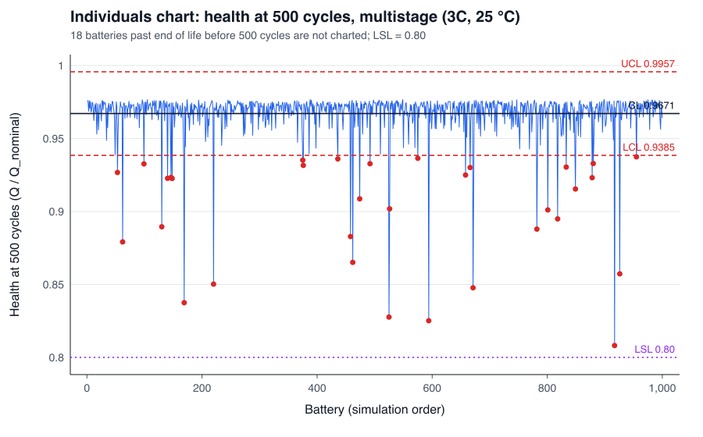
Figure 4. Individuals chart on health at 500 cycles, multistage strategy (3C, 25 °C). Red points fall beyond the 3σ limits; LSL = 0.80.

References
Apple Inc. (n.d.-a). Battery service and recycling. Retrieved October 28, 2026, from https://www.apple.com/batteries/service-and-recycling/
Diao, W., Saxena, S., & Pecht, M. (2019). Accelerated cycle life testing and capacity degradation modeling of LiCoO2-graphite cells. Journal of Power Sources, 435, 226830. https://doi.org/10.1016/j.jpowsour.2019.226830
Severson, K. A., Attia, P. M., Jin, N., Perkins, N., Jiang, B., Yang, Z., Chen, M. H., Aykol, M., Herring, P. K., Fraggedakis, D., Bazant, M. Z., Harris, S. J., Chueh, W. C., & Braatz, R. D. (2019). Data-driven prediction of battery cycle life before capacity degradation. Nature Energy, 4(5), 383–391. https://doi.org/10.1038/s41560-019-0356-8
Tahir, M. U., Sangwongwanich, A., Stroe, D.-I., & Blaabjerg, F. (2024). Multi-objective optimization for multi-stage constant current charging for Li-ion batteries. Journal of Energy Storage, 86(Part A), 111313. https://doi.org/10.1016/j.est.2024.111313

