Six Sigma Report — Rough Draft
Does fast charging make smartphone batteries degrade faster?

1. Introduction
[Project Charter — insert the template completed in the earlier assignment; not in the word count.]

Background and project motivation
Smartphone owners now expect a phone to charge from empty to most of its capacity in well under half an hour, and manufacturers compete on charging wattage. Yet the battery is also the component that wears out first: Apple rates iPhone batteries to retain 80% of their capacity after 500 complete cycles for iPhone 14 and earlier and 1,000 cycles for iPhone 15 models (Apple, n.d.-a), and a battery below 80% is the most common reason owners pay for a replacement or buy a new phone. Laboratory studies show that high charging currents accelerate lithium-ion degradation (Keil & Jossen, 2016; Severson et al., 2019), but phone users and IT managers have no quantified guide to how much lifespan fast charging costs and what that is worth in dollars. That gap motivates this project.

Project objectives and expected contributions
Our research question is: does fast charging make smartphone batteries degrade faster, and by how much? The objectives are to (1) build a simulation model in which every parameter is traceable to a published dataset or paper; (2) quantify how charge rate, ambient temperature, charge limit and charging method affect cycles to 80% health, health at Apple's rated cycle counts, charging time and battery temperature; (3) compare practical strategies a user or fleet manager could adopt — normal fast charging, an 80% charge limit, multistage charging and slower charging — with confidence intervals; and (4) translate the results into ownership cost. The expected contribution is a transparent, reproducible decision aid that states clearly what is supported by evidence and what still is not.

2. Literature review
[SIPOC diagram — insert the template completed in the earlier assignment; not in the word count.]
[Process map — insert the template completed in the earlier assignment; not in the word count.]
[Voice of the Customer tree — insert the template completed in the earlier assignment; not in the word count.]

Background literature
Severson et al. (2019) cycled 124 commercial lithium iron phosphate (LFP) cells under 72 fast-charging protocols and found cycle lives from about 150 to 2,300 cycles. They released the full dataset, which we use to fit our life model. Attia et al. (2020) extended that work with a further 45-cell batch and machine-learning-guided optimisation of four-step charging protocols.
For the lithium cobalt oxide (LCO) chemistry used in phones, Diao et al. (2019) ran an accelerated full-factorial life test on 3.36 Ah pouch cells. It varied ambient temperature, discharge rate and charge cut-off, with eight replicate cells per condition, and the capacity data is public. Saxena et al. (2016) showed that the mean state of charge and the size of the charge swing both change the fade rate of LCO cells, which motivates our charge-limit factor.
Keil and Jossen (2016) tested charging protocols on three 18650 cell types. Charging current harmed cycle life more than discharge current, and the size of the effect differed widely between cell types. That warns against carrying one cell's numbers to another.
On heat, Huang et al. (2019) embedded thermocouples in a 2 Ah pouch cell. The core rose 22.5 °C within five minutes at 7C under forced air but less than 1.5 °C at 1C, and natural convection gave higher temperature rises than forced convection.
Multistage constant-current charging is reported to shorten charge time without extra heating. Tahir et al. (2024) measured 10.2% faster charging than CC-CV at 25 °C with a comparable maximum temperature rise, and Liu and Luo (2010) reported longer cycle life for an optimised multistage pattern. Together, this literature says fast charging should shorten life, but in amounts that depend on chemistry, temperature and protocol.

3. Methodology
[Research Design — insert the template completed in the earlier assignment; not in the word count.]

Data
We used five data sources. The Severson et al. (2019) and Attia et al. (2020) batch files (four MATLAB files, 10.9 GB) give per-cycle capacity, charge time, temperature and internal resistance for 185 LFP cells. We applied the authors' published curation to recover their 124-cell set and fitted life, fade, charge-time and temperature relationships to it. The Diao et al. (2019) file holds LCO capacity curves for 24 test conditions with 8 cells each, but which condition is which temperature is described only in the paper, which we have not yet obtained. The CALCE partial-cycling cells behind Saxena et al. (2016) are downloaded but stored in a MATLAB format our toolset cannot read. Tahir et al. (2024) supplies measured charge times and temperature rises for CC-CV versus multistage charging. Apple's published ratings and prices anchor validation and costs.

Measures
The unit of observation is one simulated smartphone battery, and we record five measures for each. Cycles to 80% health counts equivalent full charge cycles until capacity falls to 80% of nominal, the end-of-life definition used by Severson et al. (2019) and by Apple's ratings (Apple, n.d.-a). Health at 500 and 1,000 cycles is capacity as a fraction of nominal at Apple's two rated cycle counts; a battery already past end of life is flagged rather than given a number. Minutes to 80% charge is the convenience measure users notice. Peak battery temperature is ambient temperature plus the charge-phase rise. Together these put the trade-off in one place: speed and heat against lifespan. Life is also summarised as Weibull reliability (β, η, MTTF and R(t)).

Model / approach
We built a full-factorial Monte Carlo simulation: charge rate (1C, 2C, 3C) × ambient temperature (10, 25, 40 °C) × charge limit (80%, 100%) × method (CC-CV, multistage). That is 36 scenarios with 1,000 batteries each, a fixed seed, and common random numbers, so each battery uses the same random draws in every scenario. Each battery's life is drawn from a Weibull distribution with shape β = 2.595 and a scale that falls with charge rate, η(r) = 820.2 × exp(−0.531 × (r − 4.74)). These were fitted together by maximum likelihood to the 124 Severson cells. Health at 500 and 1,000 cycles follows the median fade curve of those cells. Time to 80% charge is fitted to Severson charge times, with Tahir et al.'s measured multistage-to-CC-CV ratios. Temperature rise is fitted to raw Severson traces and reported only at 3C, where the fit is valid. We analysed the output with factorial ANOVA, a regression of log life with two-way interactions, paired bootstrap comparisons of strategies, Weibull reliability, and an individuals control chart with capability indices. Every parameter, its source and every extrapolation is listed in outputs/parameters.csv.

Preliminary results
Charge rate is the dominant driver of both lifespan and charging speed. Median cycles to 80% health fall from 5,237 at 1C to 3,080 at 2C and 1,811 at 3C. In the regression of log life, the 3C coefficient is −1.062 (95% CI [−1.088, −1.035], p < 0.001) relative to 1C, which means about 65% shorter life; the 2C coefficient is −0.531 ([−0.558, −0.504], p < 0.001). The model explains R² = 0.459 of the variance in log life; the rest is battery-to-battery spread. Charge rate has a partial η² of 0.459 for log life, 0.102 for health at 500 cycles and 0.212 for health at 1,000 cycles (all p < 0.001). By 1,000 cycles, 0.9% of batteries charged at 1C are past end of life, against 3.1% at 2C and 13.2% at 3C. Mean health at 500 cycles is 0.976, 0.973 and 0.967 respectively.
Fast charging buys time. Mean minutes to 80% are 51.1 (1C), 25.6 (2C) and 17.0 (3C) with CC-CV. Rate explains almost all of the variance in charge time (partial η² = 0.963), and charging method explains a further 0.222 (both p < 0.001). Multistage charging saves 1.75 minutes per charge at 3C (paired bootstrap 95% CI [1.74, 1.76]). The ambient-temperature term is small (partial η² = 0.006) and exists only because the 40 °C scenarios borrow Tahir's 35 °C ratio.
Charge limit, ambient temperature and method show zero effect on life — by construction, not as a finding. Their F statistics for life are exactly 0 because no verified source quantified their life effects. Reliability at 3C is therefore identical for the three practical strategies: β = 2.63 [2.51, 2.76], η = 2,088 [2,037, 2,140] cycles, MTTF = 1,855 cycles, R(500) = 0.977 and R(1,000) = 0.866.
Results are sensitive to the rate slope. With the slope at its 95% CI bounds, median life at 1C ranges from 2,552 to 10,750 cycles and at 3C from 1,296 to 2,531. The baseline fails validation: at 1C and 25 °C the model predicts a median of 5,187 cycles, five to ten times Apple's ratings of 500 (iPhone 14 and earlier) and 1,000 cycles (iPhone 15 models) (Apple, n.d.-a). We did not tune the model to force a match. The most likely reason is chemistry: LFP cells last much longer than phone LCO cells. Absolute lifetimes are therefore not credible; the direction and relative size of the rate effect are the defensible results.
Control chart and capability. The individuals chart on health at 500 cycles for the multistage strategy has CL = 0.967, UCL = 0.996 and LCL = 0.938. It flags 33 points and a 16-point run, but the batteries are independent by design. The signals come from health being bounded and skewed (Shapiro–Wilk p < 0.001), not from instability. Against a lower specification of 0.80 at 500 cycles, Cpk = 5.84 and Ppk = 3.49, yet 1.8% of batteries are already past end of life at 500 cycles and cannot be charted. Capability indices overstate quality here, and the observed nonconforming fraction (1.8%) is the honest metric.
Term (baseline 1C, 25 °C, 100%, CC-CV) | Estimate | SE | 95% CI | p
Intercept | 8.4903 | 0.0111 | [8.4686, 8.5121] | < 0.001
rate[2.0] | -0.5309 | 0.0136 | [-0.5575, -0.5043] | < 0.001
rate[3.0] | -1.0618 | 0.0136 | [-1.0884, -1.0352] | < 0.001
ambient[10] | 0.0000 | 0.0136 | [-0.0266, 0.0266] | 1.000
ambient[40] | 0.0000 | 0.0136 | [-0.0266, 0.0266] | 1.000
limit[80] | 0.0000 | 0.0122 | [-0.0238, 0.0238] | 1.000
method[MSCC] | 0.0000 | 0.0122 | [-0.0238, 0.0238] | 1.000
13 two-way interactions | all |b| ≤ 1.0e-14 | 0.010–0.015 | each CI contains 0 | all = 1.000
Table 1. Regression of log(cycles to 80% health) on all factors with two-way interactions (n = 36,000; R² = 0.459).
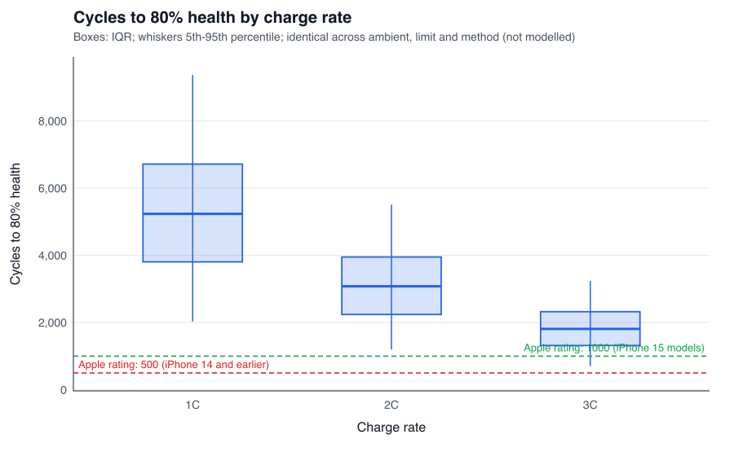
Figure 1. Simulated cycles to 80% health by charge rate, against Apple's 500- and 1,000-cycle ratings.

4. Discussion
What the results support. Within the model, faster charging clearly shortens battery life: moving from 1C to 3C cuts median life by about 65% while cutting time to 80% charge from 51 to 17 minutes. Because the life model is exponential in charge rate, each extra 1C costs the same share of life, about 41%. The largest absolute changes, in both directions, are therefore between 1C and 2C. That step saves 25.6 minutes per charge and costs about 2,160 cycles of median life. Going from 2C to 3C saves 8.6 more minutes and costs about 1,270 more cycles. Multistage charging is a free improvement in charging speed (1.75 minutes faster at 3C) with no measured cost in heat in Tahir et al. (2024); whether it also protects lifespan, as Liu and Luo (2010) report, we cannot yet quantify.
What the results do not support yet. The model's lifetimes are five to ten times longer than Apple's ratings, so absolute numbers do not describe real phones. Three of the four factors (ambient temperature, the 80% limit and charging method) have no verified life effect in the model, so their zero effects are gaps in evidence, not findings. These are exactly the levers a phone owner controls, so closing them is the priority.
Status, problems and strategies. Completed: data extraction and curation; a 29-parameter verified parameter table; the model specification; the 36,000-battery simulation; the statistical analysis; and the financial module. Remaining problems and our plan:
- LCO baseline. Obtain the Diao et al. (2019) paper through Cornell Library, map its 24 conditions to temperatures, and replace the LFP baseline. This should bring lifetimes toward Apple's ratings and add a real temperature effect.
- Charge window and multistage life effects. Obtain Saxena et al. (2016) and Liu and Luo (2010), and convert the CALCE files with a short MATLAB export.
- Temperature at 1–2C. Obtain Huang et al. (2019) to replace the weak temperature fit.
- Statistical method. Replace the individuals chart, which raises false alarms on bounded, skewed health data, with a chart on a transformed or attribute measure (share past end of life).
Timeline. Literature PDFs and the LCO re-fit in week 1; re-run of Phases 3–5 in week 2; final report in week 3.

Summary of findings
Faster charging shortens simulated battery life: median cycles to 80% health fall from 5,237 at 1C to 1,811 at 3C, a coefficient of −1.062 on log life (95% CI [−1.088, −1.035]). Charging three times faster saves 34 minutes per charge to 80%, and multistage charging adds 1.75 minutes of saving at 3C. By 1,000 cycles, 13.2% of 3C batteries are past end of life against 0.9% at 1C. The effects of temperature, the 80% limit and multistage charging on lifespan remain unquantified, and absolute lifetimes overstate real phones because the model is fitted to LFP rather than LCO cells.

Financial impacts
Proposed change: default phones to 2C charging unless the user asks for a fast charge. Over three years this saves an expected $4.55 per owner in battery replacements (95% CI $3.37–$5.84), cutting the three-year cost from $25.14 to $20.58. Slowing to 1C saves $5.84 ($4.46–$7.33). Across a 10,000-phone corporate fleet, the 2C saving is about $45,500 ($33,700–$58,400). The inputs are: $99 per battery replacement (Burkhardt, 2024), no service fee in store (Apple, n.d.-b), three years of use (Apple, 2024) and 0.7 equivalent full cycles per day (Aussems, 2025). When owners replace the whole $799 phone at end of battery life (Apple, n.d.-c), the savings rise to $36.75 (2C) and $47.14 (1C) per owner. We built the intervals by bootstrapping 1,000 simulated owners 2,000 times, with the same owners under both strategies. The savings are small because the LFP-based model predicts long lives: only 6.2% of fast-charging owners need a replacement within three years. With phone-realistic lifetimes they would be larger, so we treat them as a lower bound. Charging time carries no cost here, and it is the main counterweight a CTO should weigh: 2C takes 25.6 minutes to reach 80% versus 17.0 at 3C.
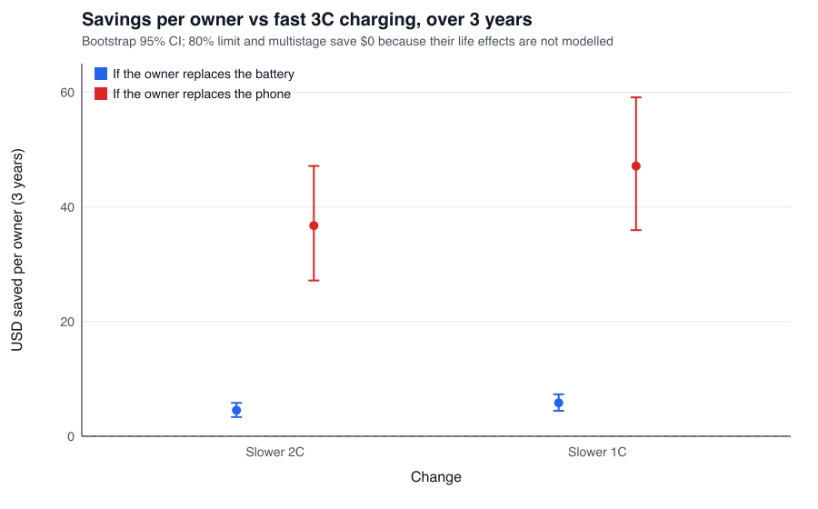
Figure 2. Three-year savings per owner from slower charging versus fast 3C charging (bootstrap 95% CIs).

References
Apple Inc. (n.d.-a). Battery service and recycling. Retrieved October 28, 2026, from https://www.apple.com/batteries/service-and-recycling/
Apple Inc. (2024). Product environmental report: iPhone 16 and iPhone 16 Plus. https://www.apple.com/environment/pdf/products/iphone/iPhone_16_and_iPhone_16_Plus_PER_Sept2024.pdf
Apple Inc. (n.d.-c). Buy iPhone 16. Apple Store. Retrieved October 28, 2026, from https://www.apple.com/shop/buy-iphone/iphone-16
Attia, P. M., Grover, A., Jin, N., Severson, K. A., Markov, T. M., Liao, Y.-H., Chen, M. H., Cheong, B., Perkins, N., Yang, Z., Herring, P. K., Aykol, M., Harris, S. J., Braatz, R. D., Ermon, S., & Chueh, W. C. (2020). Closed-loop optimization of fast-charging protocols for batteries with machine learning. Nature, 578(7795), 397–402. https://doi.org/10.1038/s41586-020-1994-5
Aussems, M. (2025, July 4). iPhone battery twice as bad as Samsung: Which manufacturer performs best? ITdaily. https://itdaily.com/blogs/workplace/iphone-battery-twice-as-bad-as-samsung-which-manufacturer-performs-best/
Burkhardt, M. (2024, September 15). iPhone 16 Pro battery replacement [News article]. 9to5Mac. https://9to5mac.com/2024/09/15/iphone-16-pro-battery-replacement/
Diao, W., Saxena, S., & Pecht, M. (2019). Accelerated cycle life testing and capacity degradation modeling of LiCoO2-graphite cells. Journal of Power Sources, 435, 226830. https://doi.org/10.1016/j.jpowsour.2019.226830
Huang, S., Wu, X., Cavalheiro, G. M., Du, X., Liu, B., Du, Z., & Zhang, G. (2019). In situ measurement of lithium-ion cell internal temperatures during extreme fast charging. Journal of The Electrochemical Society, 166(14).
Keil, P., & Jossen, A. (2016). Charging protocols for lithium-ion batteries and their impact on cycle life—An experimental study with different 18650 high-power cells. Journal of Energy Storage, 6, 125–141. https://doi.org/10.1016/j.est.2016.02.005
Saxena, S., Hendricks, C., & Pecht, M. (2016). Cycle life testing and modeling of graphite/LiCoO2 cells under different state of charge ranges. Journal of Power Sources, 327, 394–400.
Severson, K. A., Attia, P. M., Jin, N., Perkins, N., Jiang, B., Yang, Z., Chen, M. H., Aykol, M., Herring, P. K., Fraggedakis, D., Bazant, M. Z., Harris, S. J., Chueh, W. C., & Braatz, R. D. (2019). Data-driven prediction of battery cycle life before capacity degradation. Nature Energy, 4(5), 383–391. https://doi.org/10.1038/s41560-019-0356-8
Tahir, M. U., Sangwongwanich, A., Stroe, D.-I., & Blaabjerg, F. (2024). Multi-objective optimization for multi-stage constant current charging for Li-ion batteries. Journal of Energy Storage, 86(Part A), 111313. https://doi.org/10.1016/j.est.2024.111313
Liu, Y.-H., & Luo, Y.-F. (2010). Search for an optimal rapid-charging pattern for Li-ion batteries using the Taguchi approach. IEEE Transactions on Industrial Electronics, 57(12), 3963–3971.

