Team Project Report: Pulse Mind AI
Name: Divyanshu Ratti, Nikita Gupta & Rachhpal Sidhu
Student ID: 100366564, 100432739, 100443829
Kwantlen Polytechnic University
Course ID: INFO 3245
Section: S10
Professor Xing Liu
April 15, 2026

Contents
1. Name of the App: 3
2. Motivation of the App: 3
3. Features Specifications: 3
4. Screenshots and Explanation: 4
5. New Concepts or Insights Learned: 10

Name of the App:
Pulse Mind AI

Motivation of the App:

The development of PulseMindAI was driven by the current healthcare crisis in Canada. With a significant doctor shortage and approximately 20% of the Canadian population (5 – 6 millions of people) lacking access to a consistent family doctor, there is a critical information gap.
When individuals experience health concerns, they often lack a reliable, immediate source of information, leading to either unnecessary emergency room visits or, conversely, ignoring potentially serious symptoms. PulseMindAI was created to be a centralized health hub where users can store all their medical data and receive AI-driven guidance to help them navigate their health concerns when professional medical advice is not immediately available.

Features Specifications:

- Centralized Health Storage: A unified dashboard to log and track medications, medical history, and personal health metrics.
- GrokAI Integration: A sophisticated AI chatbot interface that provides immediate answers to medical questions.
- Smart Triage/Severity Levels: The AI is designed to categorize queries based on severity, helping users understand if they need a simple home remedy or urgent medical attention.
- Medication Management: A dedicated module (as seen in MedicationActivity) to track prescriptions, dosages, and schedules.
- Sensor Connectivity: Integration with mobile and wearable sensors to track real-time health data (e.g., heart rate, steps).
- Modern UI/UX: A clean, intuitive interface designed for ease of use during stressful health-related situations.

Screenshots and Explanation:
- Login/ Register page:
e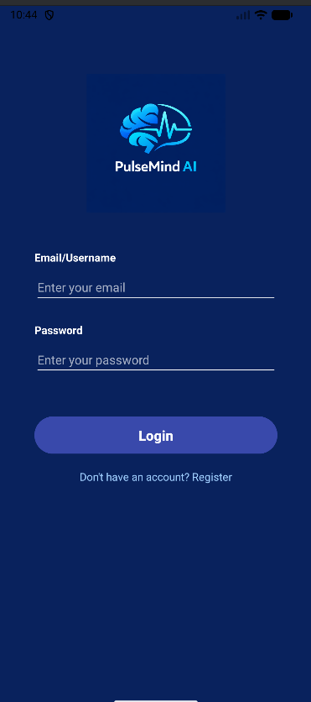 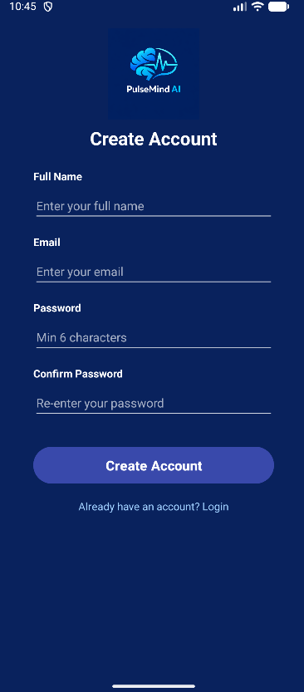
The login page allows existing users to securely access their account by entering their email/username and password. The registration page enables new users to create an account by providing basic details like name, email, and password.

- Home Dashboard:
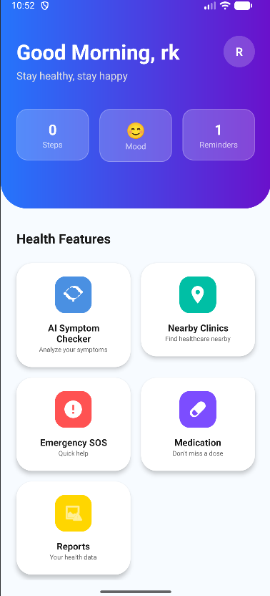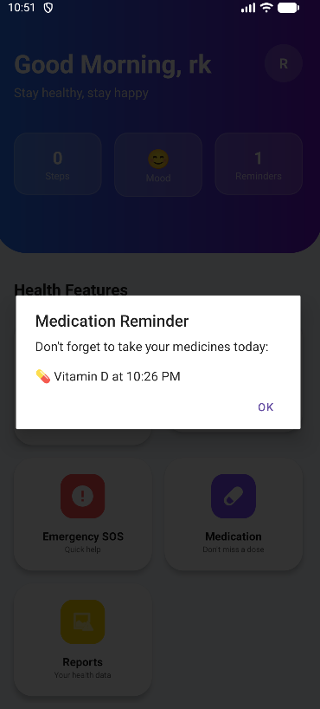

The main hub of the app. It provides a quick overview of the user's current health status, recent alerts, and quick-access buttons to the AI assistant and medication logs.
- AI Symptom Checker:
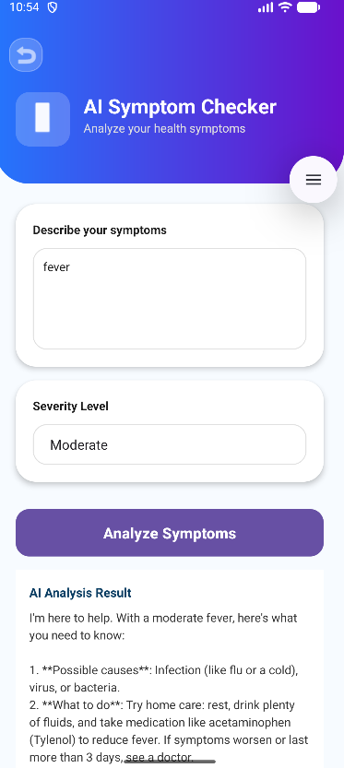
This screen allows users to type symptoms or questions. The interface displays GrokAI’s responses categorized by severity.

- Medication tracker:
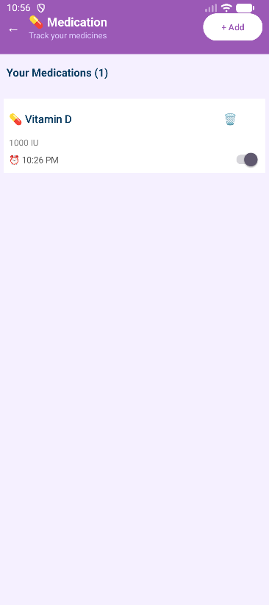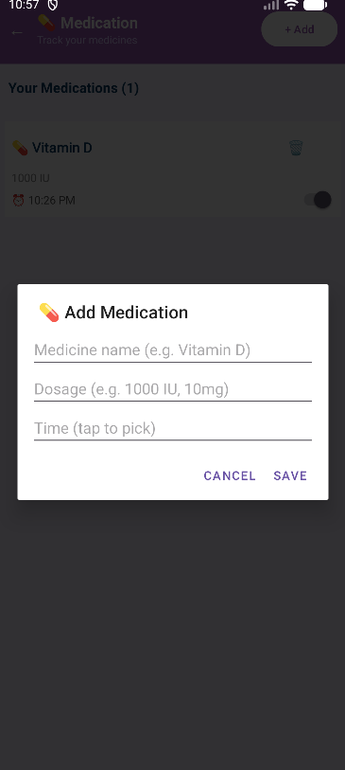
This screen (handled by MedicationActivity) allows users to manage their medications. Users can add new prescriptions and view upcoming doses to ensure adherence to their health plans.

- Nearby Clinics:
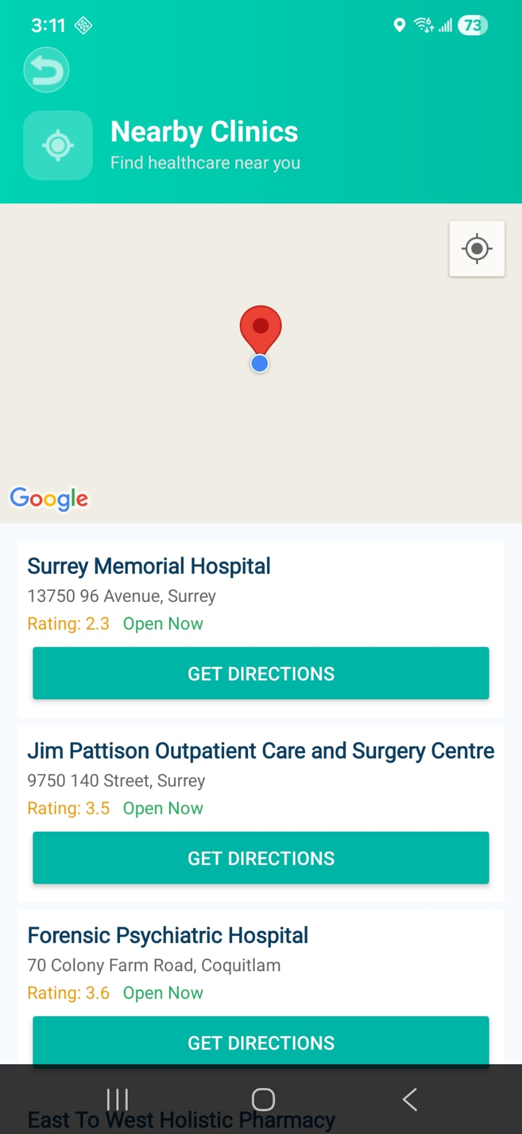
The Nearby Clinics screen uses a map to display healthcare facilities near the user’s current location. It also lists nearby hospitals with details like address, ratings, and an option to get directions for easy navigation.

- Emergency SOS
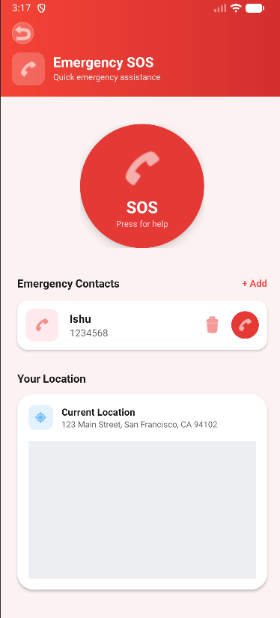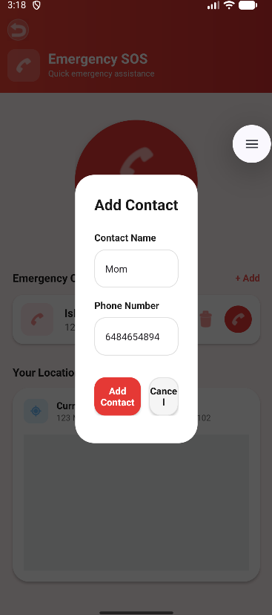
The Emergency SOS screen allows users to quickly send alerts to saved emergency contacts with a single tap for immediate assistance. Users can also add or manage contacts and view their current location to share accurate information during emergencies.

- Reports:
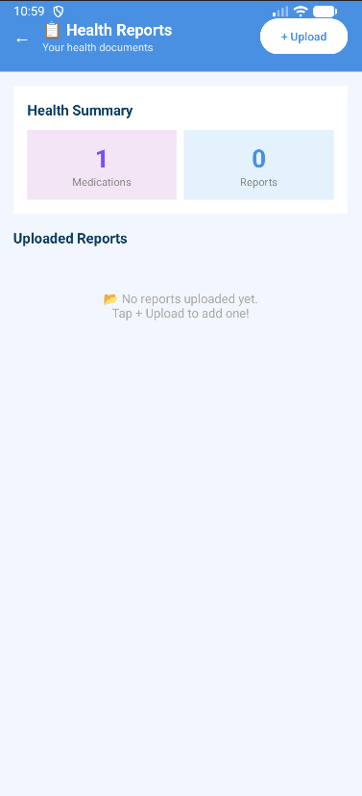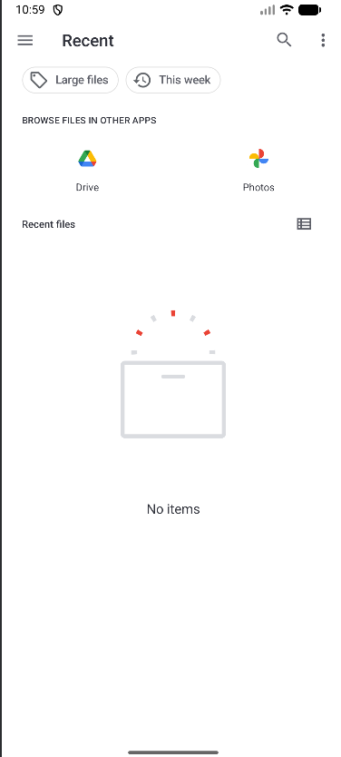
The health summary screen displays key information such as the number of medications and reports, along with an option to upload new health documents. The file selection screen allows users to browse and choose files from device storage or apps like Google Drive and Photos for uploading reports.

New Concepts or Insights Learned:
Building PulseMindAI pushed our technical boundaries beyond the standard classroom curriculum:
- Advanced AI Integration: We went beyond simple API calls by integrating GrokAI, learning how to handle streaming responses and prompt engineering to ensure health-related answers remain helpful and safety-conscious.
- Modern Android UI Architecture: We implemented View Binding and specialized layout techniques (like <include> tags and custom components) to maintain a professional, scalable UI.
- Hardware Interfacing: We learned how to interface with mobile hardware sensors, handling real-time data streams and permissions in Android.
- Professional Software Lifecycle: By using Git and GitHub for version control, we practiced industry-standard collaboration, branching, and debugging workflows.
- Complex Database Connectivity: We implemented local database solutions to ensure that a user’s health history is stored securely and is persistent across sessions.
- API Management: We gained experience in managing secure API keys and handling asynchronous network calls to provide a seamless user experience.

