**Details with Results**

The crime records have been retrieved from the ‘National Crime Records Bereau’.

The ‘districtwise’ dataset contains the various crime records for each year in different cities.

The dataset is shown below.

Code:

dst2.PNG

dst1.PNG

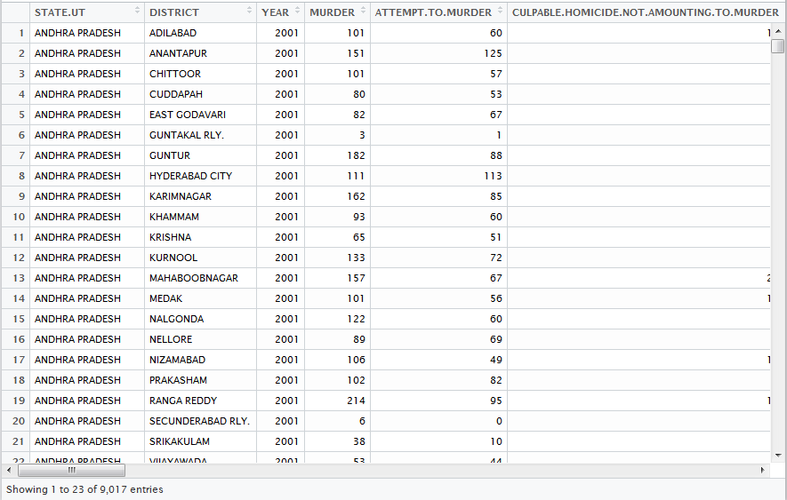

**Data Analysis of Crime Reports of the City of Hyderabad**

The dataset for crime reports of Hyderabad city is retrieved by the following code.

>Hyderabad <- dst[which(dst$DISTRICT== 'HYDERABAD CITY'),]

**Murder**

First we analyse the reported murders in Hyderabad.

1.Average no. Of murders per year in Hyderabad

hydmean.PNG

2. Bargraph of the no. Of murders occurred yearwise

Code:

>h <- barplot(Hyderabad$MURDER,width = 1,names.arg = Hyderabad$YEAR,xlab="years",ylab="no. of murders",main = "Murders in Hyderabad", xlim = c(0,20),ylim = c(0,200),las=2,cex.names = 0.8)

>text(x=h,y=Hyderabad$MURDER,labels = Hyderabad$MURDER,pos = 3,cex= 0.6,col="black")

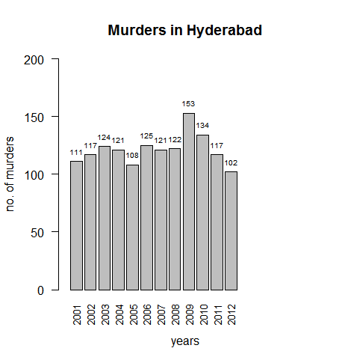

From the graph we can see, the highest no. of murders took place in 2009(153),which is significantly higher than the mean,and the lowest no. of murders took place in 2012(102). 121 murders happened in 2007 which is nearest to the mean.

**Rape**:

1.Avg no. of rapes per year in Hyderabad

RAPE1.PNG

2. Bargraph of no. of rapes yearwise

Code:

h <- barplot(Hyderabad$RAPE,width = 1,names.arg = Hyderabad$YEAR,xlab="years",ylab="no. of rapes",main = "Rapes in Hyderabad", xlim = c(0,20),ylim = c(0,100),las=2,cex.names = 0.8)

text(x=h,y=Hyderabad$RAPE,labels = Hyderabad$RAPE,pos = 3,cex= 0.6,col="black")

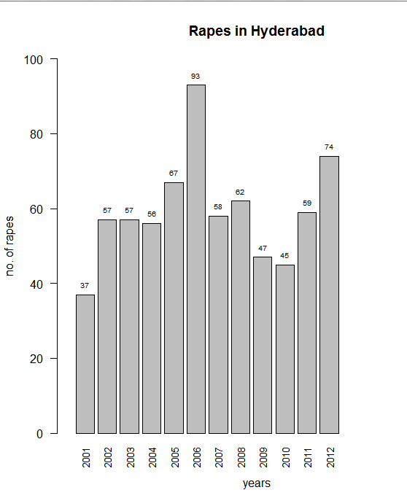

The highest no. of rapes occurred in 2006(93) and the lowest no. of rapes occurred in 2001(37).

58 rapes occurred in 2007 which is closest to the mean.

Theft

1.Average no. of theft per year in Hyderabad

hyd-thef.PNG

2.Bargraph of theft in Hyderabad yearwise

Code:

h <- barplot(Hyderabad$THEFT,width = 1,names.arg = Hyderabad$YEAR,xlab="years",ylab="no. of theft",main = "Theft in Hyderabad", xlim = c(0,20),ylim = c(0,7000),las=2,cex.names = 0.8)

text(x=h,y=Hyderabad$THEFT,labels = Hyderabad$THEFT,pos = 3,cex= 0.6,col="black")

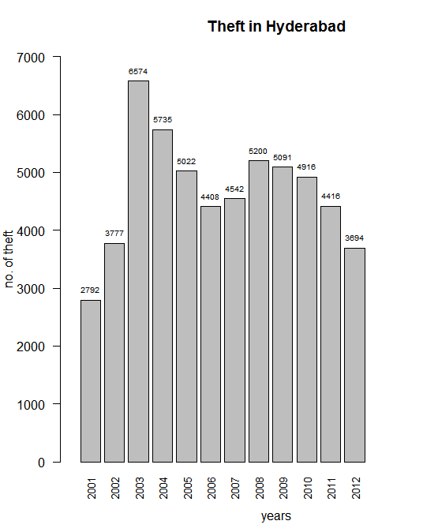

From the graph we can see that the no. of theft was highest in 2003(6574) and lowest in 2001(2792).

4542 no. of theft happened in 2007 which is closest to the mean.

Domestic violence:

1.Average no. of domestic violence incidents

hyd-domestic.PNG

2.Bargraph of no. of domestic violence incidents in Hyderabad yearwise

Code:

h <- barplot(Hyderabad$CRUELTY.BY.HUSBAND.OR.HIS.RELATIVES,width = 1,names.arg = Hyderabad$YEAR,xlab="years",ylab="no. of domestic violence",main = "Domestic violence in Hyderabad", xlim = c(0,20),ylim = c(0,1500),las=2,cex.names = 0.8)

text(x=h,y=Hyderabad$CRUELTY.BY.HUSBAND.OR.HIS.RELATIVES,labels = Hyderabad$CRUELTY.BY.HUSBAND.OR.HIS.RELATIVES,pos = 3,cex= 0.6,col="black")

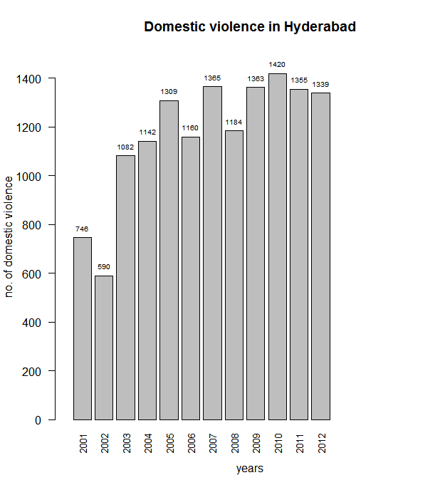

From the graph we can see that no. of domestic violence incidents was highest in2010(1420), and lowest in 2002(590).

1184 no. of incidents happened in 2008 which is closest to the mean.

Total no. of crimes:

1.Average total no. of crimes in Hyderabad per year

hydtotal.PNG

2.Bargraph of total no. crimes in Hyderabad yearwise

Code:

h <- barplot(Hyderabad$TOTAL.IPC.CRIMES,width = 1,names.arg = Hyderabad$YEAR,xlab="years",ylab="no. of total crimes",main = "Total no. of crimes in Hyderabad", xlim = c(0,20),ylim = c(0,25000),las=2,cex.names = 0.8)

text(x=h,y=Hyderabad$TOTAL.IPC.CRIMES,labels = Hyderabad$TOTAL.IPC.CRIMES,pos = 3,cex= 0.6,col="black")

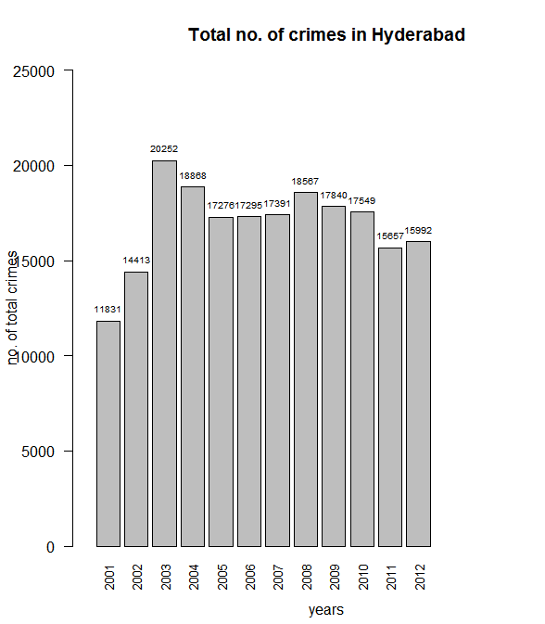

From the graph we can see that the no. of total crimes was highest in 2003(20252) and lowest in 2001(11831).17276 no. of crimes happened in 2005 which is closest to the mean.

Time series of total no. crimes in Hyderabad:

Here the data of total no. of crimes of Hyderabad has been extracted and converted into a time series.

Code:



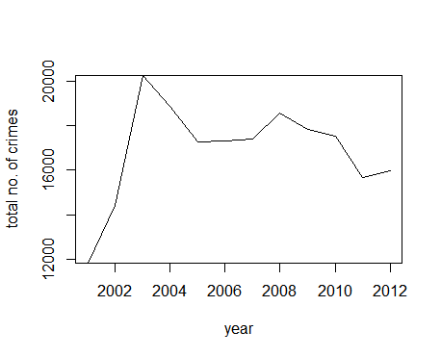

The line shows the growth in no. crimes in Hyderabad.

From the line we get the observation that the no. criminal activities increased at an alarming rate from 2001, reached its peak in the yr 2003, and then started to decrease. Again, there has been a slight increase in no. in 2008, then there has been gradual decrease upto 2012.

**Data Analysis of Crime Reports of the City of Mumbai**

The dataset for crime reports of the city of Mumbai is retrieved by the following code.

Mumbai <-dst[which(dst$DISTRICT == 'MUMBAI COMMR.'),]

1.Average no. Of murders per year in Mumbai

mum1.PNG

2. Bargraph of no. of murders in Mumbai yearwise

h1 <- barplot(Mumbai$MURDER,width = 1,names.arg = Mumbai$YEAR,xlab="years",ylab="no. of murders",main = "Murders in Mumbai", xlim = c(0,20),ylim = c(0,300),las=2,cex.names = 0.8)

text(x=h1,y=Mumbai$MURDER,labels = Mumbai$MURDER,pos = 3,cex= 0.6,col="black")

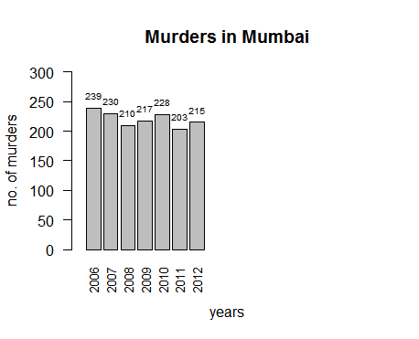

From the graph we can see, the highest no. of murders took place in 2006(239) and the lowest no. of murders took place in 2011(203). 217 murders happened in 2009 which is nearest to the mean.

Rape:

1. Average no. Of rapes per year in Mumbai

mum2.PNG

1. Bargraph of no. of rapes in Mumbai yearwise

Code:

h1 <- barplot(Mumbai$RAPE,width = 1,names.arg = Mumbai$YEAR,xlab="years",ylab="no. of rapes",main = "Rapes in Mumbai", xlim = c(0,20),ylim = c(0,300),las=2,cex.names = 0.8)

text(x=h1,y=Mumbai$RAPE,labels = Mumbai$RAPE,pos = 3,cex= 0.6,col="black")

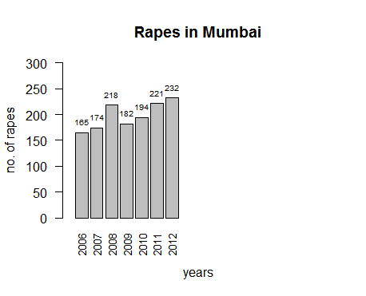

From the graph we can see, the highest no. of rapes took place in 2012(232) and the lowest no. of rapes took place in 2006(165). 194 rapes happened in 2010 which is nearest to the mean.

Theft-

1.Average no. Of theft per year in Mumbai

mum5.PNG

2.Bargraph of no. of rapes in Mumbai yearwise

Code:

h1 <- barplot(Mumbai$THEFT,width = 1,names.arg = Mumbai$YEAR,xlab="years",ylab="no. of theft",main = "Theft in Mumbai", xlim = c(0,20),ylim = c(0,14000),las=2,cex.names = 0.8)

text(x=h1,y=Mumbai$THEFT,labels = Mumbai$THEFT,pos = 3,cex= 0.6,col="black")

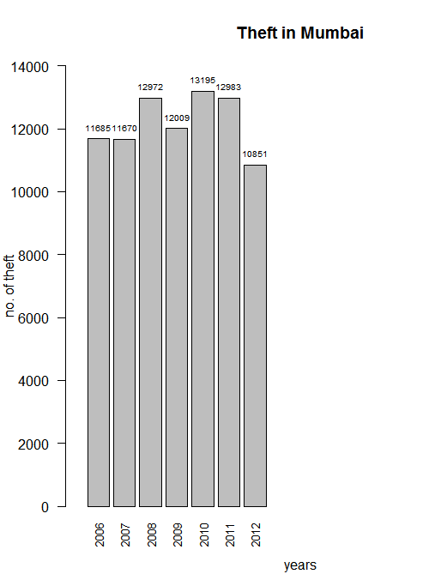

From the graph we can see that the no. of theft was highest in 2010(13195) and lowest in 2012(10851).

12009 no. of theft happened in 2009 which is closest to the mean.

Domestic violence-

1.Average no. Of domestic violence incidents per year in Mumbai

mum8.PNG

2.Bargraph of no. of domestic volence incidents in Mumbai yearwise

Code:

h1 <- barplot(Mumbai$CRUELTY.BY.HUSBAND.OR.HIS.RELATIVES,width = 1,names.arg = Mumbai$YEAR,xlab="years",ylab="no. of domestic violence",main = "Domestic violence in Mumbai", xlim = c(0,20),ylim = c(0,600),las=2,cex.names = 0.8)

text(x=h1,y=Mumbai$CRUELTY.BY.HUSBAND.OR.HIS.RELATIVES,labels = Mumbai$CRUELTY.BY.HUSBAND.OR.HIS.RELATIVES,pos = 3,cex= 0.6,col="black")

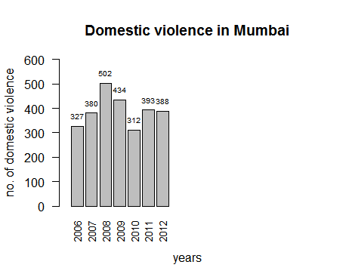

From the graph we can see that the no. of domestic violence incidents was highest in2008(502) and lowest in 2010(312).

393 no. of domestic violence incidents happened in 2011 which is closest to the mean.

Total no. of crimes-

1.Average no. Of total no. of crimes per year in Mumbai

mum9.PNG

2.Bargraph of total no. of crimes in Mumbai yearwise

Code-

h1 <- barplot(Mumbai$TOTAL.IPC.CRIMES,width = 1,names.arg = Mumbai$YEAR,xlab="years",ylab="no. of total crimes",main = "Total crimes in Mumbai", xlim = c(0,20),ylim = c(0,40000),las=2,cex.names = 0.8)

text(x=h1,y=Mumbai$TOTAL.IPC.CRIMES,labels = Mumbai$TOTAL.IPC.CRIMES,pos = 3,cex= 0.6,col="black")

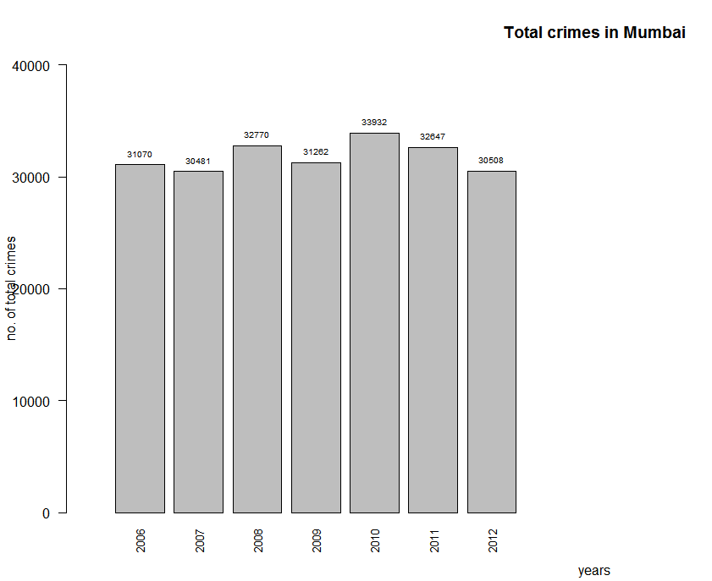

From the graph we can see that the no. of crimes was highest in 2010(33932) and lowest in 2007(30481).

31262 no. of crimes happened in 2009 which is closest to the mean.

Time series of total no. of crimes in Mumbai-

Here the total no. of crimes in Mumbai have been retrieved and converted into a time series.

Code:

tm2.PNG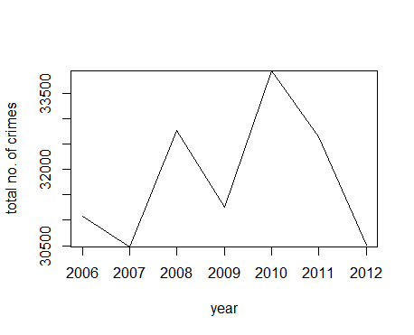

The line shows the growth of crimes in Mumbai.

As we can see, the no. of crimes decreased from 2006 to 2007, thereafter started to increase .After 2008 the no. again decreased till 2009. Again the no. started to increase and reached at peak in 2010. After 2010 there has been a steady fall of no. of crimes till 2012.

**Data Analysis of Crime Reports of the city of Chennai**

The dataset for crime reports of the city of Chennai is retrieved by the following code.

Chennai<-dst[which(dst$DISTRICT = 'CHENNAI'),]

1.Summary statistics:

Summary statistics helps us gain the first insight into a dataset.

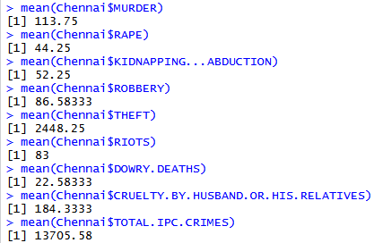

2.Bargraph of no. of murders in Chennai yearwise

h2 <- barplot(Chennai$MURDER,width = 1,names.arg = Chennai$YEAR,xlab="years",ylab="no. of murders",main = "Murders in Chennai", xlim = c(0,20),ylim = c(0,200),las=2,cex.names = 0.8)

text(x=h2,y=Chennai$MURDER,labels = Chennai$MURDER,pos = 3,cex= 0.6,col="black")

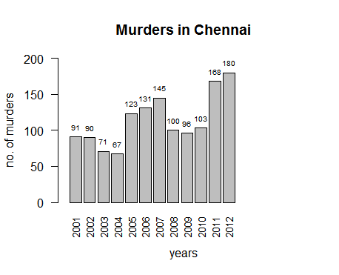

From the graph we can see that the no. of murders was highest in2012(180) and lowest in 2004(67).123 no. of murders happened in 2005 which is closest to the mean.

1. Bargraph of no. of rapes in Chennai yearwise

Code:

h2 <- barplot(Chennai$RAPE,width = 1,names.arg = Chennai$YEAR,xlab="years",ylab="no. of rapes",main = "Rapes in Chennai", xlim = c(0,20),ylim = c(0,100),las=2,cex.names = 0.8)

text(x=h2,y=Chennai$RAPE,labels = Chennai$RAPE,pos = 3,cex= 0.6,col="black")

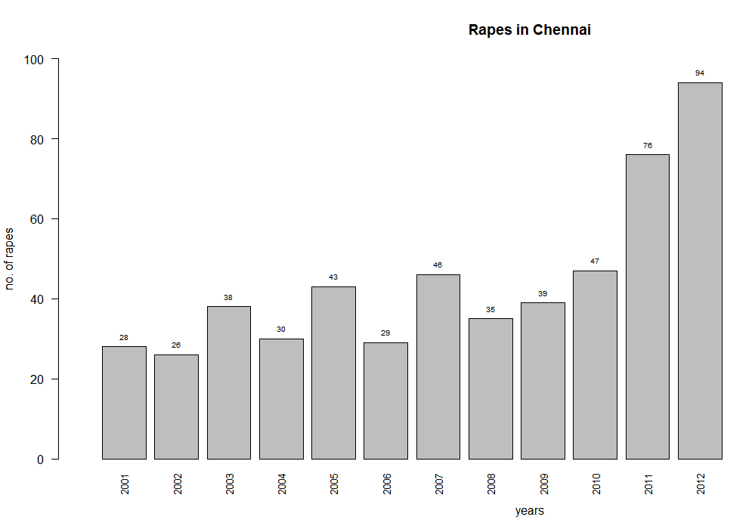

From the graph we can see that the no. of rape was highest in2012(94) and lowest in 2002(26).

43 rapes happened in 2004 which is closest to the mean.

4.Bargraph of no. of thefts in Chennai yearwise

Code:

h2 <- barplot(Chennai$THEFT,width = 1,names.arg = Chennai$YEAR,xlab="years",ylab="no. of thefts",main = "Thefts in Chennai", xlim = c(0,20),ylim = c(0,4000),las=2,cex.names = 0.8)

text(x=h2,y=Chennai$THEFT,labels = Chennai$THEFT,pos = 3,cex= 0.6,col="black")

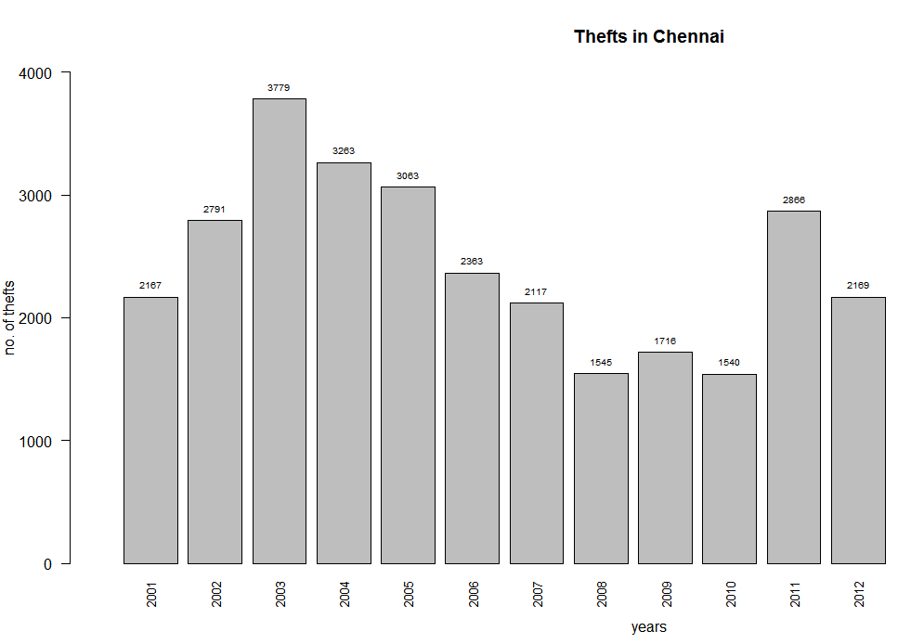

From the graph we can see that the no. of theft was highest in 2003(3779) and lowest in 2010(1540).

2363 no. of theft happened in 2006 which is closest to the mean.

5.Bargraph of no. of domestic violence incidents in Chennai yearwise

Code:

h2 <- barplot(Chennai$CRUELTY.BY.HUSBAND.OR.HIS.RELATIVES,width = 1,names.arg = Chennai$YEAR,xlab="years",ylab="no. of domestic violence",main = "Domestic violence in Chennai", xlim = c(0,20),ylim = c(0,400),las=2,cex.names = 0.8)

text(x=h2,y=Chennai$CRUELTY.BY.HUSBAND.OR.HIS.RELATIVES,labels = Chennai$CRUELTY.BY.HUSBAND.OR.HIS.RELATIVES,pos = 3,cex= 0.6,col="black")

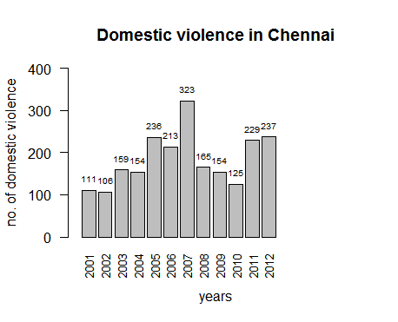

From the graph we can see that the no. of domestic violence incident was highest in 2007(323) and lowest in 2002(106).

165 no. of domestic violence incidents happened in 2008 which is closest to the mean.

6.Bargraph of total no. of crimes in Chennai yearwise

h3 <- barplot(Kolkata$MURDER,width = 1,names.arg = Kolkata$YEAR,xlab="years",ylab="no. of murders",main = "Murders in Kolkata", xlim = c(0,20),ylim = c(0,100),las=2,cex.names = 0.8)

text(x=h3,y=Kolkata$MURDER,labels = Kolkata$MURDER,pos = 3,cex= 0.6,col="black")

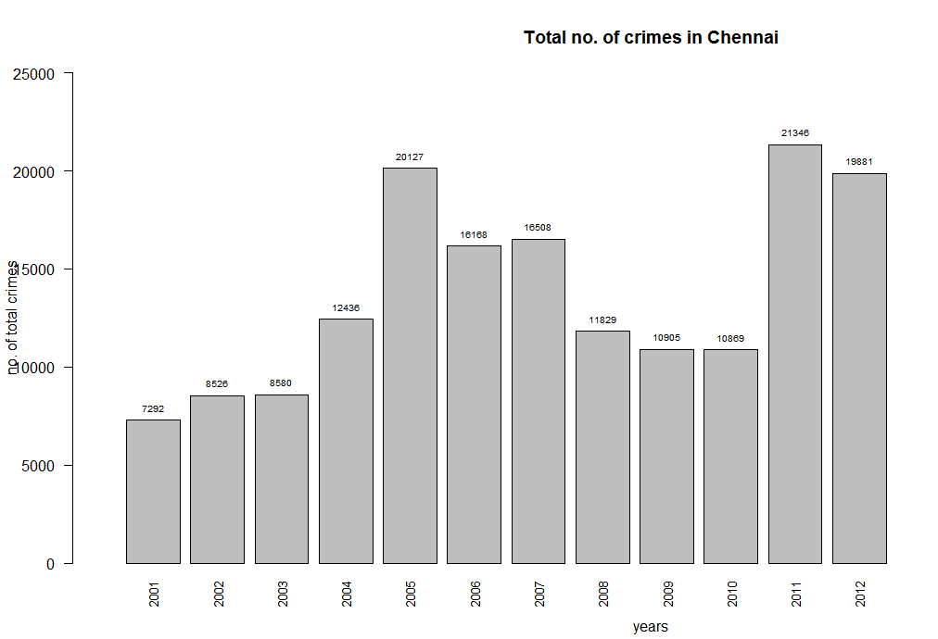

From the graph we can see that the total no. of crimes was highest in 2011(21346) and lowest in 2001(7292).

12436 no. of crimes happened in 2004 which is closest to the mean.

7.Time series of total no. of crimes in Chennai

Here the dataset of the total no. of crimes in Chennai has been retrieved and converted into a time series.

chenntotal.PNG

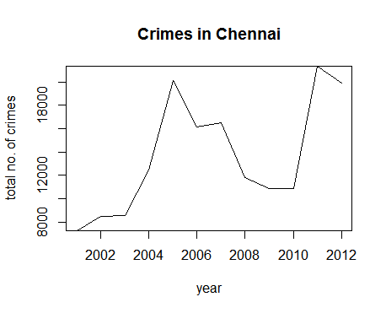

The line here shows the growth of crime in Chennai.

As we can see, the no. of crimes increased gradually from 2001 and after 2003 there has been a steep rise in the crimes till 2005. Then the no. started to decrease till 2010. Afterwards it started to rise and reached its peak in 2011. Then it has decreased slightly till 2012.

**Data Analysis of Crime Reports of the City of Kolkata**

The dataset for crime reports of the city of Kolkata is retrieved by the following code.

Kolkata <-dst[which(dst$DISTRICT == 'KOLKATA'),]

1.Summary statistics:

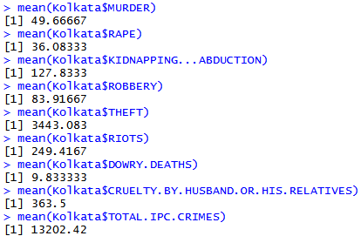

2.Bargraph of no. of murders in Kolkata yearwise

Code:

h3 <- barplot(Kolkata$MURDER,width = 1,names.arg = Kolkata$YEAR,xlab="years",ylab="no. of murders",main = "Murders in Kolkata", xlim = c(0,20),ylim = c(0,100),las=2,cex.names = 0.8)

text(x=h3,y=Kolkata$MURDER,labels = Kolkata$MURDER,pos = 3,cex= 0.6,col="black")

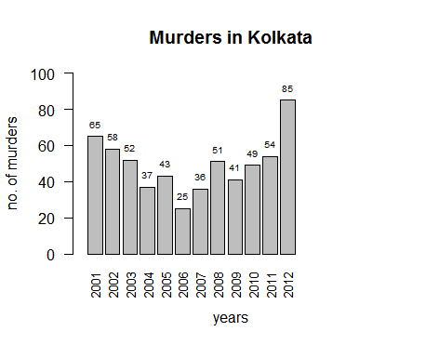

From the graph we can see that the no. of murders was highest in 2012(85) and lowest in 2006(26). 51 murders happened in 2008 which is closest to the mean.

3.Bargraph of no. of rapes in Kolkata yearwise

h3 <- barplot(Kolkata$RAPE,width = 1,names.arg = Kolkata$YEAR,xlab="years",ylab="no. of rapes",main = "Rapes in Kolkata", xlim = c(0,20),ylim = c(0,100),las=2,cex.names = 0.8)

text(x=h3,y=Kolkata$RAPE,labels = Kolkata$RAPE,pos = 3,cex= 0.6,col="black")

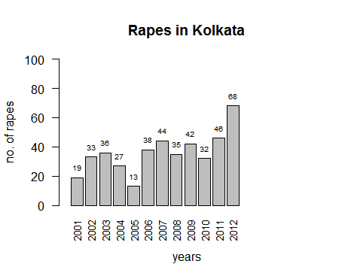

From the graph we can see that the no. of theft was highest in 2012(68) and lowest in 2005(13).

35 no. of rapes happened in 2008 which is closest to the mean.

4.Bargraph of no. of thefts in Kolkata yearwise

Code:

h3 <- barplot(Kolkata$THEFT,width = 1,names.arg = Kolkata$YEAR,xlab="years",ylab="no. of thefts",main = "Thefts in Kolkata", xlim = c(0,20),ylim = c(0,6000),las=2,cex.names = 0.8)

text(x=h3,y=Kolkata$THEFT,labels = Kolkata$THEFT,pos = 3,cex= 0.6,col="black")

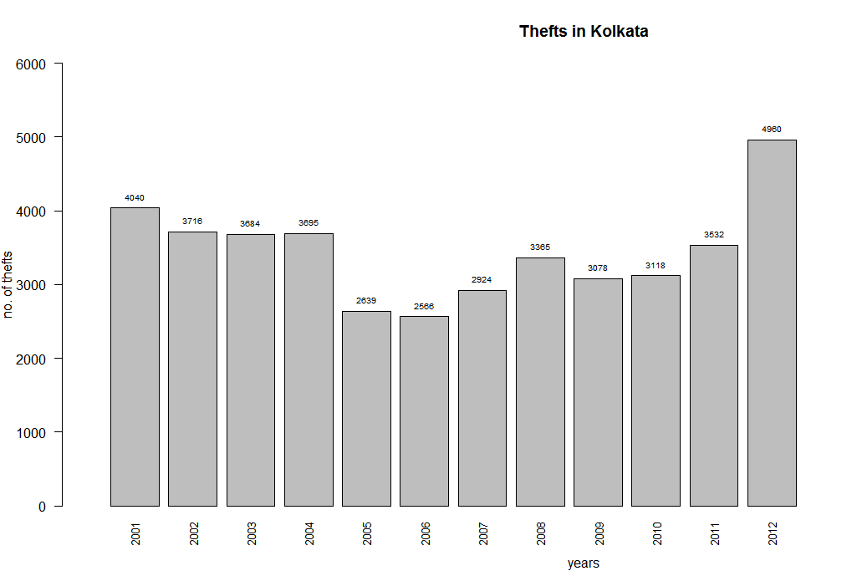

From the graph we can see that the no. of theft was highest in 2012(4980) and lowest in 2006(2566).

3365 no. of theft happened in 2008 which is closest to the mean.

5.Bargraph of no. of domestic violence incidents in Kolkata yearwise

Code:

h3 <- barplot(Kolkata$CRUELTY.BY.HUSBAND.OR.HIS.RELATIVES,width = 1,names.arg = Kolkata$YEAR,xlab="years",ylab="no. of domestic violence",main = "Domestic violence in Kolkata", xlim = c(0,20),ylim = c(0,1000),las=2,cex.names = 0.8)

text(x=h3,y=Kolkata$CRUELTY.BY.HUSBAND.OR.HIS.RELATIVES,labels = Kolkata$CRUELTY.BY.HUSBAND.OR.HIS.RELATIVES,pos = 3,cex= 0.6,col="black")

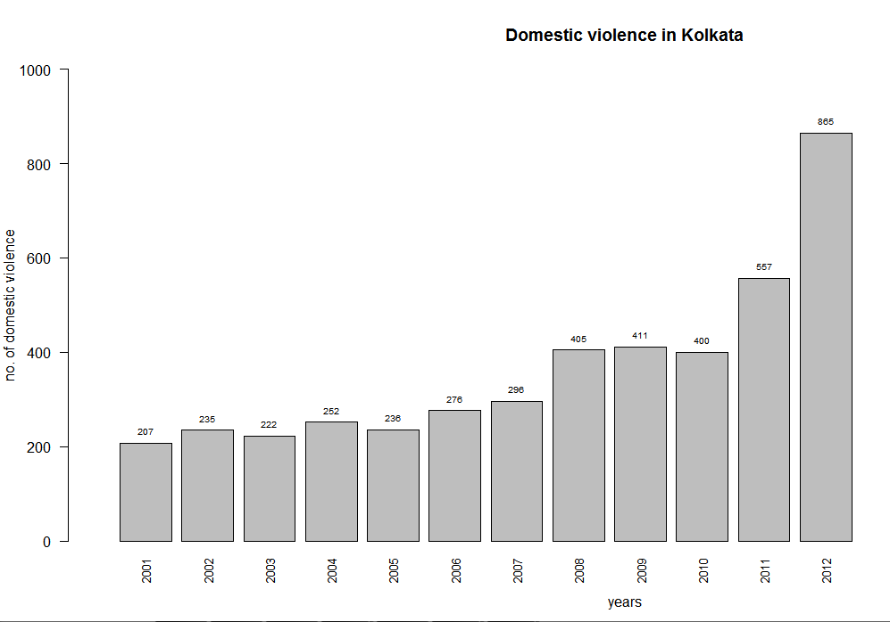

From the graph we can see that the no. of domestic violence incident was highest in 2012(865) and lowest in 2001(207).

405 no. of domestic violence incident happened in 2008 which is closest to the mean.

6.Bargraph of total no. of crimes in Kolkata yearwise

h3 <- barplot(Kolkata$TOTAL.IPC.CRIMES,width = 1,names.arg = Kolkata$YEAR,xlab="years",ylab="no. of total crimes",main = "Total no. of crimes in Kolkata", xlim = c(0,20),ylim = c(0,30000),las=2,cex.names = 0.8)

text(x=h3,y=Kolkata$TOTAL.IPC.CRIMES,labels = Kolkata$TOTAL.IPC.CRIMES,pos = 3,cex= 0.6,col="black")

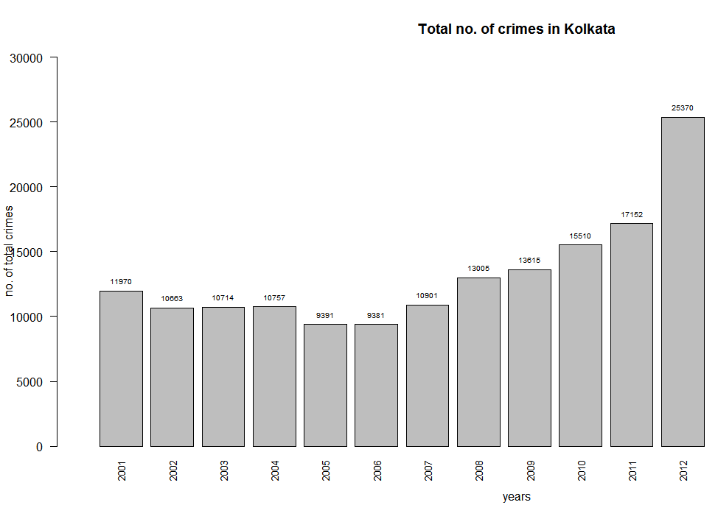

From the graph we can see that the total no. of crimes was highest in 2012(25370) and lowest in 2006(9381).

13005 no. of crimes happened in 2008 which is closest to the mean.

7.Time series of total no. of crimes in Kolkata-

Here the dataset of total no. of crimes in Kolkata have been retrieved and converted into a time series.

Code:

kolkatasnip.PNG

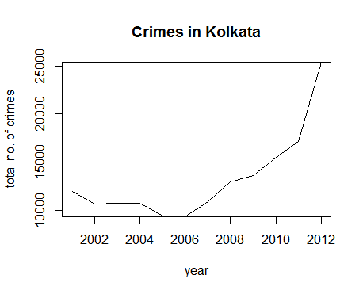

Here the line shows the growth of crime in Kolkata.

As we can see, the no. of crime decreased from 2001 to 2005. Then it started to increase from 2006 and has reached its peak in 2012.

**Data Analysis of Crime Records of the City of Bangalore**

The dataset for crime reports of the city of Bangalore is retrieved by the following code.

Bangalore <- dst[which(dst$DISTRICT == 'BANGALORE COMMR.'),]

1.Summary statistics-

The summary statistic gives us the first insight into the data. Here we calculate the average no. of each different crimes per year in Bangalore.

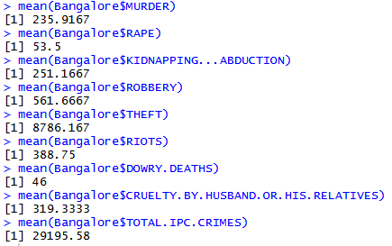

2.Bargraph of no. of murders in Bangalore yearwise

Code:

h4 <- barplot(Bangalore$MURDER,width = 1,names.arg = Bangalore$YEAR,xlab="years",ylab="no. of murders",main = "Murders in Bangalore", xlim = c(0,20),ylim = c(0,300),las=2,cex.names = 0.8)

text(x=h4,y=Bangalore$MURDER,labels = Bangalore$MURDER,pos = 3,cex= 0.6,col="black")

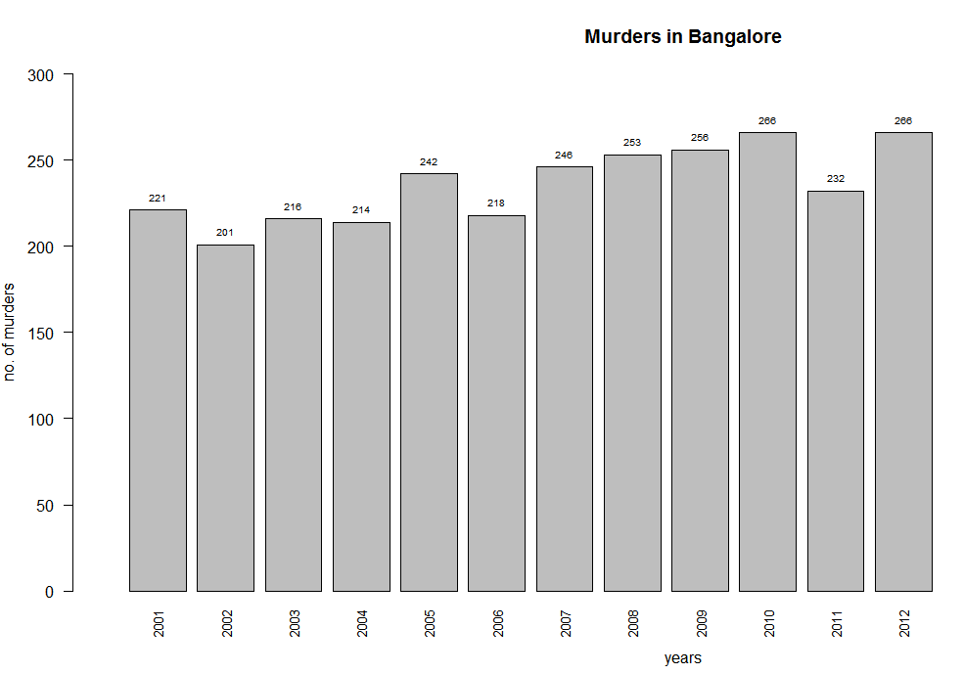

From the graph we can see that the no. of murder was highest in 2010 and 2012(266) and lowest in 2002(201).

242 murders happened in 2005 which is closest to the mean.

3.Bargraph of no. of rapes in Bangalore yearwise

Code:

h4 <- barplot(Bangalore$RAPE,width = 1,names.arg = Bangalore$YEAR,xlab="years",ylab="no. of rapes",main = "Rapes in Bangalore", xlim = c(0,20),ylim = c(0,100),las=2,cex.names = 0.8)

text(x=h4,y=Bangalore$RAPE,labels = Bangalore$RAPE,pos = 3,cex= 0.6,col="black")

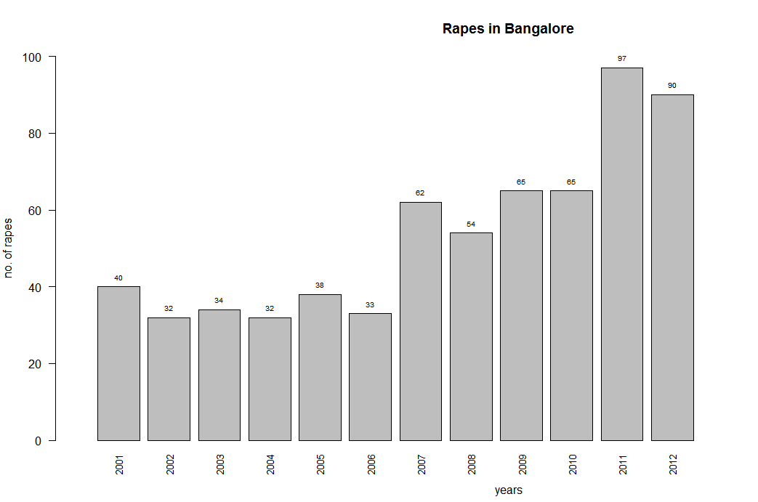

From the graph we can see that the no. of rapes was highest in 2011(97) and lowest in 2002 and 2004(32).

54 rapes happened in 2008 which is closest to the mean.

4.Bargraph of no. of thefts in Bangalore yearwise

h4 <- barplot(Bangalore$THEFT,width = 1,names.arg = Bangalore$YEAR,xlab="years",ylab="no. of thefts",main = "Thefts in Bangalore", xlim = c(0,20),ylim = c(0,12000),las=2,cex.names = 0.8)

text(x=h4,y=Bangalore$THEFT,labels = Bangalore$THEFT,pos = 3,cex= 0.6,col="black")

h4 <- barplot(Bangalore$RIOTS,width = 1,names.arg = Bangalore$YEAR,xlab="years",ylab="no. of riots",main = "Riots in Bangalore", xlim = c(0,20),ylim = c(0,1000),las=2,cex.names = 0.8)

h4 <- barplot(Bangalore$RIOTS,width = 1,names.arg = Bangalore$YEAR,xlab="years",ylab="no. of riots",main = "Riots in Bangalore", xlim = c(0,20),ylim = c(0,1000),las=2,cex.names = 0.8)

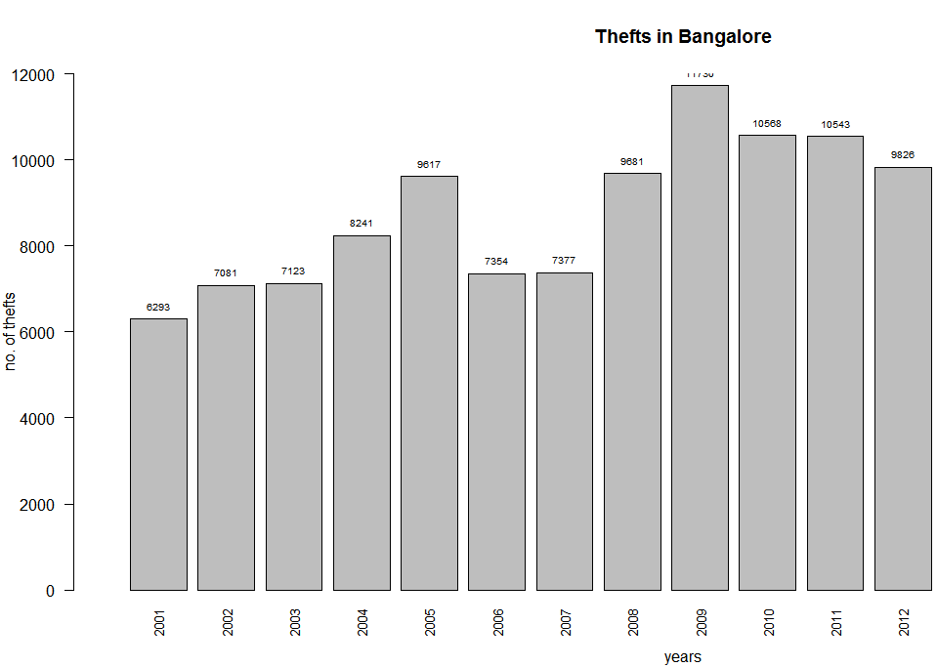  
From the graph we can see that no. of theft was highest in 2009(11730) and lowest in 2001(6293).

h4 <- barplot(Bangalore$RIOTS,width = 1,names.arg = Bangalore$YEAR,xlab="years",ylab="no. of riots",main = "Riots in Bangalore", xlim = c(0,20),ylim = c(0,1000),las=2,cex.names = 0.8)

text(x=h4,y=Bangalore$RIOTS,labels = Bangalore$RIOTS,pos = 3,cex= 0.6,col="black")

8241 thefts happened in 2004, which is closest to the mean.

5.Bargraph of no. of domestic violence incidents in Bangalore yearwise

Code:

h4 <- barplot(Bangalore$CRUELTY.BY.HUSBAND.OR.HIS.RELATIVES,width = 1,names.arg = Bangalore$YEAR,xlab="years",ylab="no. of domestic violence",main = "Domestic violence in Bangalore", xlim = c(0,20),ylim = c(0,600),las=2,cex.names = 0.8)

text(x=h4,y=Bangalore$CRUELTY.BY.HUSBAND.OR.HIS.RELATIVES,labels = Bangalore$CRUELTY.BY.HUSBAND.OR.HIS.RELATIVES,pos = 3,cex= 0.6,col="black")

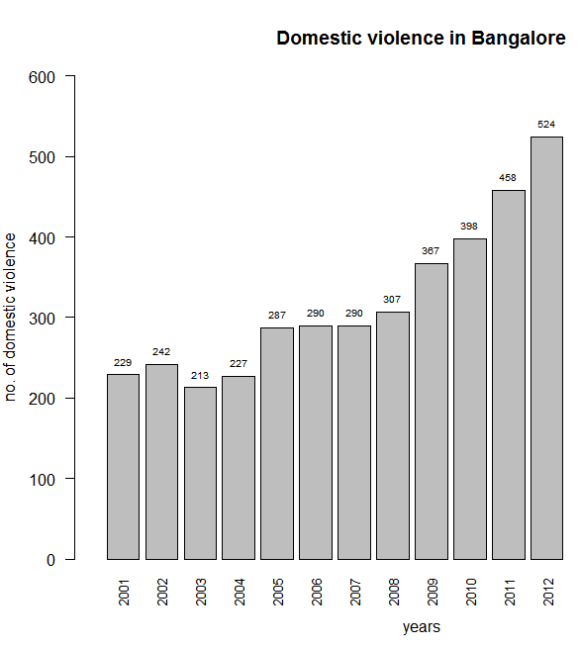

From the graph we can see that highest no. of domestic violence occurred in 2012(524) and lowest no. occurred in 2003(213).

307 domestic violence incidents occurred in 2007, which is closest to the mean.

6.Bargraph of total no. of crimes in Bangalore yearwise

Code:

h4 <- barplot(Bangalore$TOTAL.IPC.CRIMES,width = 1,names.arg = Bangalore$YEAR,xlab="years",ylab="no. of total crimes",main = "Total no. of crimes in Bangalore", xlim = c(0,20),ylim = c(0,50000),las=2,cex.names = 0.8)

text(x=h4,y=Bangalore$TOTAL.IPC.CRIMES,labels = Bangalore$TOTAL.IPC.CRIMES,pos = 3,cex= 0.6,col="black")

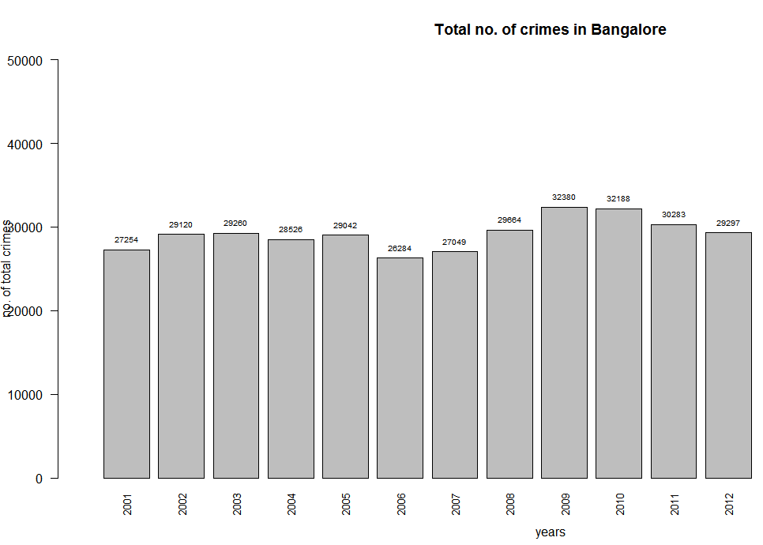

From the graph we can see that the total no. of crimes was highest in 2009(32380) and lowest in 2006(26284).

29200 no. of crimes happened in 2003 which is closest to the mean.

7.Time series of total no. of crimes in Bangalore-

Here the dataset of the total no. of crimes in Bangalore has been retrieved and converted into a time series.

Code:

bang1.PNG

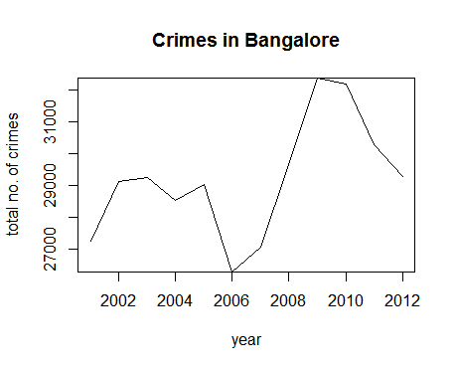

The line here shows the growth of crimes in Bangalore.

As we can see, the no. of crimes started to rise from 2001 and then steeply decreased from 2005 to 2006. Again, there has been a steep rise in the no. from 2006 to 2009.After that, it decreased till 2012.

**Data Analysis of Crime Reports of the City of Delhi**

The dataset for crime reports of the city of Delhi is retrieved by the following code.

Delhi <- dst[which(dst$DISTRICT=='DELHI UT TOTAL'),]

1.Summary statistics-

Summary statistics gives us the first insight into the dataset. Here we calculate the average no. of each crimes per year in Delhi.

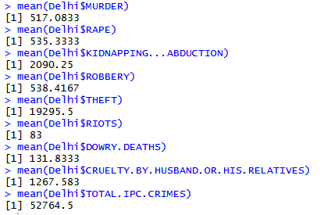

2.Bargraph of no. of murders in Delhi yearwise

Code:

h5 <- barplot(Delhi$MURDER,width = 1,names.arg = Delhi$YEAR,xlab="years",ylab="no. of murders",main = "Murders in Delhi", xlim = c(0,20),ylim = c(0,600),las=2,cex.names = 0.8)

text(x=h5,y=Delhi$MURDER,labels = Delhi$MURDER,pos = 3,cex= 0.6,col="black")

Fr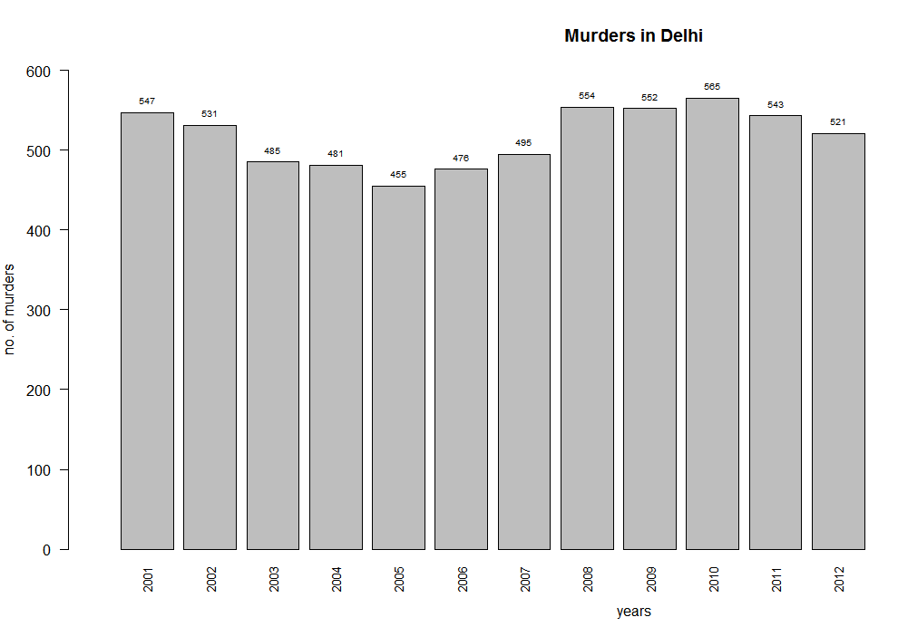

From the graph we can see that the no. of murders was highest in 2010(565) and lowest in 2005(456).

521 murders occurred in 2012 which is closest to the mean.

3.Bargraph of no. of rapes in Delhi yearwise

Code:

h5 <- barplot(Delhi$RAPE,width = 1,names.arg = Delhi$YEAR,xlab="years",ylab="no. of rapes",main = "Rapes in Delhi", xlim = c(0,20),ylim = c(0,1000),las=2,cex.names = 0.8)

text(x=h5,y=Delhi$RAPE,labels = Delhi$RAPE,pos = 3,cex= 0.6,col="black")

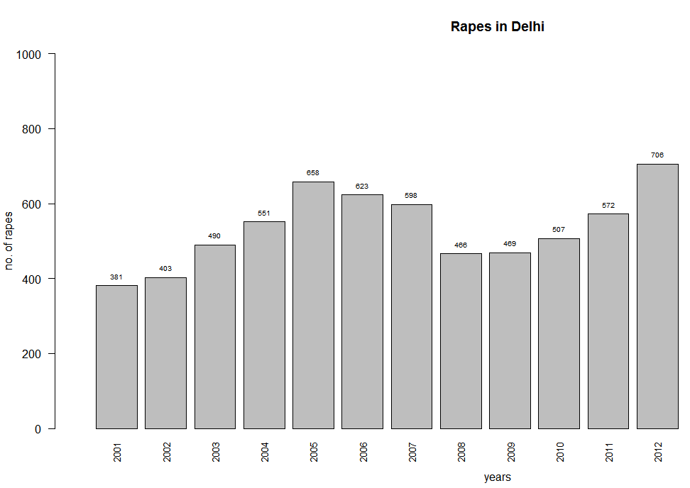

From the graph we can see that the highest no. of rapes happened in 2012(706),and lowest no. of rapes happened in 2001(381).

551 no. of rapes happened in 2004, which is closest to the mean.

4.Bargraph of no. of thefts in Delhi yearwise

Code:

h5 <- barplot(Delhi$THEFT,width = 1,names.arg = Delhi$YEAR,xlab="years",ylab="no. of theft",main = "Thefts in Delhi", xlim = c(0,20),ylim = c(0,25000),las=2,cex.names = 0.8)

text(x=h5,y=Delhi$THEFT,labels = Delhi$THEFT,pos = 3,cex= 0.6,col="black")

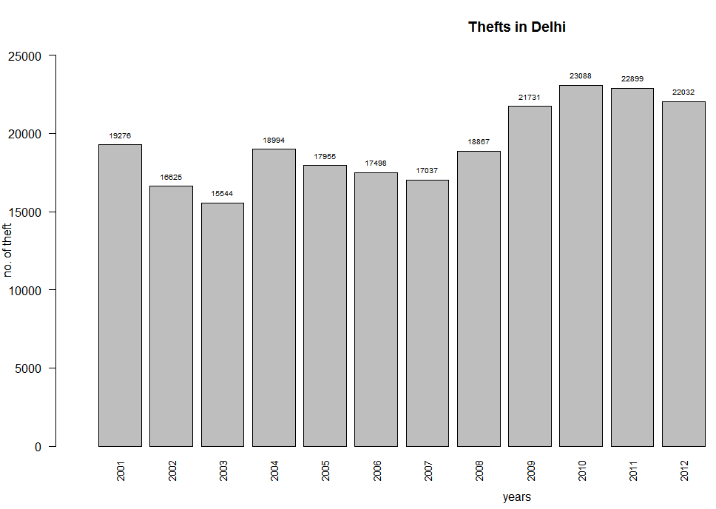

From the graph we can see that the highest no. of thefts happened in 2010(23088) and the lowest no. of thefts happened in 2003(15644).

19276 no. of thefts happened in 2001 which is closest to the mean.

5.Bargraph of no. of domestic violence incidents in Delhi yearwise

Code:

h5 <- barplot(Delhi$CRUELTY.BY.HUSBAND.OR.HIS.RELATIVES,width = 1,names.arg = Delhi$YEAR,xlab="years",ylab="no. of domestic violences",main = "Domestic violence in Delhi", xlim = c(0,20),ylim = c(0,2000),las=2,cex.names = 0.8)

text(x=h5,y=Delhi$CRUELTY.BY.HUSBAND.OR.HIS.RELATIVES,labels = Delhi$CRUELTY.BY.HUSBAND.OR.HIS.RELATIVES,pos = 3,cex= 0.6,col="black")

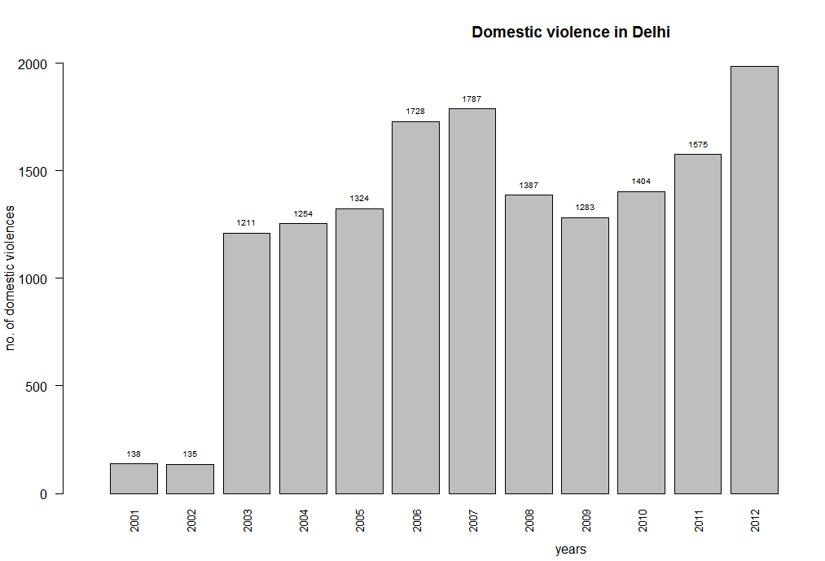

From the graph we can see that the no. of domestic violence was highest in 2012(1985) and lowest in 2002(135).

1254 no. of domestic violence incident took place in 2004, which is closest to mean.

6.Bargraph of total no. of crimes in Delhi yearwise

Code:

**h5 <- barplot(Delhi$TOTAL.IPC.CRIMES,width = 1,names.arg = Delhi$YEAR,xlab="years",ylab="no. of total crimes",main = "Total no. of crimes in Delhi", xlim = c(0,20),ylim = c(0,60000),las=2,cex.names = 0.8)**

**text(x=h5,y=Delhi$TOTAL.IPC.CRIMES,labels = Delhi$TOTAL.IPC.CRIMES,pos = 3,cex= 0.6,col="black")**

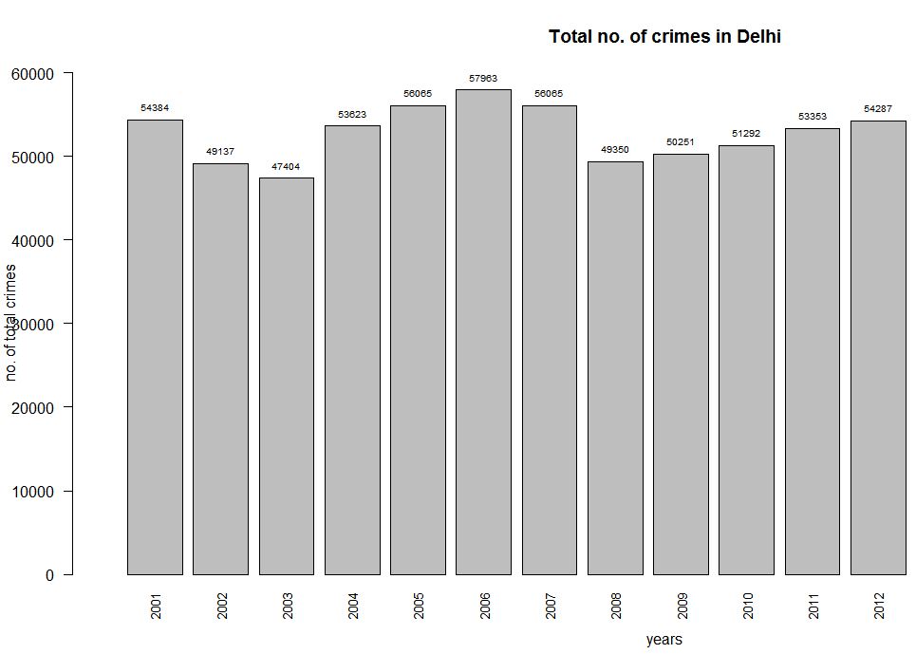

From the graph we can see that he highest no. of crimes occurred in 2006(57963), and the lowest no of crimes occurred in 2003(47404).

53353 no. of total crimes happened in 2011, which is closest to mean.

7.Time series of total no. of crimes in Delhi-

Here the dataset of total no. of crimes in Delhi has been retrieved and converted into a time series.

Code:

del1.PNG

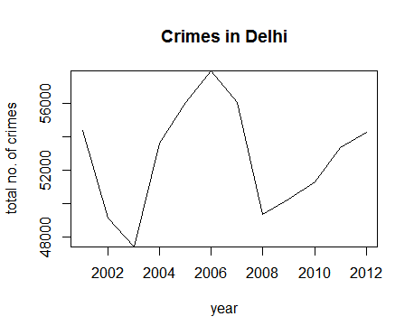

The line here shows the growth of crime in Delhi.

As we can see, the no. of crimes decreased from 2001 to 2003. Then it increased till 2006 and reached its peak. Then there was a steep fall till 2008. Again it started to go up and increased till 2012.

**Comparative study of the crime data of the major cities in India (Year 2006-2012)**

Here we compare the crime data of the different cities to gain insights into the reports.

First we select the dataset of the cities’ crime record for the years 2006 to 2012.

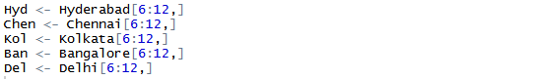

Summary statistics:

Summary statistics is the basic analysis of a data. As mean is the most popular and well known measure of central tendency, here will work with the mean data.

1.Murder

Here we calculate the average no. of murders in the different cities per year .

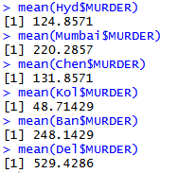

2.Rape

Average no. of rapes in the different cities per year

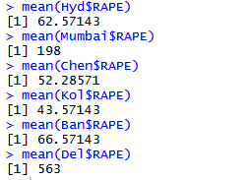

3.Theft

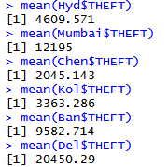Average no. of thefts in the different cities per year

4.Domestic violence

Average no. of domestic violence in the different cities per year

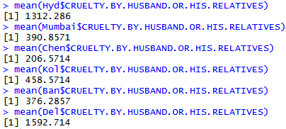

5.Total no. Of crimes

Average no. of total no. of crimes in the different cities per year

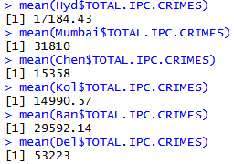

Data visualisation:

Here we create another dataset ‘df’ with the retrieved mean data and analyse it to gain various insights.

Code:

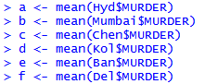

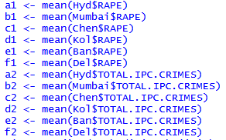

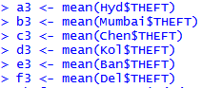

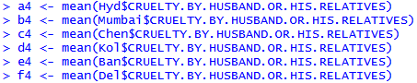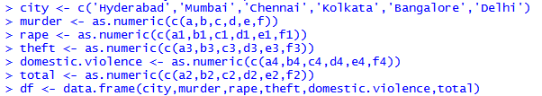

view.PNG

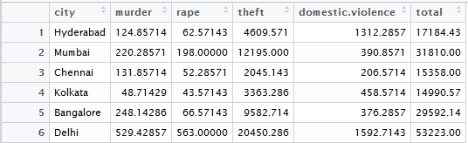

Bargraph of average no. of murders in the cities per year in decreasing order

Code:

code2.PNG

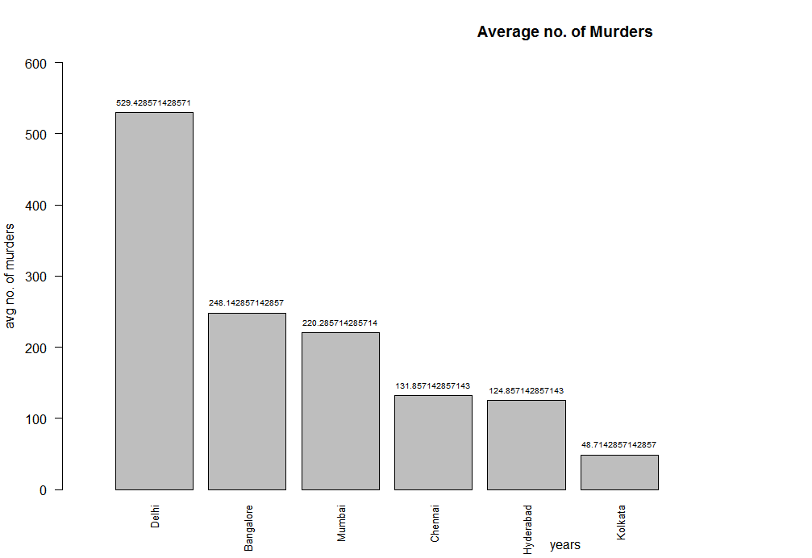

As we can see from the graph, the cities with highest no. of average murders per year are respectively Delhi, Bangalore, Mumbai, Chennai, Hyderabad and Kolkata, with Delhi having the highest no. (629.43) and Kolkata having the lowest(48.71).

Bargraph of average no. of rapes in the cities per year in decreasing order

Code:

rapecode.PNG

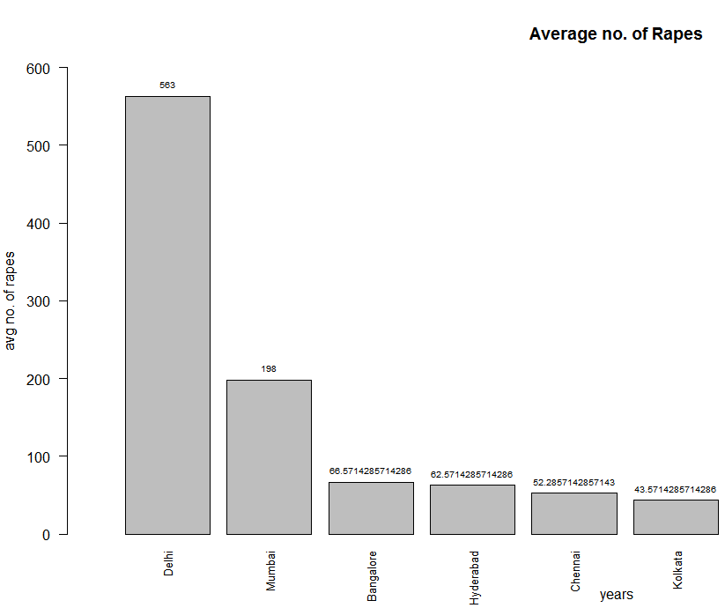

As we can see from the graph, the cities with the average no. of rapes in decreasing order are-Delhi, Mumbai, Bangalore, Hyderabad, Chennai and Kolkata. Delhi has the highest no. of average rapes per year(563) and Kolkata has the lowest(43.57).

Bargraph of average no. of theft per year in cities in decreasing order

Code:

codesnip.PNG

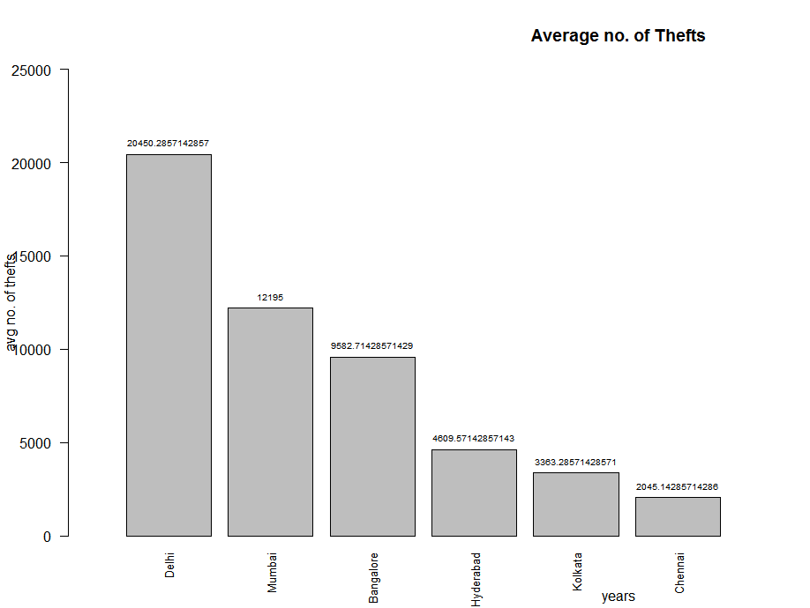

As we can see from the graph, the cities with average no. of thefts in decreasing order is –Delhi,Mumbai,Bangalore,Hyderabad,Kolkata and Chennai. Delhi has the highest average no. of theft(20450.29) where as Chennai has the lowest(2045.14).

Bargraph of average no. of domestic violence incidents per year in cities in decreasing order

Code:

domesticcity.PNG

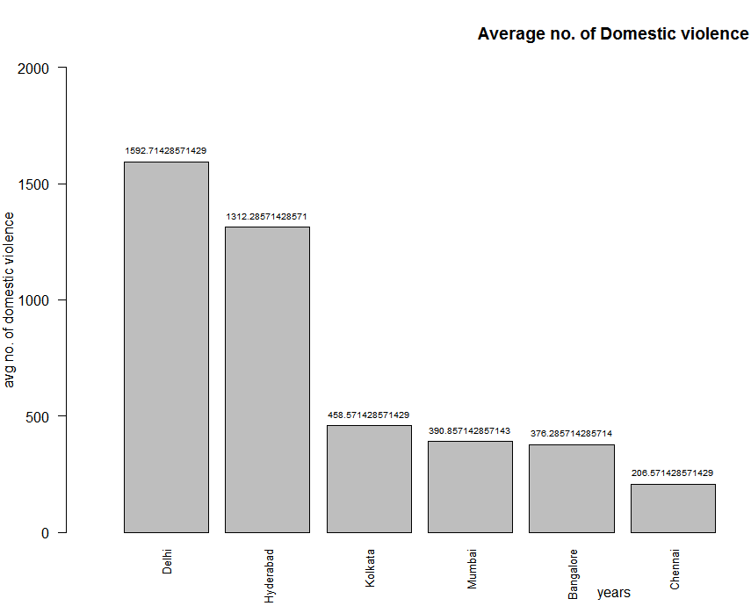

As we can see from the graph,The cities with average no. of domestic violence in decreasing order are Delhi,Hyderabad, Kolkata,Mumbai,Bangalore and Chennai.Delhi has the highest average no. of domestic violence cases(1592.71) where as Chennai has the lowest(206.571).

Bargraph of the average no.of total crimes per year in cities in decreasing order

Code:

totalcity.PNG

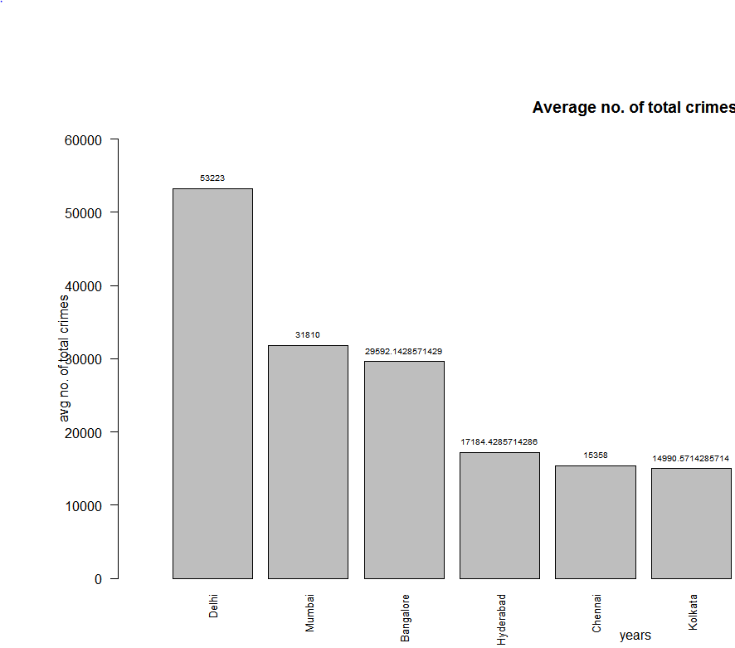

As we can see from the graph, the cities with average no. of total crimes in decreasing order are Delhi,Mumbai, Bangalore,Hyderabad,Chennai and Kolkata. Delhi has the highest average no. of crimes(53223) where as Kolkata has the lowest(14990.57).

The overall analysis proves Delhi to have the most criminal activities(for every individual crime and total no. of crimes) and there by unsafe, wheras Kolkata proves to be the safest.

Time series of the cities’ total no. of crimes over the years-

First, the total no. of crimes of the cities are converted into a time series.

Code: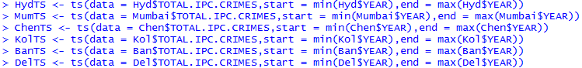

Next, the time series lines are plotted.

crimetotal2.PNG

Here the colors red,blue,green,purple,magenta and orange represents the time series of total no. of crimes of the cities Hyderabad,Mumbai,Chennai,Kolkata,Bangalore and Delhi respectively.

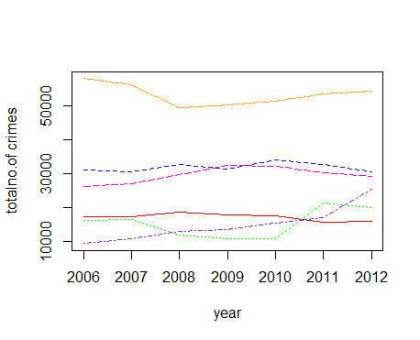As we can see, the orange line which represents Delhi shows growth in crime over the years, which is significantly higher than all the other cities(near 50000).

The blue and magenta lines, which represents Mumbai and Bangalore respectively are very near to each other, implying these two cities’ growth of crimes are quite similar in number(near 30000).

The red,purple and the green line are in much lower region than the others, which implies the cities that the lines denotes-namely Hyderabad,Chennai and Kolkata have quite low growth in crimes(near 10000).