Team No. | Reg. No. | Name | Title
2 | 23BDS1128 | Saumyarup Guha | Self-Healing Drone Propellers for Enhanced Durability
2 | 23BDS1155 | Divyanshu Sharma | Self-Healing Drone Propellers for Enhanced Durability

Smart Self-Healing Propellers: Making Drones More Durable and Reliable

Abstract:
Drone propellers are an essential part of drones, which are used in various fields like surveillance, delivery, and aerial photography. One of the major issues with drones is propeller damage, which can happen due to collisions with birds, trees, or buildings, as well as harsh weather conditions or prolonged use. These damages reduce the drone’s performance and reliability. To solve this issue, we are working on a mechanism that enables drone propellers to self-heal after minor damages, improving their durability and reducing maintenance needs.
We have planned to solve this issue using advanced materials such as shape memory alloys and self healing polymers. These materials will come in use when there is a minor crack or deformation on the propellers and the materials can automatically fill those cracks. We have also planned to add damage sensors to the propellers which can sense the weather conditions and closeness to obstacles and auto start the healing process. This idea when implemented will be able to increase the durability of drones and decrease the maintenance cost.

Detailed Description:
- Use of Self-Healing Polymers: Self-healing polymers are special materials that contain microcapsules filled with healing agents. When a crack forms on the surface of the propeller, these capsules break open and release the healing agent into the damaged area. The agent reacts with the surrounding material and fills the crack.
- Use of Shape Memory Alloys (SMAs): Shape memory alloys are metal alloys that can return to their original shape after being deformed, simply by applying heat. We plan to embed SMA wires within or around the propeller blades. When the propeller is bent or deformed slightly due to an impact with something, the SMA wire can be heated (by electric current or from flight heat), causing it to return to its original shape and repair the deformation.
- Sensor Integration: Small, lightweight damage sensors will be attached to the propeller structure. These sensors will detect vibrations, wind, temperature and minor cracks. When a damage is detected, the sensor can either alert the drone's built-in system or automatically trigger the healing process, such as releasing the polymer or activating the SMA using a heating element.
Working Methodology:
- Step 1: Material Integration
Propeller blades will be constructed using a mix of regular plastic (for structure), self-healing polymer (for crack repair), and SMA wires (for shape recovery).
- Step 2: Sensor Setup
Sensors will be added to detect damage and gather information like temperature, speed, and proximity to obstacles which can be used to predict and prevent damage in advance.
- Step 3: Response Mechanism
If damage occurs, sensors trigger a microcontroller, which then checks if there is a crack or deformation:
- If there is a crack: Healing agents are released which fill up the crack
- If there is deformation: Heating of SMA wires is started to restore the original shape.
- Step 4: System Feedback
The drone system checks the propeller's performance (speed, balance, etc.) after the healing process. If the problem still exists, it the drone will send a message or alert the operator to land it safely for inspection.
- Step 5: Testing & Iteration
Multiple test scenarios such as small crash tests, weather simulation, windy or hot weather conditions and repeated use of the drones to see how many times it can self-heal will be done to evaluate effectiveness of our idea. We can then improve the design or materials if needed. This step helps us make sure the idea works properly in real-life situations.

Architecture diagram
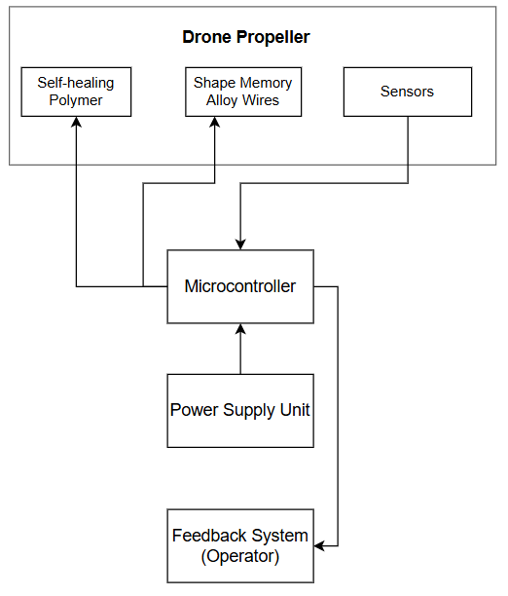

Flow Chart
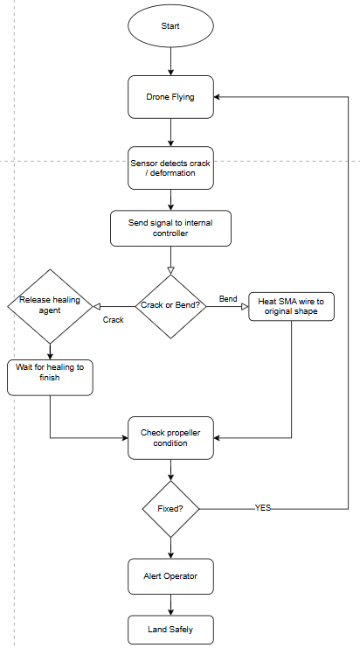

Novelty of Our Proposal:

Our proposal is novel because it brings together multiple innovative ideas and materials in a way that has not been used before in drone technology. Our approach is unique due to the following reasons:
- Self-Healing Polymers in Propellers: Most solutions use either one material or none at all but we are combining self-healing polymers (to fix cracks) and shape memory alloys (to recover the original shape after bending). This approach increases the chance of full recovery after minor damages, which makes it unique.

- Real-Time Damage Detection Sensors: Most drones use obstacle sensors, but our idea is of placing damage sensors directly on the propellers. These sensors will be able to spot small cracks and alert the system early, a feature which is not seen in normal drones.

- No Need for Manual Repair: Currently, if a drone propeller is slightly damaged, the drone has to be landed and the propeller is either repaired manually or replaced. This costs time and money. In our idea, the drone can fix minor damage by itself while it’s still flying. This reduces downtime, increases efficiency, and makes the drone a lot more durable. There’s no need to wait for technicians or carry spare blades all the time.

- Eco-Friendly and Cost-Saving Approach: By reducing the need to replace broken propellers, our project helps in minimizing waste and lowers the cost of maintenance. This makes drones more sustainable in the long run and gives them a longer operational life.

- Safety: Our proposal prioritizes in-flight safety by allowing damaged propellers to restore themselves during a mission. This reduces the risk of sudden failures during critical operations such as medical drone deliveries or rescue missions.

- Smart System: In our proposal, we use smart healing process. We have planned to use a microcontroller that can decide when and how to activate the healing process based on the type and severity of damage. It will not waste resources on tiny scratches or ignore serious cracks. This makes the system smart, efficient, and more reliable than simple mechanisms.

- Upgrade-Friendly Design: We have planned the system in a way that the self-healing propellers can be easily removed, upgraded, or reused. If a better self-healing material becomes available in the future, only the propeller would be replaced but the same drone can still be used. This makes the design future-proof and flexible.

- Expandable Beyond Propellers: Though or approach’s main focus is on propellers, our concept has potential to be expanded to other drone parts like the arms, body or landing gear. In the future, our innovative idea will be able to develop a fully self-healing drone.

Hardware Components:

Following are the main hardware components we plan to use and how each one will contribute to the project:

- Self-Healing Polymers: These are special materials that can automatically repair small cracks or surface damage without any external help. We plan to coat or embed these polymers on the surface of the propellers. When there is a crack due to a collision or stress, the polymer reacts to the damage and starts the healing process by filling the crack and bonding again. This helps in maintaining the strength and balance of the propeller.

- Shape Memory Alloys: Shape Memory Alloys are metals that can remember their original shape. If the propeller bends slightly due to an impact, the Shape Memory Alloy will help it return to its original shape when triggered by heat or electric current. This makes sure the propeller does not stay deformed and continues to spin properly and the drone keeps on working.

- Damage Detection Sensors: To detect when and where the damage has occurred, we have planned to place small sensors on the propellers. These sensors can feel unusual movements or tiny cracks and will send signals to the system if something is wrong. This allows for early detection, even before a visible crack becomes dangerous.

- Microcontroller: Microcontroller will receive signals from the sensors, analyse the situation, and decide whether to activate the healing materials (for minor cracks) or use Shape Memory Alloys (for deformation). We plan to use a microcontroller like Arduino Nano which is small, lightweight, and perfect for use in drones. It helps to automate the healing process without human control.

- Small Power Source: Our system needs extra power to run the sensors and trigger the Shape Memory Alloys, we will add a small battery extension or power booster. This will be connected to the drone’s main battery and will supply energy when needed. The system will be designed to consume very low power to avoid draining the main battery quickly.

- Lightweight Circuit Board: All the connections between the sensors, Shape Memory Alloys, microcontroller, and power supply will be mounted on a small, lightweight PCB or breadboard. This helps to keep the system compact and easy to fit on the drone without affecting its weight balance.

Novelty of Hardware Components:

- Self-Healing Polymers Used in Propellers: These materials are known in other fields for use of phone screens or coatings, but these are not used in drone propellers, especially for automatic crack healing. We are applying this technology to repair propeller cracks mid-flight, an area where it has never been used before.

- Shape Memory Alloys: Shape Memory Alloys are used in robotics and medical tools, but using them in a rotating, lightweight part like a drone blade is very rare. In our case, we’re letting the SMA bring the bent propeller back to shape without needing any manual help.

- Sensors on Propellers: Usually, drones use sensors to avoid hitting obstacles, but we are placing sensors directly on the propeller to detect minor damage or cracks. These are also used to check on weather conditions. This is new because normally, no one checks the condition of the propellers in real-time while the drone is flying.

- Healing Controlled by Microcontroller: Microcontrollers are usually used in drones for flight control or lights but in our proposal, the microcontroller is used to monitor damage and start the healing process. This is a new way of using microcontrollers like a tiny decision-making system just for the propeller.

- Designed to Work on the Propeller Itself: Most of the hardware in drones is usually placed on the main body — things like navigation systems, cameras, or battery management. But in our idea, we’re focusing on the propeller itself, which is a moving part. That’s not common, because propellers are generally seen as simple plastic blades. We’re turning them into smart components that can detect damage and heal on their own.

- Easy to Upgrade: Our components are planned in such a way that if something breaks or gets outdated, the whole unit need not be thrown. Just the damaged part can be replaced or upgraded. This makes it easy to maintain the drone and keep it future-ready.

Present Technologies and How is Our Proposal Different:

Presently, there are some technologies dealing with damaged drone propellers, but most of them are basic and not built for long-term durability. Our proposal is different from these existing methods. Following are some comparisons that explain how our idea is better:

- Manual Repair or Replacement
  - Current Technology: If a propeller gets damaged, most drones have to be landed and the propeller is either fixed by hand or replaced entirely.
  - Our Proposal: In our idea, the drone can heal itself mid-flight using smart materials without needing to stop, land, or rely on a technician.

- No Damage Detection on Propellers
  - Current Technology: Drones may have sensors to avoid obstacles, but they do not have sensors on the propellers to check for damage.
  - Our Proposal: Our idea is to place tiny sensors directly on the blades to detect early signs of damage and trigger healing. This makes the system react quickly saving the drone from critical damage.

- No Environmental Adaptation
  - Current Technology: Existing drones don’t adapt their repair process based on weather or surrounding conditions.
  - Our Proposal: We have planned to use temperature and humidity sensors to make sure healing happens only when it’s effective, giving better results in real-world use.

- One-Time Use of Propellers
  - Current Technology: Most drone propellers are treated as disposable, once they break or bend, they are thrown away.
  - Our Proposal: Our propellers are reusable and designed to last longer by healing themselves. This reduces waste and saves cost in the long run.

- No Smart Feedback Loop
  - Current Technology: Existing drones do not have a system where the propellers communicate with the main controller about their condition.
  - Our Proposal: Our propellers include sensors that send feedback to a microcontroller, which monitors health and controls healing which creates a smart feedback loop between the blade and the system for better function.

- Focus Only on Navigation Safety
  - Current Technology: Most drones are designed with safety in mind, but only for avoiding external obstacles, like trees or buildings.
  - Our Proposal: We focus on internal safety of the propellers, which are critical for flight. Self-healing helps prevent sudden failures, especially in rescue or delivery drones.

References:

