**Chain-of-Thought Prompting Techniques**

**-By Divyanshu Gupta**

**1. What is Chain-of-Thought Prompting?**

* A technique to enable **complex reasoning** in LLMs by guiding them to break tasks into intermediate steps.
* Best suited for tasks requiring **multi-step reasoning** like arithmetic, logical inference, or step-by-step question answering.
* CoT works well with **larger models** (like GPT-3.5, GPT-4) and shows **emergent abilities** with increased scale.

**2. Few-Shot CoT Prompting**

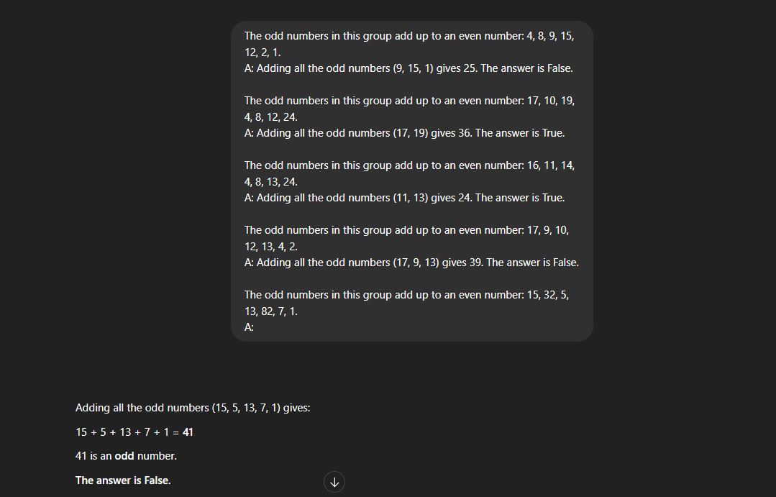

**This prompt style ensures accurate reasoning by demonstrating how to think through the problem.**

**3. One-Shot CoT Prompting**

**Even with only one example, the reasoning pattern is captured and applied successfully.**

**4. Zero-Shot CoT Prompting**

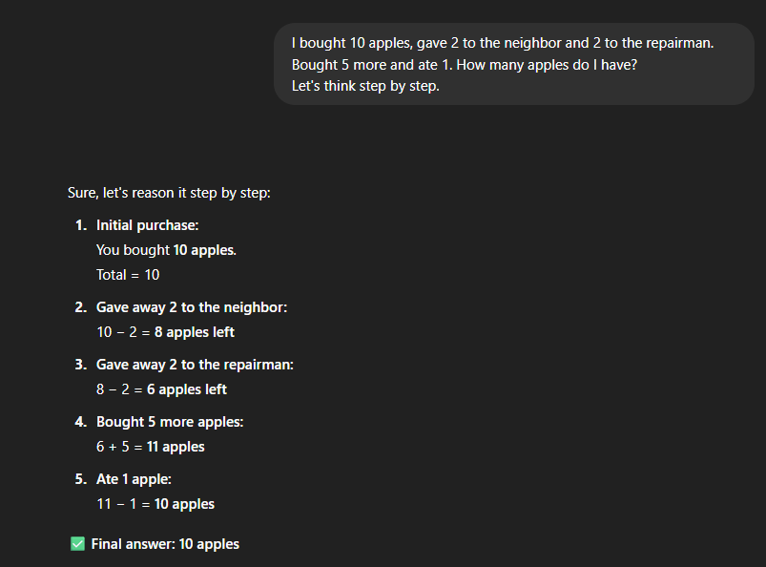

**5. Automatic CoT (Auto-CoT)**

**Steps in Auto-CoT:**

**Stage 1: Question Clustering**

* **Groups dataset questions by attributes (e.g., length, complexity).**

**Stage 2: Demonstration Sampling**

* **Selects one representative per cluster.**
* **Uses Zero-Shot CoT ("Let’s think step by step") to generate reasoning steps.**
* **Applies simple heuristics (e.g., 60 tokens or 5 reasoning steps).**

**Benefits:**

* **Reduces manual effort**
* **Improves diversity in reasoning patterns**
* **Scales well for large datasets or exams**

1. **Summary Points**

* **Chain-of-Thought (CoT) Prompting** enables intermediate reasoning and improves accuracy in complex tasks.
* **Few-shot CoT** uses multiple reasoning examples to guide the model.
* **Zero-shot CoT** requires no examples—just add *"Let’s think step by step"* to the prompt.
* **Auto-CoT** automatically generates reasoning examples using clustering and Zero-shot CoT strategies.
* CoT prompting is particularly effective with **larger language models** like GPT-3.5 and GPT-4.
* CoT helps in making the model’s output **more explainable, logical, and reliable**.