

About us

Help

**Home** **Page**

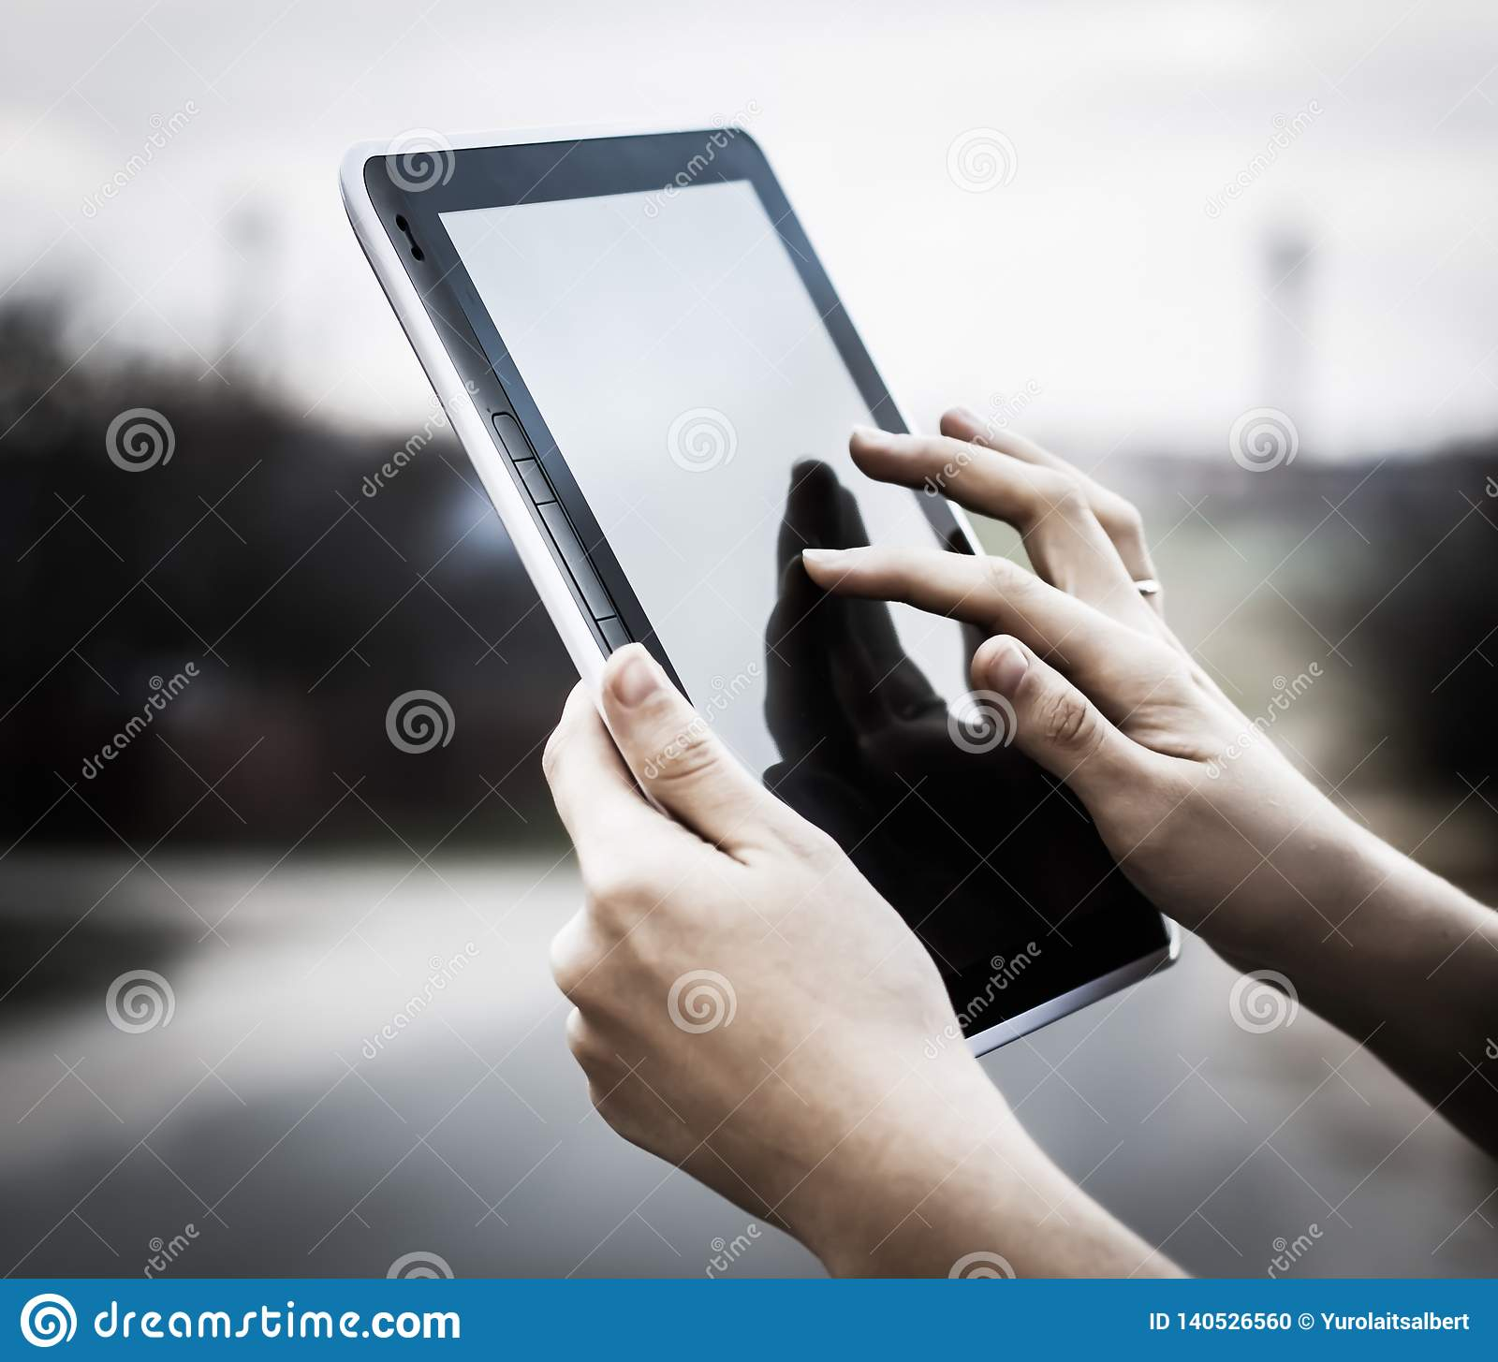

Access

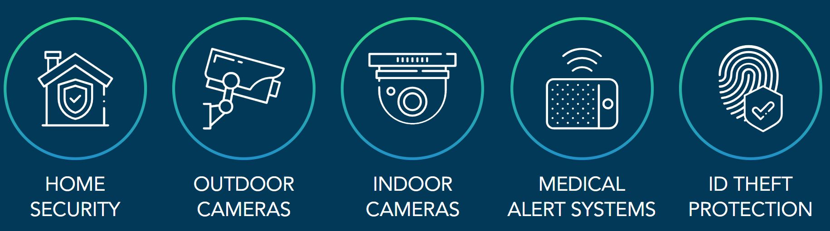

**Safety products for your home**

**Our products have helped people protect their property and live a more secure life.**

Monitoring

View

System Status

Configurere