**5.3 - Hess’s Law**

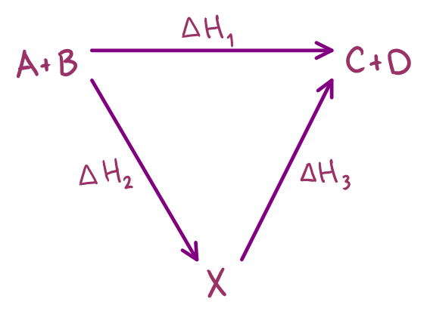**5.3.1 - Determine the enthalpy change of a reaction that is the sum of two or three reaction with known enthalpy changes**

The energy difference between two states is independent of the route between them

* i.e. The heat evolved or absorbed in a chemical process is the same, whether the process takes place in one or several steps

Energy can be neither created nor destroyed, it can only change state. This law can be used to determine the enthalpy of a reaction by manipulating known equations that could be used as a reaction pathway to the desired reaction

i.e. To determine the enthalpy for $A+B →C+D$, we can use

$A+B →X$ and $X →C+D$

The reactions are added. They are all put into an enthalpy cycle to show the relationship between them.

