CODE 1:
#include<iostream>
#include<conio.h>
using namespace std;
int main() {
int a, b, sum;
cout<<"Hello World";
cout<<"\nEnter the numbers: ";
cin >> a >> b;
sum = a + b;
cout << "Sum = " << sum;
_getch();
}
OUTPUT:
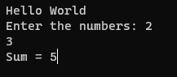

CODE 2:
#include<iostream>
#include<conio.h>
using namespace std;
int main() {
int a;
cout << "Enter the numbers: ";
cin >> a;
if (a % 2 == 0) {
cout << "The number " << a << " is even";
}
else {
cout << "The number " << a << " is odd";
}
_getch();
}
OUTPUT:
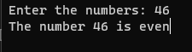

CODE 3:
#include<iostream>
#include<conio.h>
using namespace std;
int main() {
int a;
cout << "Enter the number: ";
cin >> a;
for (int i = 1; i <= 10;i++) {
cout << a << "*" << i << "=" << a * i << endl;
}

_getch();
}
OUTPUT:
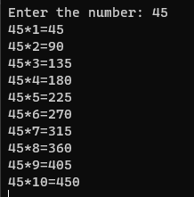

CODE 4:
#include<iostream>
#include<conio.h>
using namespace std;
int main() {
int a[5];

for (int i=0; i < 5; i++) {
cout << "Enter the number: ";
cin >> a[i];
}
for (int i = 0; i < 5; i++) {
cout << a[i] << " ";
}
_getch();
}
OUTPUT:
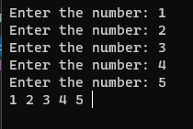

CODE 5:
#include<iostream>
#include<conio.h>
using namespace std;

long factorial(int n) {
if (n == 0 || n == 1) {
return 1;
}
else {
return n * factorial(n - 1);
}
}

int main() {
int a;
cout << "Enter the number: ";
cin >> a;
int result = factorial(a);
cout << "The factorial of " << a << " is " << result;

_getch();
}

OUTPUT:
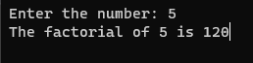

CODE 6:
#include<iostream>
#include<conio.h>
using namespace std;
int main() {
float a, b;
char ch;
cout << "Enter the first No.: ";
cin >> a;
cout << "Enter the Second No.: ";
cin >> b;
cout << "Operation you want to perform(+,-,*,/): ";
cin >> ch;
switch (ch) {
case '+':
cout << "a + b = " << a+b;
break;
case '/':
cout << "a / b = " << a/b;
break;
case '*':
cout << "a * b = " << a*b;
break;
case '-':
cout << "a - b = " << a-b;
break;
default:
cout << "Enter the correct operator!!";
break;
}
_getch();
}
OUTPUT:
