**Implementation of the Control section of the single-cycle data path for MicroMIPS**

**Code:**

module controlunit(op,fn,clk,reg_write,reg_dst,reg_insrc,ALU_src,add_sub,logic_fn,fn_class,data_read,data_write,brtype,PCsrc);

input [5:0]op,fn;

input clk;

output reg [1:0]reg_dst,reg_insrc,logic_fn,fn_class,brtype,PCsrc;

output reg reg_write,ALU_src,add_sub,data_read,data_write;

always @(posedge clk)

begin

case({op,fn})

12'b001111xxxxxx:

begin

reg_write <= 1'b1;

reg_dst <= 2'b00;

reg_insrc <= 2'b01;

ALU_src <= 1'b1;

add_sub <= 1'bx;

logic_fn <= 2'bx;

fn_class <= 2'b00;

data_read <= 1'b0;

data_write <= 1'b0;

brtype <= 2'b00;

PCsrc <=2'b00;

end

12'b000000100000:

begin

reg_write <= 1'b1;

reg_dst <= 2'b01;

reg_insrc <= 2'b01;

ALU_src <= 1'b0;

add_sub <= 1'b0;

logic_fn <= 2'bx;

fn_class <= 2'b10;

data_read <= 1'b0;

data_write <= 1'b0;

brtype <= 2'b00;

PCsrc <=2'b00;

end

12'b000000100010:

begin

reg_write <= 1'b1;

reg_dst <= 2'b01;

reg_insrc <= 2'b01;

ALU_src <= 1'b0;

add_sub <= 1'b1;

logic_fn <= 2'bx;

fn_class <= 2'b10;

data_read <= 1'b0;

data_write <= 1'b0;

brtype <= 2'b00;

PCsrc <=2'b00;

end

12'b000000101010:

begin

reg_write <= 1'b1;

reg_dst <= 2'b01;

reg_insrc <= 2'b01;

ALU_src <= 1'b0;

add_sub <= 1'b1;

logic_fn <= 2'bx;

fn_class <= 2'b01;

data_read <= 1'b0;

data_write <= 1'b0;

brtype <= 2'b00;

PCsrc <=2'b00;

end

12'b001000xxxxxx:

begin

reg_write <= 1'b1;

reg_dst <= 2'b00;

reg_insrc <= 2'b01;

ALU_src <= 1'b1;

add_sub <= 1'b0;

logic_fn <= 2'bx;

fn_class <= 2'b10;

data_read <= 1'b0;

data_write <= 1'b0;

brtype <= 2'b00;

PCsrc <=2'b00;

end

12'b001010xxxxxx:

begin

reg_write <= 1'b1;

reg_dst <= 2'b00;

reg_insrc <= 2'b01;

ALU_src <= 1'b1;

add_sub <= 1'b1;

logic_fn <= 2'bx;

fn_class <= 2'b01;

data_read <= 1'b0;

data_write <= 1'b0;

brtype <= 2'b00;

PCsrc <=2'b00;

end

12'b000000100100:

begin

reg_write <= 1'b1;

reg_dst <= 2'b01;

reg_insrc <= 2'b01;

ALU_src <= 1'b0;

add_sub <= 1'bx;

logic_fn <= 2'b00;

fn_class <= 2'b11;

data_read <= 1'b0;

data_write <= 1'b0;

brtype <= 2'b00;

PCsrc <=2'b00;

end

12'b000000100101:

begin

reg_write <= 1'b1;

reg_dst <= 2'b01;

reg_insrc <= 2'b01;

ALU_src <= 1'b0;

add_sub <= 1'bx;

logic_fn <= 2'b01;

fn_class <= 2'b11;

data_read <= 1'b0;

data_write <= 1'b0;

brtype <= 2'b00;

PCsrc <=2'b00;

end

12'b000000100110:

begin

reg_write <= 1'b1;

reg_dst <= 2'b01;

reg_insrc <= 2'b01;

ALU_src <= 1'b0;

add_sub <= 1'bx;

logic_fn <= 2'b10;

fn_class <= 2'b11;

data_read <= 1'b0;

data_write <= 1'b0;

brtype <= 2'b00;

PCsrc <=2'b00;

end

12'b000000100111:

begin

reg_write <= 1'b1;

reg_dst <= 2'b01;

reg_insrc <= 2'b01;

ALU_src <= 1'b0;

add_sub <= 1'bx;

logic_fn <= 2'b11;

fn_class <= 2'b11;

data_read <= 1'b0;

data_write <= 1'b0;

brtype <= 2'b00;

PCsrc <=2'b00;

end

12'b001100xxxxxx:

begin

reg_write <= 1'b1;

reg_dst <= 2'b00;

reg_insrc <= 2'b01;

ALU_src <= 1'b1;

add_sub <= 1'bx;

logic_fn <= 2'b00;

fn_class <= 2'b11;

data_read <= 1'b0;

data_write <= 1'b0;

brtype <= 2'b00;

PCsrc <=2'b00;

end

12'b001101xxxxxx:

begin

reg_write <= 1'b1;

reg_dst <= 2'b00;

reg_insrc <= 2'b01;

ALU_src <= 1'b1;

add_sub <= 1'b1;

logic_fn <= 2'b01;

fn_class <= 2'b11;

data_read <= 1'b0;

data_write <= 1'b0;

brtype <= 2'b00;

PCsrc <=2'b00;

end

12'b001110xxxxxx:

begin

reg_write <= 1'b1;

reg_dst <= 2'b00;

reg_insrc <= 2'b01;

ALU_src <= 1'b1;

add_sub <= 1'b1;

logic_fn <= 2'b10;

fn_class <= 2'b11;

data_read <= 1'b0;

data_write <= 1'b0;

brtype <= 2'b00;

PCsrc <=2'b00;

end

12'b100011xxxxxx:

begin

reg_write <= 1'b1;

reg_dst <= 2'b00;

reg_insrc <= 2'b00;

ALU_src <= 1'b1;

add_sub <= 1'b0;

logic_fn <= 2'bx;

fn_class <= 2'b10;

data_read <= 1'b1;

data_write <= 1'b0;

brtype <= 2'b00;

PCsrc <=2'b00;

end

12'b101011xxxxxx:

begin

reg_write <= 1'b0;

reg_dst <= 2'bx;

reg_insrc <= 2'bx;

ALU_src <= 1'b1;

add_sub <= 1'b0;

logic_fn <= 2'bx;

fn_class <= 2'b10;

data_read <= 1'b0;

data_write <= 1'b1;

brtype <= 2'b00;

PCsrc <=2'b00;

end

12'b000010xxxxxx:

begin

reg_write <= 1'b0;

reg_dst <= 2'bx;

reg_insrc <= 2'bx;

ALU_src <= 1'bx;

add_sub <= 1'bx;

logic_fn <= 2'bx;

fn_class <= 2'bx;

data_read <= 1'b0;

data_write <= 1'b0;

brtype <= 2'bx;

PCsrc <=2'b01;

end

12'b000000001000:

begin

reg_write <= 1'b0;

reg_dst <= 2'bx;

reg_insrc <= 2'bx;

ALU_src <= 1'bx;

add_sub <= 1'bx;

logic_fn <= 2'bx;

fn_class <= 2'bx;

data_read <= 1'b0;

data_write <= 1'b0;

brtype <= 2'bx;

PCsrc <=2'b10;

end

12'b000001xxxxxx:

begin

reg_write <= 1'b0;

reg_dst <= 2'bx;

reg_insrc <= 2'bx;

ALU_src <= 1'bx;

add_sub <= 1'bx;

logic_fn <= 2'bx;

fn_class <= 2'bx;

data_read <= 1'b0;

data_write <= 1'b0;

brtype <= 2'b11;

PCsrc <=2'b00;

end

12'b000100xxxxxx:

begin

reg_write <= 1'b0;

reg_dst <= 2'bx;

reg_insrc <= 2'bx;

ALU_src <= 1'bx;

add_sub <= 1'bx;

logic_fn <= 2'bx;

fn_class <= 2'bx;

data_read <= 1'b0;

data_write <= 1'b0;

brtype <= 2'b01;

PCsrc <=2'b00;

end

12'b000101xxxxxx:

begin

reg_write <= 1'b0;

reg_dst <= 2'bx;

reg_insrc <= 2'bx;

ALU_src <= 1'bx;

add_sub <= 1'bx;

logic_fn <= 2'bx;

fn_class <= 2'bx;

data_read <= 1'b0;

data_write <= 1'b0;

brtype <= 2'b10;

PCsrc <=2'b00;

end

12'b000011xxxxxx:

begin

reg_write <= 1'b1;

reg_dst <= 2'b10;

reg_insrc <= 2'b10;

ALU_src <= 1'bx;

add_sub <= 1'bx;

logic_fn <= 2'bx;

fn_class <= 2'bx;

data_read <= 1'b0;

data_write <= 1'b0;

brtype <= 2'b00;

PCsrc <=2'b01;

end

12'b000000001100:

begin

reg_write <= 1'b0;

reg_dst <= 2'bx;

reg_insrc <= 2'bx;

ALU_src <= 1'bx;

add_sub <= 1'bx;

logic_fn <= 2'bx;

fn_class <= 2'bx;

data_read <= 1'b0;

data_write <= 1'b0;

brtype <= 2'bx;

PCsrc <=2'b11;

end

endcase

end

endmodule

**RTL view:**

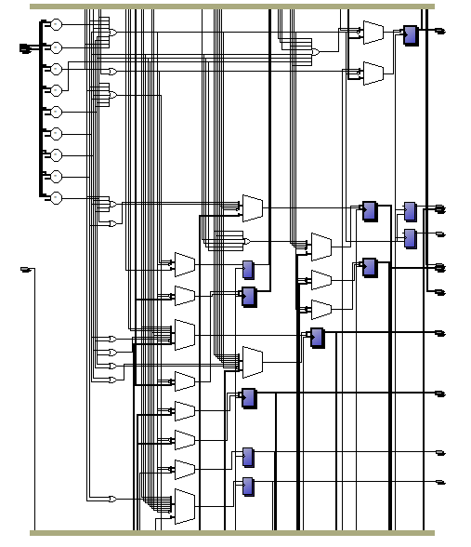

**Technology Mapping View:**

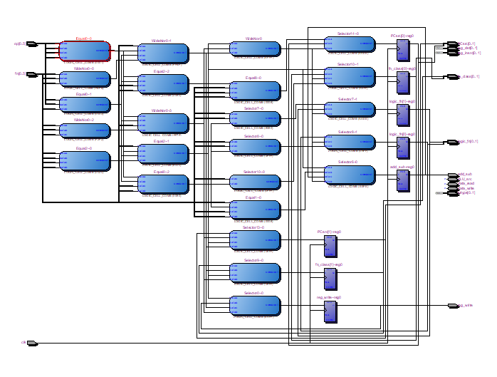

**RTL Simulation:**

