Business case: Automating monthly PMO reporting across a 40-project portfolio
Structured on the HM Treasury Five Case Model. Recommended option: Buy a SaaS PPM tool. Prepared by Divyaprakash S M.

Executive summary
Recommendation: approve Buy a SaaS PPM tool. Over 5 years it delivers a net present value of £239k and a benefit-cost ratio of 1.66 (medium value for money), paying back in 1.9 years.
Risk: across 10,000 simulated outcomes it pays for itself 96% of the time and is the best option in 97% of them. The middle outcome (P50) is £160k; a bad outcome (P10) is £41k.
Key sensitivity: the answer depends most on annual benefit. Benefits could fall 40% before the option stops paying for itself.

1. Strategic case

Case for change
Monthly status reporting across the 40-project portfolio is compiled by hand from six different trackers. It absorbs roughly 80 analyst-days a month, reports are a week old by the time the board reads them, and figures regularly disagree between packs. Leadership wants decisions made on current, single-source data.

Objectives
Cut reporting effort by at least 60%; deliver reports within 2 working days of month end; one source of truth for cost, schedule, risk and resourcing data.

2. Economic case
Options are appraised over 5 years at a 3.5% discount rate. Costs carry a 15% optimism-bias uplift (plus option-specific delivery-risk uplifts) and benefits a 10% haircut, in line with Green Book guidance that early estimates are systematically optimistic.
Option | PV costs | PV benefits | NPV | BCR | Value for money | Payback
Do minimum (keep manual) | £0k | £0k | £0k | baseline | - | -
Buy a SaaS PPM tool | £360k | £599k | £239k | 1.66 | Medium | 1.9 years
Build in-house dashboard | £312k | £508k | £196k | 1.63 | Medium | 2.5 years

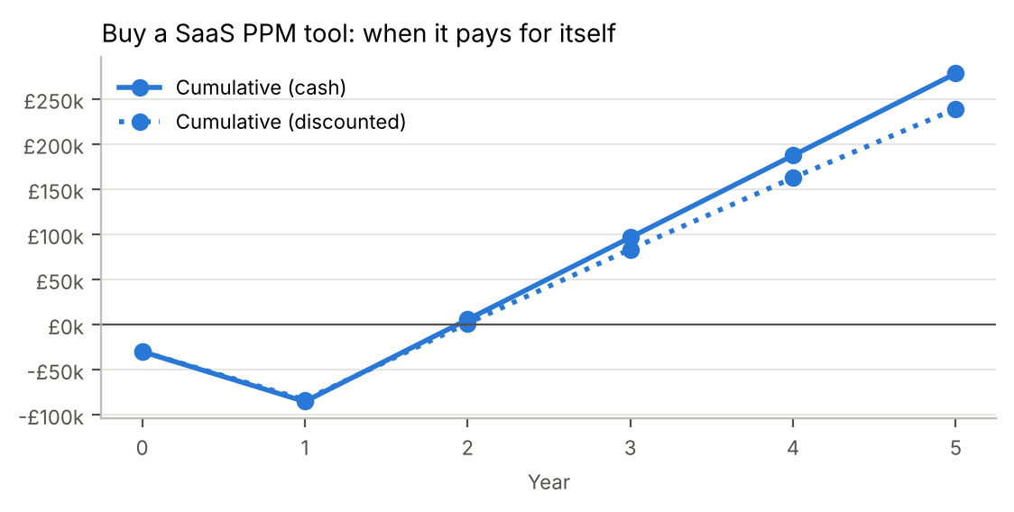

Risk analysis
Option | P10 NPV | P50 NPV | P90 NPV | Chance NPV > 0 | Chance best option
Buy a SaaS PPM tool | £41k | £160k | £240k | 96% | 97%
Build in-house dashboard | £29k | £130k | £195k | 95% | 3%

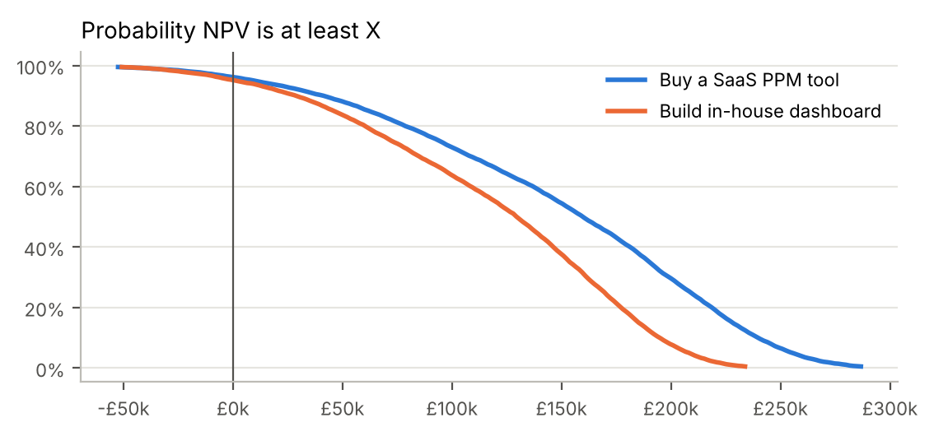
Simulation ranges: costs -10% to +30%, benefits -30% to +10%, 20% chance benefits start a year late.

Sensitivity and scenarios
Driver (±20%) | NPV if lower | NPV if higher | Swing
Annual benefit | £119k | £359k | £239k
Annual running cost | £291k | £187k | £104k
Year-1 implementation cost | £253k | £225k | £28k
Discount rate | £246k | £232k | £14k
Upfront cost | £245k | £233k | £12k

Scenario | NPV | BCR | Payback
Pessimistic | £46k | 1.11 | 3.7 years
Base | £239k | 1.66 | 1.9 years
Optimistic | £336k | 2.02 | 1.6 years

3. Commercial case
Procure via an existing public-sector framework (e.g. G-Cloud) to shorten the timeline. Three-year term with a two-year extension option; data export rights and exit support written into the contract.

4. Financial case
Cash required by year for the recommended option (including optimism bias):
Year | Costs | Benefits | Net | Cumulative
0 | £30k | £0k | -£30k | -£30k
1 | £130k | £74k | -£55k | -£85k
2 | £58k | £148k | £91k | £6k
3 | £58k | £148k | £91k | £96k
4 | £58k | £148k | £91k | £187k
5 | £58k | £148k | £91k | £278k

Peak funding requirement is £85k (the lowest point of cumulative cash flow), which is the budget that must be secured up front.

5. Management case
Senior Responsible Owner: Programme Director. Delivery via a 6-month phased rollout with a pilot on 5 projects. Benefits owned by named individuals and reviewed quarterly at the portfolio board; the business case is re-validated at each stage gate.
Benefits will be tracked quarterly against this case. If the re-forecast NPV turns negative, the project will be returned to the board for a stop / continue decision (continued business justification).

