Follow these steps to run a face matching demo from the command prompt.
Step-1: Open Command Prompt / PowerShell
Navigate to the project directory
Step-2: Activate Virtual Environment
.\venv\Scripts\activate
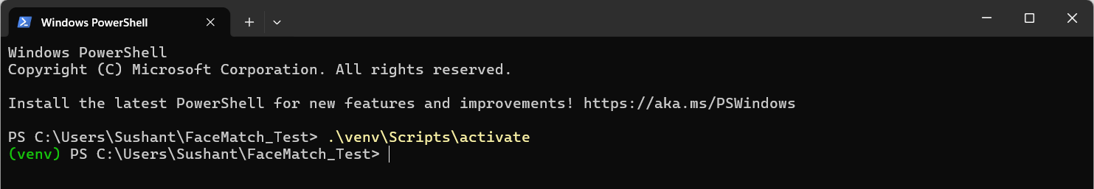
Step-3: Run Face Matching Demo
python match_face.py --image test.jpg
python match_face.py --image test.jpg --top_k 10
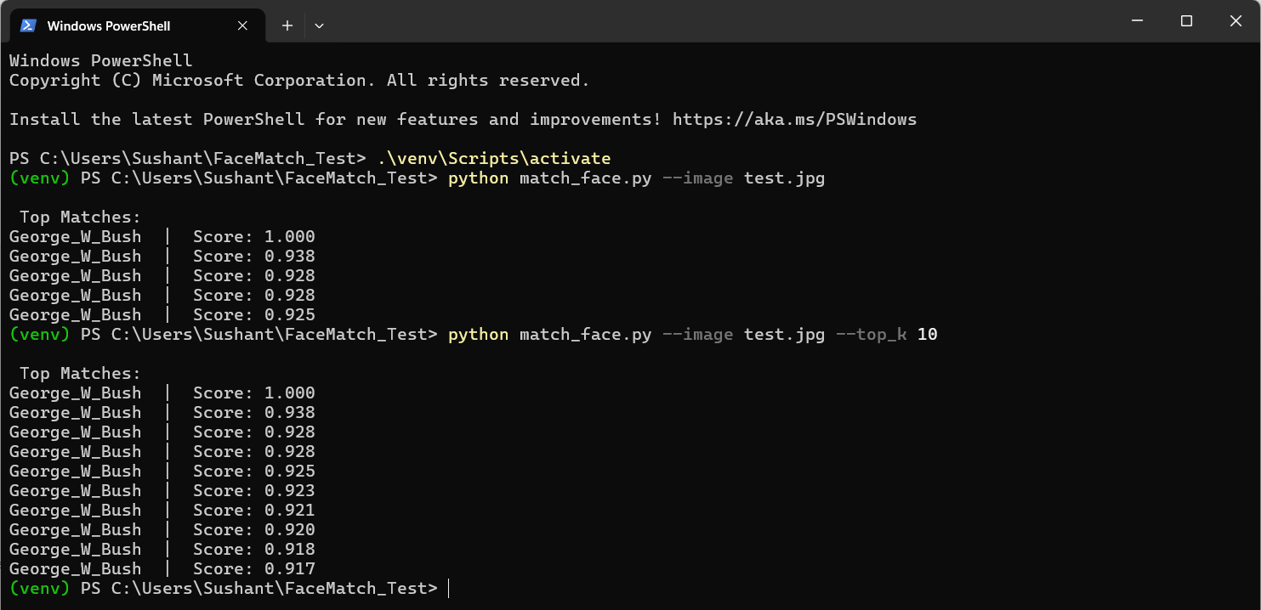

Details-
1. face_index.faiss - FAISS index has been built from the face dataset
https://www.kaggle.com/datasets/jessicali9530/lfw-dataset?resource=download
2. labels.npy - Stores the identity label for each face embedding stored in the FAISS index
3. build_index.py
build_index.py is the one-time (or periodic) indexing script that prepares face recognition system for fast search.
It converts face images into numerical vectors and builds a FAISS index for fast matching
1. Reads face images from the dataset directory
2. Detects faces in each image using MTCNN
3. Generates face embeddings using a FaceNet model
4. Adds embeddings to a FAISS index
5. Stores identity labels in labels.npy
6. Saves the FAISS index as face_index.faiss

