Experiment: Linux File and Directory Commands
Name: Divyaraj Vihol
Module:4
Subject: Linux
1. Creating and Renaming Files/Directories

a. Create a directory named test_dir using mkdir.
EXPLANATION; Mkdir Is a command use to create a new Directiories, in which we have given your directory as a test_dir name.

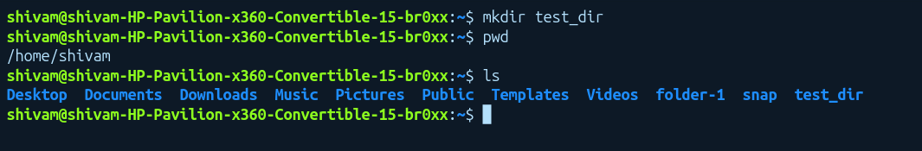
b.
Inside test_dir, create an empty file called example.txtEXPLANATION:First we have created a test_dir directory, and in then we are creating a empty file using touch keyword and giving the file name as example.txt.
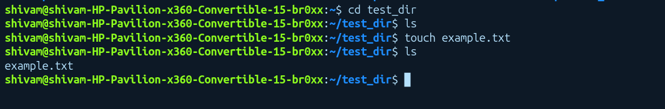
c. Rename example.txt to renamed_example.txt using mv
EXPLANATION:After creating a empty file named as example.txt, now we changed the name of that existing file using mv command to renamed_example.txt.
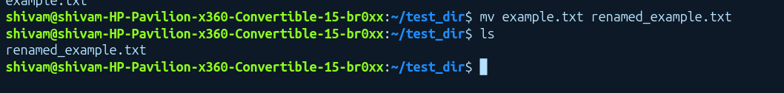

2. Viewing File Contents
a. Use cat to display the contents of /etc/passwd.
EXPLANATION:cat command is use to show the contents present in any file, in your case we have /etc/passwd file
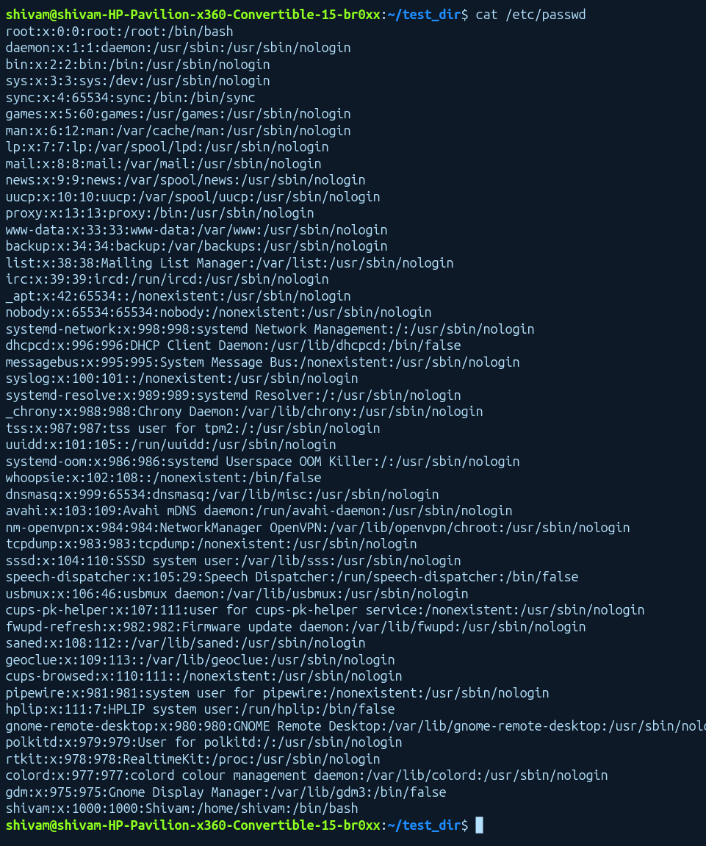
b. Display only the first 5 lines of /etc/passwd using head.
EXPLANATION: head command is use to show some lines from the top of the file, by using -n 5 we can display only the first 5 lines of the /etc/passwd.
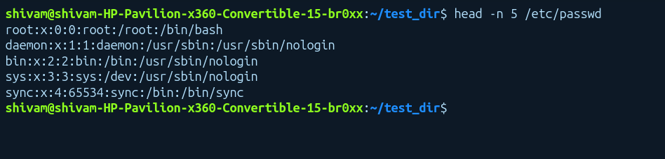
c. Display only the last 5 lines of /etc/passwd using tail
EXPLANATION: tail command is use to show some lines from the bottom of the file, by using -n 5 we can display only the last 5 lines of the /etc/passwd.
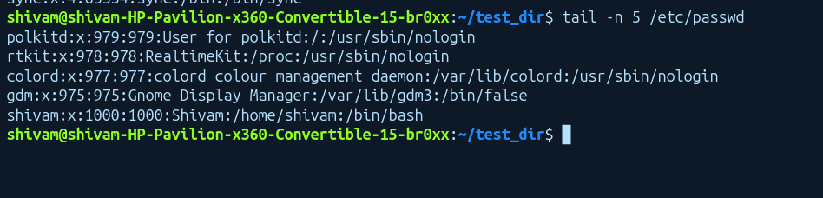
3.Searching for Patterns
a. Use grep to find all lines containing the word "root" in /etc/passwd.
EXPLANATION: So basically grep command is used to search a word/pattern in the given string, in this case we are searching “root” word inside the /etc/passwd.
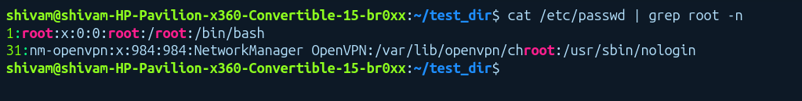

4. Zipping and Unzipping
a. Compress the test_dir directory into a file named test_dir.zip using zip.
EXPLANATION: zip command is used to convert any directory/file into a zip file/directory . It works same as Windows zip and unzip command.
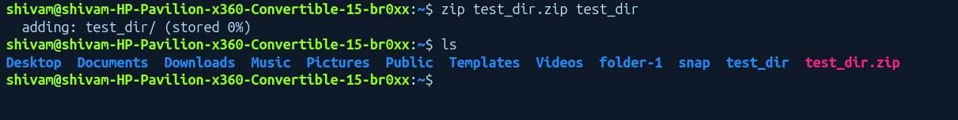
b.Unzip test_dir.zip into a new directory named unzipped_dir.
EXPLANATION: So unzip command is used to unzip or extract a zip file, in our case we unzip a test_dir.zip directory into unzipped_dir by using -d because we have to unzip a Directory.
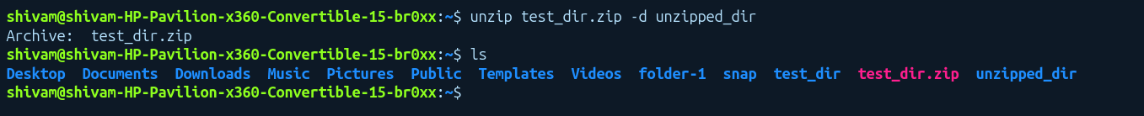
5. Downloading Files
a. Use wget to download a file from a URL (e.g., https://example.com/sample.txt).
EXPLANATION: So wget command is used to download direct files from internet , so I have downloaded the linux-commands.txt file from the internet.
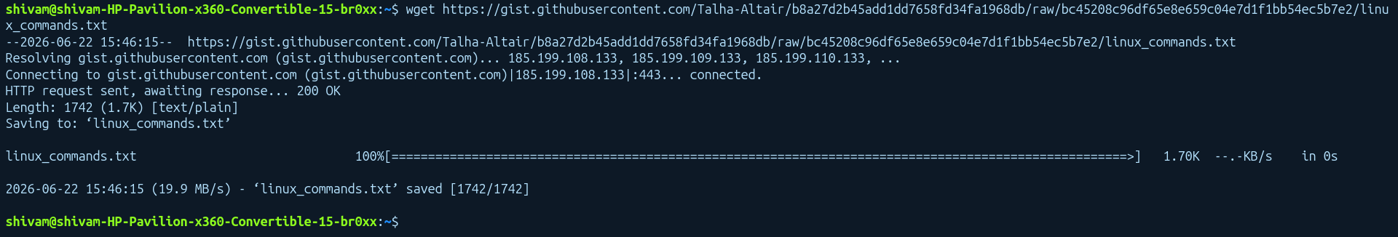

. 6.Changing Permissions
a. Create a file named secure.txt and change its permissions to read-only for everyone using chmod.
EXPLANATION: So chmod is used to change the permissions of the file from user, so we have created a secure.txt file using touch and then we have given read-only permissions for everyone using chmod.
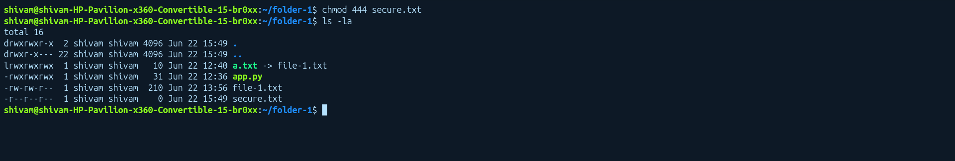

7. Working with Environment Variables
a. Use export to set a new environment variable called MY_VAR with the value "Hello, Linux!".
EXPLANATION: we have created a MY_VAR environment variable and gives value “Hello,Linux!” and then printed using echo and $ sign.
