- Assignment Name : Python Basics
- Name : Divyaraj Vihol
- Subject Name : DevOps
- Date: 23/06/2026
1.. Grade Checker
Take a score as input and print the grade based on the following:
90+ : "A"
80-89 : "B"
70-79 : "C"
60-69 : "D"
Below 60 : "F"
here we used a basic if else statement to carry out marks and all.
IMPLEMENTATION:
score=float(input("Enter Your Score of 5 Subjects="))
per=score/500*100
print("Your Percentage=",per)
if per>=90:
print("Grade A")
elif per<=89 and per>=80:
print("Grade B")
elif per<=79 and per>=70:
print("Grade C")
elif per<=69 and per>=60:
print("Grade D")
else:
print("Grade F")

EXPLANATION:
- So here we are taking input in a float variable name score from user and then finding percentage of that score entered by the user of its 5 subjects. On the basis of percentage It will print its Grade
OUTPUT:
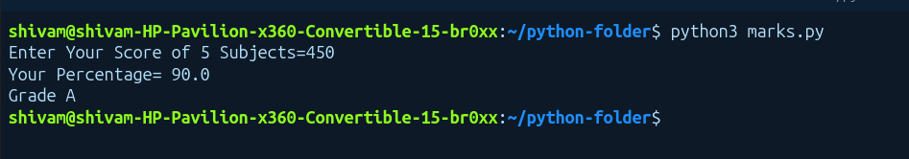

2.Student Grades
Create a dictionary where the keys are student names and the values are their grades. Allow the user to: Add a new student and grade. Update an existing student’s grade. Print all student grades. Used dictionary and basic operations. Using if else:

IMPLEMENTATION:
students={}
x=0
while x!=4:
print("----GRADEBOOK----")
print("1. Add A New Student")
print("2. Update Existing Student Grade")
print("3. Display Name and Grade of a Student")
print("4. Exit")
x=int(input("Enter Your Choice: "))
match x:
case 1:
name=input("Enter Your Name: ")
grade=input("Enter Your Grade: ")
students[name]=grade
print("Student Added Successfully")
case 2:
name=input("Enter Your Name: ")
if name in students:
grade=input("Enter Your New Grade: ")
students[name]=grade
print("Student Grade Updated Successfully")
else:
print("Student Not Found")
case 3:
name=input("Enter Your Name: ")
if name in students:
print(f"Name: {name}, Grade: {students[name]}")
else:
print("Student Not Found")
case 4:
x=4
case _:
print("Invalid Choice")

EXPLANATION:
- So here we have created a empty Dictionary name Students, then we have created a menu for user for his choice to enter , on the basis of user input , he/she can add Students and grades ,edit grades and display the grade on the basis of Student name
OUTPUT:
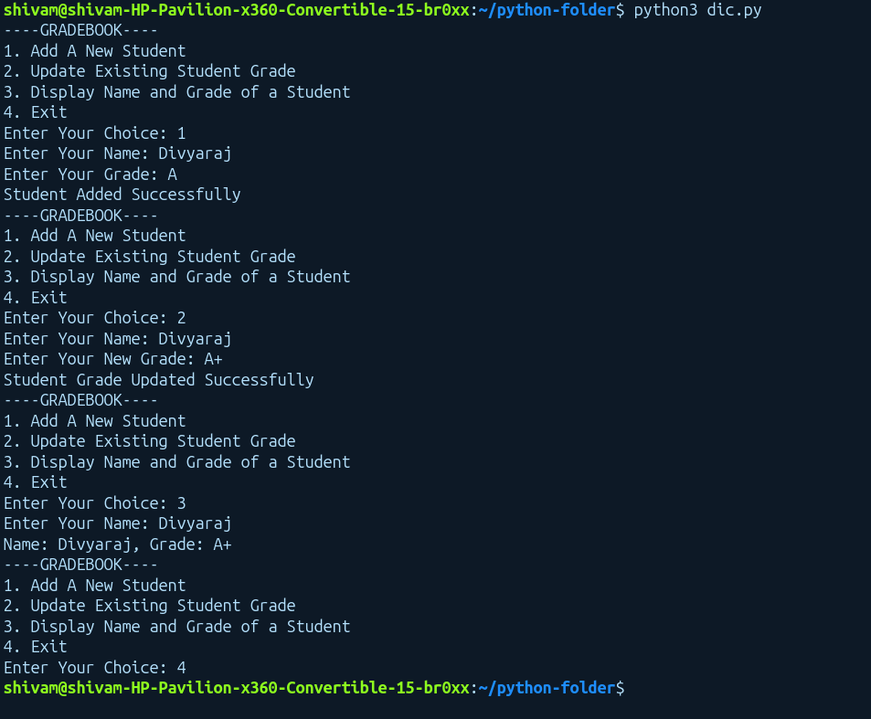

3..Write to a File
Write a program to create a text file and write some content to it. Using file functions like write and open.
IMPLEMENTATION:
f=open("sample.txt","w")
f.write("This is a Line added In a file name sample.txt")
f.write("\nThis is the Second line Added in a file name Sample.txt")
f.close()

EXPLANATION:
- Here we open a file called sample.txt in write mode, in write mode if file exists it will write in it or else it will create a new file then start writing into it . In our case we have created a new file name sample.txt, in which we have write 2 lines in it and then we have close that file
OUTPUT:

4. Read from a File
We used open in read mode and file.read to read and print to display.
IMPLEMENTATION:
f=open("sample.txt","r")
data=f.read()
print(data)
f.close()

EXPLANATION:
- we have open a file name sample.txt in a read mode and by using read function we are reading file and storing its data into a variable name data and then we have print data . And at last we close the file using close function
OUTPUT:

