Name:Divyaraj Vihol
Course:DevOps
Assignment:git version control

1. Create a new GitHub repository.
- Clone the repository to your local machine using SSH (generate an SSH key if needed, add the public key to your GitHub account).
Implantation :
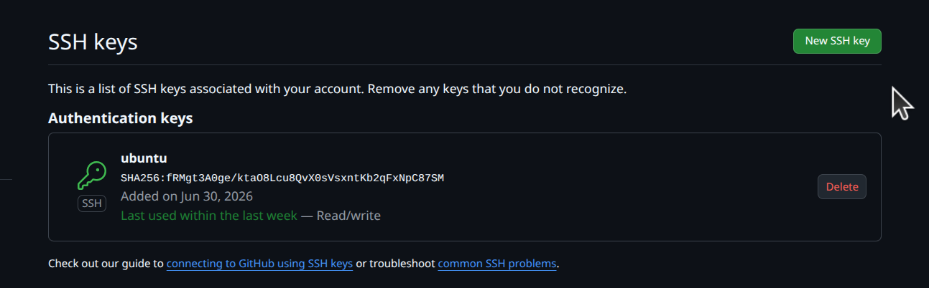
Explanation :
“ssh-keygen -t rsa -b 4096 -C "email@gmail.com"
eval "$(ssh-agent -s)"
ssh-add ~/.ssh/id_rsa
cat ~/.ssh/id_rsa.pub”
used this code to generate the ssh key from my device and then went to the git hub and in settings in SSH and GPS keys I created a new ssh key named Ubuntu.

- Create a new branch named after your username (e.g., Tutedude).
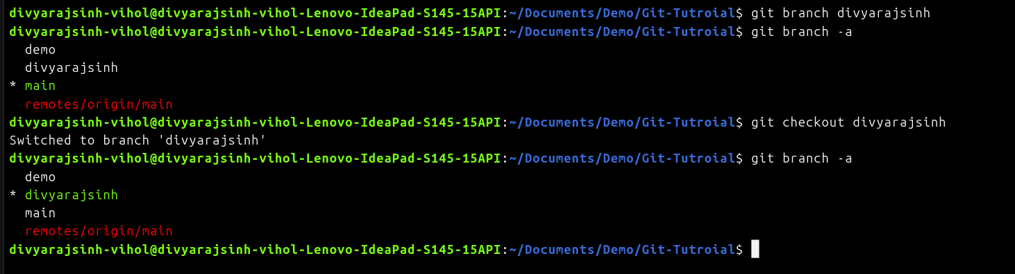
Implantation :

Explanation :

used the command “git branch divyarajsinh” to make a new branch called divyarajsinh. And then used “git checkout divyarajsinh” to went to that branch.

- Add your Flask project files to this branch.
Implantation :
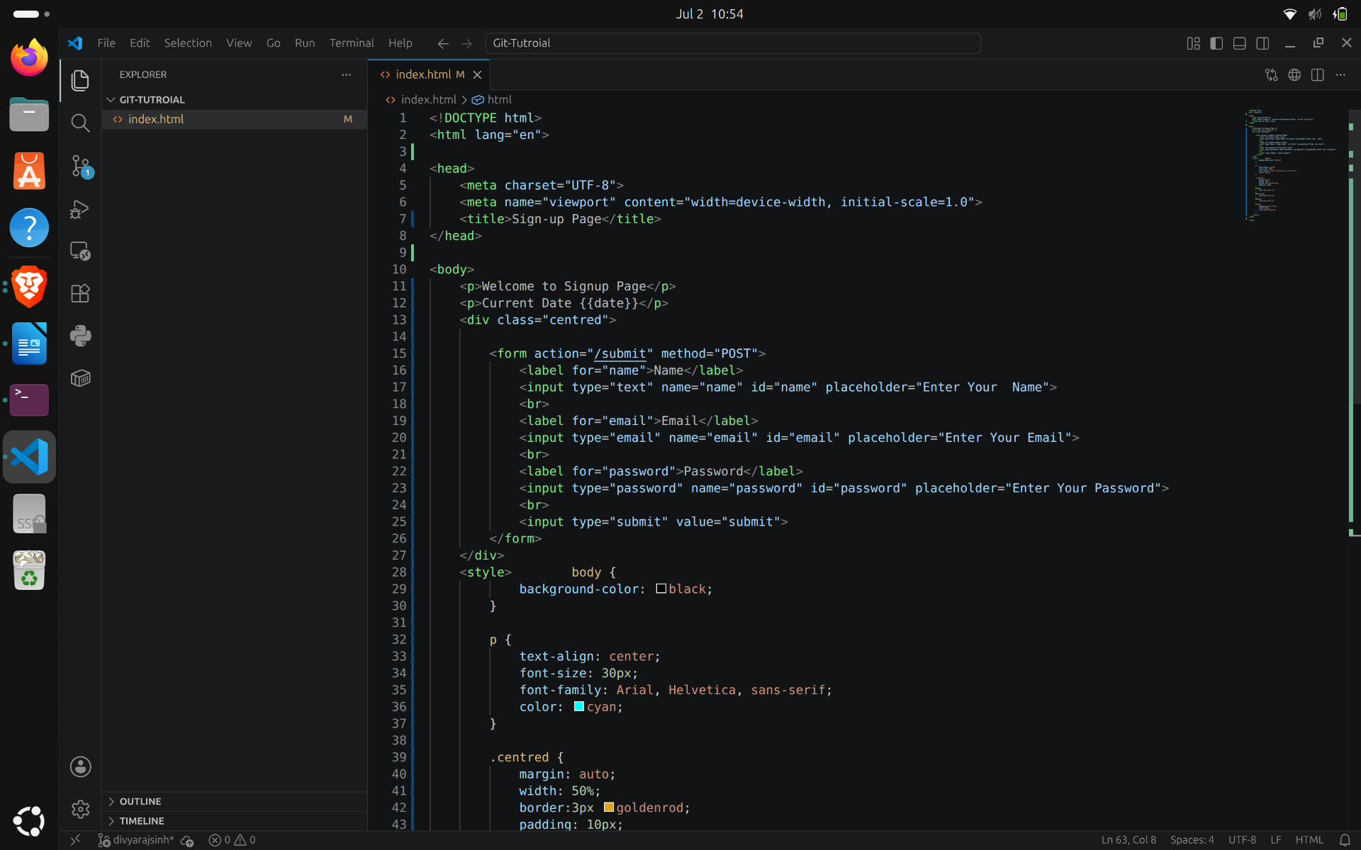
Explanation :
copyed the code from my flask files to new file in the new branch

- Commit the changes and merge the branch into the main branch.
Implantation :
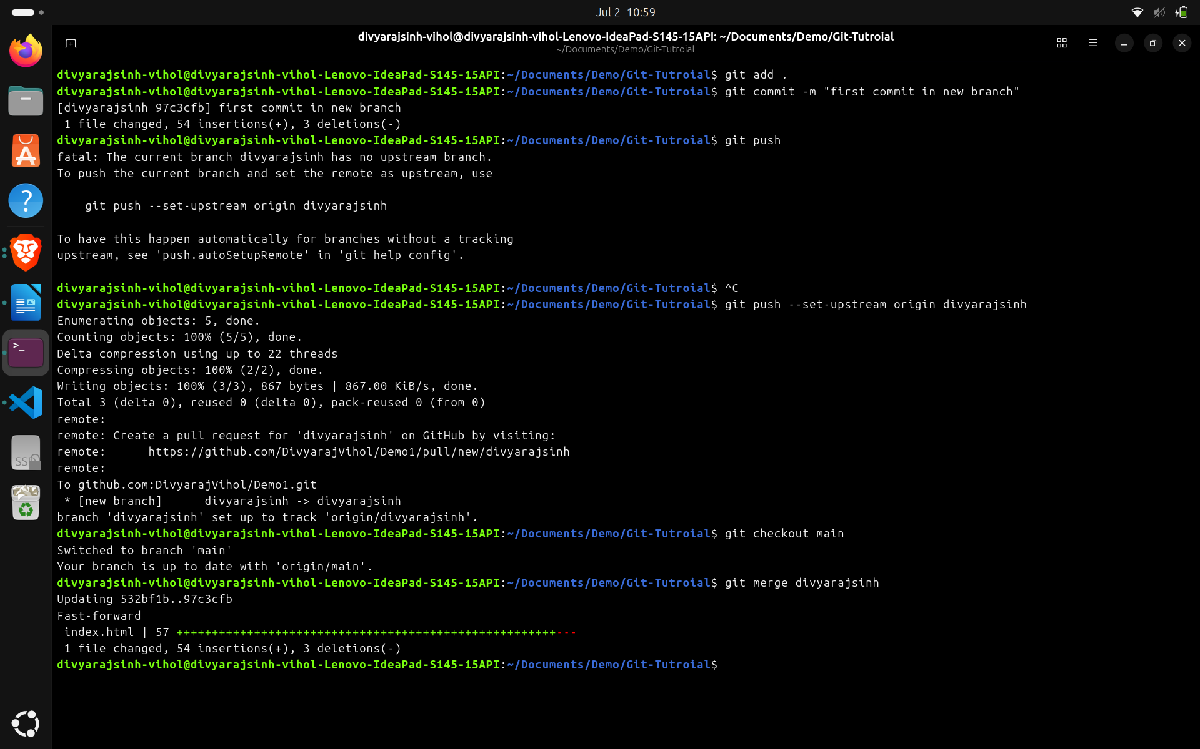
Explanation :
made the changes in the second branch and then commited them to second branch. After that I pushed the changes to git hug. Then I went to the main branch. Then I used the command “git merge divyarajsinh” to merge second branch to main.

2. Create a new branch named <your_name>_new (e.g.,
Tutedude_new).
- Update the content of the JSON file used for the /api route in this branch.
Implantation :
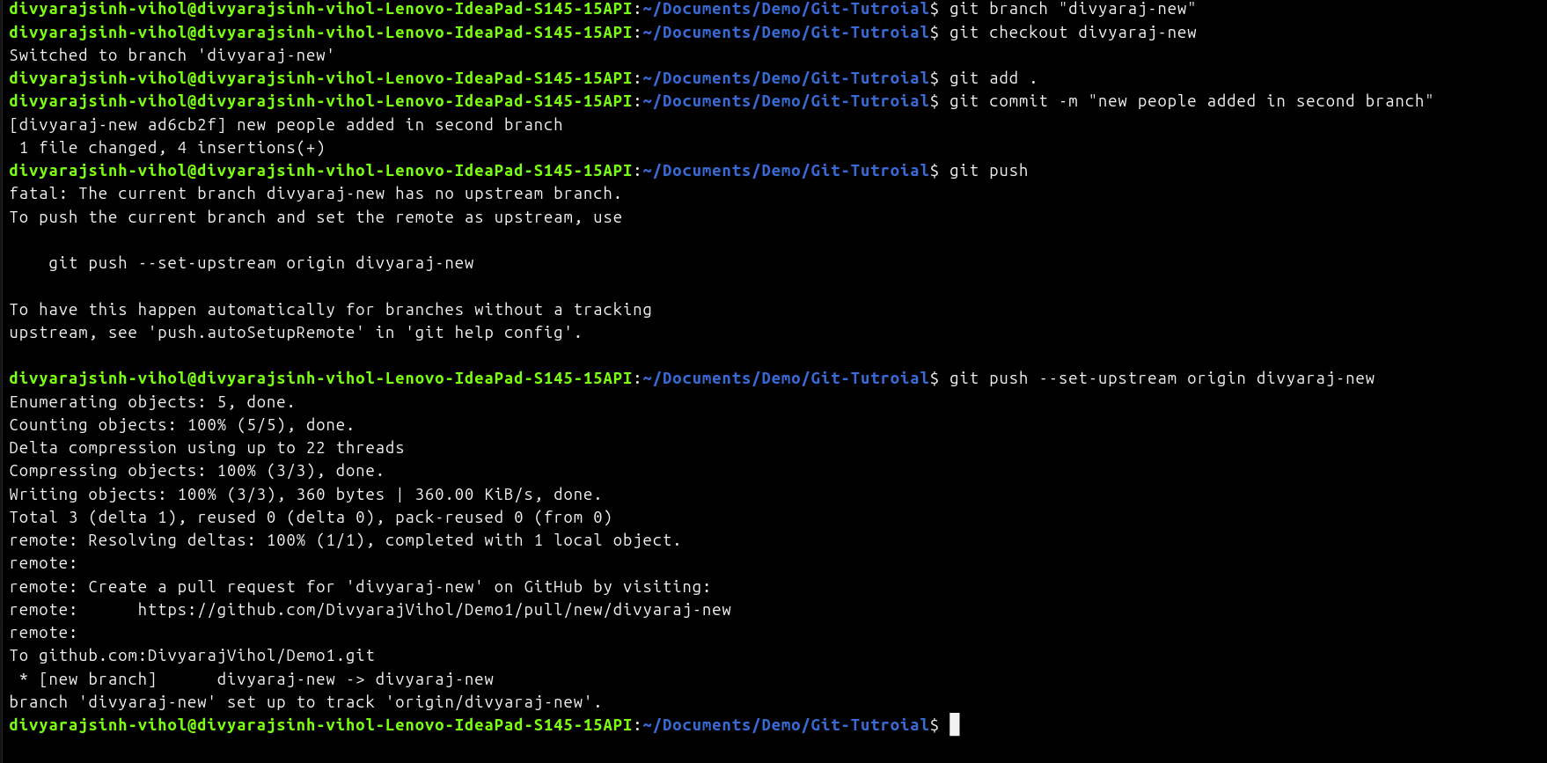
Explanation :
made a new branch name “divyaraj-new”, then made added a few names in the data.json file and commit them to the new branch.

- Merge the <your_name>_new branch into the main branch.
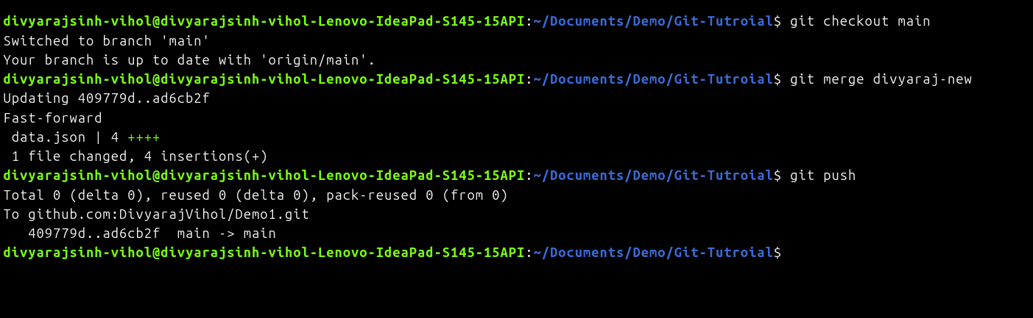
Implantation :

Explanation :
merged the second branch into the main branch using “git merge divyaraj-new” and then pushed the changes to git hub.

- If there are conflicts during the merge, resolve them by accepting the changes from the <your_name>_new branch.
Explanation : no conflicts occurred during merging.

- Add the resolved changes to the staging area, commit them, and push the updates to the remote repository.
Implantation :
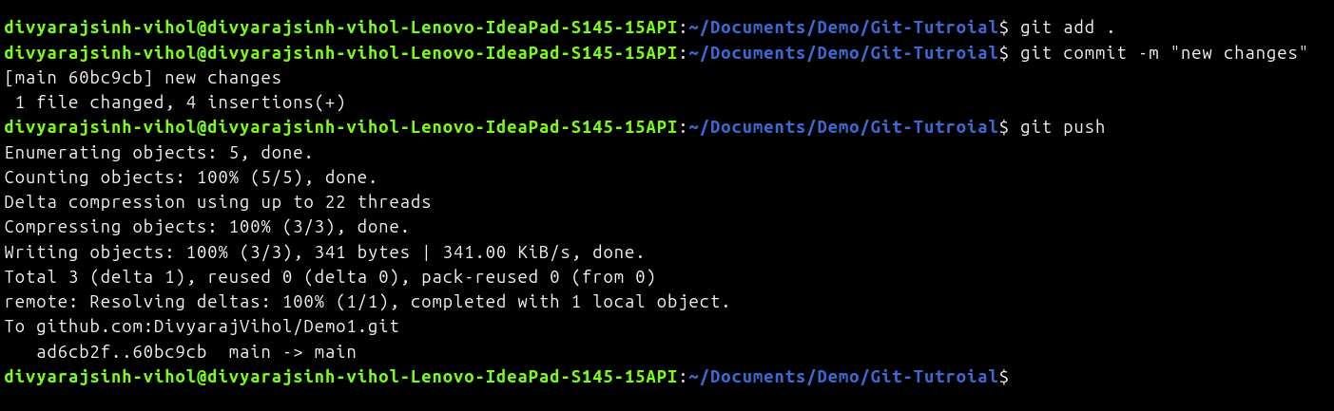
Explanation :
stashed the commits using “git add .”, then commited the changes using “ git commit -m "new changes” and at the end pushed them to the git hub using “git push”.

3. Branch Creation:
- Create two branches: master_1 and master_2 from the main branch.
Implantation :
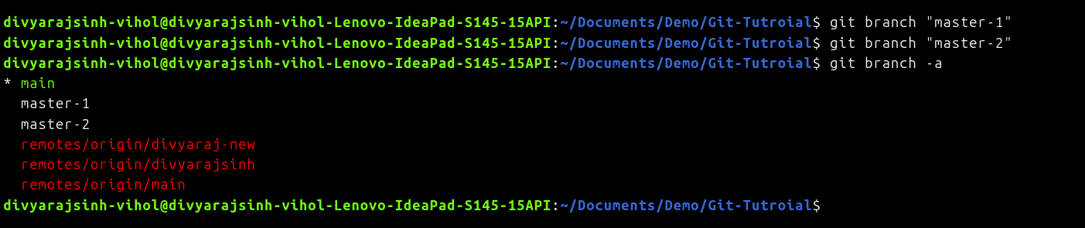
Explanation :
made two new branches named master-1 and master-2 using “git branch “master-1” & “git branch “master-2”.

- Feature Development in master_1:
- In the master_1 branch, create a To-Do Page in the frontend.
  - The page should contain a form with the following fields:
    - Item Name
    - Item Description
Implantation :
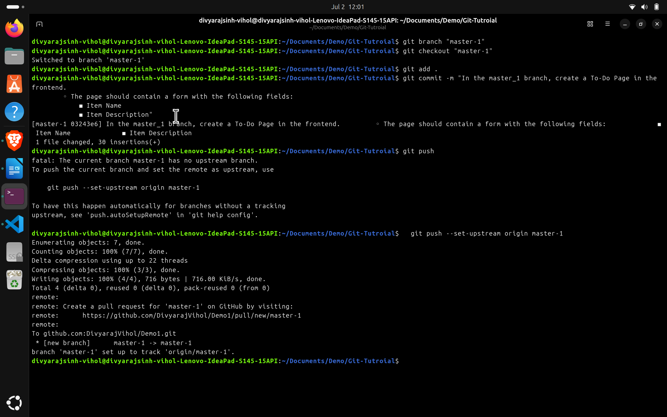
Explanation :
made the required HTML page in Frontend and commited all the changes in the master-1 branch.

- Backend API in master_2:
- In the master_2 branch, create a backend route named /submittodoitem.
- This route will:
  - Accept itemName and itemDescription via a POST request.
  - Store these details in a MongoDB database.
Implantation :
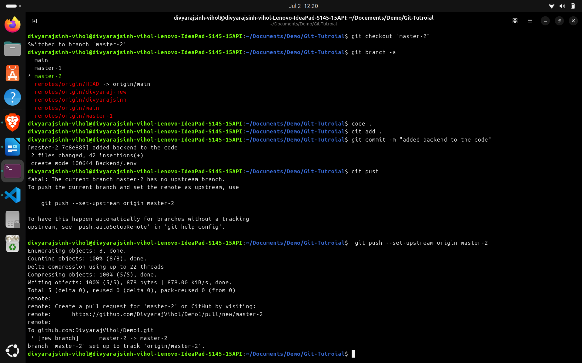
Explanation :
made the backend as requested and commited it in the master-2 branch

- Merging Changes:
- Merge the changes from both master_1 and master_2 into the main branch.
Implantation :
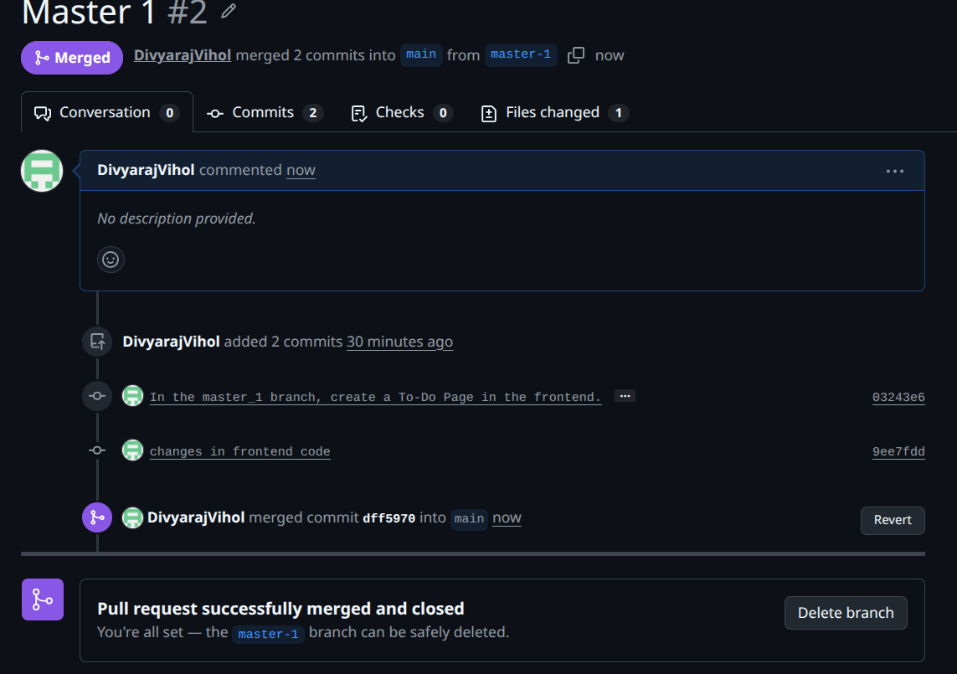
Explanation :
merged both branches using git hub.

4. Enhancing the To-Do Form in master_1:
- In the master_1 branch, add the following fields to the To-Do form:
  - Item ID
  - Item UUID
  - Item Hash
- Committing in Sequence:
- Add and commit each field separately in the following order:
  - First commit: Add Item ID field.

  - Second commit: Add Item UUID field.

  - Third commit: Add Item Hash field.
Implantation :
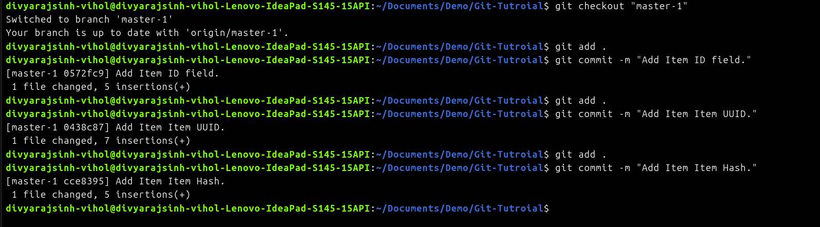
Explanation :
added made : Item ID
  - Item UUID
  - Item Hash
and commited them in sequnce

- Merging to main:
- Merge the master_1 branch into the main branch.
merged master-1 into main

Implantation :
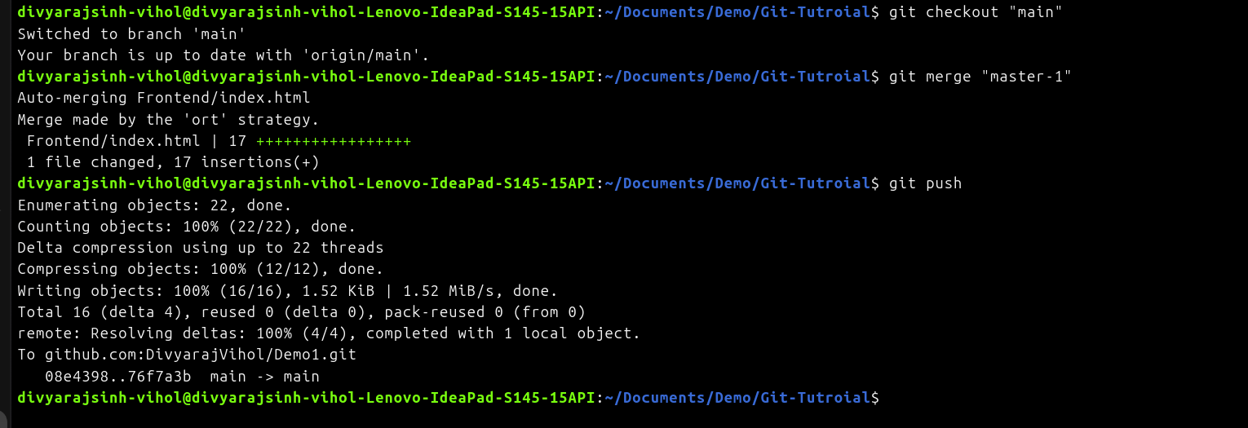
Explanation :

- Git Reset and Commit Deletion:
- In the main branch, use Git Reset to roll back to the commit where only the Item ID field was added.
- Use git reset --soft to ensure changes remain staged.
- Re-commit this state to the main branch.
- Merge this updated state to the main branch.
Implantation :
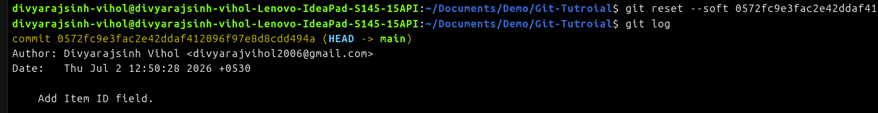
Explanation :
rested to the add item id using “git reset –soft” and then recommited it.

- Rebasing Changes:
- Rebase the updated changes in the main branch to the master_1 branch.
Clarification:
  - During rebasing, preserve individual commits to maintain the commit history for each change (i.e., do not squash commits).
  - Use git rebase main master_1 to integrate changes from the main branch back into the master_1 branch.

