Name:Divyaraj Vihol
Course:DevOps
Assignment:Flask and MongoDb

1. Create a Flask application with an /api route. When this route is accessed, it should return a JSON list. The data should be stored in a backend file, read from it, and sent as a response.

- IMPLEMENTATION:
from flask import Flask, jsonify import json
app = Flask(name)
@app.route("/api") def get_data(): with open("data.json", "r") as file: data = json.load(file)
return jsonify(data)
if name == "main": app.run(debug=True)
- EXPLANATION:
we read data from a json file called data.json and view it from the route /api. we open the file in the read mode and then use load method to read the data and then we return that data.
- OUTPUT:
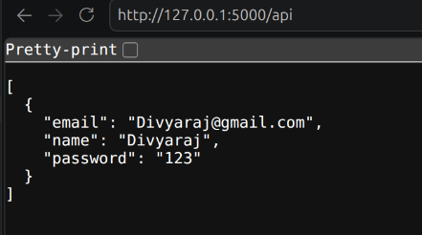

2. Create a form on the frontend that, when submitted, inserts data into MongoDB Atlas. Upon successful submission, the user should be redirected to another page displaying the message "Data submitted successfully". If there's an error during submission, display the error on the same page without redirection.

IMPLEMENTATION:
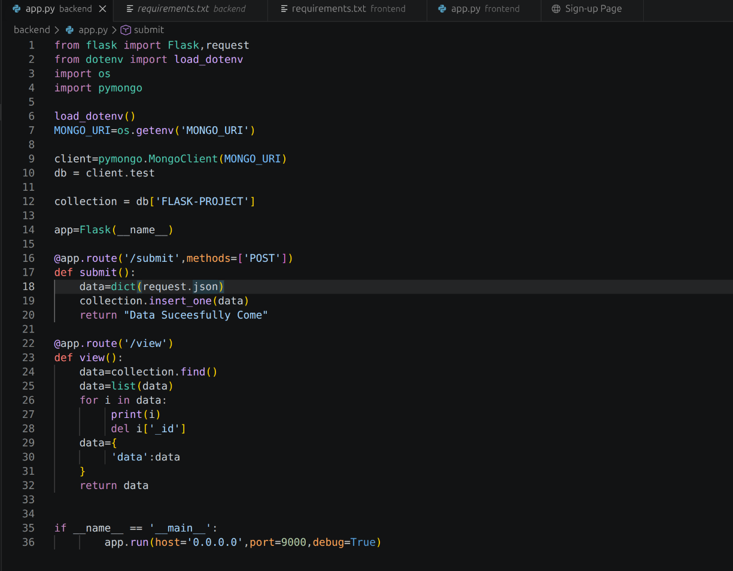
FRONTEND:
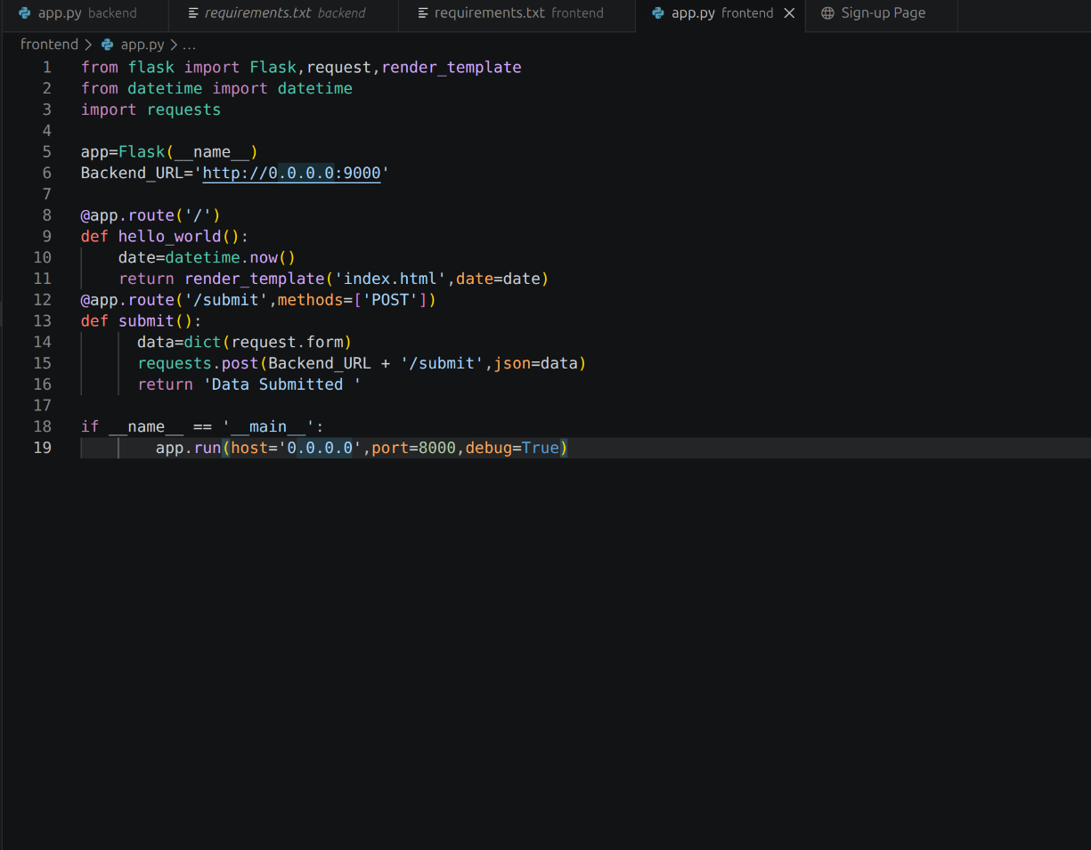
EXPLANATION:
so here we have created a form in html which take a input of name, email and password and this data gets stored in the mongoDb atlas , after submitting the detail, it will redirect to a new page where a msg get printed of “Data submitted successfully”.

OUTPUT:

