**Task 12 Output screenshots**

1. **Employee class**

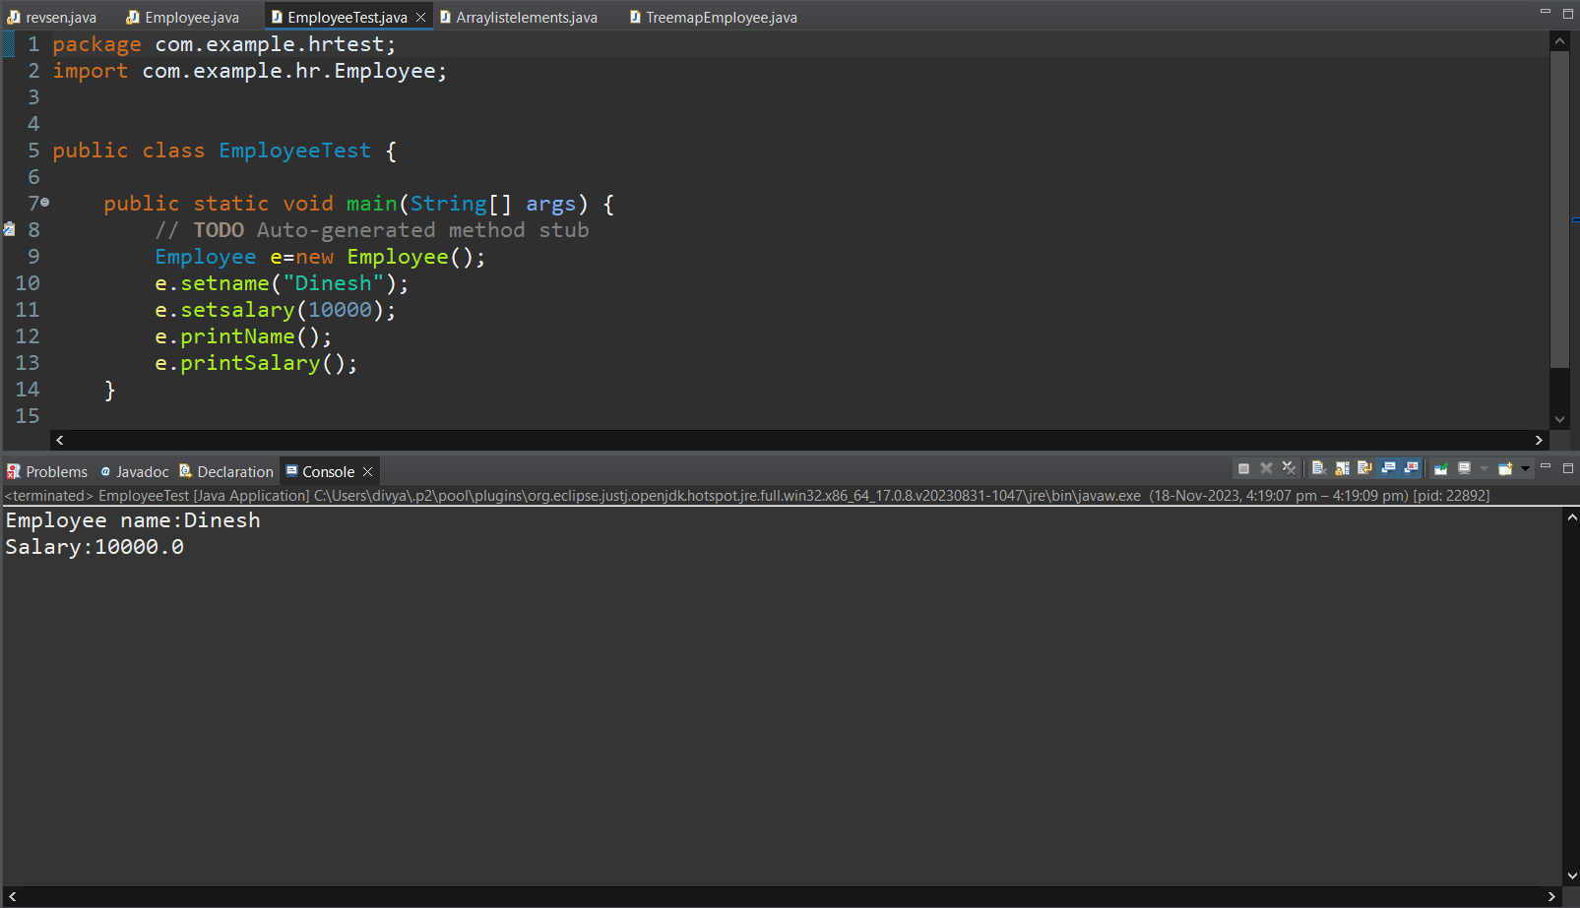

1. **To Create a ArrayList of strings and remove all the elements in the array**

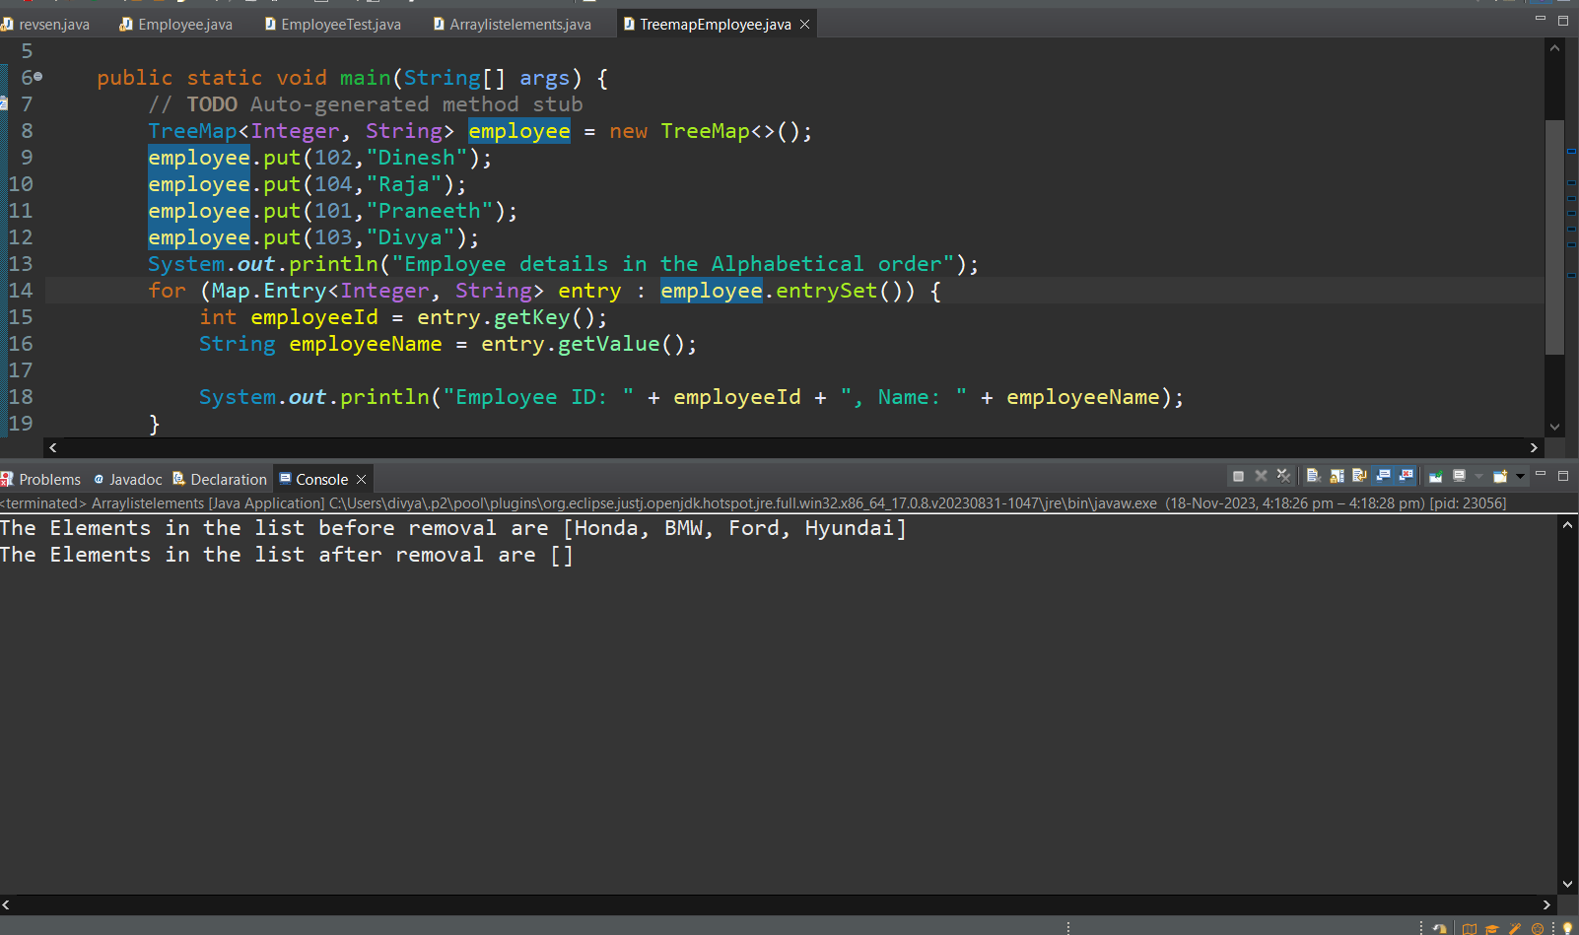

1. **To Create a TreeMap of Employee Id’s and Name’s and print it in alphabetical order**

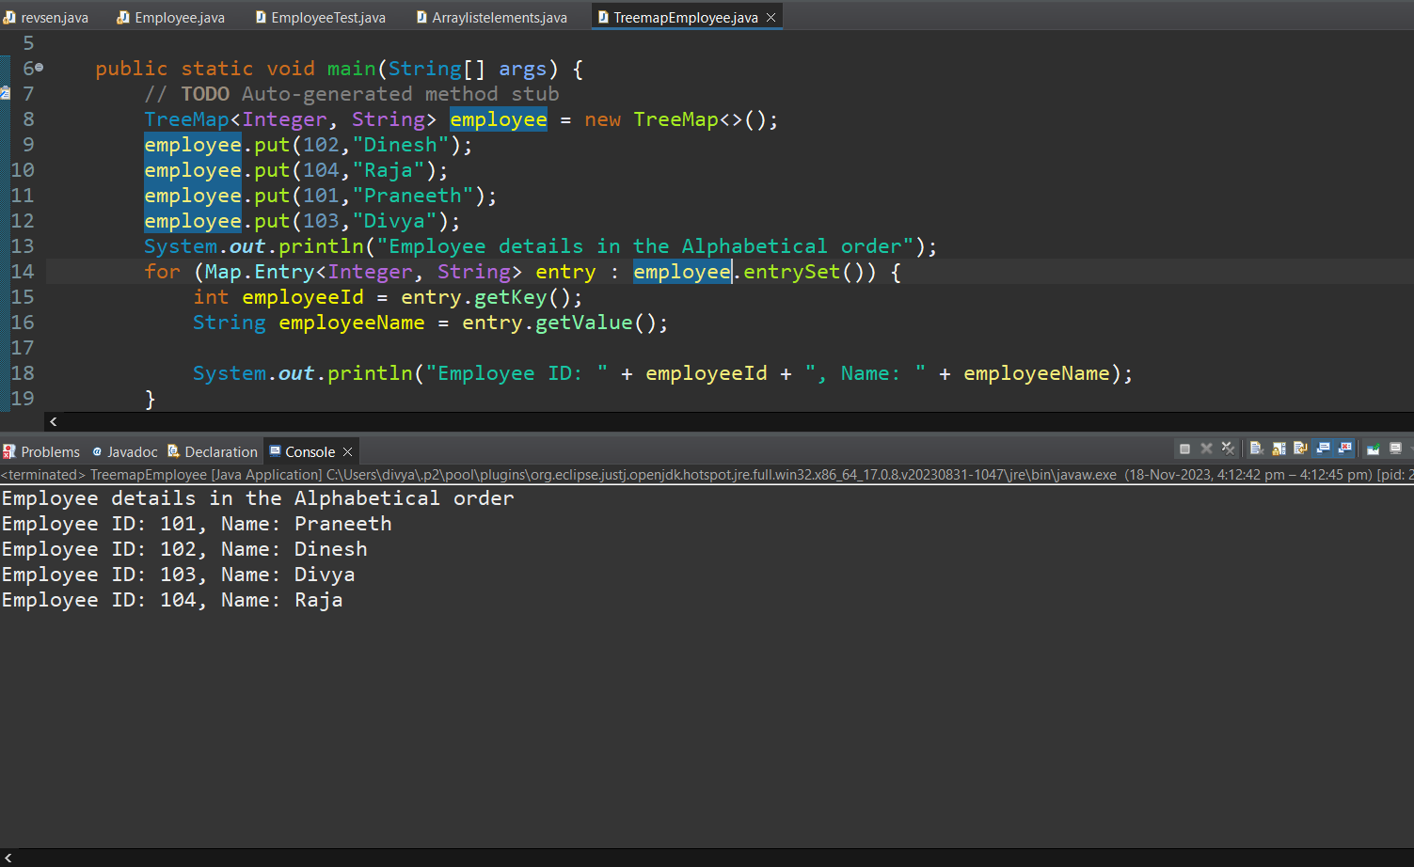

1. **Convert List to Array**

