Creating the table Empl

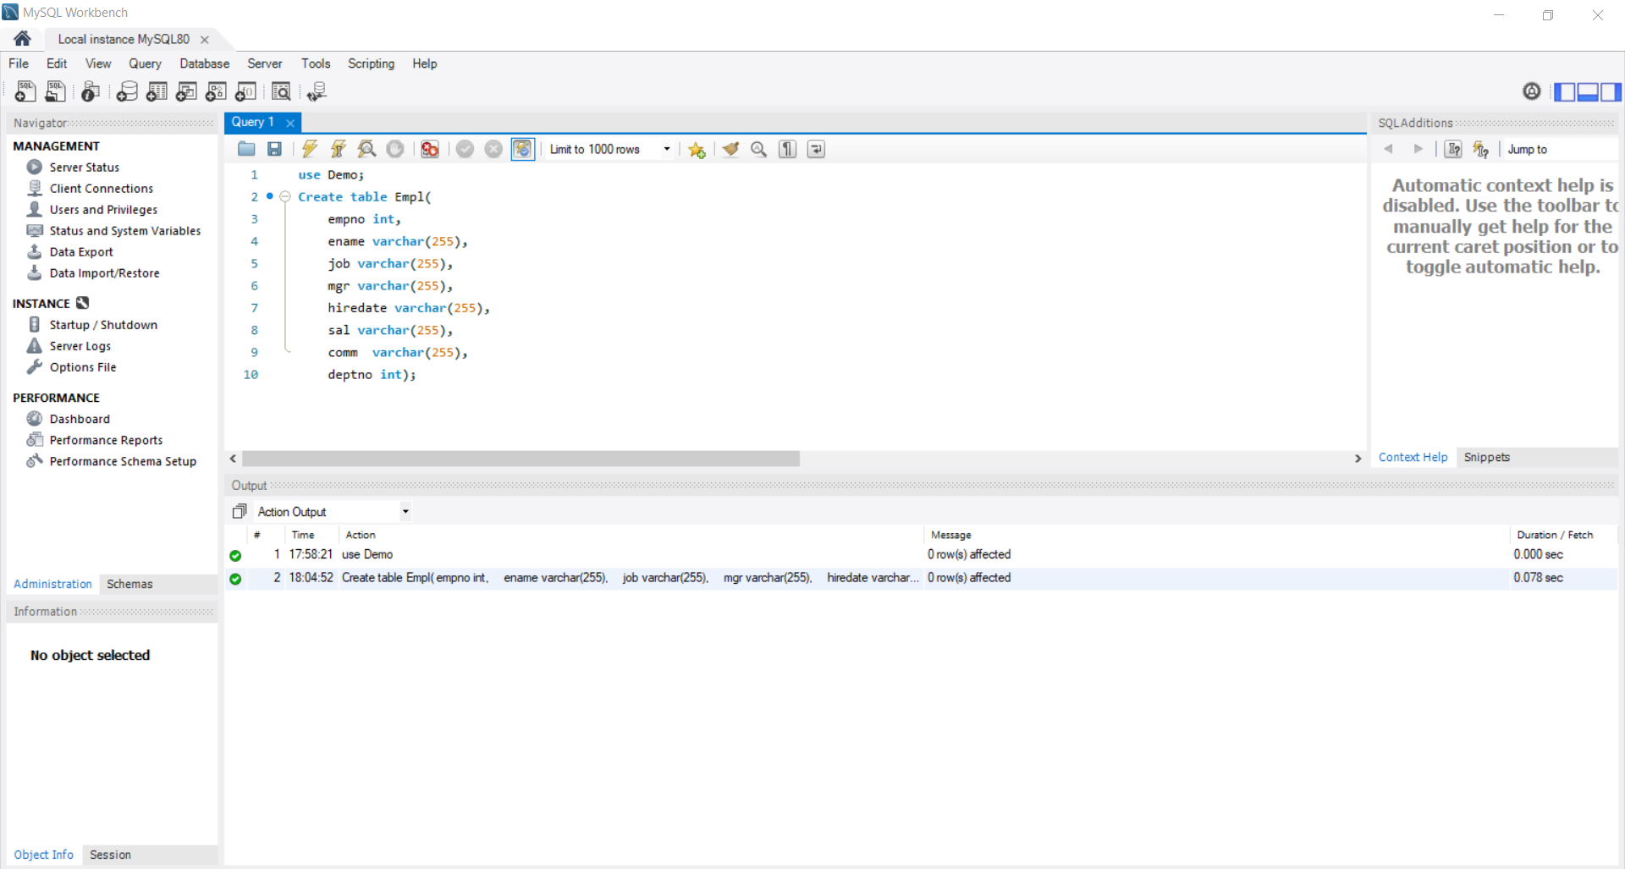

Table with values

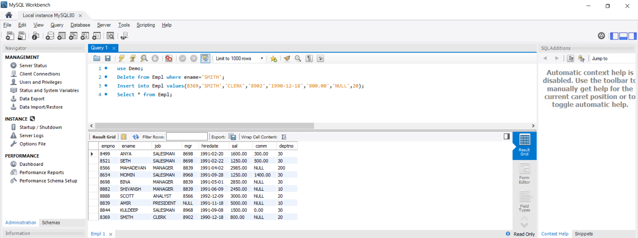

Q1.A.Query to display EName and sal of employees whose salary are greater than or equal to 2200

Q1.B.Write a query to display details of employees who are not getting commission?

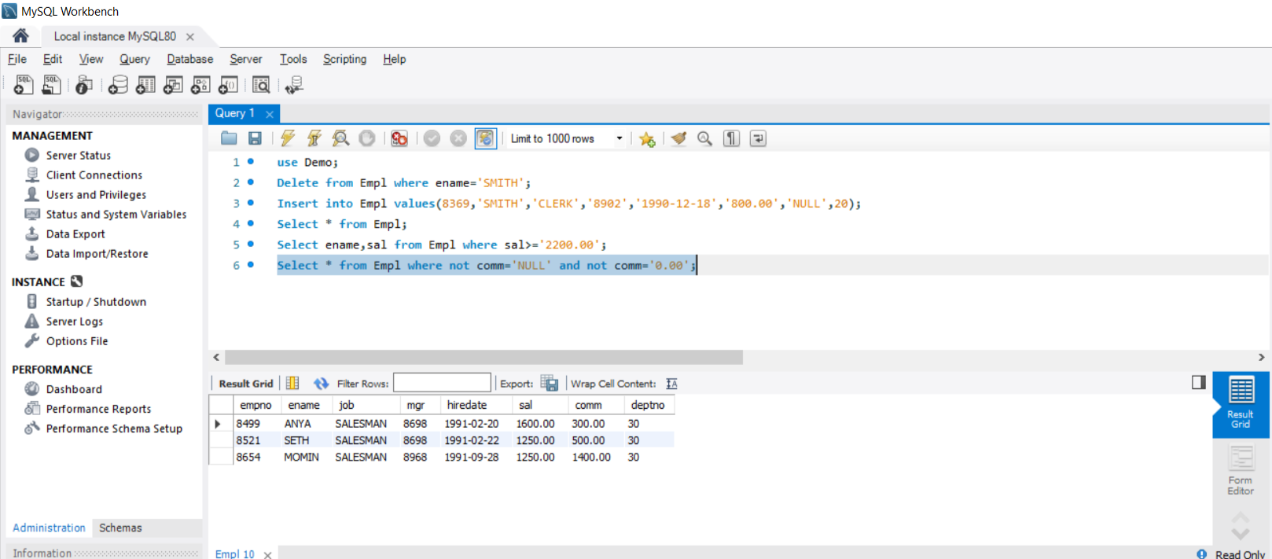

Q1.C.Write a query to display employee name and salary of those employees who don’t have their salary in the range of 2500 to 4000?

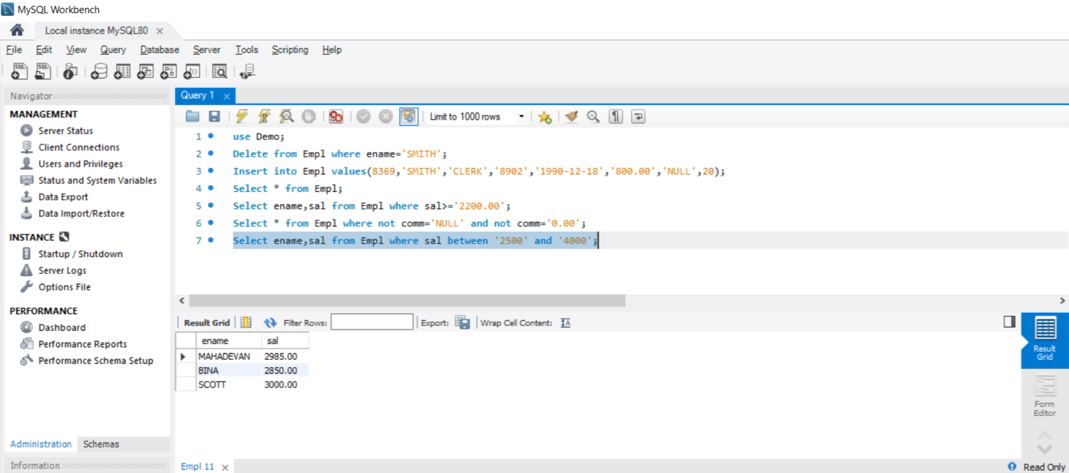

Q1.D.Write a query to display the name,job title and salary of employees who don’t have a manager?

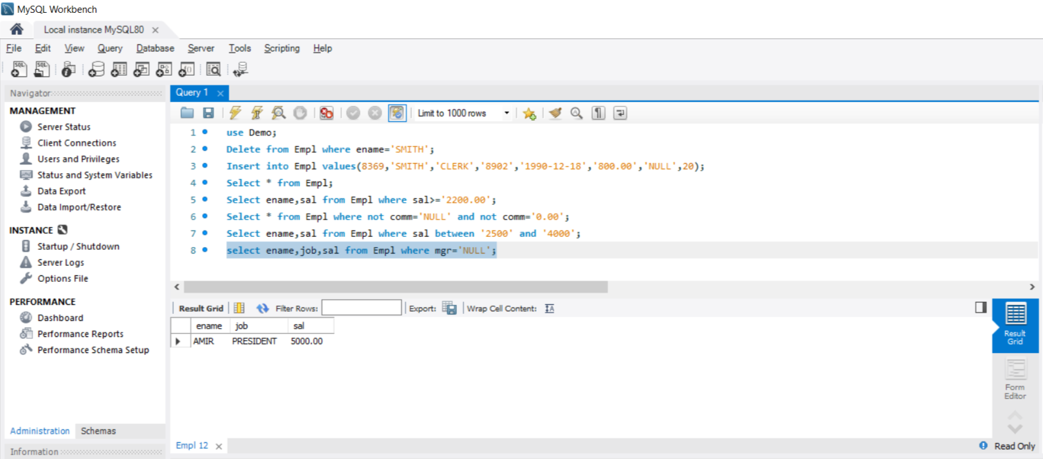

Q1.E.Write a query to display the name of an employee whose name contains “A” as third alphabet?

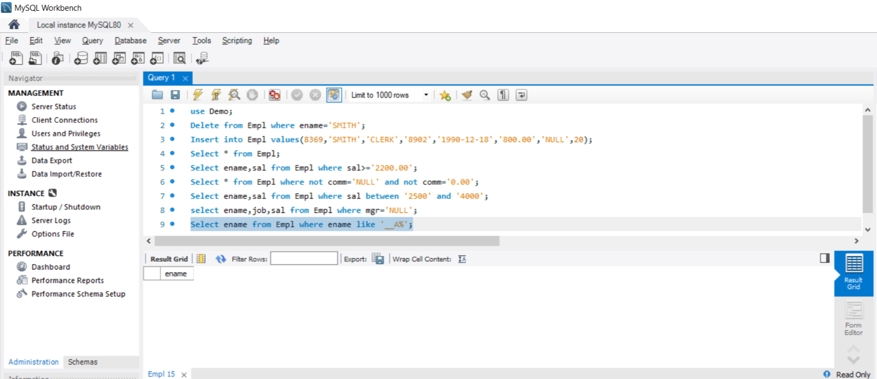

Q1.F.Write a query to display the name of an employee whose name contains ”T” as the last alphabet?