1.Greatest sum of two numbers

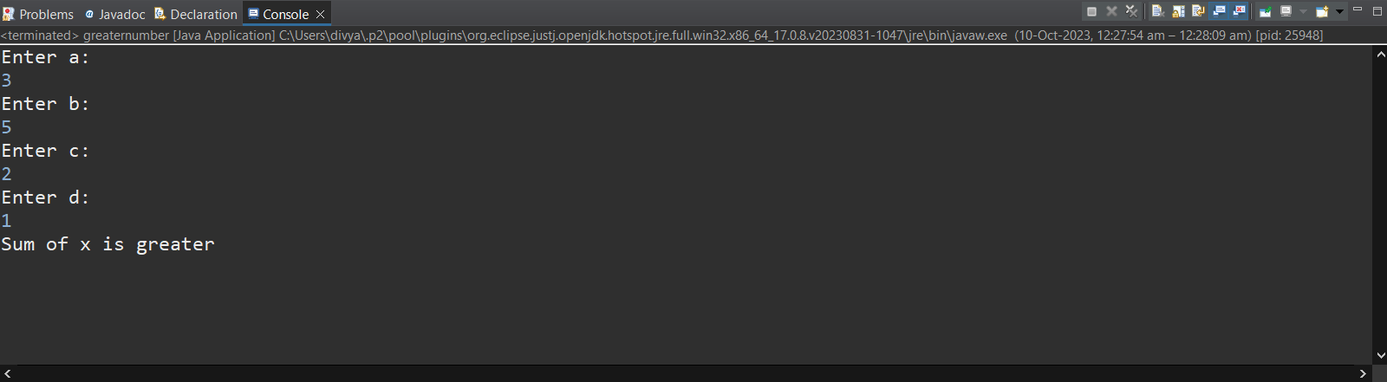

2. To find Even number

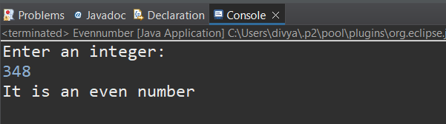.

3.To Print characters from A-Z

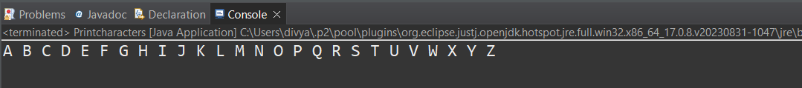

4.Swapping of two numbers

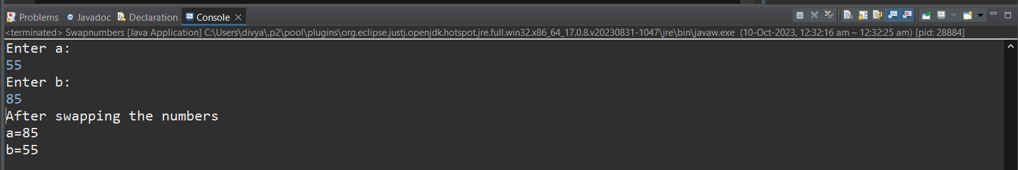

5. To find prime number

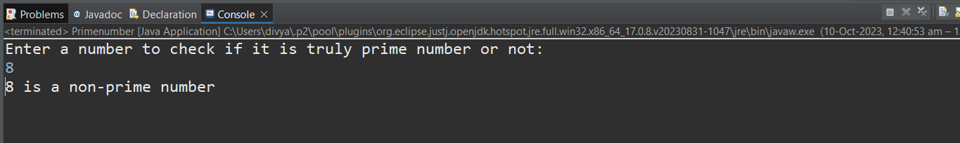

6. Factorial of the given number

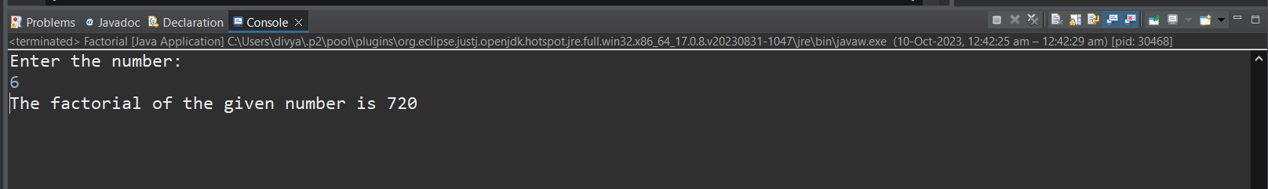

7. Length of the string



8.Print the characters 10 times

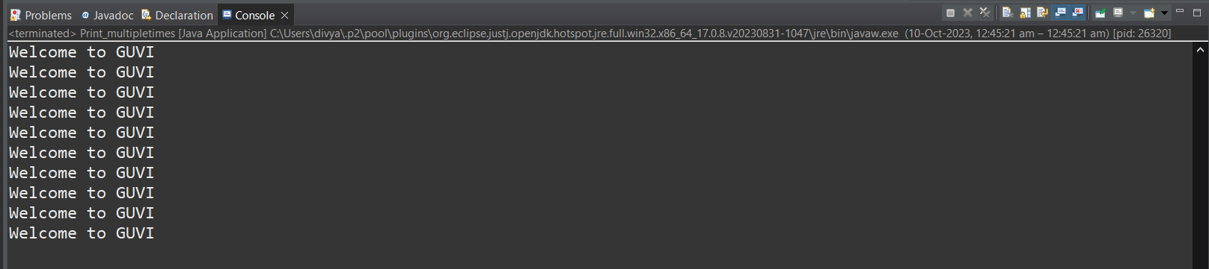

9. Identifying Senior citizen

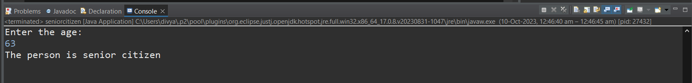

10.Count number of digits in the integer

