CRICKET HIGHLIGHT PROJECT

Feature | T20 Cricket (Twenty20) | ODI Cricket (One Day International) | Test Cricket
Meaning | 20 overs per side | 50 overs per side | No fixed overs
Balls per Over | 6 balls | 6 balls | 6 balls
Total Balls per Team | 120 balls | 300 balls | No limit
Match Duration | 3–4 hours | 7–8 hours | Up to 5 days
Innings per Team | 1 innings | 1 innings | 2 innings
Game Style | Fast, aggressive, entertaining | Balanced (attack + patience) | Slow, strategic, endurance-based
Player Approach | Power hitting, quick wickets | Strategy + consistency | Technique, patience, stamina
Result Types | Win/Loss/Tie | Win/Loss/Tie/No result | Win/Loss/Draw/Tie
Main Focus | Entertainment, high scoring | Strategy and planning | Skill, consistency, mental strength
Famous Tournaments | T20 World Cup, IPL | Cricket World Cup | Test Championships
Key Features | Short duration, high excitement | Medium length, balanced gameplay | Long duration, purest form

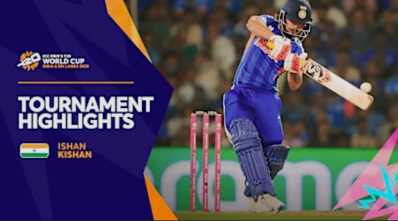
CASE STUDY:

To determine the highlights of the T20 match

OBJECTIVE:

- To determine the most exciting and important moments of a cricket match and generate highlights automatically according to the selected criteria.

SYSTEM ARCHITECTURE (3-LAYER MODEL)

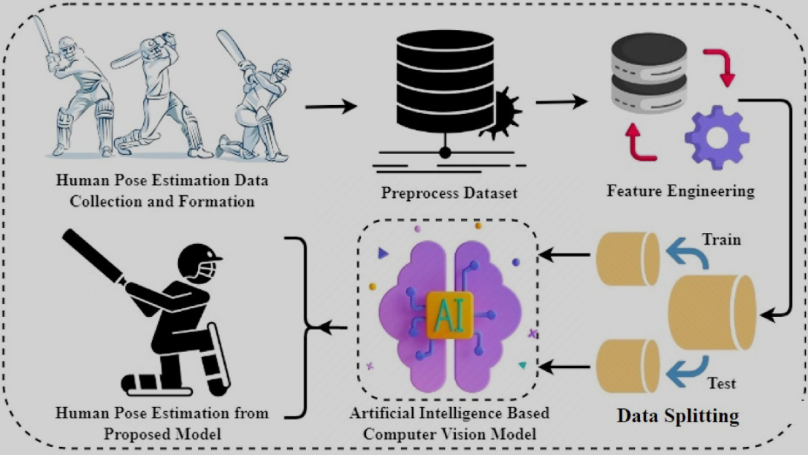
- Field Layer
- Transport Layer (Networking Layer)
- Backend Layer (AI + Rule Engine)

2.1 Field Layer

- Known as the data acquisition layer
- C + Embedded Systems

Components:
- Cameras (Ball tracking / player detection)
- Audio Sensors (crowd noise detection)
- IoT / Embedded Devices (ESP8266 / Microcontroller)
- Edge Processor (C-based logic)

Data Captured:
- Ball number (over, ball)
- Runs scored
- Event type (six, four, wicket)
- Player info (batsman, bowler)
- Crowd intensity
- Shot quality
- Pressure level

Embedded Logic (C):
- Event detection (e.g., boundary, wicket)
- Basic filtering (remove noise data)
- Packet formation

2.2 Transport Layer

- Known as the Networking layer
- Network + Data Link Layer

Purpose:
Transmit match data from field → backend

Functions:
- Data transmission
- Packet validation
- Error handling
- Real-time streaming
Protocols:
- MQTT (lightweight IoT communication)
- TCP/IP (reliable transfer)
- RTP (video streaming)
Flow:
Sensors Edge Devices Gateway Cloud Server

2.3.1 Backend Layer

Purpose:
Process data and generate highlights intelligently

Modules:

1Data Ingestion Module
- Accepts:
  - JSON / CSV / Excel (as seen in your UI )
- Validates and normalizes data

2️Feature Extraction
Extract:
- Event type
- Pressure score
- Crowd emotion
- Shot quality
- Milestones (50, 100, etc.)

AI Highlight Scoring Engine

Scoring Example:
- Six → +40
- Four → +30
- Wicket → +38
- Milestone → +50 to +65
- Pressure → weighted
- Crowd → emotional boost
- Turning point → +20
Final Score = Event + Pressure + Emotion + Skill + Context

2.3.2 Frontend Layer

Features:
- Upload data (Excel / CSV / JSON)
- Manual entry
- Highlight criteria selection
- Threshold tuning
- Visualization:
  - Highlight cards
  - Stats dashboard
  - Match info

End-to-end data flow:
Proposed Method:

Field Layer
↓
Sensors + Embedded (C)
↓
Structured Match Data
↓
Transport Layer
↓
MQTT / HTTP / WiFi
↓
Cloud Backend
↓
Backend Layer
↓
AI Scoring Engine
↓
Highlight Selection
↓
Frontend UI
↓
Highlight Display + Export

HIGHLIGHT CRITERIA USED:
The system checks these selected criteria:
- Sixes (P1)
- Fours (P1)
- Wickets (P1)
- Milestones (P3)
- High Pressure
- Crowd Emotion
- Shot Quality
- Turning Points

Minimum Highlight Score
- Threshold = 49
Only deliveries with score ≥ 49 are marked as highlights.

EXAMPLE:
T20 Match Analysis: The system processes all 72 deliveries.

For each ball:

Read delivery details from Excel
Check event type (four/six/wicket/normal)
Add score for pressure, crowd, shot quality, turning point, milestone
Compare with threshold (49)
If score ≥ 49 → mark as highlight

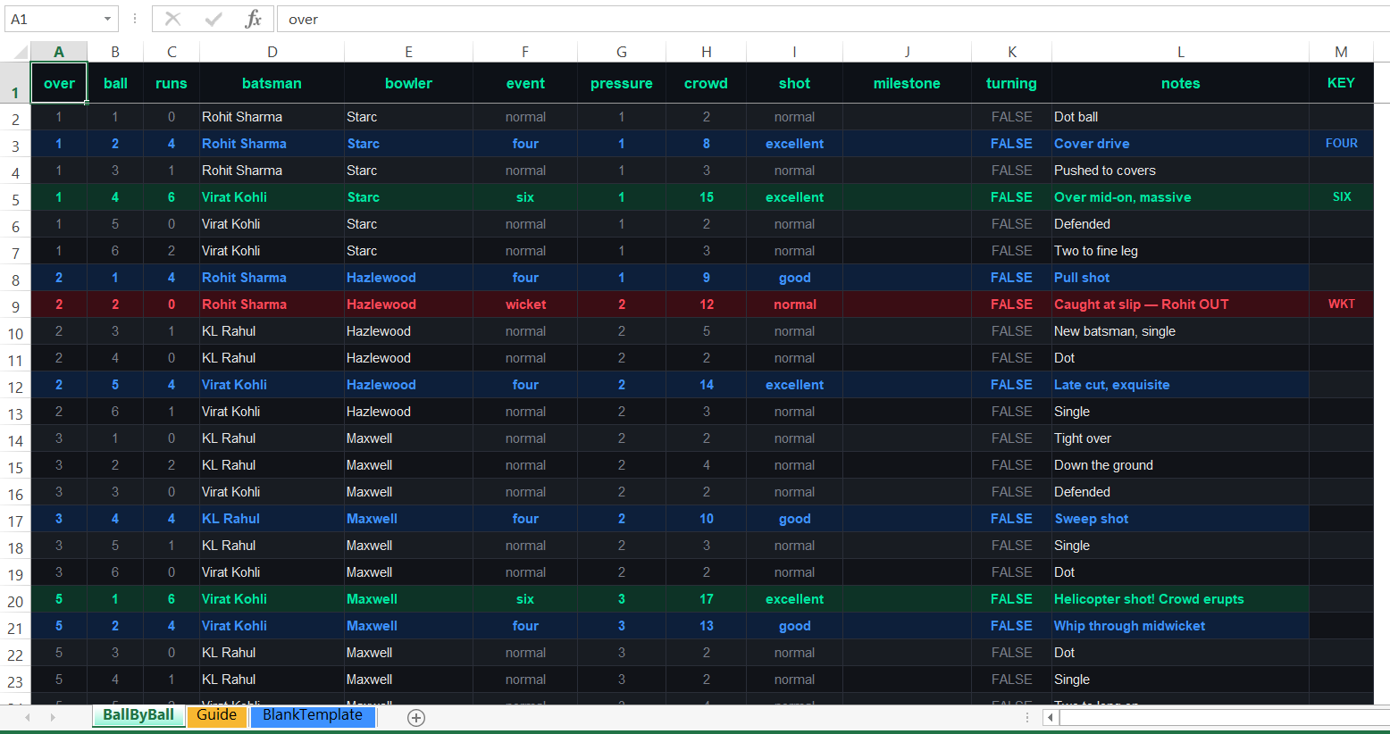

OUTPUT OBSERVED:

Category Breakdown
Sixes: 11 clips (48%)
Boundaries: 6 clips (26%)
Wickets: 3 clips (13%)
Milestones: 2 clips (9%)
Winning Moment: 1 clip (4%)

Top Highlight:
16.2 – CENTURY! Stadium on fire!
Score = 100
Pressure Highlights:
9 moments with pressure ≥ 8
Average Highlight Score:
77
Estimated Highlight Reel Duration:
4 min 36 sec
(assuming 12 sec per clip)

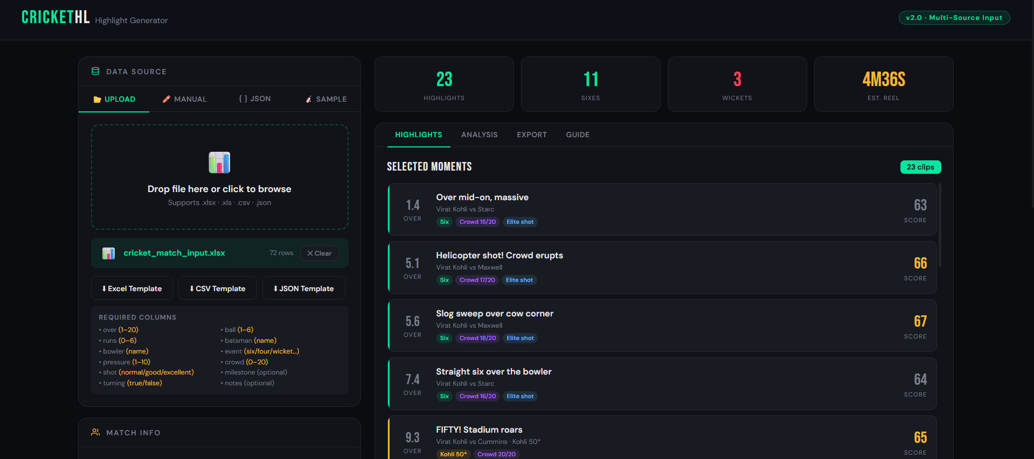

Interpretation
This shows the system is working correctly because:
- Big events like sixes, wickets, and milestones are selected
- Pressure situations are also considered
- Turning points increase importance
- Crowd excitement improves realism
- Final highlights are not random — they are score-based

4 layer Architecture
The AI Powered Cricket Highlight Generator is a smart system designed to automatically identify and generate key moments from a cricket match. The system integrates embedded systems, networking, and artificial intelligence to process ball-by-ball data and produce highlight clips based on contextual importance such as milestones, pressure situations, and crowd reactions.
The architecture is divided into four major layers:
- Data Capture Layer
- Real-Time Processing & AI Layer
- Network & Infrastructure Layer
- Viewer Engagement & Output Layer

1. Data Capture Layer

Current Implementation
In the current system, the data capture layer is simulated using structured input formats:
- JSON input (ball-by-ball data)
- CSV / Excel upload
- Manual entry through HTML interface
Each data entry contains:
- Over, ball number
- Runs scored
- Batsman and bowler
- Event type (six, four, wicket, etc.)
- Pressure level
- Crowd intensity
- Shot quality
- Milestone (optional)
- Turning point flag
This structured data acts as a digital representation of real match events, replacing physical sensors.

How It Works
- The HTML interface allows users to input or upload match data
- The system validates required fields (over, ball, runs, etc.)
- Data is normalized into a standard format (JSON objects)

Future Enhancements
- Integration with computer vision systems for automatic event detection
- Use of audio sensors to capture crowd excitement
- Real-time data capture using IoT devices and embedded systems (ESP8266, Raspberry Pi)
- Direct integration with live cricket APIs or broadcast feeds

2. Real-Time Processing & AI Layer

Current Implementation
The system currently uses a rule-based AI scoring engine implemented in JavaScript (within the HTML application).

Working Mechanism
- Each ball is assigned a highlight score based on predefined criteria:
  - Six → +40
  - Four → +30
  - Wicket → +38
  - Milestone → +50 to +65
  - Pressure → Weighted score
  - Crowd emotion → Bonus score
  - Shot quality → Additional score
  - Turning point → +20
- Final Score Calculation:
- Highlight Score = Event + Pressure + Emotion + Skill + Context
- Events exceeding a threshold (e.g., 50) are selected as highlights
- Highlights are ranked and sorted based on importance

Special Feature
- Player milestone detection ensures key achievements (50, 100 runs) are always highlighted

Future Enhancements
- Replace rule-based system with Machine Learning models
  - Supervised learning using historical match data
  - Deep learning for video-based highlight detection
- Use of Natural Language Processing (NLP) for commentary analysis
- Predictive analytics for anticipating key moments

3. Network & Infrastructure Layer

Current Implementation
- The system operates as a web-based standalone application
- Data flow is local:
  - Input → Browser → Processing → Output
- No real-time networking is currently implemented

How It Works
- Users upload files or input JSON data
- Processing happens entirely within the browser (client-side)
- No external server communication is required

Future Enhancements
- Integration with cloud platforms (AWS, Azure, Firebase)
- Real-time streaming using:
  - MQTT protocol
  - WebSockets
- Deployment of backend APIs using Python (Flask/Django)
- Scalable infrastructure for handling live match data streams

4. Viewer Engagement & Output Layer

Current Implementation
The system provides an interactive HTML-based user interface with the following features:
- Highlight cards displaying key events
- Match statistics (total highlights, sixes, wickets)
- Data preview table
- Threshold-based filtering
- Export options (JSON, CSV, Excel)

User Interaction
- Users can select highlight criteria
- Adjust threshold values dynamically
- View ranked highlights in real time
- Export processed results

Output Generated
- Structured highlight list
- Ranked moments based on importance
- Match insights and statistics

Future Enhancements
- Integration with video clipping tools to generate actual highlight reels
- Mobile app for real-time notifications
- Personalized highlights based on user preferences
- Social media integration for instant sharing
- Dashboard with advanced analytics and visualizations
