Smart Automatic Toll Gate system
Using Arduino



ECI215A- Internship
by

Sl. No. | Reg. No. | Student Name | Department
1. | 24ETEC004009 | Divyashree | Electronics and Communication Engineering

Industrial Supervisor:M. Harsha G
Place of work: Cranes Varsity
Date of Submission: 25-05-2026

B-Tech 2024
Faculty of ENGINEERING AND TECHNOLOGY
Ramaiah University of Applied Sciences

Declaration

I hereby declare that this internship report title “ Smart Automatic Gate System using Arduino” is an original work completed by me and has not been submitted elsewhere for any academic purpose.
Signature:
Name:
Date:

Acknowledgements
I would like to express my sincere gratitude to Cranes Varsity for providing me with the opportunity to undergo this internship and gain practical exposure in the field of embedded systems and automation. The internship helped me improve my technical knowledge and understand the real-time implementation of Arduino-based projects. I am thankful to the organization for providing a supportive learning environment and valuable guidance throughout the internship period.
I would also like to thank my supervisor and mentors for their continuous support, encouragement, and technical guidance during the development of the “Smart Automatic Gate System” project. Their suggestions and motivation helped me successfully complete the project. I am equally grateful to Ramaiah University of Applied Sciences, Faculty of Engineering and Technology, for encouraging students to participate in internships and practical learning activities. Finally, I thank my friends and teammates for their cooperation and support throughout the internship journey.

Contents
Certificate
1. Introduction
2. Organization Profile
3. Internship Objectives
4. Roles & Responsibilities
5. Tasks Completed
6. Skills & Knowledge Gained
7. Challenges Faced
8. Key Learnings
9. Conclusion
10. Appendix

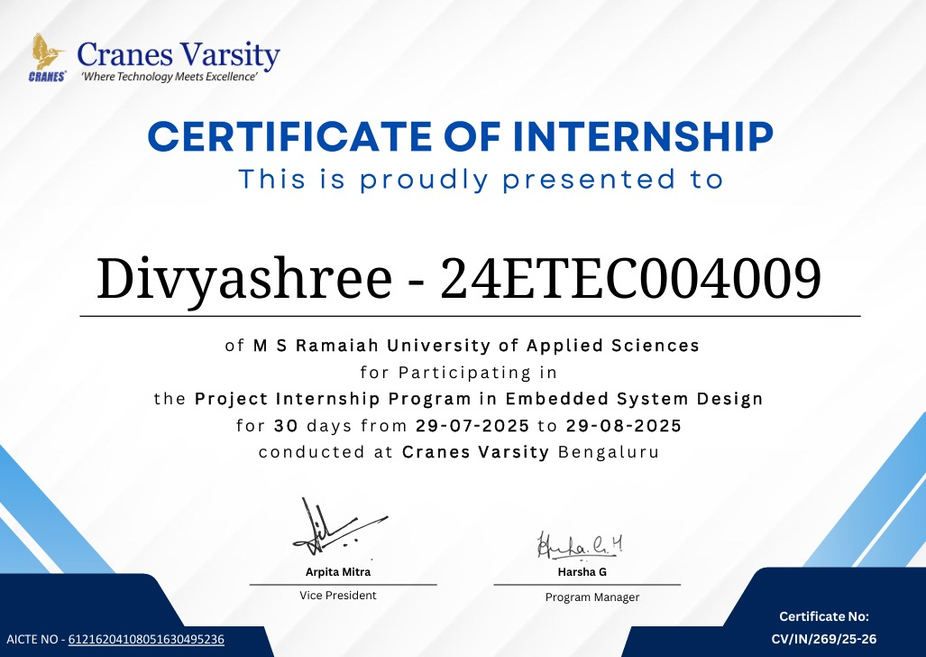

1. Introduction
During my internship at Cranes Varsity, I had the opportunity to work on a project titled Smart Automatic Gate System using Arduino. The primary aim of this internship was to bridge the gap between classroom learning and real-world applications by engaging in a hands-on embedded systems project. I chose Cranes Varsity because of its strong reputation in embedded systems training and its emphasis on practical, industry-oriented projects.
The internship spanned for 30 days starting from 29-07-2025 to 29-08-2025, during which I was placed in the Embedded Systems department. My role involved designing, programming, and testing an automation system that could control gate movement using sensors and motors. The project was highly relevant to current industry trends, as automation and IoT are increasingly being adopted in residential, commercial, and industrial spaces.
This introduction sets the context for the report by explaining the background of the internship, the motivation behind choosing the organization, and the scope of the project undertaken.

2. Organization Profile

Overview of the Organization
During my internship at Cranes Varsity, I observed that the organization focuses on providing practical technical training in electronics, embedded systems, robotics, IoT, and automation technologies. The institution helps students gain real-time experience through hands-on projects, workshops, and internship programs. It provides a good learning environment where students can improve both technical and practical skills required for industry applications.

Vision
The vision of Cranes Varsity is to provide quality technical education and encourage innovation through practical learning and real-time project development.

Mission
- To bridge the gap between theoretical and practical knowledge.
- To provide hands-on experience in embedded systems and automation.
- To improve technical and problem-solving skills among students.
- To encourage innovation and creativity through projects and experiments.

Values
- Practical learning approach
- Innovation and creativity
- Teamwork and collaboration
- Technical excellence

Key Products
During the internship, I learned that Cranes Varsity provides several technical services and training programs such as:
- Embedded systems and Arduino training
- Robotics and automation projects
- IoT-based applications
- Sensor interfacing and microcontroller programming
- Internship and workshop programs
- Real-time project guidance for students

Organizational Structure
- The institution is structured into training divisions, project development teams, and research support units. Each division works cohesively to provide students with exposure to both theoretical and practical aspects of technology.
By working at Cranes Varsity, I was able to gain insights into how training institutions collaborate with industries to prepare students for real-world challenges.

3. Internship Objectives
The internship was carried out with the aim of improving practical knowledge and technical skills in the field of embedded systems and automation. Through the development of the “Smart Automatic Gate System” project, valuable experience was gained in both hardware and software implementation.
The internship provided an opportunity to work on real-time applications using Arduino, sensors, and servo motors. It helped in understanding how automation systems function in practical environments and how electronic components are integrated to create smart systems.
Practical skills such as Arduino programming, circuit connections, sensor interfacing, testing, and debugging were improved during the internship period. The project also enhanced problem-solving abilities and technical confidence while working with embedded systems.
In addition to technical learning, the internship helped in understanding workplace practices such as project planning, teamwork, communication, time management, and documentation. Interaction with mentors and fellow interns improved coordination skills and teamwork abilities throughout the project development process.

4. Roles & Responsibilities

During the internship, the following responsibilities were carried out:
- Studied the working principle of ultrasonic sensors.
- Learned Arduino IDE installation and programming.
- Connected servo motor with Arduino board.
- Designed the gate mechanism prototype.
- Wrote and tested Arduino programs.
- Performed circuit assembly and debugging.
- Tested sensor detection accuracy.
- Prepared project documentation and presentation.

Tools and Components Used
- Arduino UNO
- Servo Motor
- Ultrasonic Sensor (HC-SR04)
- Jumper Wires
- Breadboard
- LEDs
- USB Cable
- Arduino IDE Software

5. Tasks Completed

Understanding Arduino Programming
Initially, basic Arduino programs such as LED blinking and servo rotation were implemented to understand input and output operations.

Sensor Interfacing
The ultrasonic sensor was connected with the Arduino board to detect nearby objects and measure distance.

Servo Motor Control
The servo motor was programmed to rotate automatically whenever the sensor detected an object within a specified range.

Gate Automation
The servo motor was attached to a miniature gate model. The gate opened automatically when a vehicle approached and closed after a few seconds.

Testing and Debugging
The project was tested multiple times to improve accuracy and reduce detection errors. Wiring issues and coding errors were corrected during this stage.

These responsibilities provided me with a holistic understanding of how embedded systems projects are executed in a professional environment.

6. Skills & Knowledge Gained

Technical Skills
- Arduino Programming: Learned how to write, compile, and upload code using the Arduino IDE. Gained confidence in handling sensor inputs and motor outputs through embedded C programming.
- Sensor Integration: Acquired hands-on experience in connecting and calibrating ultrasonic sensors for accurate distance measurement and object detection.
- Motor Control: Understood the working of servo motors and motor driver circuits, and successfully implemented them for gate automation.
- Circuit Design and Testing: Improved knowledge of wiring, power supply management, and troubleshooting electronic circuits.
- Debugging Techniques: Developed systematic approaches to identify and fix logical errors in code and hardware misalignments.

Knowledge Gained
- Embedded Systems Concepts: Strengthened my understanding of microcontroller-based systems and their applications in real-world automation.
- Hardware-Software Integration: Learned the importance of synchronizing hardware components with software logic for reliable system performance.
- Project Workflow: Gained insights into how projects are planned, executed, tested, and documented in a professional environment.
- Problem-Solving: Learned to approach technical challenges such as sensor calibration and motor alignment with patience and creativity.
- Documentation Standards: Understood the importance of maintaining clear records of project progress, code snippets, and circuit diagrams for future reference.

7. Challenges Faced

Incorrect Sensor Readings
Sometimes the ultrasonic sensor gave unstable readings due to improper object positioning.

Solution: Sensor calibration and proper alignment were performed to improve accuracy.

Servo Motor Jitter
The servo motor occasionally vibrated due to unstable power supply.

Solution: Connections were tightened and stable power was provided.

Coding Errors
Minor syntax and logic errors occurred during programming.

Solution: The code was debugged step-by-step using Arduino IDE serial monitor.

Circuit Connection Issues
Loose jumper wire connections caused interruptions in the working of the system.

Solution: All circuit connections were rechecked and assembled properly to ensure smooth operation.

Synchronization of Hardware and Software
Initially, the sensor detection and gate movement were not properly synchronized.

Solution: The delay timings and control logic in the program were modified and tested repeatedly until proper synchronization was achieved.

8. Key Learnings

Gained practical knowledge of embedded systems and automation.
- Learned Arduino programming and hardware interfacing techniques.
- Understood the working of ultrasonic sensors and servo motors.
- Improved circuit assembly and troubleshooting skills.
- Learned how to test and debug hardware and software errors.
- Developed problem-solving and analytical thinking abilities.
- Understood the importance of teamwork and communication during project development.
- Gained confidence in working on real-time automation projects.
- Learned project documentation and presentation techniques.
- Improved time management and technical skills through practical implementation.

9. Conclusion

The internship was a valuable learning experience that provided practical exposure to embedded systems, automation, and Arduino-based applications. Through the development of the “Smart Automatic Toll Gate System” project, knowledge was gained in Arduino programming, sensor interfacing, servo motor control, circuit assembly, testing, and debugging.
The project was successfully designed to detect vehicles using an ultrasonic sensor and automatically control the toll gate barrier using a servo motor. This helped in understanding the real-time implementation of automation systems and the integration of hardware with software.
The internship also improved technical knowledge, problem-solving abilities, teamwork, communication skills, and confidence in handling practical engineering projects. Overall, the experience was highly beneficial for academic growth and future career development in the field of electronics, embedded systems, and automation technologies.

10. Appendix

- Code:
#include <Servo.h>
Servo servo;
int trigPin = 11;
int echoPin = 12;
// defines variables
Long duration;
int distance
void setup()
{
servo.attach(13);
servo.write(180);
delay(2000);
// Sets the trigPin as an Output
pinMode(trigPin, OUTPUT);
// Sets the echoPin as an Input
pinMode(echoPin, INPUT);
}
void loop()
{
// Clears the trigPin
digitalWrite(trigPin, LOW);
delayMicroseconds(2);
// Sets the trigPin on HIGH state for 10 micro seconds
digitalWrite(trigPin, HIGH);
delayMicroseconds(10);
digitalWrite(trigPin, LOW);
// Reads the echoPin, returns the sound wave travel time in microseconds
duration = pulseIn(echoPin, HIGH);
// Calculating the distance
distance= duration*0.034/2;
// Prints the distance on the Serial Monitor
Serial.print("Distance: ");
Serial.println(distance);
if ( distance <= 25 ) // Change Distance according to Ultrasonic Sensor Placement
{
servo.write(180);
delay(3000);
}
Else
{
servo.write(90);
}
}

2)Circuit Diagram and Connections
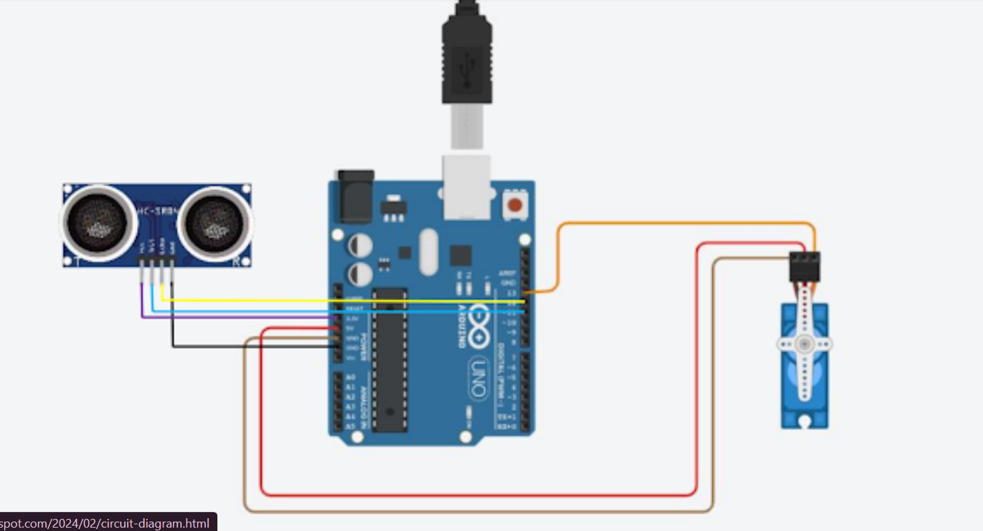
Ultrasonic Sensor (HC-SR04):
- VCC → 5V pin of Arduino Uno
- GND → GND pin of Arduino Uno
- Trig → Digital Pin 9 of Arduino Uno
- Echo → Digital Pin 10 of Arduino Uno
Servo Motor:
- Signal (Orange/Yellow) → Digital Pin 6 of Arduino Uno
- VCC (Red) → 5V pin of Arduino Uno
- GND (Brown/Black) → GND pin of Arduino Uno
Arduino Uno:
- Powered via USB cable connected to computer (for programming and power supply).

3)Smart Toll Gate System Using Arduino

