**Write a program to implement word count using Pig.**

**1.Create a file (Sample.txt) in the local file system.**

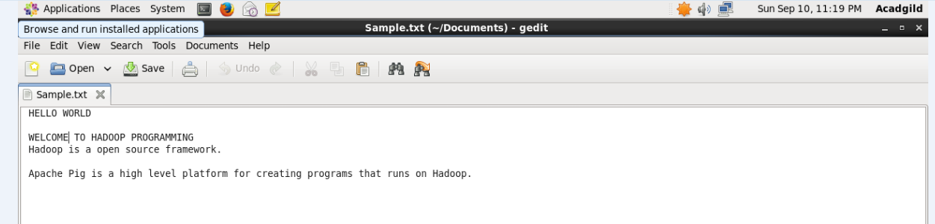

**2. Create a file (Wordcount.pig) in the local file system.**

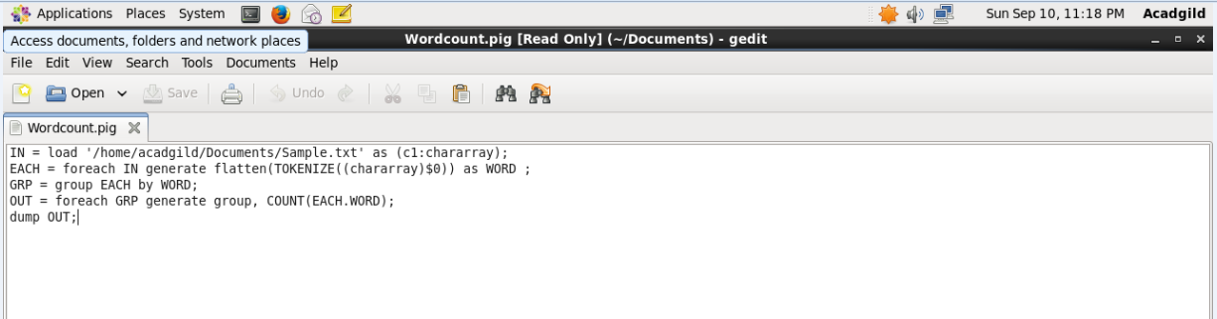

**3. Execute the file using the following command**

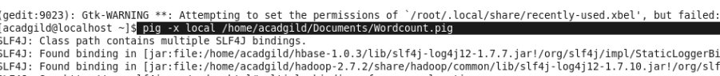

**Output:**

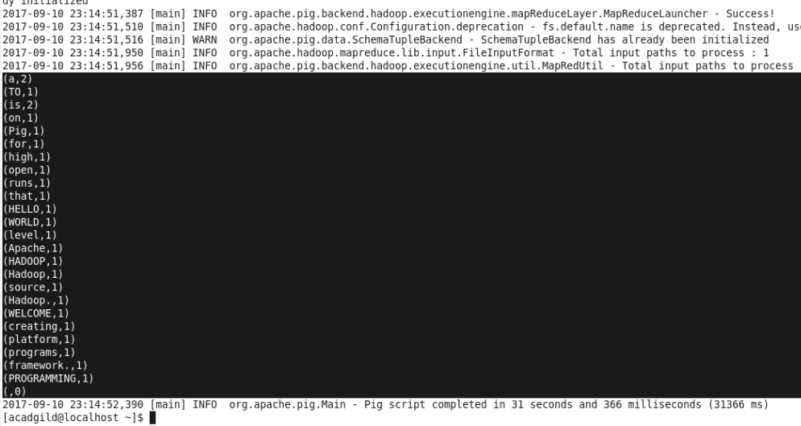

**Note**: To run in mapreduce mode .Move the file into hdfs and use

Pig –x mapreduce or pig command.