**Assignment-5.1**

1. **(a) Top 5 employees (employee id and employee name) with highest rating. (In case two employees have same rating, employee with name coming first in dictionary should get preference)**

**Sol:**

A = LOAD ‘/home/acadgild/Downloads/emp_det.txt’ USING PigStorage(‘,’) AS (no:int, name:chararray, sal:int, rating:int);

B= order A by rating DESC, name;

C = limit B 5;

DUMP C;

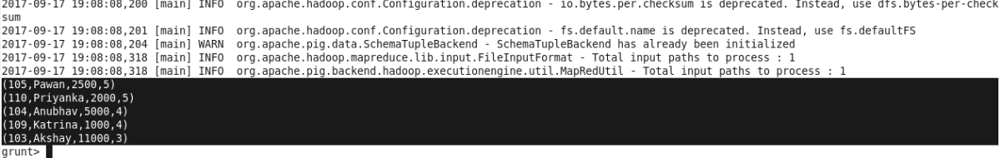

**2.(b) Top 3 employees (employee id and employee name) with highest salary, whose employee id is an odd number. (In case two employees have same salary, employee with name coming first in dictionary should get preference)**

**Sol:**

A = LOAD ‘‘/home/acadgild/Downloads/emp_det.txt’ USING PigStorage(‘,’) AS (no:int, name:chararray, sal:int, rating:int);

B = FILTER A by (no%2!=0);

C = ORDER B by sal DESC,name;

D = LIMIT C 3;

DUMP D;

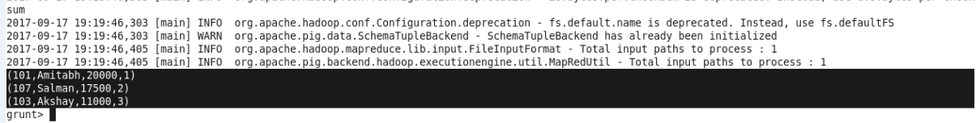

**3. (c) Employee (employee id and employee name) with maximum expense (In case two employees have same expense, employee with name coming first in dictionary should get preference)**

**Sol:**

A = LOAD ‘/home/acadgild/Downloads/emp_det.txt’ USING PigStorage(‘,’) AS (no:int, name:chararray, sal:int, rating:int);

B = LOAD ‘home/acadgild/Downloads/emp_exp.txt’ AS (no:int , expense :int);

Join_AB = JOIN A by no, B by no;

C = FOREACH Join_AB generate A::no, A::name, B::expense;

D = GROUP C by (no,name);

E = FOREACH D generate group, SUM(C.B::expense) as sum;

F = ORDER E by sum DESC;

G = LIMIT F 1;

F = FOREACH G generate FLATTEN(group);

DUMP F;

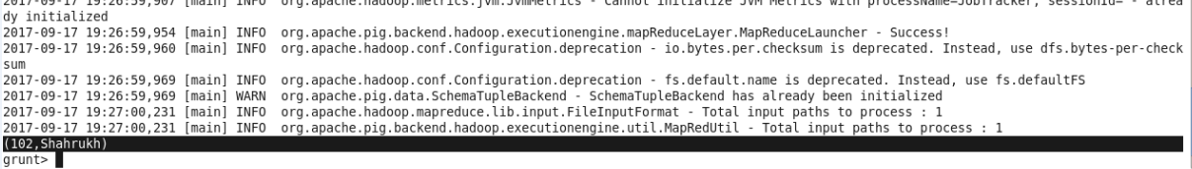

**4.( d) List of employees (employee id and employee name) having entries in employee_expenses file.**

**Sol:**

A = LOAD ‘/home/acadgild/Downloads/emp_det.txt’ USING PigStorage(‘,’) AS (no:int, name:chararray, sal:int, rating:int);

B = LOAD ‘/home/acadgild/Downloads/emp_exp.txt’ AS (no:int , expense :int);

Join_AB = JOIN A by no, B by no;

C = FOREACH Join_AB generate A::no, A::name;

D = DISTINCT C;

DUMP D;

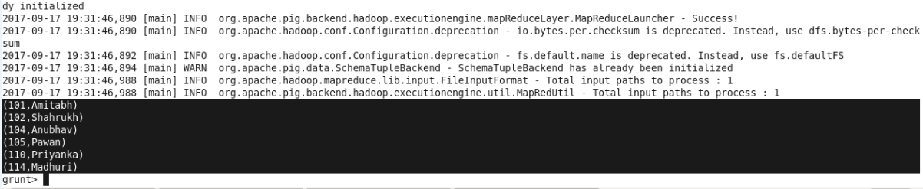

1. **(e) List of employees (employee id and employee name) having no entry in employee_expenses file.**

**Sol :**

A = LOAD ‘/home/acadgild/Downloads/emp_det.txt’’ USING PigStorage(‘,’) AS (no:int, name:chararray, sal:int, rating:int);

B = LOAD ‘/home/acadgild/Downloads/empexp.txt’ AS (no:int , expense :int);

Join_AB = JOIN A by no LEFT OUTER, B by no;

C = FILTER Join_AB by B::expense is NULL;

D = FOREACH C generate A::no, A::name;

DUMP D;

