**19.1_Assignment**

**Using Spark-sql:**

1. What are the total number of gold medal winners every year

Sol:

* Use the existing spark session and create SQLContext w.r.t sc.
* Import Sqlcontext.implicits(for registering Temptable)
* Load the data from local file system and registertemptable (for creating temptable)which can be used for writing queries using the same.

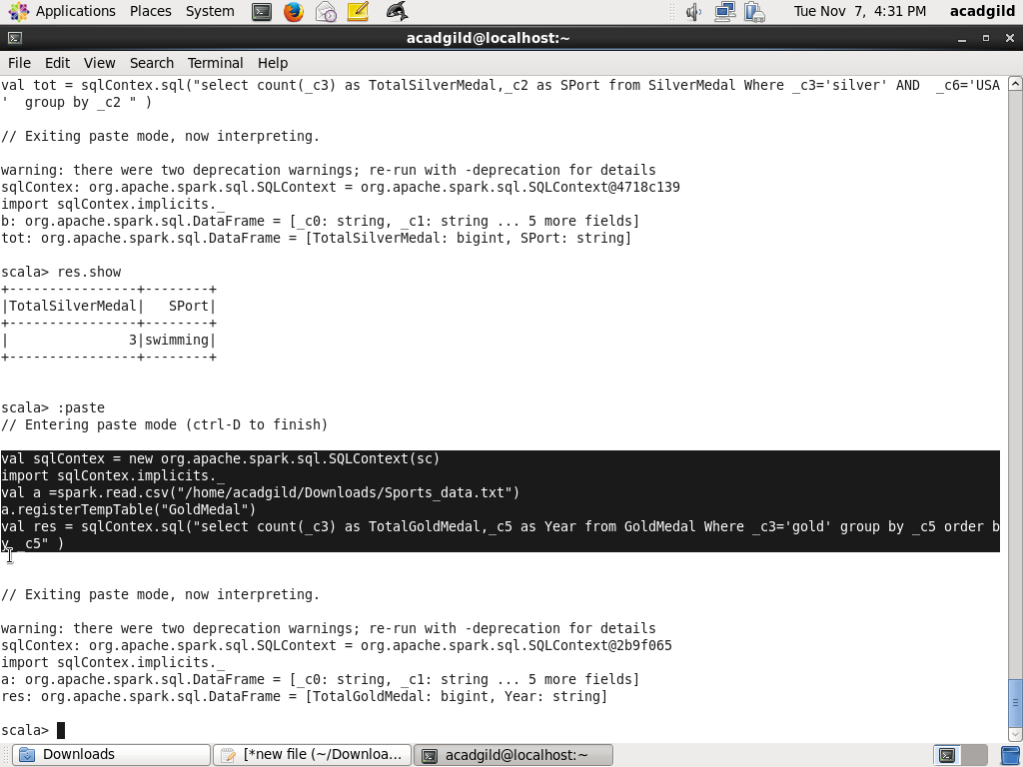

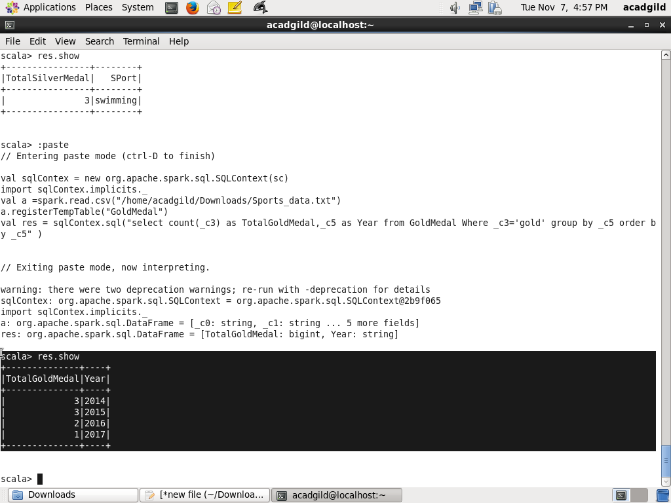

1. How many silver medals have been won by USA in each sport

Sol:

