**DAILY ONLINE ACTIVITIES SUMMARY**

|  |  |  |  |  |  |  |  |  |
| --- | --- | --- | --- | --- | --- | --- | --- | --- |
| **Date:** | **05/07/2020** | | | | | **Name:** | **Divyashree Naik** | |
| **Sem & Sec** | **8th sem A** | | | | | **USN:** | **4AL16CS034** | |
| **Online Test Summary** | | | | | | | | |
| **Subject** | | **---** | | | | | | |
| **Max. Marks** | | **---** | | **Score** | | | **---** | |
| **Certification Course Summary** | | | | | | | | |
| **Course** | **Java Programming** | | | | | | | |
| **Certificate Provider** | | | **Great Learning** | | **Duration** | | | **3.5 hrs** |
| **Coding Challenges** | | | | | | | | |
| **Problem Statement: C program to print digital clock with current time** | | | | | | | | |
| **Status: Complete** | | | | | | | | |
| **Uploaded the report in Github** | | | | | **Yes** | | | |
| **If yes Repository name** | | | | | **Alvas-Report** | | | |
| **Uploaded the report in slack** | | | | | **Yes** | | | |

**Online certification:**

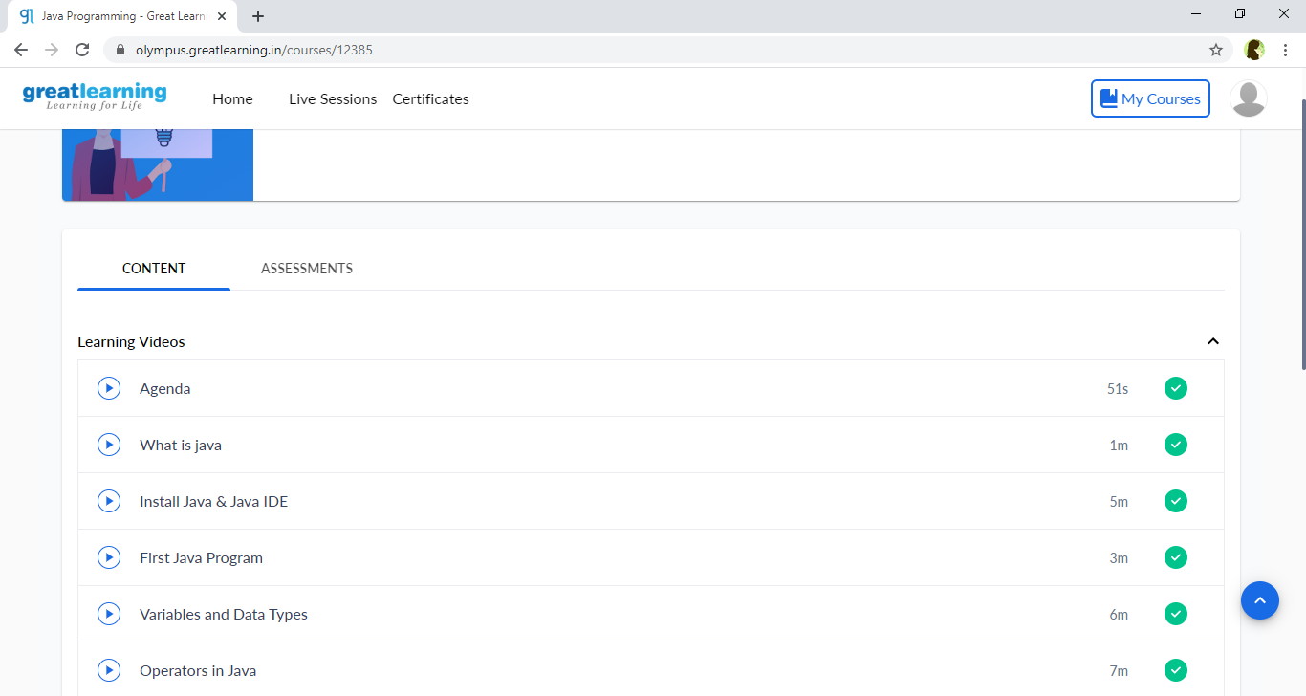

**Coding Challenge:**

