**Enhancing Stock Price Prediction: Unveiling the Power of Feature Engineering, Model Training, and Evaluation**

**Introduction:**

Welcome to the presentation on Enhancing Stock Price Prediction: Unveiling the Power of Feature Engineering, Model Training, and Evaluation. This presentation explores the key techniques and approaches to improve stock price prediction accuracy. We will delve into the importance of feature engineering, effective model training, and robust evaluation methodologies. Let's get started!

**Feature Engineering:**

Feature engineering plays a crucial role in stock price prediction. It involves transforming raw data into meaningful features that capture relevant information. Techniques like lagging indicators, moving averages, and technical analysis indicators can be employed to extract valuable insights from historical stock data.

Effective feature engineering enables models to learn and leverage patterns in the data for accurate predictions.

**Model Training:**

Model training is a critical step in stock price prediction. Various machine learning algorithms such as linear regression, random forest, and LSTM can be employed to train predictive models. The models learn from historical data and aim to capture underlying patterns and trends.

Proper parameter tuning, regularization techniques, and model selection are essential to optimize model performance.

**Evaluation Metrics:**

Evaluating the performance of stock price prediction models is crucial.

Common evaluation metrics include mean absolute error (MAE), root mean square error (RMSE), and mean absolute percentage error (MAPE).

These metrics help quantify the accuracy of predictions and assess the model's ability to capture stock price movements. A comprehensive evaluation framework ensures reliable and robust predictions.

**Advanced Techniques:**

In addition to feature engineering and model training, advanced techniques can further enhance stock price prediction. These techniques include ensemble learning, deep learning, and reinforcement learning.

Ensemble learning combines multiple models to improve prediction accuracy, while deep learning leverages neural networks for complex pattern recognition. Reinforcement learning enables models to learn optimal trading strategies.

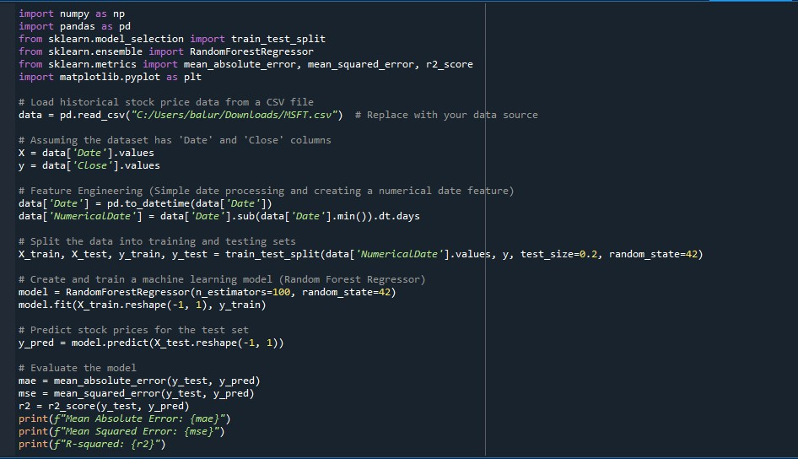

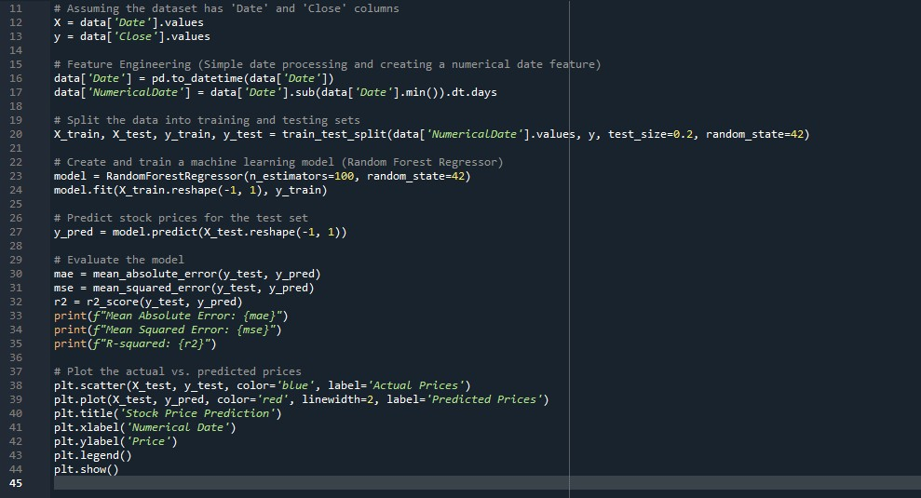

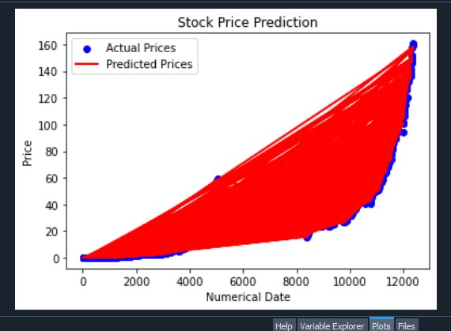

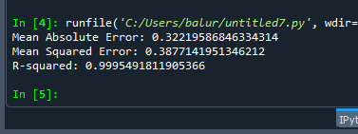

**Conclusion:**

In this presentation, we explored the power of feature engineering, model training, and evaluation in enhancing stock price prediction. Effective feature engineering helps capture relevant information, while proper model training optimizes predictive performance. Robust evaluation metrics ensure reliable predictions. By leveraging advanced techniques, we can further improve accuracy. Implementing these strategies can empower investors and financial professionals to make informed decisions.