Question 1: Library Book Management using Classes & Encapsulation
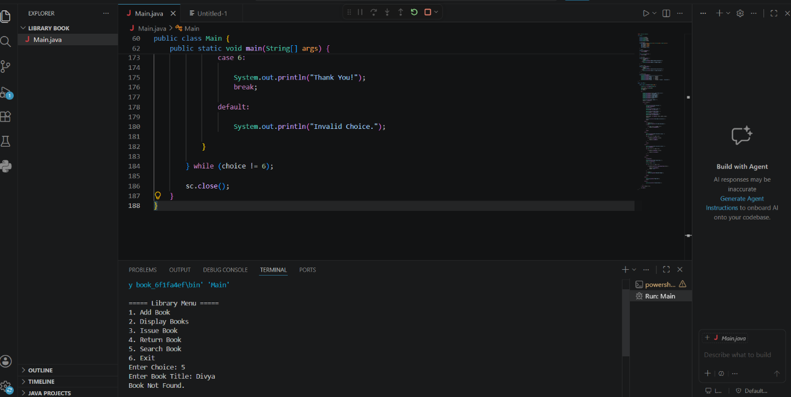

Question 2: Employee Payroll System using Inheritance
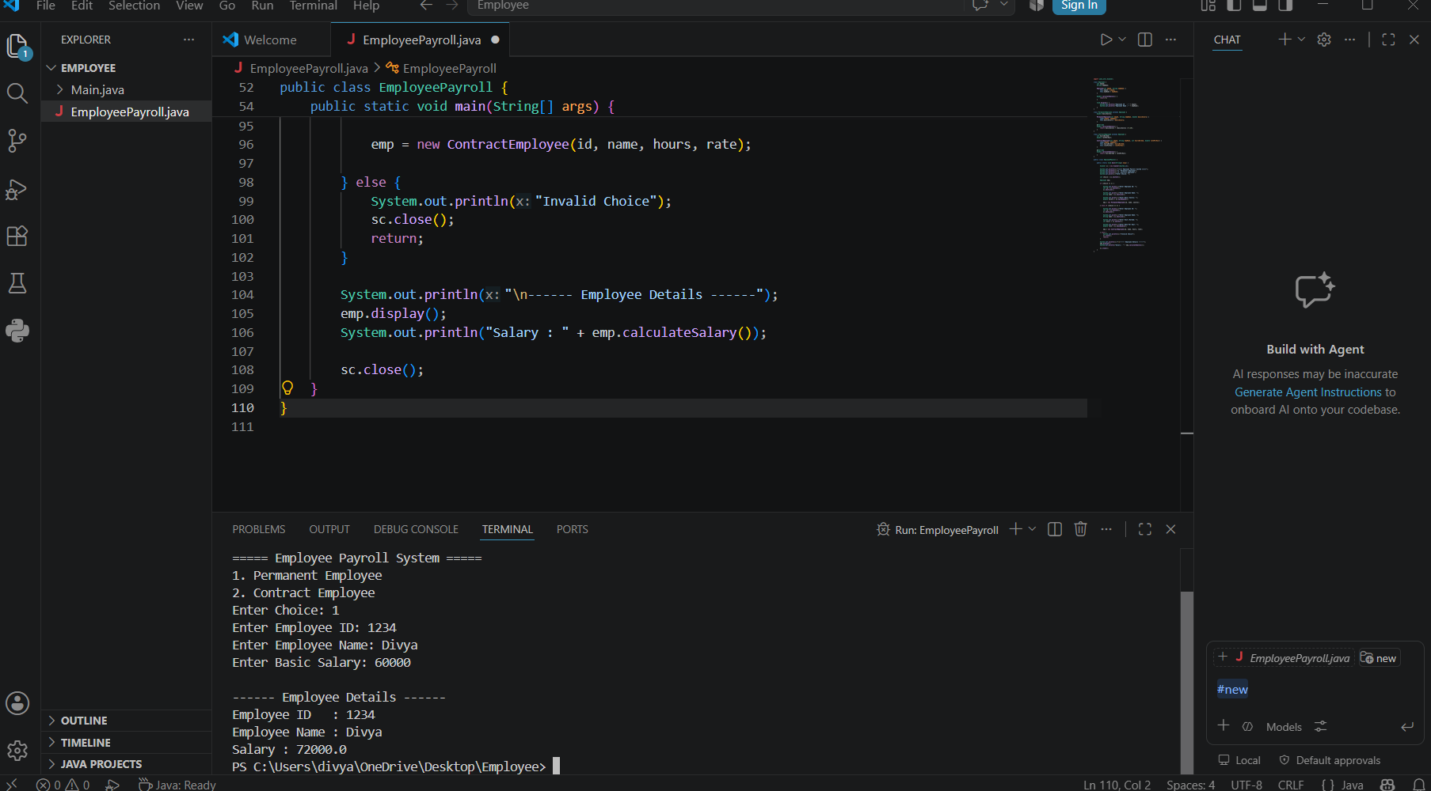

Question 3: Bank Account System using Data Hiding
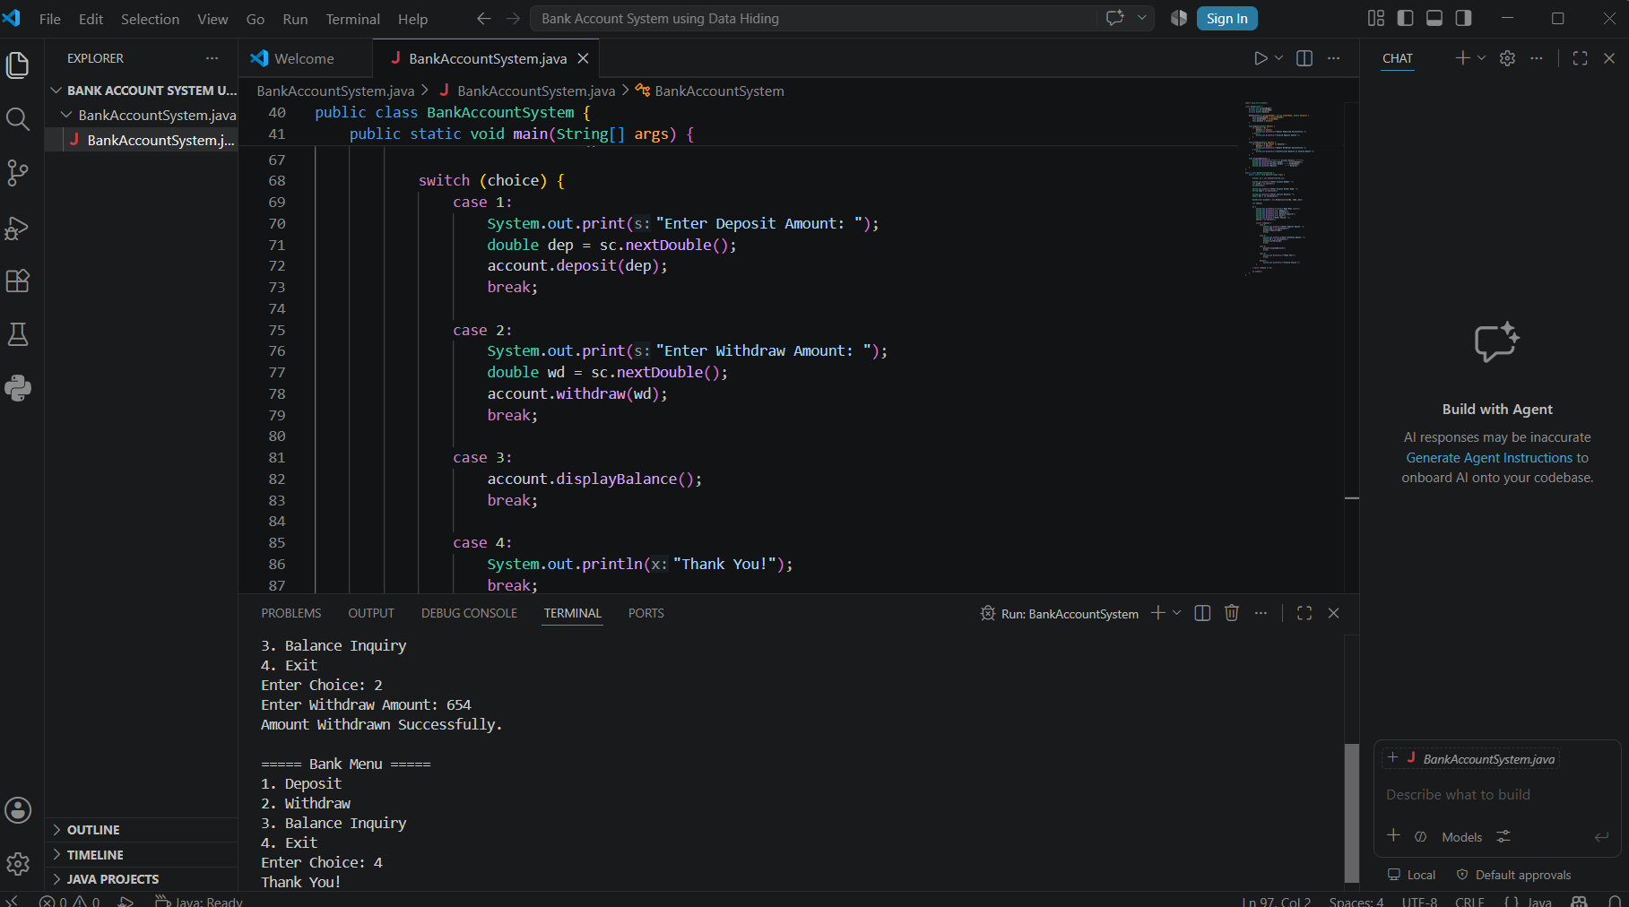

Question 4: University Admission System using Method Overloading
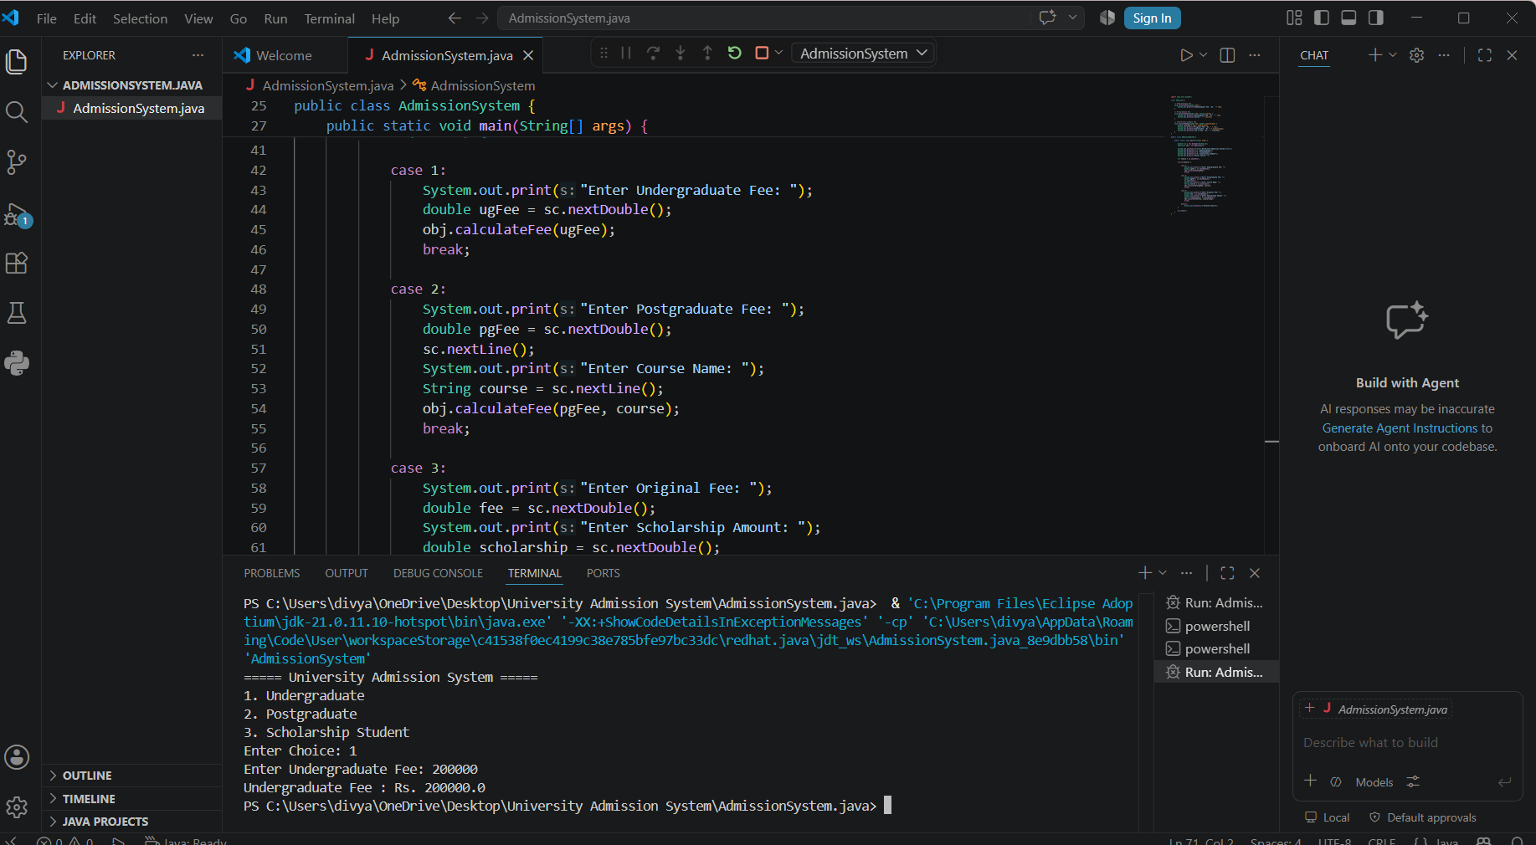

Question 5: Shape Area Calculator using Abstract Class & Polymorphism
