Assignment-6.3
Name: D. Divya Sri
HTNO:2303A51323
BTNO:19
Task 1: Classes – Student Class
Develop a Student class using AI assistance with attributes and a display method

.Prompt: #Generate a Python Student class with name, roll number, and branch. Include a method to display student details..
Code:
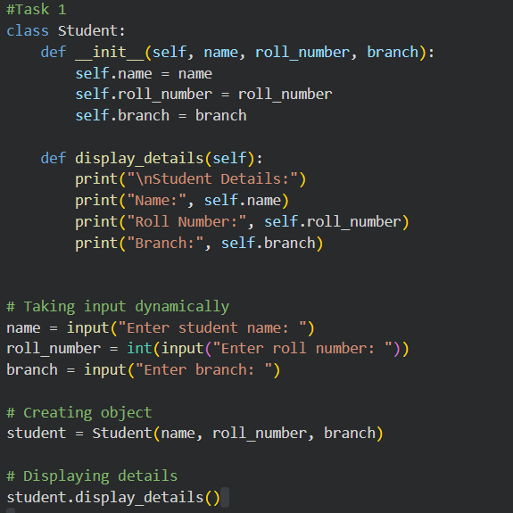
Result:
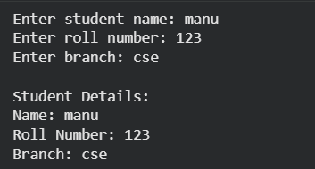
Observation:
The AI-generated class structure is clear and logically organized. The constructor correctly initializes attributes, and the display method outputs student details in a readable format. The code is simple, correct, and suitable for beginner-level object-oriented programming.

Task 2: Loops – Multiples of a Number. Generate code to print the first 10 multiples of a given number using different loop constructs.

Prompt: #Generate Python code to print the first 10 multiples of a number using a loop.
Code:
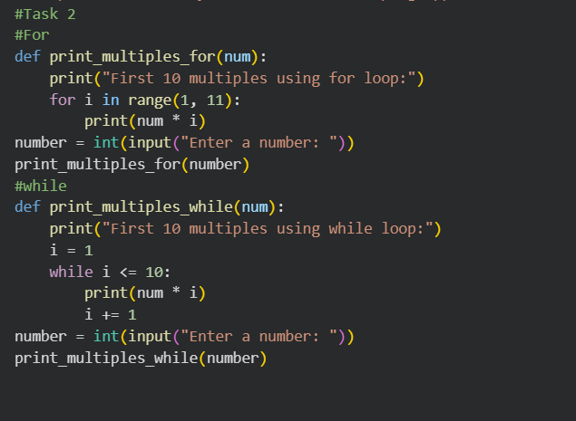
Result:
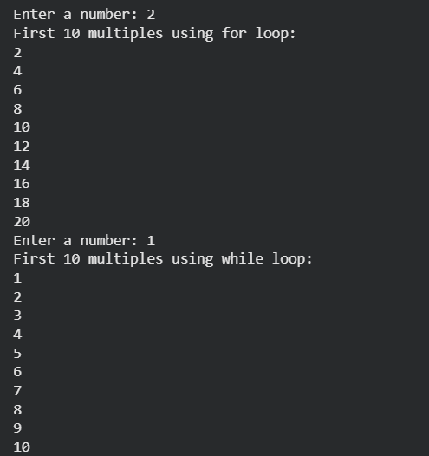
Observation:
Both loop implementations correctly generate the required output. The for-loop version is more concise and readable, while the while-loop version provides better insight into loop control and

iteration. AI suggestions for both approaches are correct and efficient.

Task 3: Conditional Statements – Age Classification. Classify a person’s age into categories
using conditional statements.
Prompt: # Generate Python code to classify age into child, teenager, adult, and senior using if-elif-else..
Code:
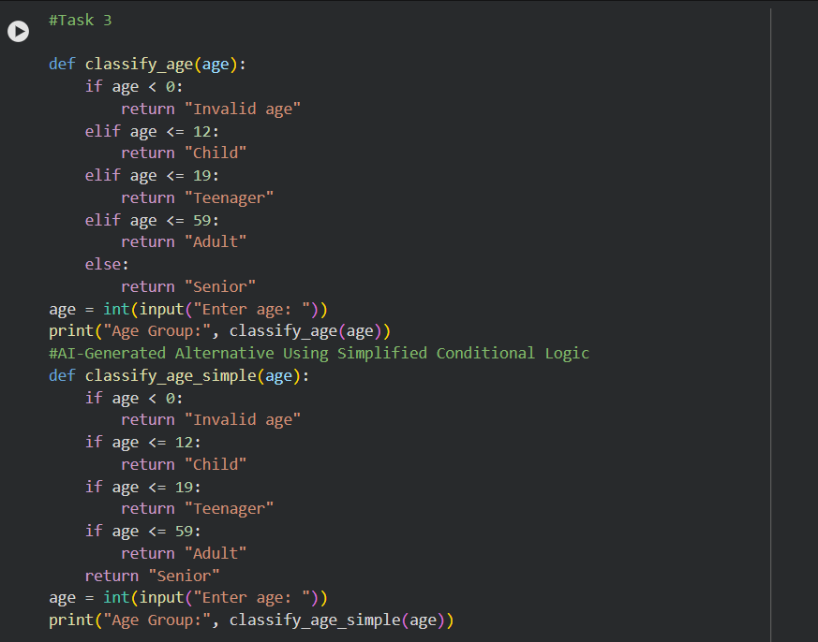
Result:
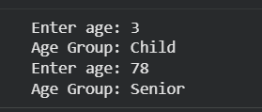
Observation:
The AI-generated conditions correctly classify age groups. The if-elif-else structure is clear and readable, while the simplified version reduces nesting and improves clarity. Both approaches are logically sound.

Task 4: For and While Loops – Sum of First n Numbers. Calculate the sum of the first n natural numbers using different approaches.
Prompt: #Generate Python code to find the sum of the first n natural numbers using loops.

Code:
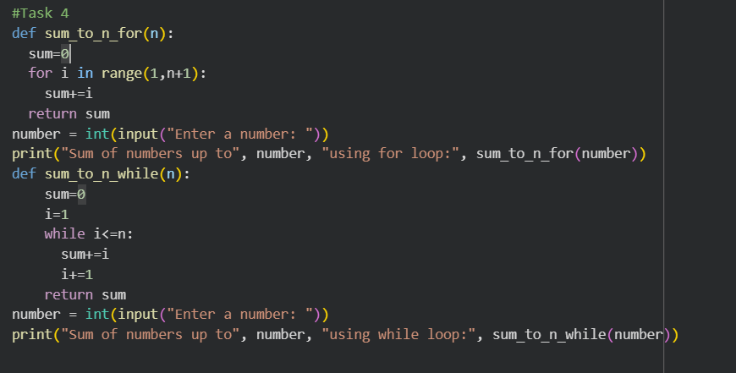
Result:
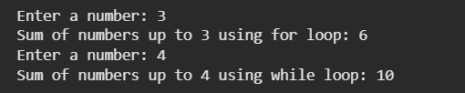
Observation
Both loop-based solutions produce the correct result. The for-loop version is more concise, while the while-loop version offers explicit control over iteration. AI-generated logic is correct and easy to understand

Task 5: Classes – Bank Account Class

Create a Bank Account class with deposit, withdraw, and balance checking functionality.

Prompt: #Generate a Python Bank Account class with deposit, withdraw, and check balance methods.

Code:
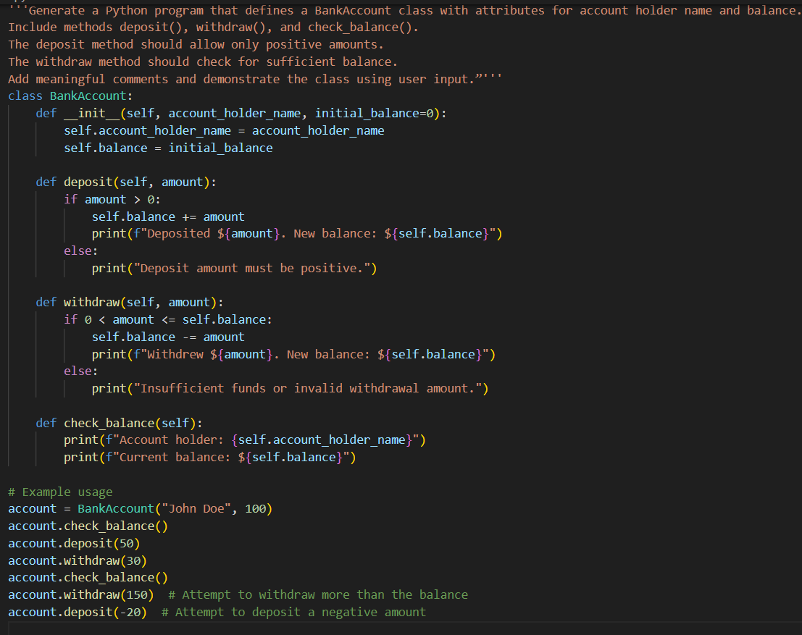
Result:
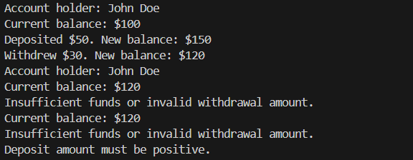
Observation:
The AI-generated class structure is well organized and logically correct. Methods perform expected operations, and balance updates are accurate. The code is readable, maintainable, and suitable for a basic banking application.

