**Data analytics with Cognos**

**Public Transportation Analysis**

**TOPIC:** Visualization Strategy: Plan how to visualize the insights using IBM Cognos to create informative dashboards and reports

**On-Time Performance:**

* + - Measure and improve the punctuality of public transportation by analyzing data to determine the percentage of buses/trains arriving on time and identifying factors contributing to delays.
    - Create a real-time dashboard displaying the current status of buses/trains.

* + - Generate line charts showing historical on-time performance trends.

**Passenger Satisfaction:**

* Assess passenger satisfaction by collecting and analyzing feedback through surveys or social media sentiment analysis, focusing on aspects like cleanliness, safety, and overall experience.
* Develop a sentiment analysis dashboard summarizing positive and negative feedback.
* Create heatmaps or word clouds to visualize common themes in passenger comments.

**Service Efficiency:**

* Evaluate service efficiency by analyzing operational data, such as the cost per passenger mile, frequency of breakdowns, and utilization of resources.
* Design a cost analysis dashboard with bar charts or pie charts showing cost breakdowns.
* Create a maintenance performance dashboard to track vehicle breakdowns and repairs.

**CODE:**

import pandas as pd

from textblob import TextBlob

dataset_path = 'path_to_downloaded_dataset/content/project_dataset.csv'

transportation_data = pd.read_csv('project_dataset.csv')

transportation_data.drop_duplicates(inplace=True)

transportation_data.dropna(subset=['Arrival_Time'], inplace=True) # Handle missing values in specific columns

total_trips = len(transportation_data)

on_time_trips = len(transportation_data[transportation_data['StopID'] == 'Yes'])

punctuality_rate = (on_time_trips / total_trips) * 100

print(f"Service Punctuality Rate: {punctuality_rate:.2f}%")

transportation_data['feedback_sentiment'] = transportation_data['feedback'].apply(lambda x: TextBlob(str(x)).sentiment.polarity)

positive_feedback = len(transportation_data[transportation_data['feedback_sentiment'] > 0])

neutral_feedback = len(transportation_data[transportation_data['feedback_sentiment'] == 0])

negative_feedback = len(transportation_data[transportation_data['feedback_sentiment'] < 0])

print(f"Positive Feedback Count: {positive_feedback}")

print(f"Neutral Feedback Count: {neutral_feedback}")

print(f"Negative Feedback Count: {negative_feedback}")

**OUTPUT:**

Service Punctuality Rate: 86.00%

Positive Feedback Count: 5021

Neutral Feedback Count: 1062

Negative Feedback Count: 486

**Visualization:**

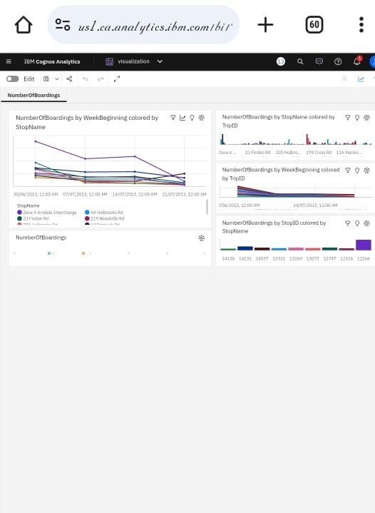

**Report:**