Bug Tracking Application
Objective:
Build a Spring Boot service with CRUD endpoints connected to a PostgreSQL database
My GitHub Link: https://github.com/Divyasri6/Bug-Tracking
STEPS:
- Created Git repository
- Download git, PostgreSQL
- Used Spring Initializer to generate the project with the required dependencies:
Spring Web
Spring Data JPA
PostgreSQL Driver
Swagger
- Database setup in PostgreSQL (bugtracker)
- Service Layer
Implemented BugService and BugServiceImpl for business logic
- Controller Layer
Created BugController for REST endpoints.\
- Testing: Tested endpoints using Swagger UI
- Performed CURD operations
- Version Control / Git Workflow

- GET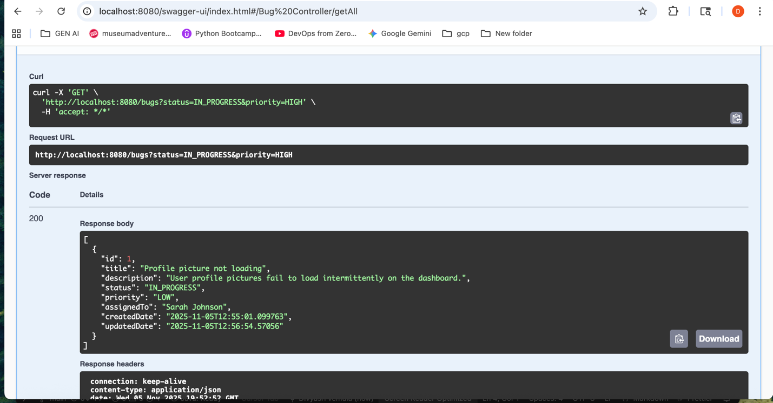
GET_ID
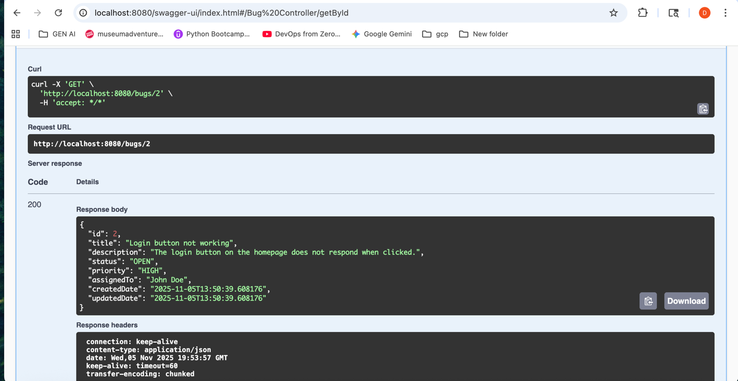

POST
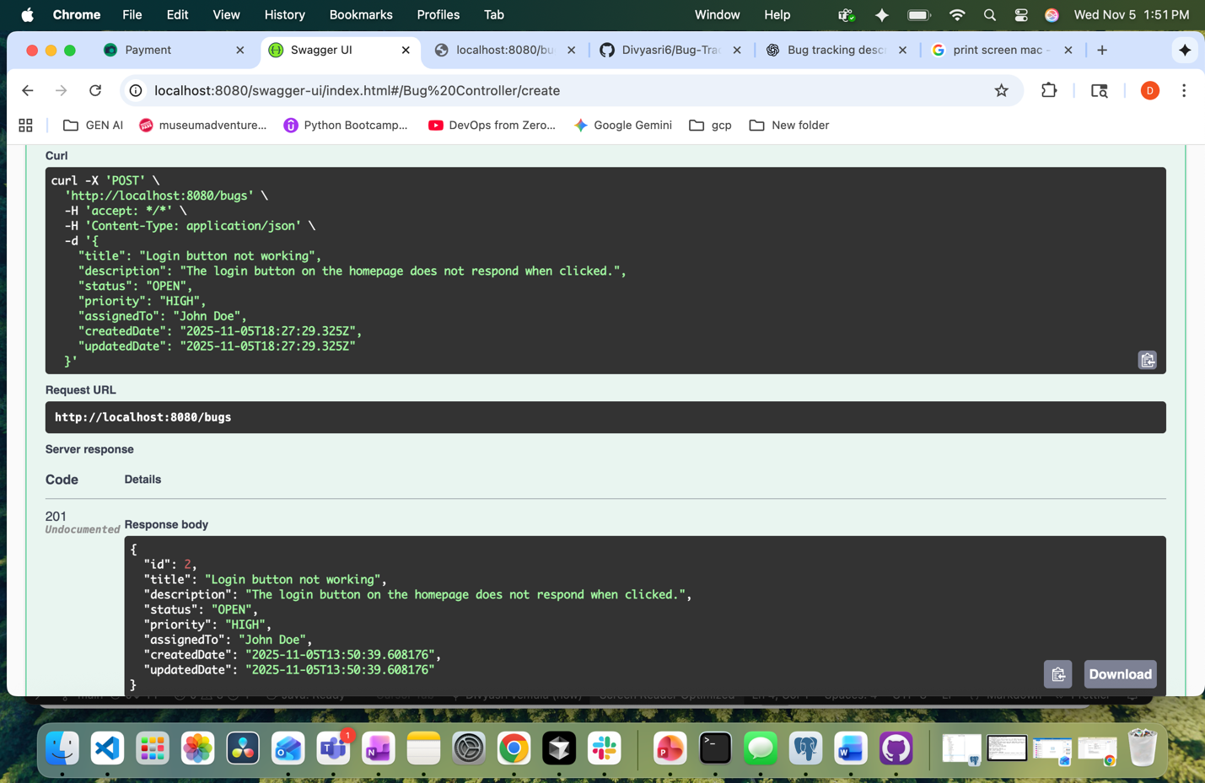
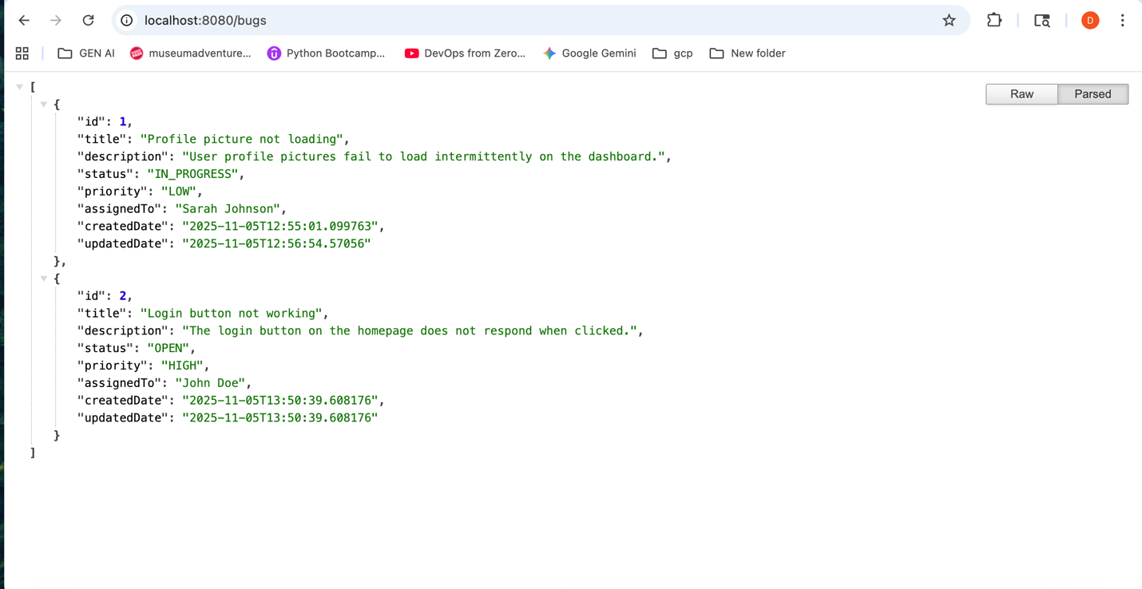

PUT
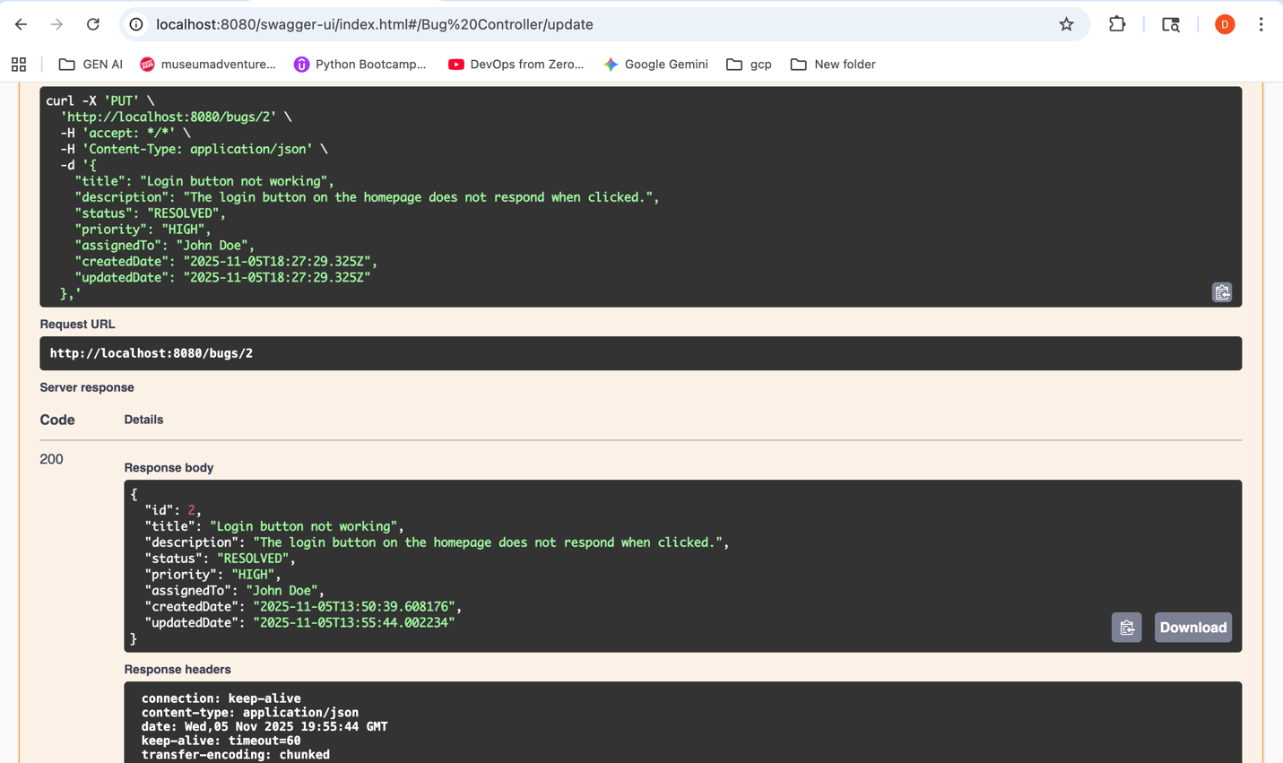
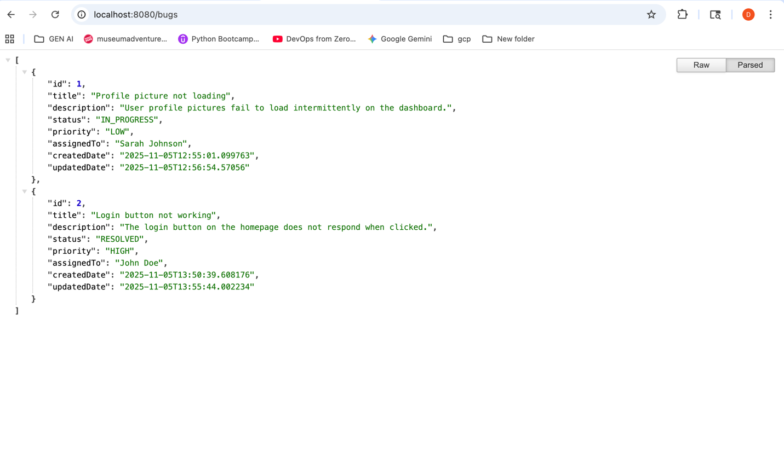

DELETE:
