**BIRLA INSTITUTE OF TECHNOLOGY & SCIENCE, PILANI HYDERABAD CAMPUS**

2nd Sem 2023-24

**Compiler Construction (CS F363)**

**Labsheet – 4**

1. Objective of this lab is

* Reading text from (and write to) a file
* REJECT macro

1. Background:

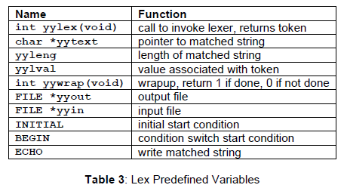

**During the session, we discuss and work on the following practice problems:**

1. Program that reads from a file and outputs content to monitor.
2. **Now modify the above program to skip any numerical or special chars (#$%?) in the file.**
3. **A lex program to read from one file and write to another file as an action.**

And a few more practice problems.

**Exercise problems:**

1. Write a LEX program to count the number of words and numbers found in a text file.

2. Write a LEX program to count the number of lines, words, characters, and blank spaces from a C file.

3. Write a lex program to read from one file and write to another file as an action

but replacing CS with Computer Science

**For instance, the content of source1.txt is :**

Hi Here in our CS department courses, not only CS students, others too register.

We offer more than 3 CS courses for others.

**The content of dest1.txt after copying must be :**

Hi Here in our Computer Science department courses, not only Computer Science students, others too register.

We offer more than 3 Computer Science courses for others.

4. /*program that reads content from sample.txt and writes the output to another file temp.txt by removing empty lines, appending line numbers, and finally, printing the number of empty lines in sample.txt */

For example, if sample .txt has the content.

------------------

This is BITS

In Hyderabad city

Of Telangana state

Welcome

Output: the content in the temp.txt is :

1 This is BITS

2 In Hyderabad city

3 Of Telangana state

4 Welcome

Number of empty lines:6

**5.**  Write a program that prints (to monitor) the longest string from the input file along with its length

REJECT

Usually, Lex separates the input into non-overlapping tokens. But sometimes, you want all occurrences of a token even if it overlaps with other tokens. The special action REJECT lets you do this. If an action executes REJECT, flex conceptually puts back the text matched by the pattern and finds the next best match for it. The example finds all occurrences of the words *pink*, *pin*, and *ink* in a file, even when they overlap:

We will discuss this macro with examples.