Full Stack Engineering

Project Report Semester-V (Batch-2023)

Smart Exam Portal



**Supervised By: Submitted By:**

Rahul Sir Deepansh Goel – 2310990320 (G-4)

Dilnawaz – 2310990326 (G-4)

Divye Rana – 2310990329 (G-4)

**Department of Computer Science and Engineering Chitkara University Institute of Engineering & Technology,**

**Chitkara University, Punjab**

# ABSTRACT

The *Smart Exam Portal* is a web-based examination management system developed to provide a secure, efficient, and user-friendly digital assessment environment. The platform aims to overcome limitations of traditional examinations such as manual question handling, high administrative workload, and lack of accessibility, by offering a fully automated online solution.

The system provides secure **Student/Admin login** using JWT-based authentication, ensuring data integrity and controlled access. Administrators have the ability to create and post questions for specific exams, making the exam setup process flexible and centralized. Students can log in, view available exams, and attempt them within a predefined time frame. To ensure fairness and efficiency, the portal automatically stores and submits the test if the allotted time expires, preventing manipulation or incomplete submissions.

In addition, the platform offers a **results management feature**, where students can view their past performance and track their progress over time. This enables transparency and provides continuous feedback, improving the overall learning experience. The system also emphasizes reliability and security through encrypted data handling and robust session management.

By integrating secure authentication, timed assessments, automated submission, and result tracking, the *Smart Exam Portal* transforms the traditional exam process into a streamlined and accessible digital solution. It not only reduces manual administrative tasks but also ensures a seamless experience for both students and administrators, thereby enhancing efficiency, transparency, and trust in the examination process.

# Table of Content

1. Abstract/Keywords
2. Introduction to the project
   1. Background
   2. Problem Statement
3. Problem Definition and Requirements
   1. Methods
   2. Programming/Working Environment
   3. Requirements to run the application
4. Proposed Design / Methodology
5. Results

# Introduction

Examinations play a critical role in evaluating student performance and ensuring academic progress. However, traditional exam systems are often associated with significant drawbacks such as manual paper handling, logistical complexity, high administrative workload, and lack of accessibility. With the rapid shift toward digital learning, there is a growing need for reliable and secure online assessment platforms that simplify the examination process while maintaining fairness and efficiency.

The *Smart Exam Portal* is a web-based platform designed to modernize and streamline examinations. It provides **role-based login for students and administrators**, secure authentication through JWT, and a centralized interface for creating, conducting, and managing exams. Students can attempt tests within a predefined time frame, and the system ensures fairness by automatically storing and submitting responses once the time limit expires. Additionally, students can track their past results, enabling continuous learning and self-evaluation.

Built with modern web technologies, the portal offers a robust and user-friendly environment that reduces administrative effort, prevents malpractices, and enhances transparency in the examination process. By digitizing exams, it transforms the traditional paper-based system into a scalable, secure, and accessible solution.

## Background and Significance

Education systems worldwide are rapidly adopting digital solutions to enhance accessibility and efficiency.

Traditional paper-based examinations pose challenges such as high costs, delayed evaluations, and increased opportunities for malpractice. Even existing online exam systems often lack robust authentication, automated timing mechanisms, or reliable result tracking, making them less effective in ensuring fairness and accountability.

The *Smart Exam Portal* addresses these gaps by integrating **secure login, real-time exam management, automated submissions, and result history tracking** into a single platform.

Its significance lies in providing students with a seamless digital exam-taking experience while enabling administrators to manage assessments effortlessly. By reducing dependency on manual processes, it ensures faster evaluations, greater transparency, and improved efficiency.

Moreover, the system’s design promotes accessibility and flexibility, allowing students to participate in examinations remotely while ensuring integrity and fairness through built-in timing and auto-submission mechanisms.

As a result, the *Smart Exam Portal* represents a practical and innovative approach to transforming the traditional exam system into a modern, technology-driven solution.

## Objectives

The primary goal of the *Smart Exam Portal* is to provide a secure, efficient, and user-friendly digital platform for conducting and managing examinations. The specific objectives of the project include:

* **To implement secure authentication** using JWT-based login for both students and administrators, ensuring data integrity and controlled access.
* **To enable administrators to create and manage exams** by posting questions for specific tests in a centralized and efficient manner.
* **To allow students to attempt exams within a given time frame**, ensuring fairness and standardization in the examination process.
* **To automate test submissions** so that if a student fails to submit within the allotted time, the system automatically stores and submits the test.
* **To provide students with access to their past results**, allowing them to track performance and support continuous improvement.
* **To reduce administrative workload** by digitizing exam management and minimizing manual intervention.
* **To enhance transparency and reliability** by integrating time-tracking, auto-submission, and secure data storage mechanisms.

## Features and Functionality

To achieve the stated objectives, the *Smart Exam Portal* incorporates the following features:

**a. Student/Admin Login using JWT**

* Secure authentication system that uses JSON Web Tokens (JWT) to verify users.
* Role-based login: Administrators and Students have separate access levels and functionalities.

**b. Exam Creation and Question Management (Admin)**

* Administrators can create new exams and post questions for each test.
* Support for adding multiple types of questions (e.g., MCQs, descriptive).
* Questions are stored securely in the database for future access.

**c. Exam Participation (Student)**

* Students can view available exams after logging in.
* Tests must be attempted within the given time frame.
* Countdown timer ensures students are aware of the remaining time during an exam.

**d. Automatic Submission**

* If a student does not manually submit the test within the allotted time, the system automatically stores and submits the answers.
* This prevents incomplete submissions and ensures fairness.

**e. Result Management and Progress Tracking**

* Students can view their past results and analyze performance over multiple exams.
* Administrators can review overall test data for monitoring and evaluation.

## Technology Stack

To ensure scalability, security, and seamless performance, the *Smart Exam Portal* is developed using the MERN (MongoDB, Express.js, React.js, Node.js) stack, along with modern authentication and hosting solutions:

* **Frontend:** React.js – for building a dynamic, responsive, and user-friendly interface for students and administrators.
* **Backend:** Node.js and Express.js – for handling server-side logic, exam management, and API endpoints.
* **Database:** MongoDB – for storing exam data, questions, student information, and results securely.
* **Authentication:** JSON Web Tokens (JWT) – for secure login, role-based access control, and protected sessions.
* **Real-Time Features:** Timer and auto-submission functionality to ensure fair exam attempts and prevent manipulation.

# Problem Definition and Requirements

## Problem Statement:

Traditional examination systems often face challenges such as logistical delays, high administrative effort, and the risk of malpractices. Paper-based exams require significant manual effort for question preparation, distribution, and evaluation, leading to inefficiencies and delays in result processing.

Even existing online exam solutions lack robust security features, reliable timing mechanisms, or comprehensive result tracking, making them less effective in ensuring fairness and transparency.

Students also face challenges in accessing their performance records, while administrators struggle to manage exams efficiently in a scalable way.

The *Smart Exam Portal* addresses these challenges by providing a secure, automated, and user-friendly digital platform that ensures fair assessments, reduces manual effort, and improves accessibility. By incorporating secure authentication, time-bound submissions, automated storage, and result tracking, the system offers a complete and modern solution for digital examinations.

## Software & Hardware Requirements:

* **Frontend:** React.js – for dynamic UI, responsive design, and smooth exam interaction.
* **Backend:** Node.js, Express.js – for handling authentication, exam management, and server-side logic.
* **Database:** MongoDB – for storing student details, exam questions, results, and submission records.
* **Authentication & Security:** JSON Web Tokens (JWT), bcrypt.js – for secure login, session handling, and data protection.

**Hardware Requirements**

* **Server:** Minimum 8 GB RAM, SSD storage, and cloud deployment support to handle concurrent users.
* **Client Devices:** Desktop/Laptop with modern browsers (Google Chrome, Firefox, Edge) and stable internet connection.

# Proposed Design / Methodology

## System Architecture:

The *Smart Exam Portal* follows a **MERN stack architecture**, ensuring scalability, security, and efficient handling of user interactions. The system is designed to provide seamless exam management, secure authentication, and real-time result tracking.

**Frontend:**

* Built with **React.js**, utilizing reusable components, modular design, and state management (e.g., Redux or Context API) for smooth and responsive user experience.
* Student and Admin dashboards are designed to be intuitive, allowing easy navigation for exam attempts, question posting, and result viewing.

**Backend:**

* Developed using **Node.js with Express.js**, handling authentication, exam creation, question management, timer functionality, and automated submissions.
* Implements optimized routing, middleware processing, and secure APIs to manage concurrent requests efficiently.

**Database:**

* **MongoDB** is used for storing student profiles, exam data, questions, submissions, and result history.
* Database is structured for quick retrieval and scalability, using indexing and optimized schemas for efficient performance.

**Authentication & Security:**

* **JWT** for secure login and session management.
* Passwords and sensitive data encrypted using **bcrypt.js**, ensuring data privacy and integrity.

**File Structure**

**Frontend:**

* Organized into **Components**, **Pages**, **Redux Store / Context**, **Styles**, **Utility Functions**, and **API Services**.

**Backend:**

* Modular structure including **Controllers**, **Routes**, **Models**, **Middleware**, **Services**, and **Configurations**.

**Database Models:**

* Efficiently structured models for **Users (Student/Admin)**, **Exams**, **Questions**, **Submissions**, and **Results**.

## Algorithms Used:

1. **JWT Authentication Algorithm**

* Ensures secure login for both students and administrators.
* Verifies user credentials, generates a token, and manages session validity for protected access.

**2. Exam Timer and Auto-Submission Logic**

* Tracks the remaining time for each student’s exam attempt.
* Automatically stores and submits answers when the allotted time expires to prevent manipulation or incomplete submissions.

**3. Randomized Question Sequencing Algorithm**

* Randomly selects and orders questions from the database for each student to minimize cheating and ensure fairness.

**4. Result Calculation Algorithm**

* Automatically evaluates objective-type questions.
* Computes total score and stores results in the database.
* Provides students with instant feedback and access to past performance.

**5. Role-Based Access Control**

* Differentiates permissions for Admins and Students.
* Admins can create exams and view aggregated results; Students can attempt exams and track their scores.

**6. Data Validation and Integrity Checks**

* Validates user input, exam submissions, and question data.
* Ensures data consistency across the database and prevents unauthorized modifications.

# Results

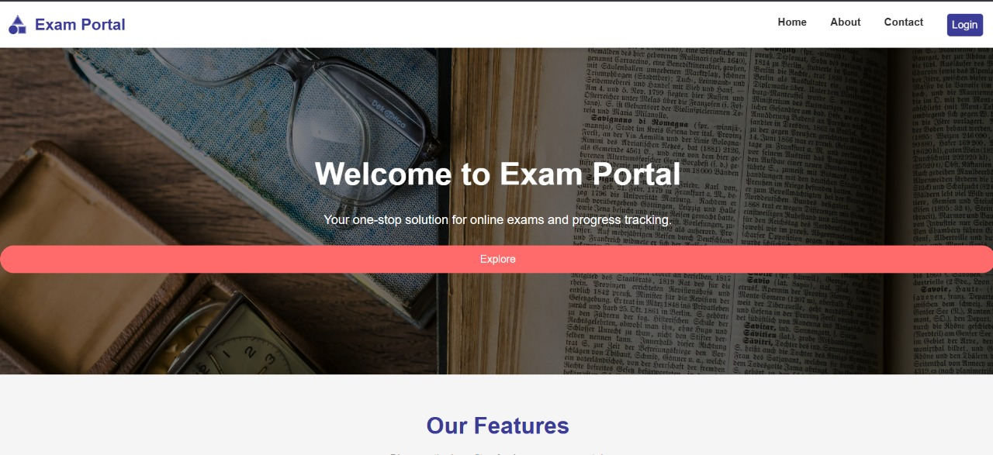

**Landing Page**

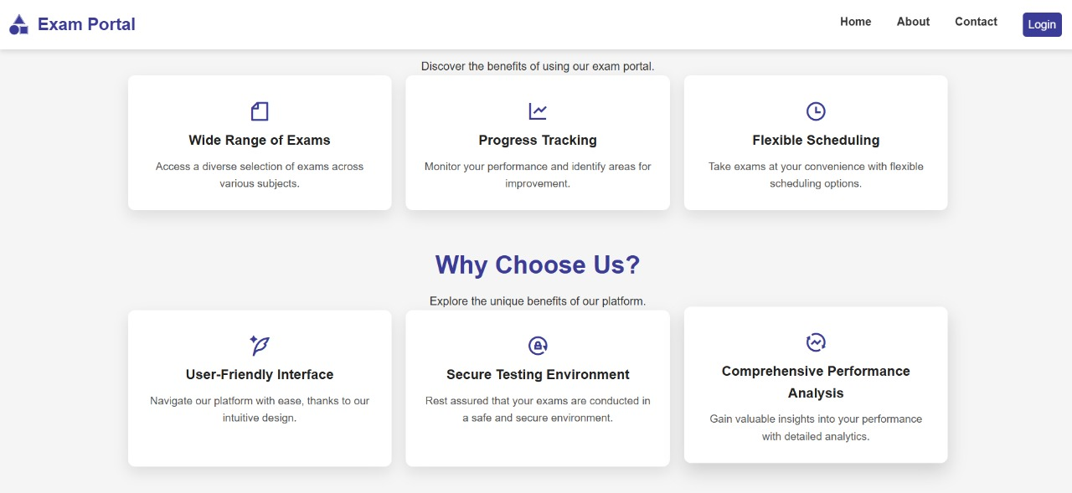



**Footer Page**

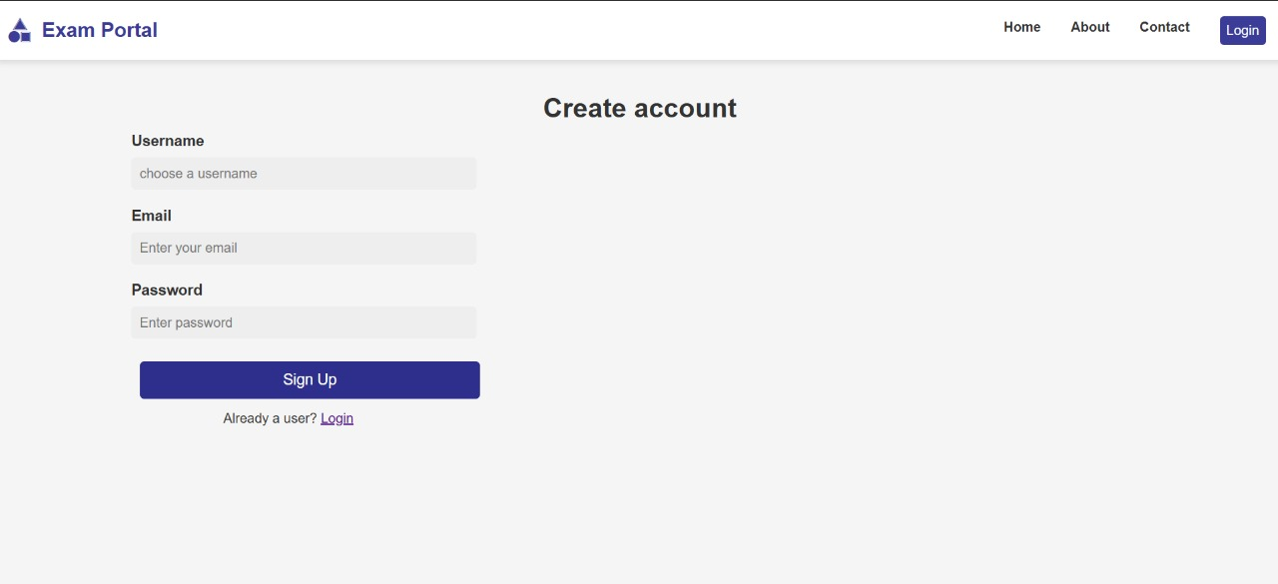

**Sign Up**

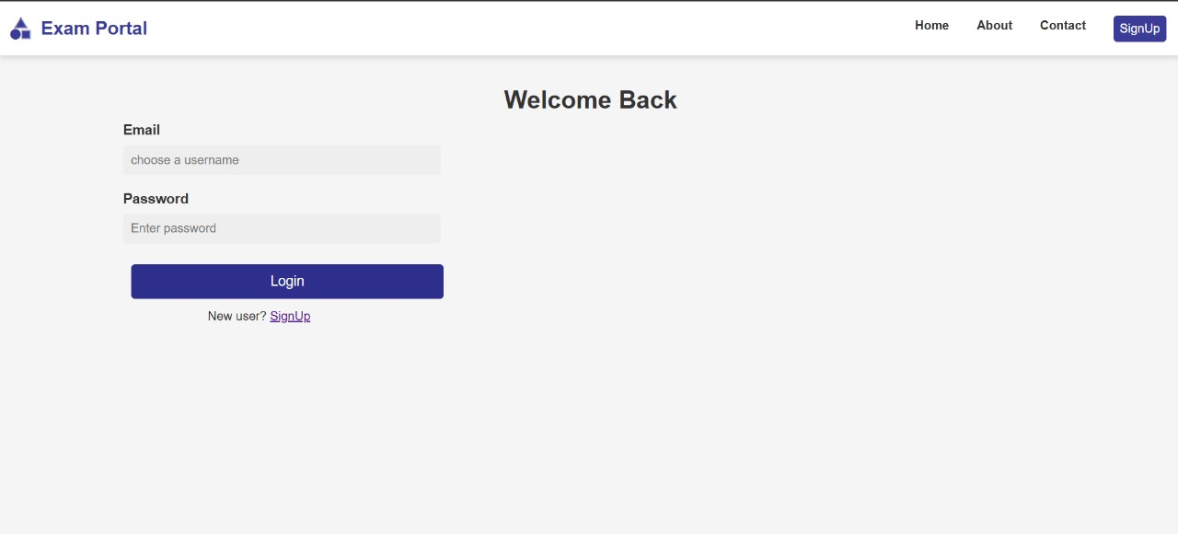

**Login Page**

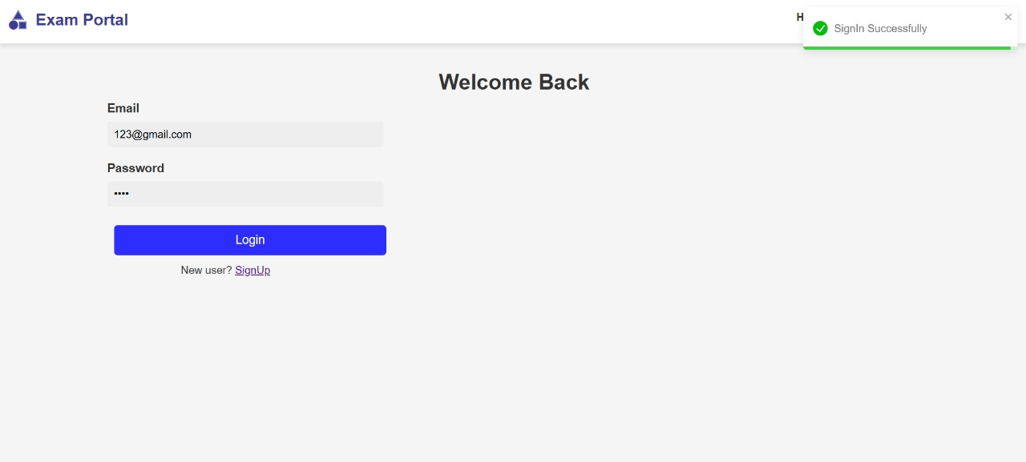

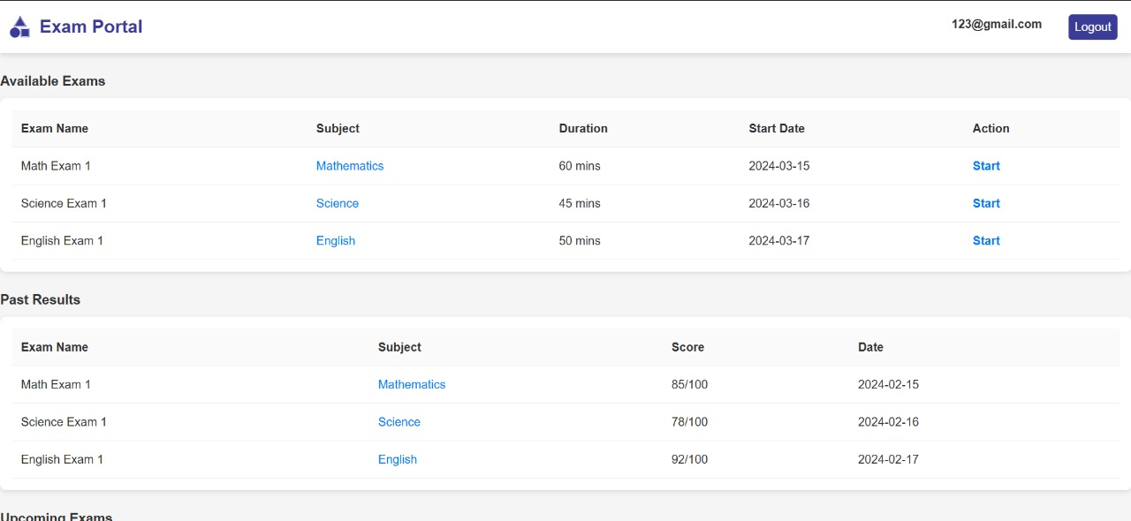

Student Dashboard

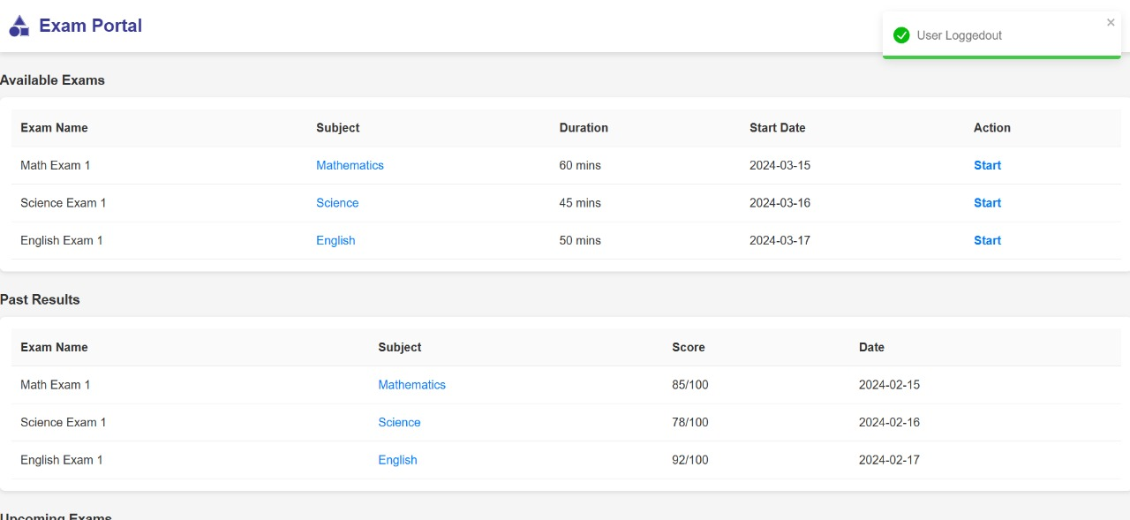

**Student Logout**

Backend Code:

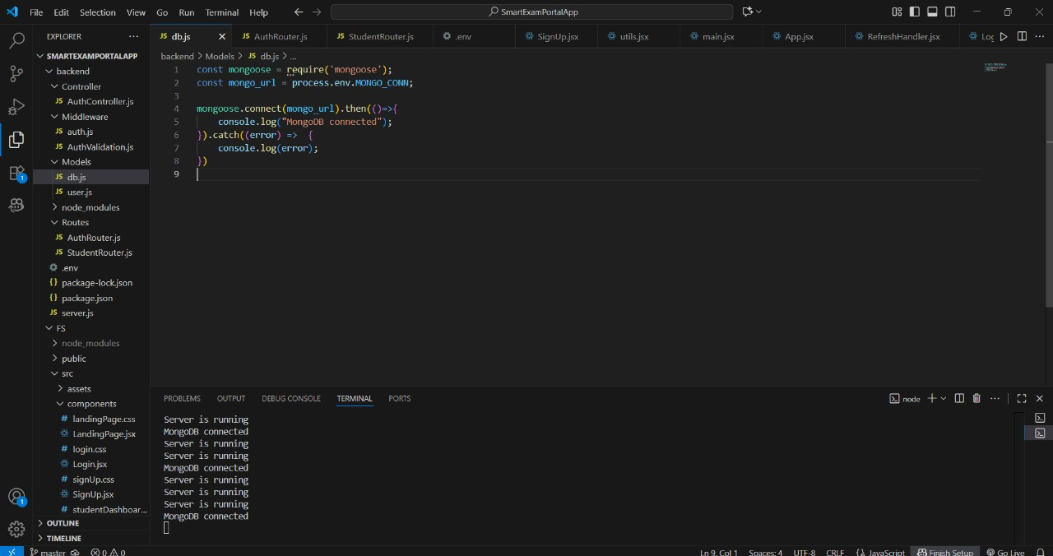

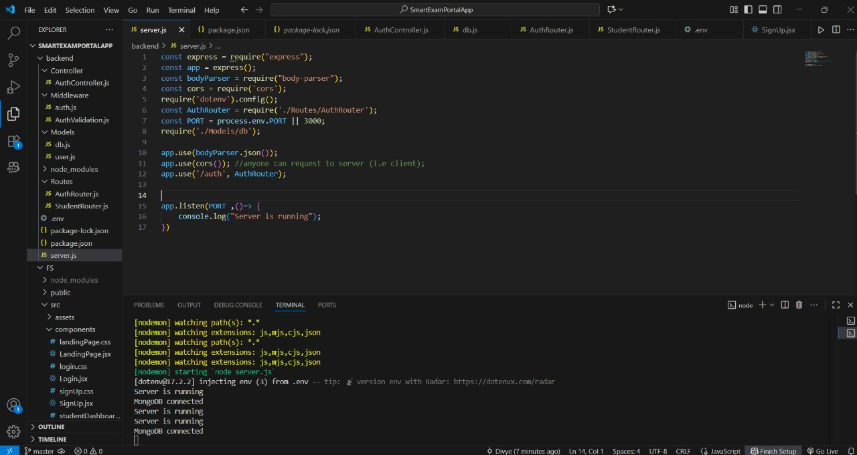

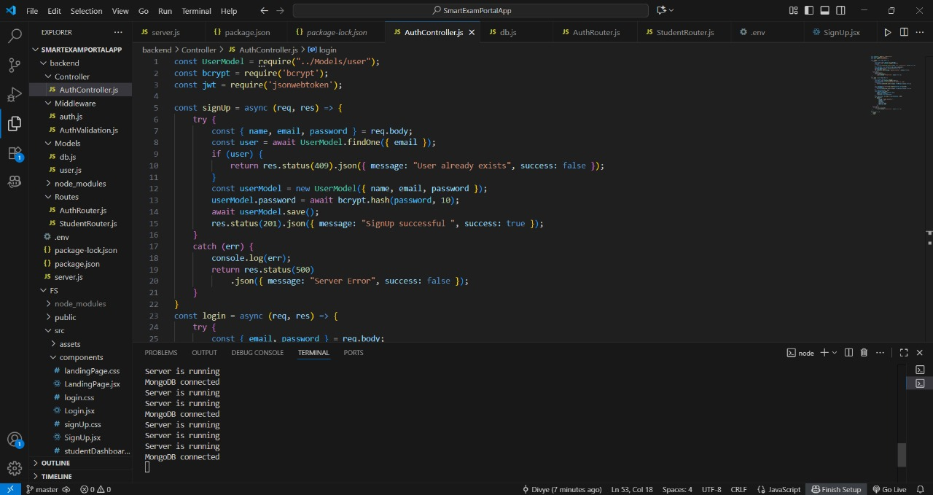

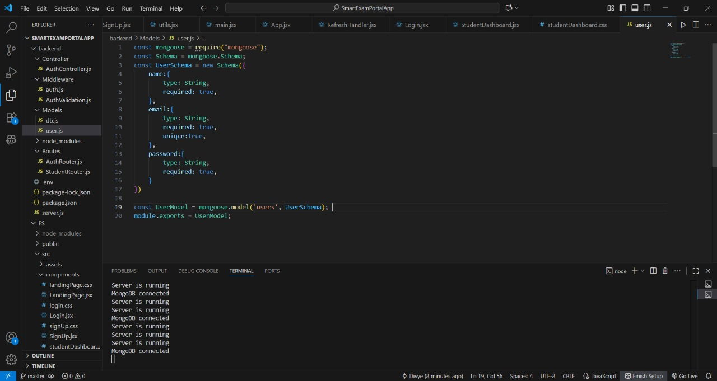

React Code :

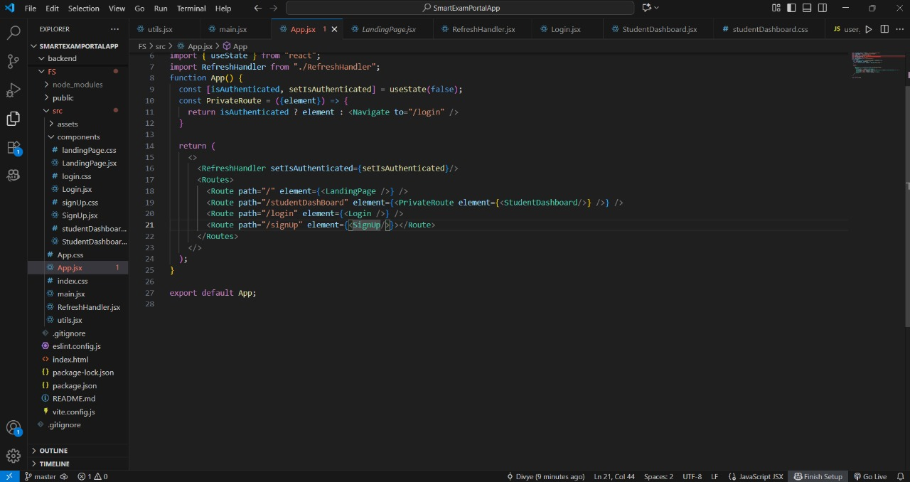

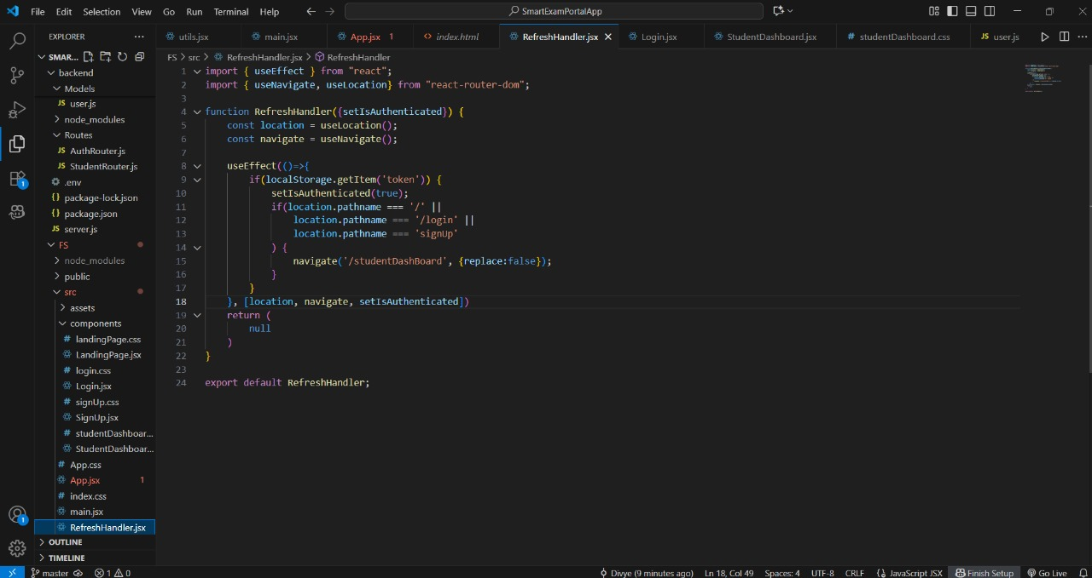

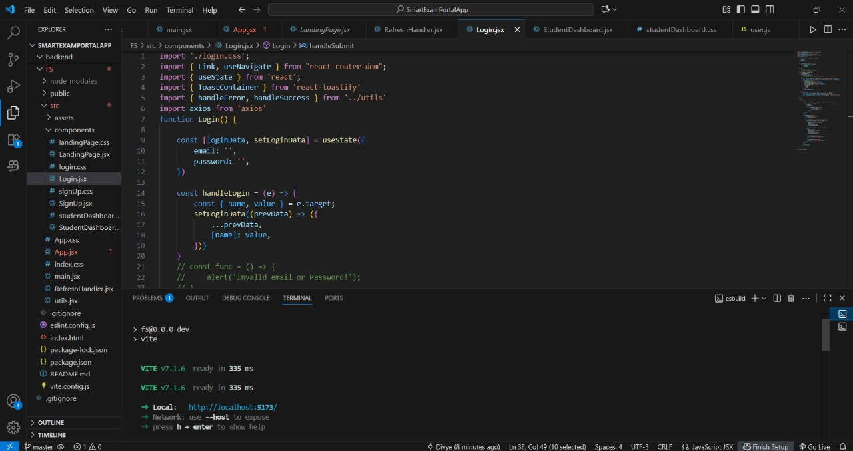

**References:**

**Official Documentation**: Documentation for libraries, frameworks, and tools used in the project, as well as APIs or services integrated.

**Tutorials and Guides**: Online tutorials, guides, blog posts, and educational videos that provided assistance or insights during development.

**Code Repositories**: GitHub repositories or other code repositories where code snippets, examples, or inspiration were found.

**Forums and Communities**: Online forums, such as Stack Overflow or Reddit, and developer communities where questions were asked, advice was sought, or discussions were participated in.

**Personal Communication**: Mentors, peers, and colleagues who provided guidance, feedback, or support during development.