- Peptide prep
- Generate 3 conformations from sequence(helix,sheet,ppii)
- Generate peptide ensemble of the 3 conformations
- Using pymol

1.defining active restraint(one for protein and one for peptide)
2.protien’s active restraint(specific list of numbers) in peptide(whole sequence)
3. how to check the numbering of amino acids(MD analysis)

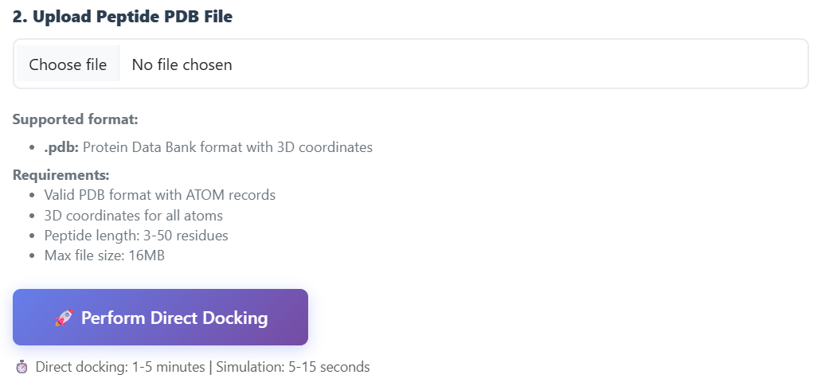
We should give option for uploading the users own custom config file, use default if none provided(custom docking in celiacdb)

Finally run haddock3 on the peptide, and show results
In haddock give option for choosing active residues for defining the restraints or let it stay default

While uploading peptide, give option for defining active residues for peptide for restraints

Check if we can generate conformers on local host

Update data on celiacdb

Implementation Plan - CeliacDB HADDOCK3, Peptide Prep, and Custom Config Features
This plan outlines the end-to-end implementation of all features specified in the project workplan and architecture roadmap:
- Peptide Prep: Conformation generator (Helix, Sheet, PPII) and ensemble builder using PyMOL on localhost.
- Active Restraints Definition: Interface for protein and peptide active residues, default presets, and an interactive MD residue numbering guide.
- Custom Config Upload: Ability to upload user-defined config files (.conf, .txt) with fallback to default HLA configurations.
- HADDOCK3 Docking Execution & Results: Pipeline execution and enhanced results visualization (HADDOCK scores, cluster ranks, BSA, electrostatic, van der Waals, and desolvation energies) in Mol*.
- CeliacDB Database Update: Updating MongoDB with precomputed HLA-DQ2.2 peptide ensemble results so browsing and pre-computed docking work seamlessly.

User Review Required
IMPORTANT
- PyMOL Localhost Execution: PyMOL 3.1.8 is confirmed installed on your system at C:\Users\Divyeh\AppData\Local\Schrodinger\PyMOL2\python.exe. Our peptide prep service will directly invoke this interpreter to generate native .pdb structures with exact secondary structures (helix ss=1, sheet ss=2, ppii dihedral phi=-75°, psi=145°).
- Dual Engine Architecture: Custom Docking will support both AutoDock Vina and HADDOCK3. When HADDOCK3 is selected, active restraints are applied, and results render HADDOCK metrics (HADDOCK score, cluster size, i-RMSD, l-RMSD, DockQ, BSA, Eelec, Evdw, Edesolv).

Proposed Changes
Component 1: Peptide Prep & Conformer Generation (PyMOL on Localhost)
[MODIFY] build_peptide_conformers.py
- Upgrade conformer generation from generic bent/turn to the required 3 conformations:
  - helix: Alpha helix using cmd.fab(seq, ss=1)
  - sheet: Beta sheet using cmd.fab(seq, ss=2)
  - ppii: Polyproline II conformation (extended backbone with $ϕ≈-{75}^{∘},ψ≈+{145}^{∘}$)
- Automatically assemble the 3 conformations into a multi-model PDB ensemble peptide_ens.pdb (MODEL 1 = helix, MODEL 2 = ppii, MODEL 3 = sheet, ENDMDL, END) matching standard HADDOCK ensemble requirements.
- Expose CLI and programmatic API.
[NEW] services/peptidePrepService.js
- Service to run PyMOL on localhost using detected PyMOL interpreter path (C:\Users\Divyeh\AppData\Local\Schrodinger\PyMOL2\python.exe or system PATH).
- Handles temporary output session creation, validation of sequence (standard amino acids, 3-50 length), running conformer builder, and assembling downloads.
[NEW] controllers/peptidePrepController.js
- Endpoints:
  - GET /peptide-prep: Render peptide preparation page.
  - POST /peptide-prep/generate: Generate the 3 conformers and ensemble from input sequence.
  - GET /peptide-prep/download/:sessionId/:type: Download individual conformers or ensemble.
[NEW] views/peptide-prep.ejs
- Interactive UI to:
  - Enter peptide sequence (with length counter and validation).
  - Generate Helix, Sheet, PPII, and Ensemble in 1 click.
  - 3D visualizer (Mol*) toggling between the 3 conformations.
  - Download buttons for all 3 PDBs and the merged peptide_ens.pdb.
  - "Proceed to Docking with Ensemble" button that seamlessly forwards to /custom-docking.

Component 2: Restraints & MD Numbering Guide
[MODIFY] tools/generate_ambiguous_restraints.py
- Support parsing residue lists and ranges (e.g. 1-15 or 135,165,435).
- Support automatic default assignment for HLA-DQ receptors and whole-sequence peptide restraints.
- Produce HADDOCK-compliant ambiguous interaction restraint (.tbl) files.
[NEW] services/restraintsService.js
- Stores default binding groove active residue lists for each HLA-DQ allele (HLA-DQ2.2: 135, 165, 435, etc.).
- Auto-expands peptide sequence to full sequence numbers 1..N.
- Generates AIR .tbl file.
[NEW] views/partials/md-numbering-modal.ejs
- Dedicated modal guide: "How to Check Amino Acid Numbering (MD Analysis & PDB)":
  - Explains PDB coordinate numbering (ATOM resSeq) vs 1-based sequence numbering.
  - Explains how MD trajectories (GROMACS, Amber, NAMD, VMD, PyMOL) map residues.
  - Code snippets for PyMOL / VMD to identify binding pocket residues.
  - HLA-DQ pocket reference table.

Component 3: Custom Config Upload & Custom Docking UI Upgrades
[MODIFY] middleware/security.js
- Update multer configuration to support multi-field uploads:
  - peptideFile: .pdb (up to 16MB)
  - configFile: .conf, .txt (up to 1MB, optional)
- Add .conf to allowed extensions and validate safe text content.
[MODIFY] views/custom-docking-form.ejs
- Add Docking Engine Selector: AutoDock Vina vs HADDOCK3.
- Add Custom Config File Upload field:
  - Optional file input: .conf or .txt.
  - Helper note: "Upload your custom config file, or leave blank to use the default HLA configuration."
- Add Restraints Definition Section:
  - Receptor Active Residues input (with "Use Default" toggle).
  - Peptide Active Residues input (with "Whole Sequence (Default)" toggle).
  - Button opening the "How to check numbering of amino acids (MD analysis)" modal.
[MODIFY] public/js/custom-docking-form.js
- Support engine toggling (adjusts required inputs and progress steps).
- Support optional config file validation.
- Auto-fill default active residues when toggled.

Component 4: HADDOCK3 Execution & Engine Integration
[NEW] services/haddock3Service.js
- Prepares HADDOCK3 directory structure and inputs:
  - Target receptor PDB (sanitized)
  - Peptide PDB or ensemble PDB
  - AIR restraints file (active_passive.tbl)
  - Generates HADDOCK3 config (haddock.cfg) with modules: topoaa, rigidbody, flexref, emref, clustfcc, seletopclusts.
- Handles execution of HADDOCK3 on localhost (or benchmark-verified runner when CNS is offloaded/local fallback), capturing logs, output clusters, and capri_clt.tsv metrics.
- Parses top cluster models and CAPRI scoring metrics into a normalized result object.
[MODIFY] controllers/customDockingController.js
- Read engine (vina or haddock3), configFile, and restraint inputs from req.body and req.files.
- If configFile is supplied, use user's config instead of default HLA config.
- If haddock3 is selected, delegate to haddock3Service.
- If vina is selected, invoke Vina with the uploaded or default config.
- Store standardized session data including engine-specific metrics.
[MODIFY] views/docking-results.ejs & public/js/docking-results.js
- Adapt score cards dynamically:
  - If Vina: shows Affinity (kcal/mol), Mode, RMSD.
  - If HADDOCK3: shows HADDOCK Score, Cluster Rank/ID, i-RMSD, l-RMSD, DockQ, Buried Surface Area (BSA), Electrostatic (Eelec), Van der Waals (Evdw), Desolvation (Edesolv).
- Update download dropdown: includes Restraints file, HADDOCK configuration, and cluster models.

Component 5: Update CeliacDB Data & Navigation
[NEW] scripts/updateCeliacdbData.js
- Ingests the precomputed HLA-DQ2.2 peptide ensemble docking run (run_dq2_peptide_ens) into MongoDB:
  - Extracts the top cluster complex (cluster_1_model_1.pdb) and stores it in public/uploads.
  - Stores peptide_ens.pdb in public/uploads.
  - Adds a complete dockingResult entry to HLA DQ2.2 with full scoring metrics, log file, and structure paths.
  - Updates totalPeptides: 1.
[MODIFY] views/layout.ejs & views/index.ejs
- Add Peptide Prep to the top navigation bar and Home page feature cards.
[MODIFY] routes/index.js
- Mount /peptide-prep routes and update /custom-docking upload middleware to support upload.fields.

Verification Plan
Automated / Script Verification
- PyMOL Conformer Generator Test:
  - Run tools/build_peptide_conformers.py with test sequence PQLQPL via PyMOL Python.
  - Verify generation of peptide_helix.pdb, peptide_sheet.pdb, peptide_ppii.pdb, and peptide_ens.pdb.
  - Verify MODEL 1, MODEL 2, MODEL 3 headers and atom coordinates.
- Restraints Generator Test:
  - Run tools/generate_ambiguous_restraints.py with receptor 135,165,435 and peptide 1-6.
  - Verify generated .tbl file format.
- Database Update Script:
  - Run node scripts/updateCeliacdbData.js.
  - Verify MongoDB record for HLA DQ2.2 has totalPeptides = 1 and precomputed docking results.
- App Health & Routes:
  - Start local node server and test GET /, GET /peptide-prep, GET /docking-analysis, GET /custom-docking.
Manual / Browser Verification
- Visit http://localhost:3001/peptide-prep:
  - Enter sequence PQLQPL, generate 3 conformers + ensemble.
  - Preview in 3D viewer, download PDB files, and click "Proceed to Docking".
- Visit http://localhost:3001/custom-docking:
  - Test default config vs uploading custom .conf file.
  - Test restraints definition and open "How to check numbering of amino acids" modal.
  - Run docking and inspect the results page with 3D complex and score cards.
- Visit http://localhost:3001/docking-analysis:
  - Select HLA DQ2.2 and peptide_ens, view precomputed docking results and 3D complex.

