Instructions for attempting the multiple choice questions:
- All the below problems are part of the question 1 and responses for each of them needs to be filled in the csv which was provided in the zip file along with this problem.
- There are 10 multiple choice problems in this question and all have just one correct answer.
- The marking scheme is +1 for each correct answer. There is no negative marking.
- As part of your submission for this question you need submit a zip file containing the csv that was provided to you in the zip file of the question 1 along with your responses.
- You need to fill your responses under the column name Response. A sample submission would look like this :
Problem | Response
1 | b
2 | c
3 | a

Q1. Let X and Y be independent standard normal random variables. What is E[X | X + Y = 1]?
(A) 0
(B) 1/2
(C) 1/√2
(D) 1

Q2. Let X₁, X₂, …, Xₙ be i.i.d. Uniform(0,1). What is E[maxᵢ Xᵢ]?
(A) (n − 1) / n
(B) n / (n + 1)
(C) 1/2
(D) (2n − 1) / (2n)

Q3. A fair coin is flipped until the first head appears. What is the variance of the number of flips required?
(A) 1
(B) 2
(C) 4
(D) 1/2

Q4. Let X ~ Poisson(λ). What is E[X(X − 1)]?
(A) λ
(B) λ²
(C) λ(λ + 1)
(D) λ² + λ

Q5. You regress Y on X alone (OLS), but the true model is Y = β₀ + β₁X + β₂Z + ε, where Z is omitted and Cov(X, Z) ≠ 0. Which statement is correct?
(A) β̂₁ remains unbiased because OLS is BLUE
(B) β̂₁ is biased; the sign of the bias equals sgn(Cov(X,Z)) × sgn(β₂)
(C) Omitting Z increases R² of the regression
(D) The variance of β̂₁ falls, making inference tighter

Q6. In gradient boosting, each new tree added to the ensemble is fit to:
(A) The original labels Y
(B) The residuals from the immediately preceding tree only
(C) The negative gradient of the loss function with respect to the current model's predictions
(D) A bootstrapped subsample of the original labels

Q7. Which of the following correctly describes a key difference between L1 and L2 regularization in linear models?
(A) L1 tends to produce sparse weight vectors; L2 does not
(B) L2 tends to produce sparse weight vectors; L1 does not
(C) Both produce sparse weight vectors at different convergence rates
(D) They differ only in computational cost; both promote sparsity equally

Q8. You are given an urn with a 100 balls (50 black and 50 white). You pick balls from the urn randomly, one by one without replacement until the urn is empty. A black followed by a white, or a white followed by a black, is a “colour change”. What is the expected number of colour changes.
(A) 25
(B) 50
(C) 67
(D) 75

Q9. In the binomial tree model for pricing an American option with N time steps, backward induction visits each node exactly once. What is the total time complexity?
(A) O(log N)
(B) O(N)
(C) O(N²)
(D) O(2ᴿ)

Q10. The grid shown below can be partitioned into 9 L-shaped “hooks”. The largest is 9-by-9 (contains 17 squares), the next largest is 8-by-8 (contains 15 squares), and so on. The smallest hook is a single square.
Find where the hooks are located, and place nine 9’s in the largest hook, eight 8’s in the next-largest, etc., down to one 1 in the smallest hook.
The goal is for the sum of the numbers in each row and column to match the number given outside the grid.
Your answer will be the largest product that can be achieved using a subset of the numbered squares in the completed grid, satisfying the condition that no two squares in the subset are in the same row or column.

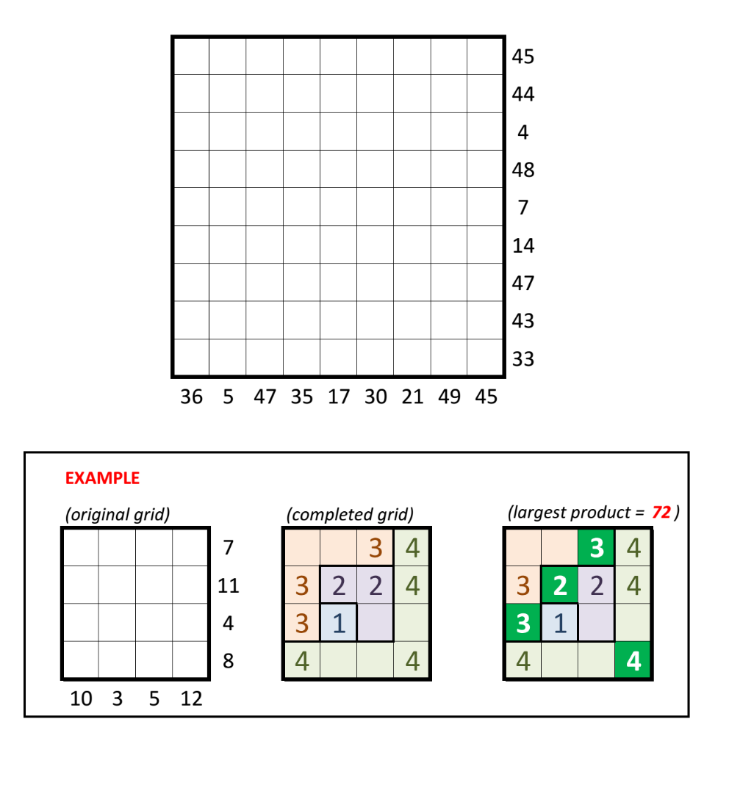

(A) 77,41,440
(B) 1,95,95,520
(C) 1,74,18,240
(D) 1,08,86,400

