Task 1 - Adversity Profiles of Each Client
A trade is adverse at horizon τ if, closing the position at t = τ, the LP PnL is negative: side · V · (M_{τ} - T_{P}) < 0. Since V > 0, only the sign of side · (M_{τ} - T_{P}) matters. Adversity(client, τ) = % of that client's trades that are adverse.
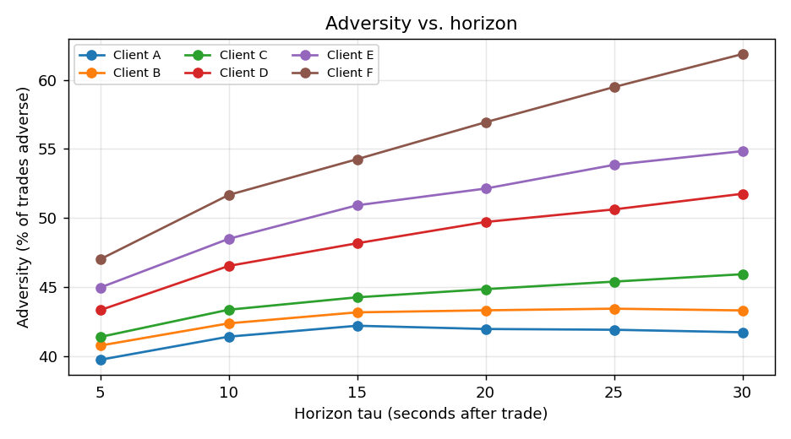

Results table (adversity %, by horizon)
client | τ=5 | τ=10 | τ=15 | τ=20 | τ=25 | τ=30
A | 39.72 | 41.40 | 42.19 | 41.95 | 41.90 | 41.71
B | 40.75 | 42.36 | 43.16 | 43.30 | 43.42 | 43.30
C | 41.37 | 43.35 | 44.25 | 44.84 | 45.39 | 45.92
D | 43.32 | 46.52 | 48.17 | 49.71 | 50.62 | 51.75
E | 44.96 | 48.49 | 50.92 | 52.13 | 53.85 | 54.84
F | 47.01 | 51.67 | 54.26 | 56.94 | 59.49 | 61.88

Trends observed
- 1. Monotone in horizon. For every client adversity rises (or is flat) as τ grows from 5s to 30s. Right after a fill the mid is still close to T_{P}, so roughly half the trades look adverse; as time passes informed flow keeps pushing the mid against us, so more positions would close at a loss. This is the signature of adverse selection / short-horizon drift.
- 2. Clear ranking across clients. A and B stay near 40-43% and almost flat - close to a coin flip, i.e. little information in their flow. C is mildly adverse. D, E and F are progressively worse, with F climbing from ~47% at 5s to ~62% at 30s. The steeper the curve, the more informed (toxic) the client: their trades systematically precede mid moves against us.
- 3. Interpretation for the LP. Clients whose adversity exceeds 50% and grows with τ (E, F, and D at long horizons) are picking us off; clients below 50% (A, B, C) are benign. This ranking directly motivates the per-client spread widening quantified in Task 2.

