Task 2 - Client Profitability and Spread Recommendation
Expected PnL: Per horizon we report the sample mean of side · V · (M_{τ} - T_{P}) (eq. 5); agg_pnl is the sample mean of side · V · (M̅ - T_{P}) with uniform 1/6 weights (eq. 6), where M̅ is the mean of M₅..M₃₀. 'Expected' = sample average per trade.

Results table
client | τ=5 | τ=10 | τ=15 | τ=20 | τ=25 | τ=30 | agg_pnl | δ* | class
A | 1.268 | 1.540 | 1.737 | 2.061 | 2.293 | 2.485 | 1.897 | 0.00000 | profitable
B | 1.211 | 1.342 | 1.542 | 1.726 | 1.909 | 2.059 | 1.632 | 0.00000 | profitable
C | 1.077 | 1.165 | 1.190 | 1.162 | 1.229 | 1.216 | 1.173 | 0.00000 | profitable
D | 0.868 | 0.682 | 0.493 | 0.177 | -0.076 | -0.347 | 0.299 | 0.00961 | profitable
E | 0.653 | 0.303 | -0.108 | -0.572 | -1.069 | -1.614 | -0.401 | 0.01898 | costly
F | 0.445 | -0.176 | -0.917 | -1.751 | -2.614 | -3.629 | -1.440 | 0.03287 | costly
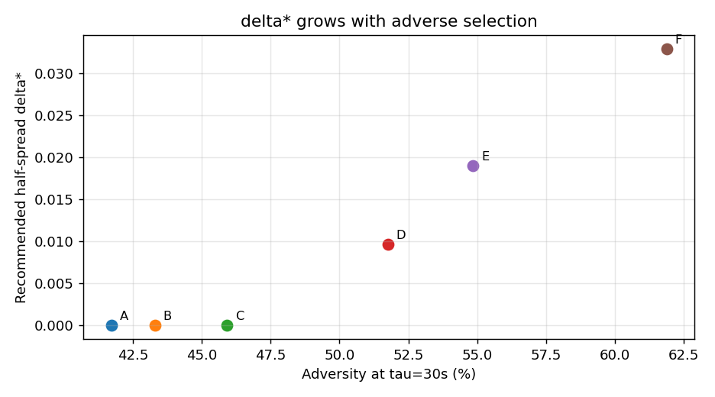

Classification (net-profitable iff agg_pnl >= 0)
Profitable: A (1.897), B (1.632), C (1.173), D (0.299). Costly: E (-0.401), F (-1.440). A, B, C earn positive PnL at every horizon. D is positive in aggregate but its per-horizon PnL turns negative by τ=25-30s, warning that its edge decays. E and F lose money in aggregate: their PnL flips negative early (E by ~15s, F by ~10s) and deteriorates sharply - classic toxic flow.

Minimum half-spread δ*
If we quote M₀ ± δ, the effective fill price is T_{P}^{eff} = M₀ - side · δ, so eq. 6 becomes E[AggPnL(δ)] = A + δ · E[V], with A = E[side · V · (M̅ - M₀)] the aggregate PnL at the mid (δ=0). Requiring non-negativity gives δ* = max(0, -A / E[V]). Results: A=B=C=0 (already profitable at the mid), D=0.0096, E=0.0190, F=0.0329.

Link to Task 1 adversity
δ* is precisely the half-spread that offsets adverse selection. The more adverse a client (Task 1), the more the mid drifts against us after a fill, the more negative A becomes, and the larger δ* must be. The ranking is identical: A,B,C (benign) need no extra spread; D, E, F (rising adversity) require monotonically larger δ*. δ* is the monetary translation of the adversity curve.

