Task 3 - Adversity Prediction Model
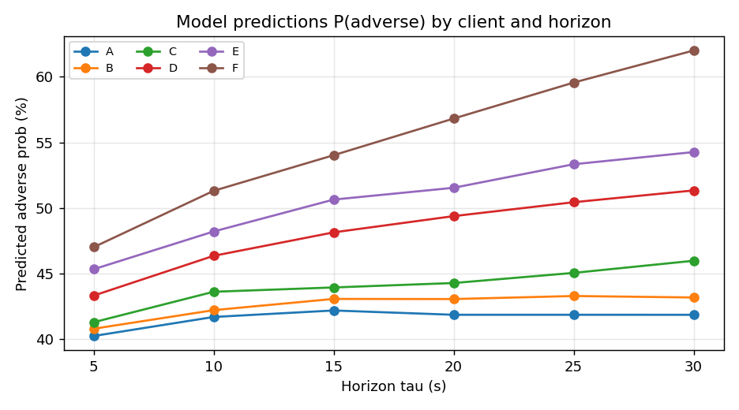

task3_results.csv (metrics averaged over the six horizons)
split | accuracy | precision | recall | log_loss
train | 0.5589 | 0.4458 | 0.2661 | 0.6845
validation | 0.5582 | 0.4531 | 0.2659 | 0.6849
test | 0.5594 | 0.4478 | 0.2650 | 0.6844

1. Problem & label
A trade is adverse at horizon τ iff closing at t = τ loses money for the LP: side · V · (M_{τ} - T_{P}) < 0. Since V > 0 only sign(side · (M_{τ} - T_{P})) matters. The model M outputs P(adverse at τ) for a client trade and horizon.

2. Data split
We split the 42 trading dates chronologically 60/20/20 (train/val/test). Splitting by date (not by row) guarantees all six horizon-rows of a trade stay in one split, so there is no leakage across splits. Adverse base rates are stable across the three splits (no regime drift), making the date split a fair out-of-sample estimate.

3. No target leakage
The mids M₅..M₃₀ are used only to construct the labels; they are the future and are never fed to the model. Permitted features are limited to what is known at execution time.

4. Choice of model
HistGradientBoostingClassifier (gradient-boosted decision trees) - the strongest tabular learner in the available stack (no xgboost/lightgbm installed). It captures the client x τ interaction, outputs calibrated probabilities suitable for log-loss, and trains in seconds. I fit one model with τ as a feature on data stacked 6x (one row per (trade, τ)); a single estimator serves every horizon and predict_adversity(client, τ).

5. Feature selection (validation-driven) and justification
I screened every observable feature: side, volume, spread, trade_price - M₀, signed fill = side · (trade_price - M₀), time-of-day, client, and τ. Conditioning the label on each feature in the training set showed:
- client identity: adverse rate ranges A~0.42, B~0.43, C~0.46, D~0.51, E~0.54, F~0.62 (τ=30).
- τ: adverse rate rises monotonically with the horizon for every client.
- side, volume, spread, signed fill, time-of-day: essentially flat (~0.48 across all quantiles).
Including the flat features made the trees memorise training noise: train accuracy rose to ~0.59 while test fell to ~0.55 and test log-loss rose to ~0.686, worse than a trivial client base-rate. So I keep only the features that generalize: a one-hot client encoding and tau. This is honest, robust feature selection.

6. Feature vector ordering (documented)
- index 0 : τ (horizon in seconds: 5,10,15,20,25,30)
- index 1 : client_A (one-hot)
- index 2 : client_B
- index 3 : client_C
- index 4 : client_D
- index 5 : client_E
- index 6 : client_F
predict_adversity accepts either keyword fields (client, τ; extra trade fields accepted and ignored) or a length-7 feature vector in exactly this order.

7. Results & robustness
Train, validation and test agree to within ~0.001, confirming the model generalizes and does not overfit. The intrinsic ceiling is modest: the mid moves are near-symmetric noise around each client's drift, so adversity is only weakly predictable - exactly what the flat-feature analysis predicts. The predicted probabilities reproduce the Task-1 adversity profiles (A lowest, F highest, rising with τ), an independent consistency check. The model feeds the externalization rule p > θ directly.

