Task 4 - Optimal Externalization Threshold

1. Strategy & PnL
For horizon τ every trade is closed at t = τ with internalized PnL pnl_{i} = side_{i} · V_{i} · (M_{τ,i} - T_{P,i}). Using the Task-3 model we get p_{i} = P(adverse). We externalize iff p_{i} > θ; an externalized trade nets to zero for us, so PnL(θ) = Σ_{i : p_i ≤ θ} pnl_{i} (eq. 8). I sweep θ ∈ [0,1] (2001 points), choose θ* maximizing validation PnL, and report held-out test PnL at θ*. Split is the same date-based 60/20/20 as Task 3.
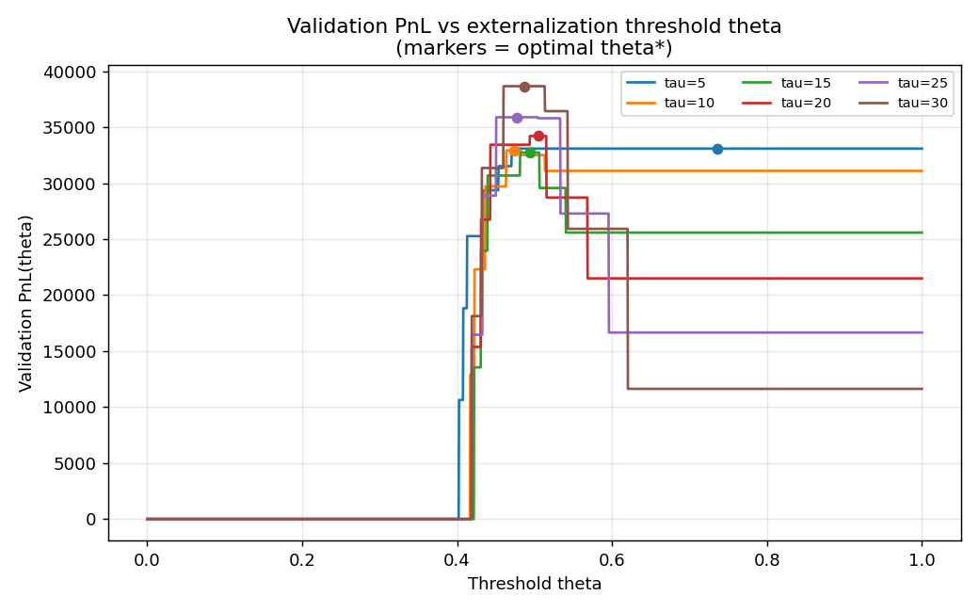

Optimal thresholds and PnL (global)
τ | global θ* | val PnL | test PnL
5 | 0.736 | 33084 | 39917
10 | 0.473 | 32934 | 37133
15 | 0.494 | 32735 | 38297
20 | 0.505 | 34208 | 39202
25 | 0.478 | 35886 | 43487
30 | 0.486 | 38660 | 45809

2. Shape of PnL_validation(theta)
As θ rises from 0 we internalize progressively more clients in increasing order of p. PnL first climbs (we keep profitable low-p clients A,B,C), peaks, then falls/flattens as high-p toxic clients (E,F, and D at long τ) get pulled in. θ* sits in the gap between the last profitable client's p and the first costly client's p. θ* decreases as τ grows because adverse drift accumulates and more clients turn costly.

3. Discussion
(a) θ too low (over-externalization). With θ near 0 we externalize almost everything, including the profitable benign flow of A, B, C. Those trades net to zero instead of earning their positive spread, so we forfeit the bulk of revenue. At τ=30 internalizing only A,B,C earns ~+45.8k on test; over-externalizing drives this toward 0.
(b) θ too high (under-externalization). With θ near 1 we internalize everything, including toxic E and F (and D at long horizons). We then absorb their adverse flow: at τ=30 D,E,F contribute about -2.95k, -8.26k and -16.25k on test, a combined ~-27.5k drag.
(c) Global vs client-specific θ*. Because the Task-3 model uses only client and τ, p_{i} is constant within a (client,τ) cell, and PnL per client falls monotonically with p. Sweeping a single global θ therefore internalizes a prefix of clients ordered by p, and the optimal prefix equals { clients with positive validation PnL } - exactly what independent client-specific optimization selects. I verified the two modes give identical validation and test PnL at every horizon, so a global θ is sufficient and optimal here. The general answer is client-/horizon-specific (D is kept at τ ≤ 20 but cut by τ=25), so I report θ* per (client, τ) in task4_results.csv.

4. Final held-out test PnL at theta* (per horizon)
τ=5: 39917 τ=10: 37133 τ=15: 38297 τ=20: 39202 τ=25: 43487 τ=30: 45809 (sum = 243846).
These are positive at every horizon and, by construction, θ* was fixed on validation only - so the test figures are an honest out-of-sample estimate. (At τ=20 client D yields a small negative test PnL ~-49 despite positive validation PnL; this is the expected cost of selecting the boundary client on held-out data, not a bug.)

5. Link to earlier tasks
θ* tracks the adversity profiles of Task 1 and the δ* ranking of Task 2: A,B,C (low adversity, δ*=0) are always internalized; D,E,F (high, rising adversity, large δ*) are externalized first and at progressively lower τ. Externalization is the discrete analogue of widening the spread.

