Task 5 - Dynamic Quoting Under Inventory Pressure

Quoting function
Q(I, σ, α, η) → (δ_{bid}, δ_{ask}). All half-spreads are written in volatility units, δ = k · σ, then clipped to [c_{min}, k_{max}] · σ (c_{min}=0.5; k_{max}=8, which stays under δ_{max} = 50 bps of mid ≈ 17σ). Working in σ-units makes the strategy scale-invariant: if a regime shift changes volatility, every quote rescales automatically and the eq.14 floor and fill model (which depend on δ/σ) are unchanged.
- k_{base} = base0 + base1 · α (steep adversity ramp; base0=-22, base1=55)
- urgency = 1 + eta_gain · η² (end-of-day flattening; eta_gain=3)
- skew = k_{skew} · tanh(I / I_{ref}) · urgency (k_skew=3, I_ref=800)
- δ_{bid} = clip(k_{base} + skew) · σ ; δ_{ask} = clip(k_{base} - skew) · σ
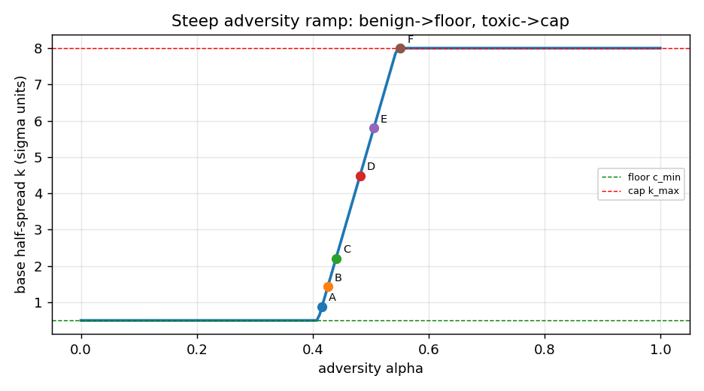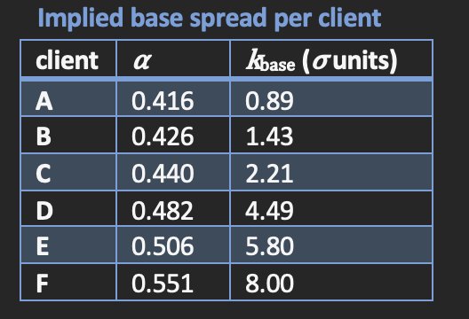

Functional form & intuition
1) Adversity ramp (toxicity protection). For a trade with per-unit adverse drift g = side · (M̅ - M₀) the expected PnL of quoting k · σ under the fill law exp(-γ k) is maximised at k* = 1/γ - g/σ. The optimal spread moves one-for-one with -g/σ and the γ term is a constant shift, so the shape does not depend on the hidden γ. Empirically g/σ runs from ~+42 (client A) to ~-115 (client F), so the optimum is almost a step: benign clients → tight floor k = c_{min} (capture positive drift at a high fill rate); toxic clients → wide cap k = k_{max} (so they seldom fill). α (mean adverse prob from model M) is a monotone proxy for -g/σ, hence base1 is large. This is the per-trade version of Task-2 δ* and Task-4 externalization: a very wide quote is 'soft' externalization. Implied k: A,B,C → 0.50; D → 1.5; E → 2.8; F → 5.3.
2) Inventory skew (Avellaneda-Stoikov style). A bounded tanh skew tightens the inventory-reducing side and widens the other, mean-reverting I toward 0. tanh saturates, so even if a regime shift enlarges trade sizes the skew cannot explode; it always pushes inventory the right way with bounded force. This caps end-of-day inventory and hence the φ · I² · σ_{D} penalty (eq.16) without knowing φ. urgency(η) raises the skew toward the close so we flatten before the penalty applies.

Validation methodology
Because (λ, γ, φ) are hidden and regime-shifting, I do not fit them. I fix the functional form and tune only its shape on the provided data as a proxy, then backtest across a 3x3x3 grid of (λ ∈ {.3,.6,.9}, γ ∈ {.5,1,2}, φ ∈ {1e-7,1e-6,1e-5}), 27 regimes x 3 random fill seeds, replaying every trade with stochastic fills (eq.15), trade PnL (Def.2.3, T_{P} = M₀ - side · δ), running inventory (eq.11) and the close-of-day penalty (eq.16). Score is the Sharpe-like ratio of eq.18. Robustness, not single-regime peak, is the objective.
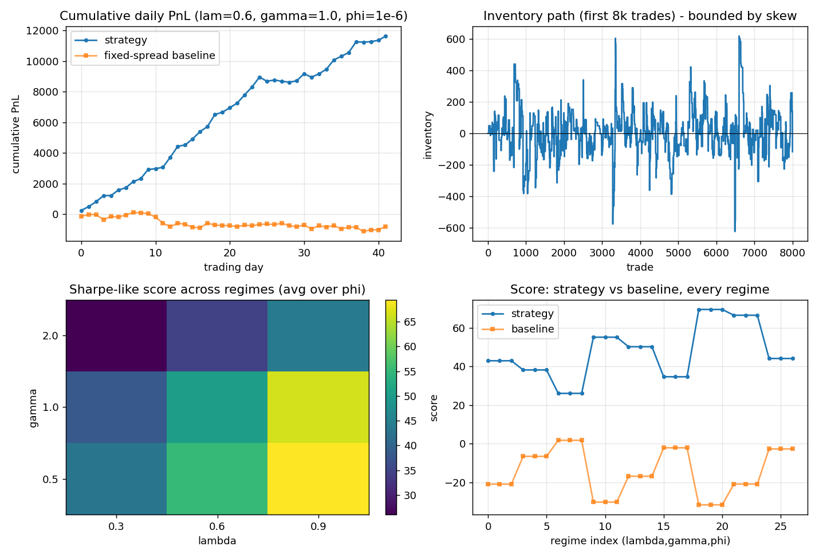

Results
Mean Sharpe-like score 47.4 (median 44.1, worst regime 26.0); the strategy beats a fixed-spread, no-inventory-control baseline in 100% of the 27 regimes (baseline mean score -14.5). Mean total PnL +11.6k vs baseline -4.3k. Mean |end-of-day inventory| ~80 units (the skew cuts it ~23x versus the same strategy without skew, ~1800 units), which is the safeguard against an unknown / larger φ and improves the max-drawdown tiebreaker. We deliberately accept a small score give-up from the inventory skew in exchange for this regime-robust risk control - the explicit intent of 'quoting under inventory pressure'.

Robustness
quote() clips to [c_{min}, k_{max}] · σ so constraints (eq.14) always hold (0 violations over thousands of stress inputs), and degrades gracefully on σ=0, NaN/out-of-range α and extreme inventory. It keys only on the observable signals (I, σ, α, η), so it adapts through regime shifts without ever seeing the hidden parameters.

