PROJECT REPORT
Factory-to-Customer
Shipping Route Efficiency
Analysis

A Data Science and Business Analysis Project for Shipping performance, Route efficiency, Sales and Profitability
REPORT DETAILS
Author | Divyesh Chavda
Qualification | B.E. Artificial Intelligence and Data Science
Project type | Data science internship Project
Dataset | Nassau Candy Distributor
Records | 10,194
Python | Pandas | NumPy | Matplotlib | Seaborn | Plotly | Streamlit

Table of Contents
Executive Summary 3
1. Introduction 4
1.1 Project Objectives 4
1.2 Scope 4
2. Dataset and Project Data 5
2.1 Original Features 5
2.2 Engineered Features 5
2.3 Dataset Summary 5
2.4 Data Quality Checks 5
3. Project Methodology 7
3.1 Data Ingestion 7
3.2 Data Transformation 7
3.3 Route Analysis 7
3.4 Route Score 7
3.5 Dashboard Layer 7
4. Exploratory Data Analysis 8
4.1 Univariate Findings 8
4.2 Correlation Structure 8
5. Ship Mode Performance Analysis 9
6. Regional Performance Analysis 11
7. State and City Shipping Analysis 12
7.1 City-Level Findings 12
8. Route Performance Score 13
8.1 Low Route Scores 14
9. Sales, Cost and Profitability Analysis 15
10. Product and Sales Analysis 16
11. Interactive Streamlit Dashboard 17
12. Key Findings and Recommendations 18
13. Project Limitations 19
14. Conclusion 20
15. References 21
Appendix A — Core Formulas 22
Appendix B — Technology Stack 22

Executive Summary
This project presents an end-to-end data science and business analytics solution for analyzing factory-to-customer shipping performance using the Nassau Candy Distributor dataset.
The dataset contains 10,194 transaction records and 18 original features covering orders, dates, shipping methods, customer locations, products and financial measures.
The project performs data ingestion, data transformation, feature engineering, exploratory data analysis, route analysis, business KPI calculation and interactive dashboard development.
Two analytical features are created: Shipping Days and Profit Margin (%). A project-defined Route Score is calculated as Total Profit divided by Average Shipping Days for city groups with at least 10 orders.
The analysis shows a strong correlation of 0.98 between Sales and Gross Profit. Second Class records the highest average sales and gross profit among ship modes, while Pacific records the highest average sales and gross profit among regions.
A major data-quality issue is identified because recorded Shipping Days range from 491 to 1,965 days. Therefore, Shipping Days is used primarily for comparative analysis within the dataset rather than as an absolute real-world delivery-time benchmark.
KEY FINDINGS AT A GLANCE
10,194  transaction records, 18 original features | $141,783.63  total sales; total gross profit $93,442.80 | 66.51%  average profit margin across all orders
0.98  correlation between sales and gross profit | 5.97  top Route Score, achieved by New York City | 491–1,965  range of recorded shipping days (data-quality flag)

1. Introduction
The Factory-to-Customer Shipping Route Efficiency Analysis project analyzes shipping performance together with sales, cost, gross profit, profit margin and product activity using transaction-level data.
The project follows an end-to-end data science workflow that converts raw transaction data into analytical insights through data preprocessing, feature engineering, exploratory data analysis, route analysis and dashboard visualization.
The objective is to compare shipping and business performance across Ship Mode, Region, State and City and to provide an interactive dashboard for further analysis.

1.1 Project Objectives
- Analyze shipping performance using the derived Shipping Days variable.
- Compare shipping performance across different Ship Modes.
- Compare Regions based on sales, gross profit and shipping duration.
- Analyze State and City-level shipping performance.
- Calculate business KPIs including Sales, Cost, Gross Profit, Units and Profit Margin.
- Analyze the relationship between Sales and Gross Profit.
- Calculate a project-defined Route Score for city-level comparison.
- Analyze product-level sales and profitability.
- Develop an interactive Streamlit Dashboard for data exploration.

1.2 Scope
The scope is limited to the data and functionality implemented in the project. It includes ingestion of the Nassau Candy Distributor CSV file, transformation of dates, feature engineering, validation, exploratory data analysis, route analysis and dashboard presentation. It does not introduce external logistics datasets, external benchmarks, machine-learning predictions or assumptions about actual carrier performance.

1.3 Industry Orientation
The project is structured in a form that can support operational review: users can filter the data by region, state and ship mode, inspect KPIs, compare route groups and export filtered data. This makes the solution relevant to data-driven shipping and distribution analysis while keeping the conclusions tied to the supplied dataset.

2. Dataset and Project Data
The project uses the Nassau Candy Distributor dataset stored in the project data directory. The raw dataset contains 10,194 records and 18 original features. The fields cover order identification, dates, shipping method, customer and geographic information, product information and financial measures.

2.1 Original Features
Row ID, Order ID, Order Date, Ship Date, Ship Mode, Customer ID, Country/Region, City, State/Province, Postal Code, Division, Region, Product ID, Product Name, Sales, Units, Gross Profit and Cost.

2.2 Engineered Features
- Shipping Days = Ship Date − Order Date, calculated in days.
- Profit Margin (%) = (Gross Profit / Sales) × 100.

2.3 Dataset Summary
Table 1: Dataset summary
Measure | Value
Records | 10,194
Original features | 18
Processed features | 20
Total Sales | $141,783.63
Total Gross Profit | $93,442.80
Total Cost | $48,340.83
Total Units | 38,654
Average Shipping Days | 1,344.24 days
Average Profit Margin | 66.51%

The engineered dataset retains the original transaction-level information and adds the two analytical variables required by the project. This preserves traceability from raw data to dashboard metrics.

2.4 Data Quality Checks
The dataset was checked for missing values, duplicate records, date consistency and invalid Shipping Days values.
- Date columns were converted to datetime values.
- Shipping Days was checked for missing values.
- Negative Shipping Days were checked.
- No missing values were identified in the EDA.
- No duplicate records were identified.
- Outliers were retained for analysis.
important data quality finding
Recorded Shipping Days range from 491 to 1,965 days, which is unusually high for normal shipping operations. Therefore, these values are treated as a data-quality limitation and are used mainly for comparative analysis within the dataset.

3. Methodology
The project follows the following analytical pipeline:
Raw Dataset → Data Ingestion → Data Transformation → Feature Engineering → Route Analysis → Business KPIs → Streamlit Dashboard
Each stage converts the raw transaction data into a structured output that is used by the next stage of the project.
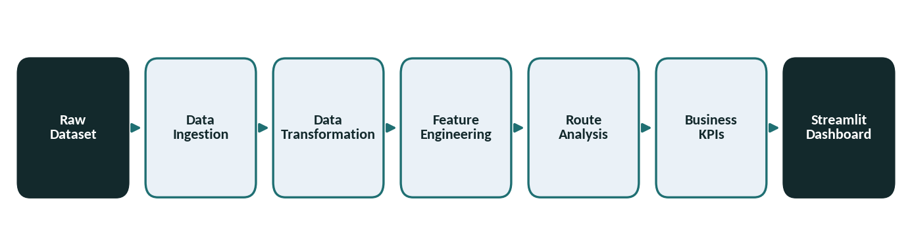
Figure 1: Project pipeline

3.1 Data Ingestion
The DataIngestion component reads the CSV file from the project data directory and stores a raw copy as artifacts/raw_data.csv. Logging records successful loading and saving steps, and exceptions are passed through the project's CustomException mechanism.

3.2 Data Transformation
The DataTransformation component reads the raw dataset, converts Order Date and Ship Date into datetime values, creates Shipping Days and Profit Margin (%), validates the derived shipping duration, and writes the processed dataset to artifacts/processed_data.csv.

3.3 Route Analysis
The RouteAnalysis component calculates KPIs and grouped summaries. Ship mode summaries contain average sales, average profit, average shipping days and total orders. Region and state summaries use similar operational and financial measures. City-level analysis additionally calculates Route Score.

3.4 Route Score
Route Score is defined as Total Profit divided by Average Shipping Days. For best- and worst-route tables, only cities with at least 10 orders are included. This threshold reduces the influence of extremely small transaction groups in the route comparison, although low-volume locations still require careful interpretation.

3.5 Dashboard Layer
The Streamlit application loads the processed data, applies sidebar filters and calculates filtered KPIs. The interface is organized into Overview, Route Analysis, Sales Analysis, Product Analysis and Data Explorer sections, with Plotly visualizations providing interactive views of the results.

4. Exploratory Data Analysis
Exploratory data analysis was used to understand the distributions and relationships present in the transaction data before interpreting route performance. The notebook examines Sales, Units, Cost, Gross Profit, Shipping Days and Profit Margin (%), followed by bivariate analysis across ship modes, regions and financial variables.

4.1 Univariate Findings
Univariate analysis was performed to understand the distribution of Sales, Units, Cost, Gross Profit, Shipping Days and Profit Margin.
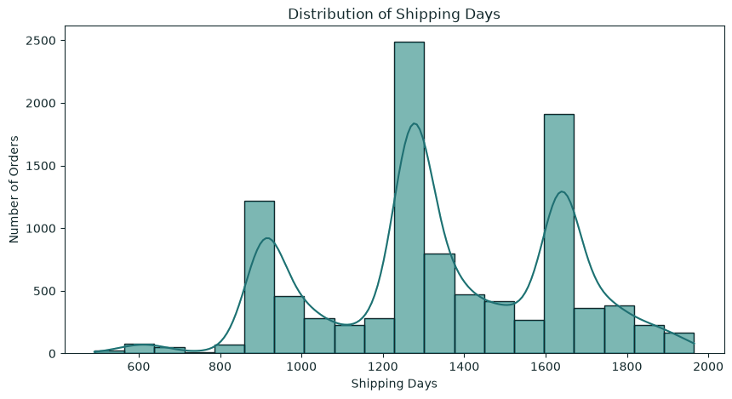
Figure 2: Distribution of Shipping Days
Observation:
The distribution of Shipping Days is multimodal, with multiple peaks across the dataset. The recorded values show unusually high shipping durations, indicating a data-quality limitation. Therefore, Shipping Days is mainly used for comparative analysis within the dataset.

4.2 Correlation Structure
The correlation matrix (Figure 2) shows strong positive relationships among Sales, Units, Gross Profit and Cost. Shipping Days has very weak correlations with the other variables, indicating that recorded shipping duration is largely independent of financial performance. Profit Margin (%) shows weaker relationships overall, including a moderate negative correlation with Cost (−0.30).
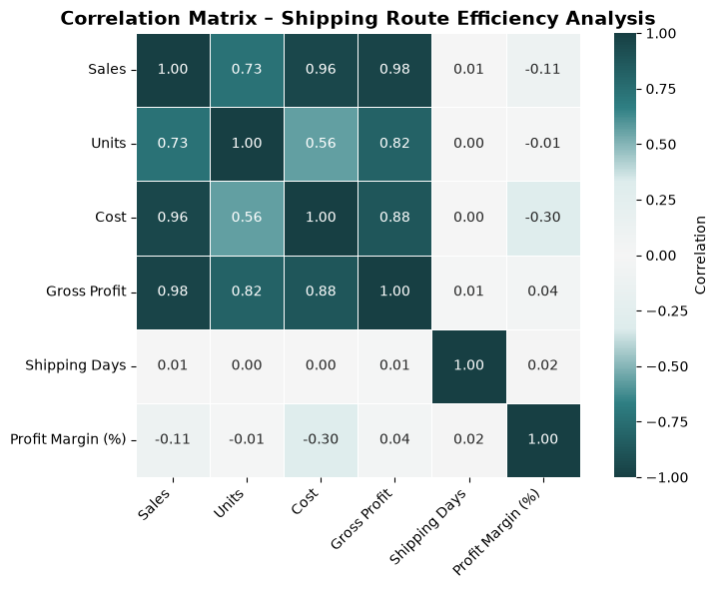
Figure 3: Correlation matrix of Shipping and Business Variables

5. Ship Mode Performance Analysis
Ship mode analysis compares First Class, Same Day, Second Class and Standard Class using average sales, average gross profit, average shipping days and order counts. The objective is to determine whether the shipping method is associated with material differences in the financial and time variables available in the dataset.
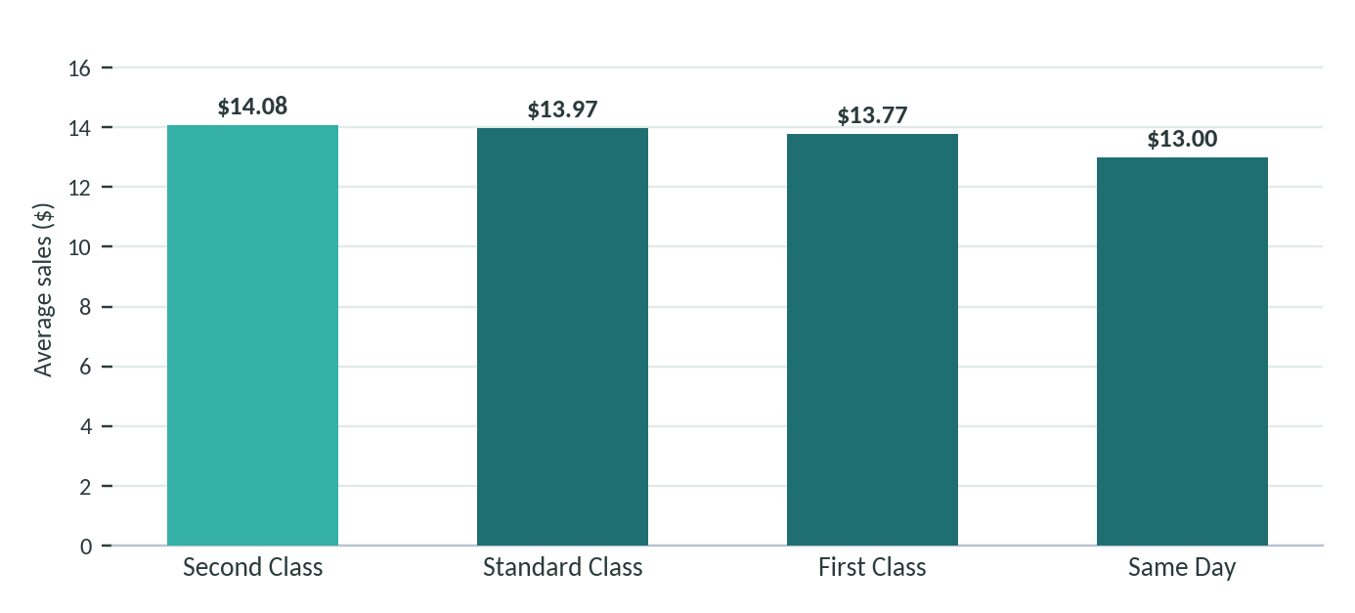
Figure 4: Average sales by ship mode
Table 2: Ship mode summary
Ship Mode | Avg. Sales | Avg. Profit | Avg. Shipping Days | Total Orders
Second Class | $14.08 | $9.25 | 1,352.12 | 1,979
Standard Class | $13.97 | $9.22 | 1,336.58 | 6,120
First Class | $13.77 | $9.05 | 1,360.13 | 1,548
Same Day | $13.00 | $8.59 | 1,356.49 | 547

Second Class has the highest average sales at $14.08 and the highest average gross profit at $9.25. Same Day has the lowest average sales at $13.00 and the lowest average gross profit at $8.59. The differences are small relative to the overall level of the measures.
Average shipping days range from 1,336.58 for Standard Class to 1,360.13 for First Class (Figure 4). The project therefore does not observe the expected operational ordering in which faster shipping methods would necessarily show shorter recorded durations. The small differences support the conclusion that ship mode has limited separation in this dataset.
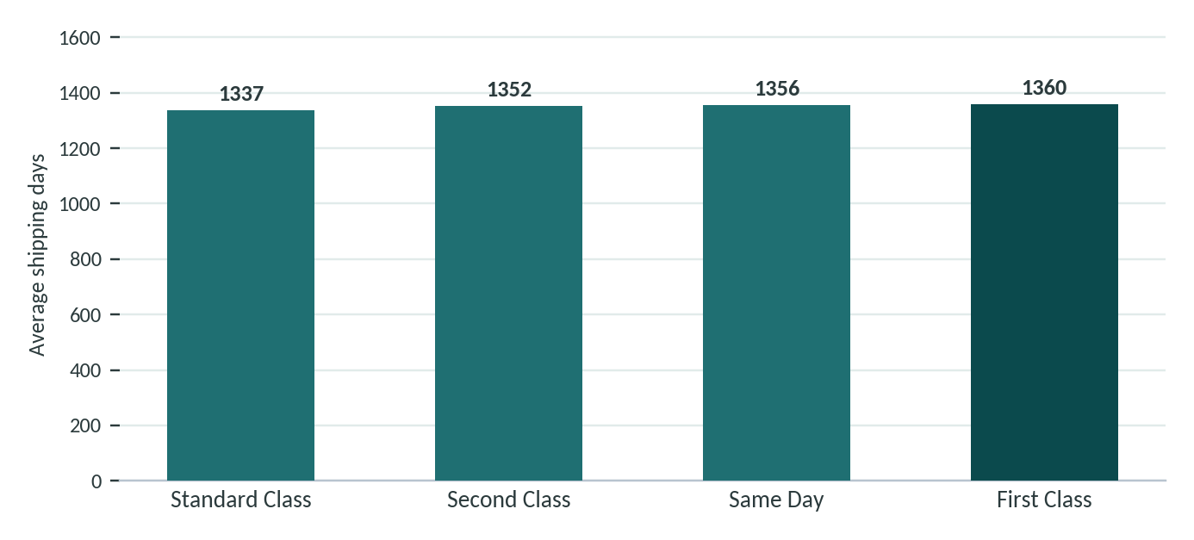
Figure 5: Average shipping days by ship mode
Interpretation note
For an industry dashboard, this comparison can be used as a monitoring view rather than a causal conclusion. The data supports comparing the observed averages, but it does not establish that changing ship mode would cause sales or profit to change.

6. Regional Performance Analysis
Regional analysis examines Pacific, Atlantic, Interior and Gulf across sales, gross profit, shipping duration and order count. The objective is to locate differences that may be useful for operational review and commercial comparison.
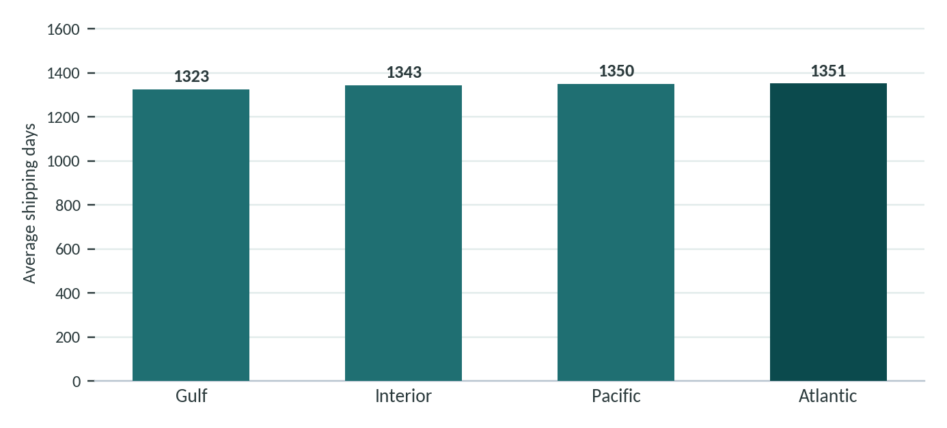
Figure 6: Average shipping days by region
Table 3: Regional summary
Region | Avg. Sales | Avg. Profit | Avg. Shipping Days | Total Orders
Atlantic | $13.80 | $9.03 | 1,350.57 | 2,986
Gulf | $13.73 | $9.07 | 1,323.10 | 1,620
Interior | $13.72 | $9.11 | 1,343.31 | 2,335
Pacific | $14.23 | $9.37 | 1,349.62 | 3,253

Pacific records the highest average sales at $14.23 and the highest average gross profit at $9.37. Interior records the lowest average sales at $13.72. Atlantic has the highest average shipping duration at 1,350.57 days, while Gulf has the lowest at 1,323.10 days.
The regional differences in shipping duration are comparatively small. The project therefore does not identify a strong regional bottleneck from this dataset alone. Atlantic can nevertheless be highlighted in the dashboard for additional review because it has the highest observed average shipping duration.

6.1 Business Use
The regional view provides a compact management layer: financial performance can be reviewed alongside shipping duration, and filters can be used to investigate a region further by state, city, ship mode or product.

7. State and City Shipping Analysis
State and city analysis provides more granular views of shipping duration. The project calculates average Shipping Days, order count, total sales and total profit for each state and city (Figure 6).
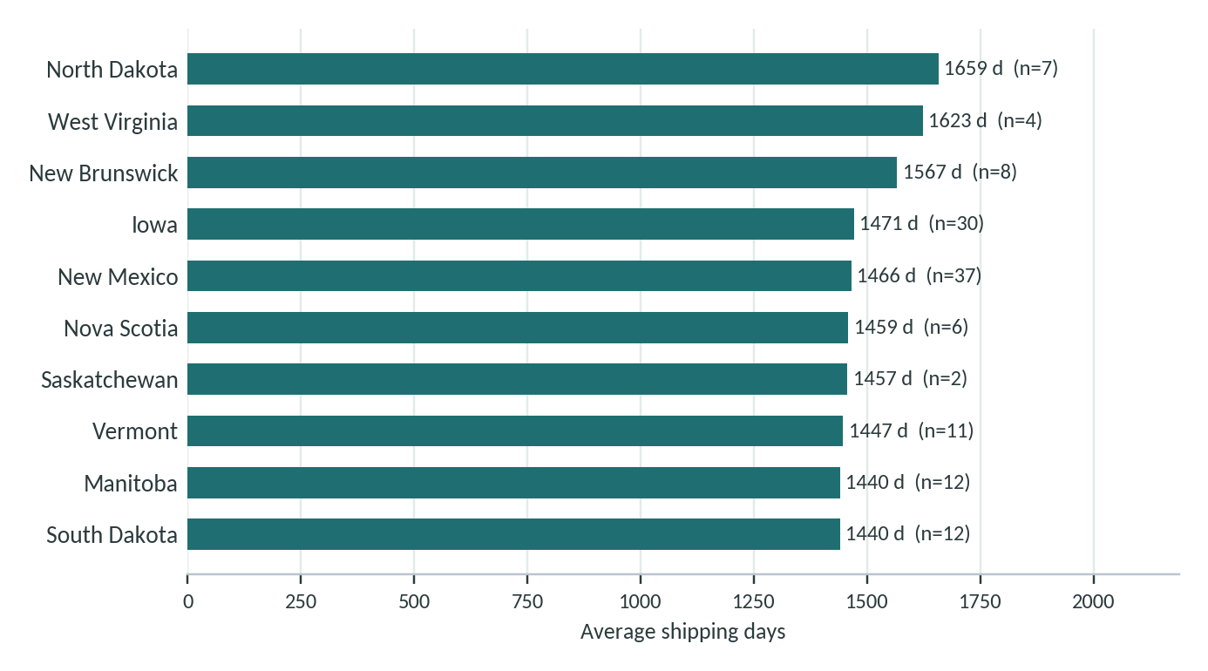
Figure 7: Ten states with the highest average shipping days
North Dakota has the highest average shipping duration at 1,658.57 days, but only 7 orders are present in the dataset. This illustrates why volume must be considered when interpreting location-level results. Several other high-duration states also have relatively small order counts.

7.1 City-Level Findings
Saginaw records the highest average shipping duration in the completed EDA. Romeoville records the lowest average shipping duration. Many cities in the fastest and slowest groups have low transaction counts, so the rankings should be treated as comparative observations rather than definitive operational diagnoses.
This city-level structure is important for an industry-oriented dashboard because a regional average can hide location-level variation. The Data Explorer and route tables allow the analyst to move from a high-level region view to individual cities.

8. Route Performance Score
To combine profitability and shipping duration into a single comparative indicator, the project calculates Route Score as Total Profit divided by Average Shipping Days. The metric is used only as a project-defined comparative score; it is not presented as a standard external logistics metric (Figure 7).
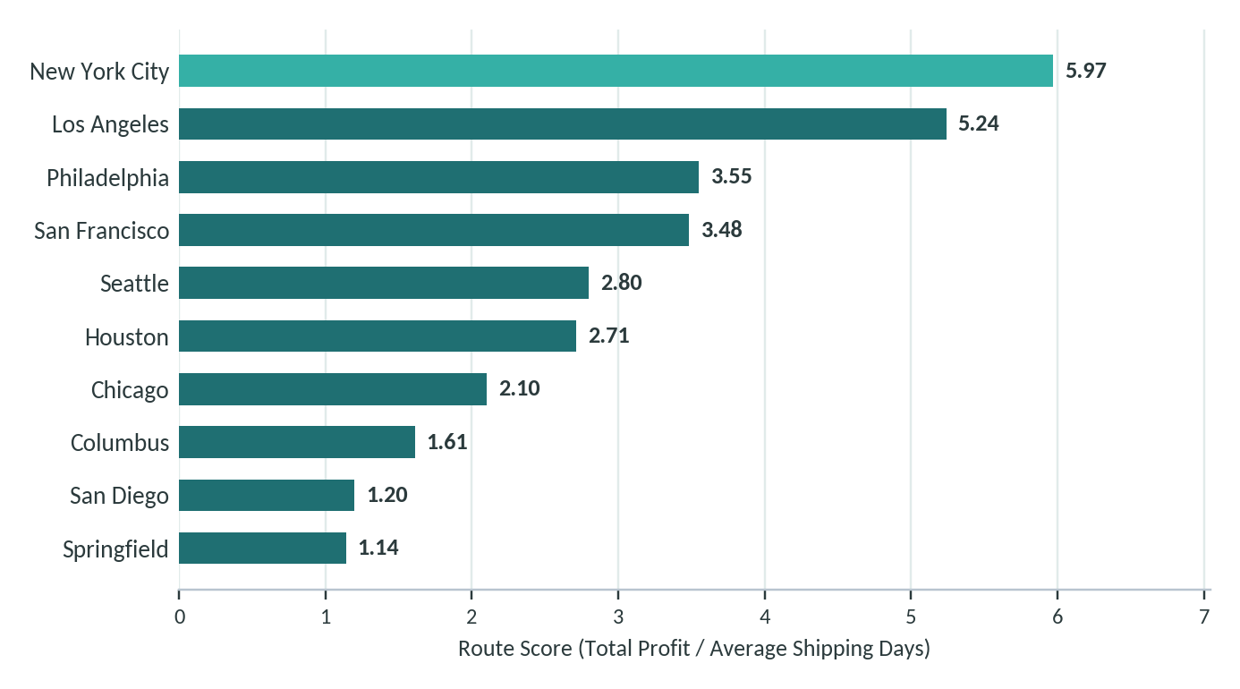
Figure 8: Highest Route Scores among cities with at least 10 orders
Table 4: Top route-performance results
City | Avg. Ship. Days | Orders | Sales | Profit | Route Score
New York City | 1,379.48 | 915 | $12,514.90 | $8,240.51 | 5.97
Los Angeles | 1,316.20 | 747 | $10,408.75 | $6,898.61 | 5.24
Philadelphia | 1,354.35 | 537 | $7,415.52 | $4,813.82 | 3.55
San Francisco | 1,336.25 | 510 | $7,018.61 | $4,650.77 | 3.48
Seattle | 1,385.93 | 428 | $5,893.39 | $3,880.68 | 2.80
Houston | 1,310.59 | 377 | $5,429.41 | $3,547.43 | 2.71
Chicago | 1,335.61 | 314 | $4,263.92 | $2,800.58 | 2.10
Columbus | 1,343.30 | 222 | $3,357.39 | $2,159.03 | 1.61
San Diego | 1,301.46 | 170 | $2,348.88 | $1,567.52 | 1.20
Springfield | 1,350.96 | 163 | $2,375.00 | $1,540.12 | 1.14

New York City has the highest Route Score among the filtered city groups, followed by Los Angeles and Philadelphia. These cities also have substantially larger order counts than many low-volume locations, making their comparative results more stable within this dataset.

8.1 Low Route Scores
Table 5: Lowest route scores among cities with at least 10 orders
City | Avg. Ship. Days | Orders | Sales | Profit | Route Score
Boynton Beach | 1,436.50 | 10 | $99.19 | $67.43 | 0.05
Belleville | 1,450.60 | 10 | $111.82 | $74.32 | 0.05
Bowling Green | 1,427.00 | 10 | $105.40 | $70.50 | 0.05
Carlsbad | 1,525.45 | 11 | $120.74 | $80.40 | 0.05
Freeport | 1,344.20 | 10 | $100.83 | $68.51 | 0.05
Meriden | 1,358.27 | 11 | $114.30 | $73.14 | 0.05
Suffolk | 1,411.00 | 10 | $113.98 | $75.76 | 0.05
Amarillo | 1,349.10 | 10 | $113.97 | $76.13 | 0.06
Madison | 1,513.70 | 10 | $133.72 | $91.72 | 0.06
Manchester | 1,545.00 | 11 | $146.89 | $99.57 | 0.06

The lowest scores are close to zero because the corresponding cities have low total sales and profit relative to their recorded shipping duration. Reviewing such cities together with transaction volume is recommended before making operational decisions.

9. Sales, Cost and Profitability Analysis
Financial analysis is integrated with route analysis because shipping performance is evaluated alongside sales and gross profit. The project calculates total sales, total cost, total gross profit, total units and profit margin as executive indicators.

9.1 Key Financial Results
- Total Sales: $141,783.63
- Total Gross Profit: $93,442.80
- Total Cost: $48,340.83
- Total Units: 38,654
- Average Sales per Order: $13.91
- Average Profit Margin: 66.51%
The Sales versus Gross Profit scatter plot (Figure 8) shows a clear upward relationship. The calculated correlation is 0.98, indicating a very strong positive linear relationship in the supplied dataset. This means higher-sales transactions generally correspond to higher gross profit within the observed records.
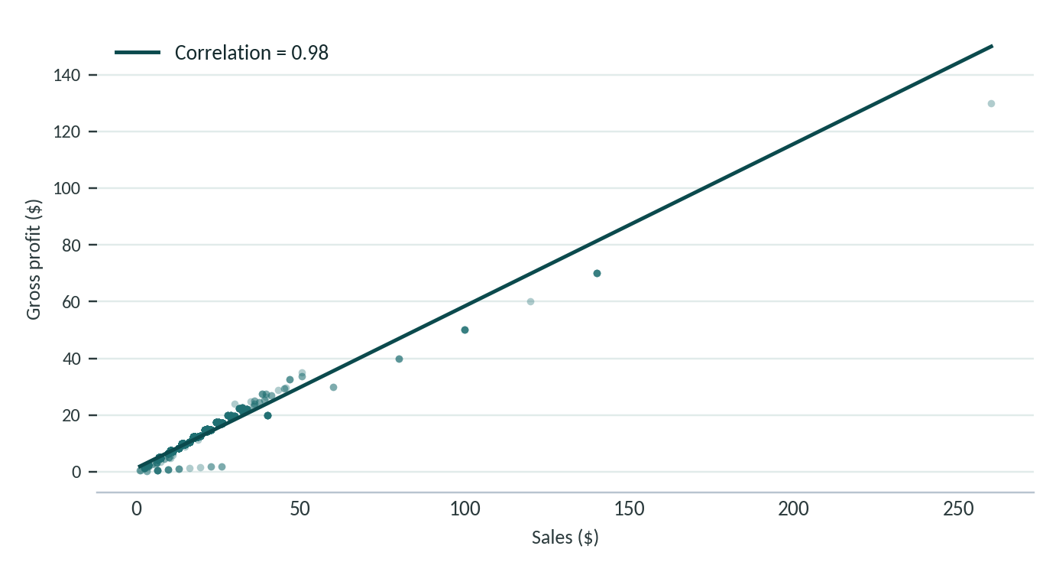
Figure 9: Relationship between Sales and Gross Profit
The correlation analysis in Section 4.2 also reports a strong relationship between Sales and Cost. Shipping Days has a comparatively weak relationship with the financial variables, while Profit Margin has only a weak relationship with Sales and Gross Profit and a modest negative relationship with Cost. Correlation is used here for descriptive analysis and is not interpreted as proof of causation.

10. Product and Sales Distribution Analysis
The dashboard includes product-level views because route efficiency is connected to the commercial composition of orders. Product analysis covers profit by product, top products by sales and a bubble-style comparison of sales, profit and units.

10.1 Product-Level Dashboard Views
- Profit by Product identifies products with higher contribution to gross profit.
- Top Products identifies products with higher sales contribution.
- Sales versus Profit combines sales and profit with units as an additional visual dimension.
- Sales by Division compares contribution across the project's product divisions.

10.2 Sales Distribution
The EDA reports a positively skewed Sales distribution, meaning many transactions have relatively low sales values while a smaller number of high-value transactions contribute disproportionately to total sales. The Units distribution similarly shows that most orders contain relatively small quantities, with bulk purchases occurring less frequently.

10.3 Operational Relevance
These product and sales views allow a business analyst to connect route performance with the commercial transactions traveling through the network. Because the project does not model causality, these views are intended for descriptive investigation and dashboard-based monitoring.

11. Interactive Streamlit Dashboard
The completed project converts the analytical workflow into an interactive Streamlit dashboard, designed for users who need to move from summary KPIs to detailed route, sales, product and transaction-level views.

11.1 Dashboard Structure
- Executive KPI cards for sales, profit, orders, units, average shipping days and profit margin.
- Overview tab for regional sales, regional profit, sales versus profit and shipping days by ship mode.
- Route Analysis tab for route summary, fastest and slowest cities, state-level shipping and regional shipping.
- Sales Analysis tab for monthly sales, ship mode, division and sales distribution.
- Product Analysis tab for profit by product, top products and sales-versus-profit relationships.
- Data Explorer for filtered transaction data and CSV download.
- Sidebar filters for region, state and ship mode.

11.2 Dashboard Workflow
The application loads artifacts/processed_data.csv, applies the selected filters and recalculates KPIs from the filtered dataset. This design keeps the displayed metrics consistent with the selected analytical scope. If no records match the filters, the dashboard displays a warning and stops the current analysis view.

11.3 Dashboard Usage
The dashboard provides an interactive interface for exploring shipping, route, sales and product performance.
Users can apply filters and move from high-level KPIs to detailed route, product and transaction-level analysis.

12. Key Findings and Recommendations

12.1 Key Findings
- The dataset contains 10,194 transaction records.
- Total Sales are $141,783.63.
- Total Gross Profit is $93,442.80.
- Average Profit Margin is 66.51%.
- Sales and Gross Profit have a correlation of 0.98.
- Second Class records the highest average sales and gross profit among ship modes.
- Pacific records the highest average sales and gross profit among regions.
- Atlantic records the highest average shipping duration among regions.
- New York City records the highest Route Score among city groups meeting the 10-order threshold.
- Recorded Shipping Days range from 491 to 1,965 days, so the metric requires caution for real-world interpretation.

12.2 Project-Based Recommendations
Table 6: Findings, implications and recommended actions
Finding | Recommended action
Shipping Days are unusually high | Verify source date fields and re-calculate Shipping Days after correction
Some locations have low order counts | Consider order volume while interpreting city/state results
Regional shipping differences exist | Monitor regional shipping performance through dashboard
Route Score is project-defiined | Use it only as a comparative project metric
Product sales and profit vary | Monitor top products through Product Analysis
Factory coordinates are available | Future version can add geographic route visualization after reliable Factory-to-Customer mapping.

These recommendations are limited to the evidence produced by the project. They are intended as analytical follow-up actions rather than claims that a particular operational change will produce a specific outcome.

13. Project Limitations

13.1 Dataset Limitation
The largest limitation is the Shipping Days field. The project records a range of 491 to 1,965 days, with a mean of 1,344.24 days. The EDA describes the distribution as multimodal, and these durations are unusually high compared with real-world logistics. The project should not be used to claim that these absolute durations represent normal delivery operations.

13.2 Analytical Limitation
The project is descriptive. It identifies associations and comparative patterns but does not estimate causal effects. For example, the higher average sales associated with Second Class does not prove that Second Class shipping causes higher sales.

13.3 Route Score Limitation
Route Score is a project-defined ratio of total profit to average shipping days. It is useful for consistent comparison within the dataset, but its interpretation depends on the quality of both profit and shipping-duration measurements. Low-volume locations should receive additional scrutiny.

13.4 Industry Applicability
The project architecture is suitable as a foundation for an industry analytics workflow because it separates ingestion, transformation, route analysis and dashboard presentation. In a real deployment, the same structure could consume validated operational data; however, this paper does not introduce such external data or claim that the current dataset represents actual logistics performance.

13.5 Reproducibility
The project includes source modules, a notebook for EDA, processed artifacts and a Streamlit application. This organization supports repeatable execution of the implemented analysis and makes the transformation logic explicit.

14. Conclusion
The Factory-to-Customer Shipping Route Efficiency Analysis project demonstrates an end-to-end data science workflow for analyzing shipping, route, sales and profitability data.
The project performs data ingestion, preprocessing, feature engineering, exploratory data analysis, route analysis, KPI calculation and interactive Streamlit dashboard development.
The analysis provides comparative insights across ship modes, regions, states, cities and products.
The project also identifies an important data-quality issue in the recorded Shipping Days values. Therefore, the current results are appropriate for comparative analysis within the supplied dataset rather than absolute real-world delivery benchmarking.
The developed dashboard provides an interactive interface for filtering and exploring shipping and business performance.

15. Project References
- README.md — Project overview
- EDA.ipynb — Exploratory Data Analysis
- data_ingestion.py — Data ingestion
- data_transformation.py — Data transformation and feature engineering
- route_analysis.py — Route and KPI analysis
- charts.py — Dashboard visualizations
- app.py — Streamlit dashboard
- processed_data.csv — Processed dataset
- factory_coordinates.csv — Factory reference coordinates

Appendix A — Core Formulas
- Shipping Days = Ship Date − Order Date
- Profit Margin (%) = (Gross Profit / Sales) × 100
- Route Score = Total Profit / Average Shipping Days

Appendix B — Technology Stack
- Python
- Pandas
- NumPy
- Matplotlib
- Seaborn
- Plotly
- Streamlit
- Scikit-learn (included in project requirements)

