DATA SCIENCE INTERNSHIP REPORT
Customer Retention
Analysis

Historical churn patterns, retention KPIs and risk scoring in banking customer data
REPORT DETAILS

Prepared by | Divyesh Chavda
Role | Data Science Intern
Organization | Unified Mentor
Document type | Internship project report

Python | Pandas | NumPy | Matplotlib | Seaborn | Plotly | Streamlit

Table of Contents
Executive Summary 3
1. Introduction 4
2. Problem Statement 4
3. Objectives 4
4. Dataset Description 5
5. Methodology 5
5.1 Data Validation 6
5.2 Data Cleaning and Feature Engineering 6
5.3 Exploratory Data Analysis 6
5.4 Key Performance Indicator Development 7
5.5 Retention Risk Scoring 7
5.6 High-Value Disengaged Customer Identification 7
5.7 Interactive Dashboard Development 8
5.8 Tools and Technologies 8
6. Results and Discussion 8
6.1 Overall Churn and Retention 8
6.2 Customer Engagement and Churn 9
6.3 Geographic Analysis 9
6.4 Product Utilization and Churn 10
6.5 Age-Based Analysis 10
6.6 Credit Card Ownership and Churn 10
6.7 High-Value Disengaged Customers 11
6.8 Relationship Strength Analysis 11
6.9 Retention Risk Scoring 11
6.10 KPI Summary 11
6.11 Overall Discussion 11
7. Business Recommendations 12
8. Limitations 13
9. Conclusion 13
10. Future Scope 13
11. References 14

Executive Summary
Customer retention is an important challenge for banking institutions because customer churn can negatively affect long-term revenue and relationship value. This study analyzes customer engagement, product utilization, financial value and demographic characteristics using a banking customer dataset containing 10,000 records. Python-based data cleaning, exploratory data analysis, KPI development, customer segmentation and retention risk scoring were used.
The analysis found an overall historical churn rate of 20.37%. Inactive customers had a higher churn rate of 26.85% compared with 14.27% among active customers. Germany recorded the highest churn rate at 32.44%, while two-product customers showed a lower churn rate of 7.58% compared with 27.71% among single-product customers. Customers aged 45–64 also showed higher historical churn rates.
The study developed retention KPIs, a Relationship Strength Index and a rule-based Retention Risk Score. Additionally, 49.88% of high-balance customers were identified as inactive, highlighting a potential high-value retention segment. The findings were integrated into an interactive Streamlit dashboard to support customer segmentation and retention analysis.
KEY FINDINGS AT A GLANCE
10,000  customer records analyzed | 20.37%  overall historical churn rate | 26.85%  churn among inactive customers (14.27% among active customers)
32.44%  churn in Germany, the highest of the countries analyzed | 7.58%  churn among two-product customers (27.71% among single-product) | 49.88%  of high-balance customers are inactive

1. Introduction
Customer retention is an important component of sustainable business performance in the banking sector. When customers discontinue their relationships with a bank, the institution may lose future revenue opportunities and relationship value.
Customer churn can be associated with observable characteristics such as customer engagement, product utilization, financial value, demographics and relationship depth. Therefore, customer-level data analysis can help identify segments requiring greater retention attention.
This project analyzes banking customer data to examine historical churn patterns, identify high-value disengaged customers and develop analytical indicators for retention prioritization. The final outcome is an interactive Streamlit dashboard for exploring churn patterns, customer segments, retention KPIs and retention risk.

2. Problem Statement
Banking institutions need to identify customers who may represent higher retention risk and understand the characteristics associated with historical churn. A simple overall churn rate does not provide sufficient information for targeted retention decisions.
Therefore, this project addresses the following business problem:
BUSINESS QUESTION
How can customer engagement, product utilization, financial value and relationship characteristics be analyzed to identify high-risk and high-value customer segments and support targeted retention strategies?

3. Objectives
The main objectives of this study are:
- To analyze customer engagement and its relationship with historical churn.
- To examine the relationship between product utilization and customer retention.
- To identify high-value but disengaged customers.
- To analyze customer segments based on demographic and relationship characteristics.
- To develop retention KPIs and a rule-based retention risk scoring framework.
- To develop an interactive Streamlit dashboard for customer retention analysis.
- To provide data-driven insights for targeted retention strategies.

4. Dataset Description
The dataset used in this study contains 10,000 customer records and 14 original attributes. It includes demographic information, financial characteristics, product usage, engagement indicators and historical churn status.
Table 1: Dataset summary
Attribute | Detail
Records | 10,000 customer records
Original attributes | 14
Data quality | No missing values and no duplicate records
Target variable | Exited (1 = customer exited, 0 = retained customer)
Excluded from interpretation | Year (constant value); CustomerId and Surname retained for identification only

The main variables include CreditScore, Geography, Gender, Age, Tenure, Balance, NumOfProducts, HasCrCard, IsActiveMember, EstimatedSalary and Exited. The Exited variable represents historical customer churn, where 1 indicates a customer who exited and 0 indicates a retained customer.
During validation, the dataset contained no missing values or duplicate records. The Year column contained a constant value and was excluded from customer-level analytical interpretation. CustomerId and Surname were retained for identification but were not used as analytical predictors.

5. Methodology
The methodology consisted of data validation, cleaning, feature engineering, exploratory data analysis, KPI development, retention risk scoring, customer segmentation and interactive dashboard development.
The overall analytical workflow followed is shown in Figure 1.
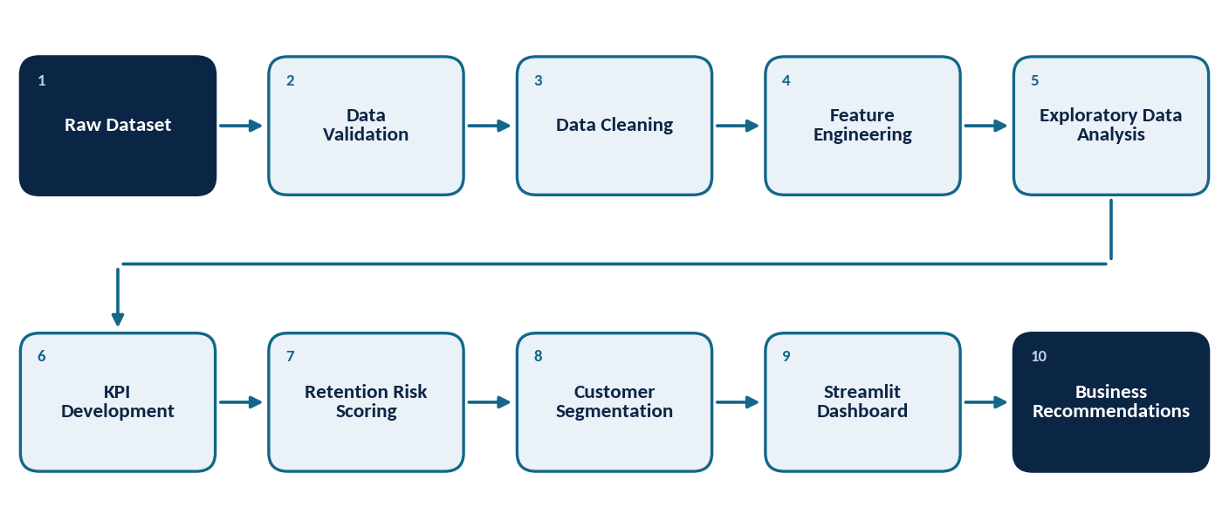
Figure 1: Analytical Workflow

5.1 Data Validation
The dataset was inspected for structure, dimensions, data types, missing values and duplicate records. The dataset contained 10,000 records and 14 original columns, with no missing values or duplicate records. The Exited variable was used to distinguish historically churned customers from retained customers.

5.2 Data Cleaning and Feature Engineering
After validation, derived variables were created to support customer segmentation and retention analysis (Table 2).
Table 2: Derived variables
Variable | Definition
EngagementStatus | Active or Inactive, based on IsActiveMember
ProductCategory | Single Product or Multi Product, based on NumOfProducts
CreditCardStatus | Classification based on credit card ownership
ChurnStatus | Churned or Retained, based on Exited
BalanceSalaryRatio | Ratio of customer balance to estimated salary
AgeGroup | 18–24, 25–34, 35–44, 45–54, 55–64 and 65+
CreditScoreGroup | <500, 500–599, 600–699, 700–799 and 800+

5.3 Exploratory Data Analysis
Exploratory Data Analysis (EDA) was performed to identify patterns and relationships associated with historical churn. The analysis covered:
- Overall churn and retention
- Geographic and gender-based churn
- Customer engagement and churn
- Product count and product category
- Credit card ownership
- Age and credit score groups
- Tenure, balance and estimated salary
- Product utilization combined with engagement
- High-balance disengaged customers
Descriptive statistics and graphical analysis were used to identify important customer segments and retention patterns.

5.4 Key Performance Indicator Development
Five analytical KPIs were developed to measure customer retention and relationship characteristics:
- Engagement Retention Ratio
- Product Depth Index
- High-Balance Disengagement Rate
- Credit Card Stickiness Score
- Relationship Strength Index
The first four KPIs provide comparative retention measures, while the Relationship Strength Index is an analyst-developed composite score based on observable customer relationship characteristics.

5.5 Retention Risk Scoring
An analyst-developed Retention Risk Score was created to prioritize customers for potential retention attention.
Table 3: Retention Risk Score – scoring rules
Customer characteristic | Points
Inactive customer | +3
Single product | +2
High balance and inactive | +2
Age 45–64 | +1
Geography = Germany | +1

The maximum score is 9. Customers are classified as Low Risk (0–2), Medium Risk (3–5) and High Risk (6–9).
Table 4: Risk classification bands
Risk band | Score range
Low Risk | 0–2
Medium Risk | 3–5
High Risk | 6–9

The historical Exited variable was not used to calculate the score. It was kept separate to evaluate historical churn patterns across the resulting risk segments.

5.6 High-Value Disengaged Customer Identification
High-value customers were identified using the 75th percentile of customer balance as the high-balance threshold. Customers at or above this threshold who were inactive were classified as high-value disengaged customers.
This segment was incorporated into the Streamlit dashboard to support customer-level retention prioritization.

5.7 Interactive Dashboard Development
An interactive dashboard was developed using Streamlit and Plotly. The dashboard provides:
- Executive retention KPIs
- Geography, gender, engagement and product filters
- Engagement versus churn analysis
- Product utilization versus churn analysis
- Product and engagement heatmap
- High-value disengaged customer detection
- Retention risk distribution
- Relationship strength analysis
- Customer-level risk and priority information
- CSV download functionality
The dashboard allows users to filter customer populations and dynamically examine analytical results.

5.8 Tools and Technologies
The following technologies were used in the project:
Table 5: Tools and technologies
Category | Technologies
Programming | Python
Data Analysis | Pandas, NumPy
Visualization | Matplotlib, Seaborn, Plotly
Dashboard | Streamlit
Development | Jupyter Notebook, VS Code
Data Format | CSV

6. Results and Discussion
The analysis of 10,000 banking customer records revealed several important patterns related to customer churn, engagement, product utilization, financial value and customer relationship strength. The major findings are discussed below.

6.1 Overall Churn and Retention
The dataset contained 10,000 customers, of which 7,963 were retained and 2,037 were historically churned. The overall historical churn rate was 20.37%, while the retention rate was 79.63%. This indicates that approximately one in five customers in the analyzed population had exited the bank.

6.2 Customer Engagement and Churn
Customer engagement showed a substantial relationship with historical churn. Active customers had a churn rate of 14.27%, compared with 26.85% among inactive customers, a difference of 12.58 percentage points (Figure 2). The Engagement Retention Ratio was 1.17, indicating stronger retention among active customers.
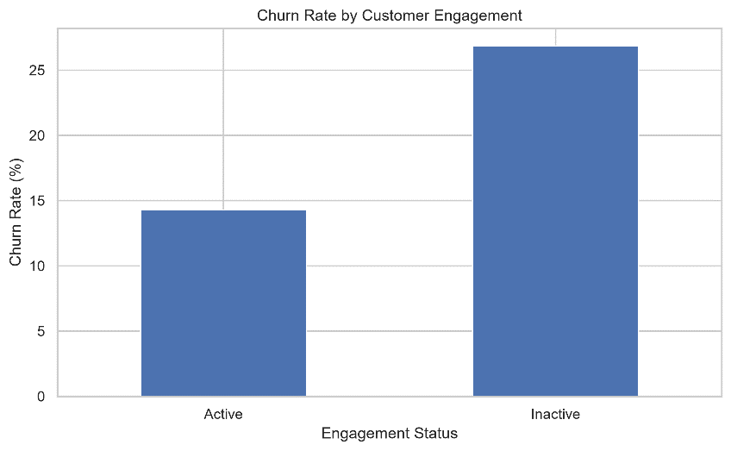
Figure 2: Historical churn rate by customer engagement status
Interpretation note
These results represent historical associations and do not establish that inactivity directly causes churn.

6.3 Geographic Analysis
Geographic analysis showed differences in historical churn rates. Germany recorded the highest churn rate at 32.44%, followed by Spain at 16.67% and France at 16.16% (Figure 3). The higher churn observed in Germany indicates a segment requiring further investigation. Possible areas include customer experience, service quality, product utilization and engagement.
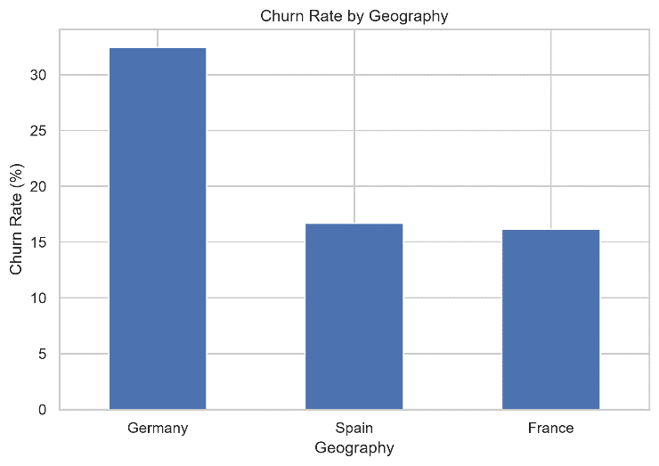
Figure 3: Historical churn rate by geography
Interpretation note
These results represent observed segment-level differences and do not establish geography as a causal factor.

6.4 Product Utilization and Churn
Product utilization showed a non-linear relationship with historical churn. Customers with one product had a churn rate of 27.71%, while customers with two products had a substantially lower churn rate of 7.58%.
Customers with three and four products showed churn rates of 82.71% and 100%, respectively; however, these groups contained relatively few customers and should therefore be interpreted cautiously (Figure 4).
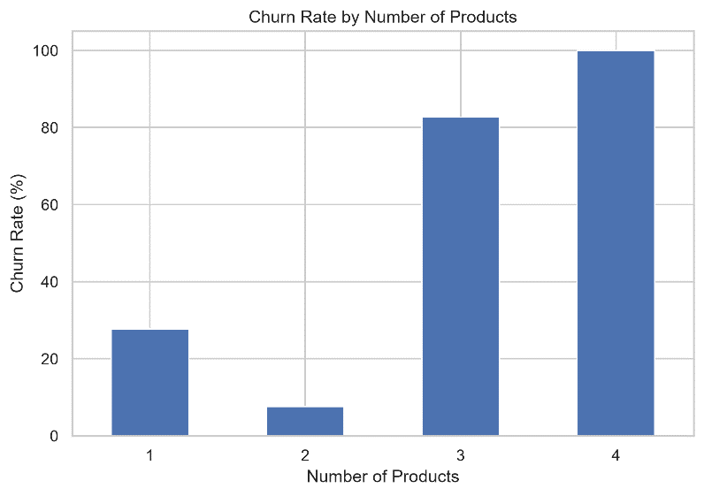
Figure 4: Historical churn rate by number of products
The Product Depth Index was 1.21, indicating higher retention among multi-product customers compared with single-product customers in the overall dataset.

6.5 Age-Based Analysis
Age-based analysis showed substantial differences in historical churn. Customers aged 45–54 had a churn rate of 48.15%, while customers aged 55–64 had a churn rate of 49.83%. In comparison, customers aged 18–24 and 25–34 had churn rates of 8.75% and 7.76%, respectively.
Table 6: Historical churn rate for the age groups discussed
Age group | Historical churn rate
18–24 | 8.75%
25–34 | 7.76%
45–54 | 48.15%
55–64 | 49.83%

The 45–64 age segment therefore represents an important group for further retention analysis.

6.6 Credit Card Ownership and Churn
Credit card ownership showed only a marginal difference in historical churn. Customers with a credit card had a churn rate of 20.18%, compared with 20.82% among customers without one. The Credit Card Stickiness Score was 1.01, indicating that credit card ownership alone was not a strong standalone retention indicator in this dataset.

6.7 High-Value Disengaged Customers
Customers at or above the 75th percentile of balance were classified as high-balance customers. Among these customers, 49.88% were inactive.
This High-Balance Disengagement Rate indicates that a substantial proportion of financially valuable customers were not actively engaged. The finding supports the use of a high-value disengaged customer detector within the retention dashboard.

6.8 Relationship Strength Analysis
An analyst-developed Relationship Strength Index was created to summarize observable customer relationship characteristics. The index considers engagement, product depth, credit card ownership, tenure and balance, with scores ranging from 0 to 7 and categories of Weak, Moderate and Strong.
The index is intended for customer segmentation and prioritization rather than as a formally validated predictive model.

6.9 Retention Risk Scoring
The rule-based Retention Risk Score ranges from 0 to 9 and classifies customers into Low, Medium and High Risk categories. The score prioritizes observable characteristics including inactivity, single-product usage, high-balance inactivity, age 45–64 and Germany.
The historical churn variable was kept separate from the score and was used to examine the relationship between risk segments and observed churn.

6.10 KPI Summary
Table 7: Retention KPI summary
KPI | Result | Business interpretation
Engagement Retention Ratio | 1.17 | Active customers showed stronger retention than inactive customers
Product Depth Index | 1.21 | Multi-product customers showed higher retention than single-product customers
High-Balance Disengagement Rate | 49.88% | A substantial share of high-balance customers were inactive
Credit Card Stickiness Score | 1.01 | Credit card ownership showed only a marginal retention difference
Relationship Strength Index | 0–7 | Analyst-developed relationship segmentation score

6.11 Overall Discussion
Overall, the analysis identified customer engagement, product utilization, age, geography and financial value as important dimensions associated with historical churn. The identification of high-value disengaged customers adds a business perspective by combining financial value with engagement.
The Streamlit dashboard operationalizes these findings by allowing users to explore customer segments, retention KPIs, high-value disengaged customers and retention priorities.

7. Business Recommendations
The findings in Section 6 point to several practical priorities for a retention team. Each recommendation below is derived from the historical associations reported in this study and should be validated through controlled experimentation before large-scale rollout (see Section 8).
Table 8: Findings, implications and recommended actions
Finding | Implication | Recommended action
Inactive customers churned at 26.85% versus 14.27% for active customers | Engagement is a strong retention signal | Run re-engagement campaigns for inactive customers and monitor activity as an early-warning indicator
49.88% of high-balance customers were inactive | Financially valuable relationships are at risk of drifting away | Prioritize high-value disengaged customers for personalized outreach using the dashboard detector
Single-product customers churned at 27.71% versus 7.58% for two-product customers | Deeper product relationships are associated with lower churn | Test targeted second-product offers for single-product customers through A/B experiments
Germany recorded 32.44% churn versus about 16% in Spain and France | Germany is a segment that needs investigation | Review customer experience, service quality and product mix in Germany before designing interventions
Customers aged 45–54 and 55–64 churned at 48.15% and 49.83% | This age band is a high-churn segment | Design and test age-tailored engagement and retention offers for customers aged 45–64
Three- and four-product groups showed very high churn but are small | Results may be unstable at this sample size | Investigate these customers separately before encouraging holdings beyond two products
Credit Card Stickiness Score was 1.01 | Card ownership alone is not a strong retention lever | Combine card ownership with engagement and product depth rather than using it alone
The rule-based Retention Risk Score segments customers into Low, Medium and High Risk | The score supports prioritization of outreach | Use risk segments to rank retention effort, and validate the score with predictive modeling before production use

8. Limitations
This study has the following limitations:
- The analysis uses historical data and therefore identifies associations rather than causal relationships.
- The Retention Risk Score and Relationship Strength Index are analyst-developed frameworks and have not been validated as production predictive models.
- Very high churn rates among customers with three and four products should be interpreted cautiously because these groups contain relatively few customers.
- The dataset does not include detailed transaction history, customer complaints, service interactions, digital activity or customer satisfaction information.
- The proposed retention strategies have not been evaluated through controlled experiments or A/B testing.
- The findings are based on a particular customer population and may not generalize to all banking institutions or populations.

9. Conclusion
This study analyzed 10,000 banking customer records to examine customer engagement, product utilization, financial value and historical churn. The overall historical churn rate was 20.37%, with inactive customers showing higher churn than active customers. Geographic, age-based and product-utilization analyses also identified important customer segments.
A key finding was that 49.88% of high-balance customers were inactive, highlighting a potential high-value retention opportunity. The project developed retention KPIs, a Relationship Strength Index and a rule-based Retention Risk Score.
These analytical components were integrated into an interactive Streamlit dashboard that enables users to explore customer segments, churn patterns, retention KPIs and high-value disengaged customers. The findings support a segmented approach to retention analysis based on engagement, product utilization, financial value and relationship characteristics.

10. Future Scope
The project can be extended in the following areas:
- Predictive Machine Learning: Develop models such as Logistic Regression, Random Forest or XGBoost to estimate individual customer churn probability.
- Transaction-Level Analysis: Incorporate transaction frequency, transaction value and account activity to improve customer engagement analysis.
- Customer Lifetime Value: Include CLV to estimate the financial importance of individual customers.
- Real-Time Monitoring: Connect the Streamlit dashboard with regularly updated customer data for continuous retention monitoring.
- Retention Experimentation: Use A/B testing to evaluate whether proposed retention strategies improve engagement and reduce churn.

11. References
- Python Software Foundation. Python Documentation.
- Pandas Documentation. Data analysis and manipulation using Python.
- NumPy Documentation. Numerical computing with Python.
- Matplotlib Documentation. Python visualization library.
- Seaborn Documentation. Statistical data visualization.
- Plotly Documentation. Interactive data visualization.
- Streamlit Documentation. Framework for building data applications using Python.

