1. Containers – Running Applications
Q1. Run an Nginx Web Server
• Pull the nginx image.
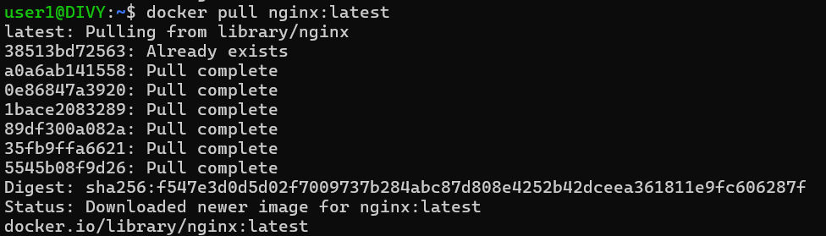
• Run it in a container.
• Map container port 80 to host port 8080.
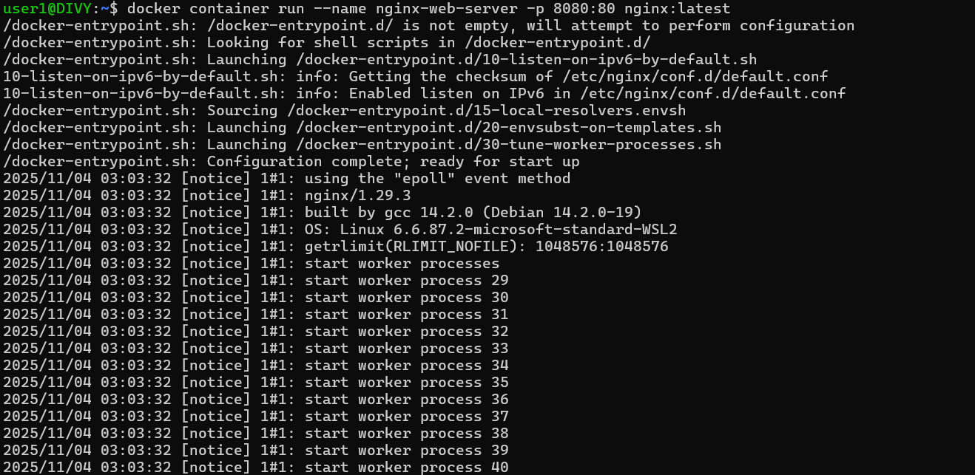
• Open the browser and check if Nginx default page is visible.
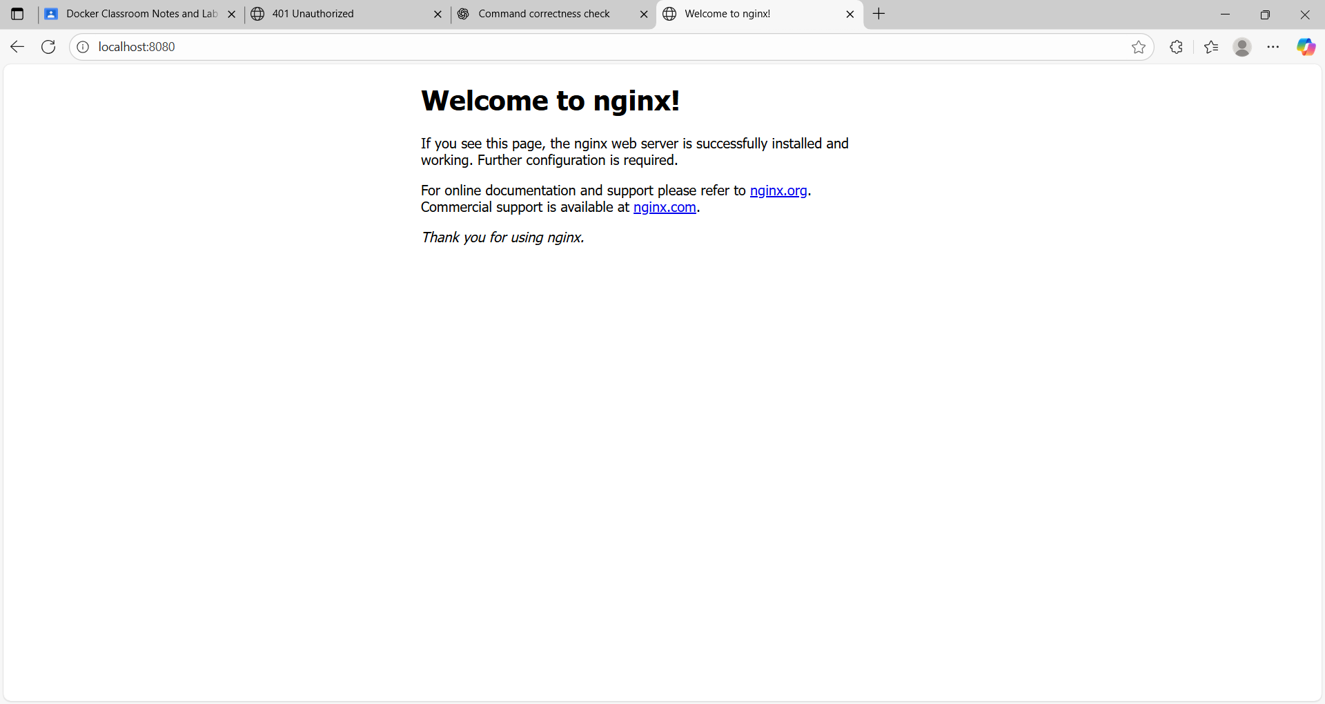
Q2. Run a Python App inside a Container
• Use the official python:3.10-slim image.
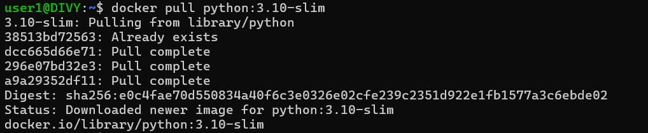
• Run a container that executes a one-line Python program printing “Hello Docker”.
• Observe what happens after execution.
Q3. Run a MySQL Database
• Start a mysql:8 container with:
o Root password set via environment variable.
o A new database created at startup.
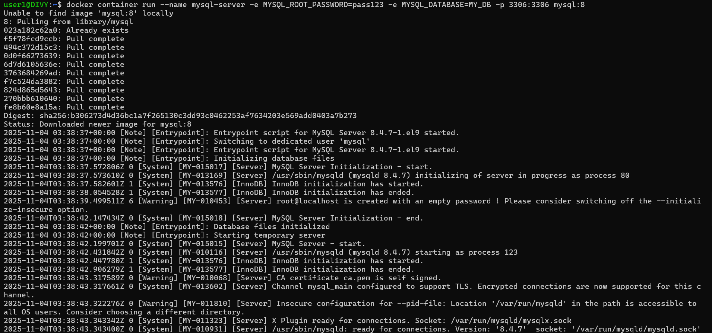
• Access the container shell.
• Connect to MySQL inside and verify the database exists.
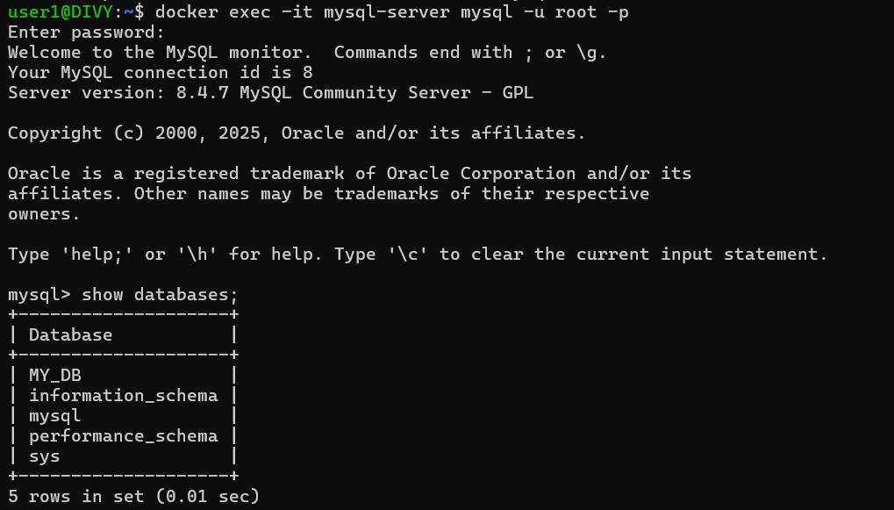
2. Custom Images – Build Your Own
Q4. Build a Flask Application Image
• Write a small Flask app that returns “Hello from Flask in Docker”.
App.py:
from flask import Flask
app = Flask(__name__)
@app.route("/")
def index():
return "Hello from Flask in Docker"
if __name__=="__main__":
app.run(host="0.0.0.0",port=5000,debug=True)

• Create a requirements.txt file and Dockerfile.
requirements.txt:
flask

Dockerfile:
From python:latest
WORKDIR /app
COPY . /app
RUN pip install -r requirements.txt
EXPOSE 5000
CMD ["python","app.py"]

• Build your own image.
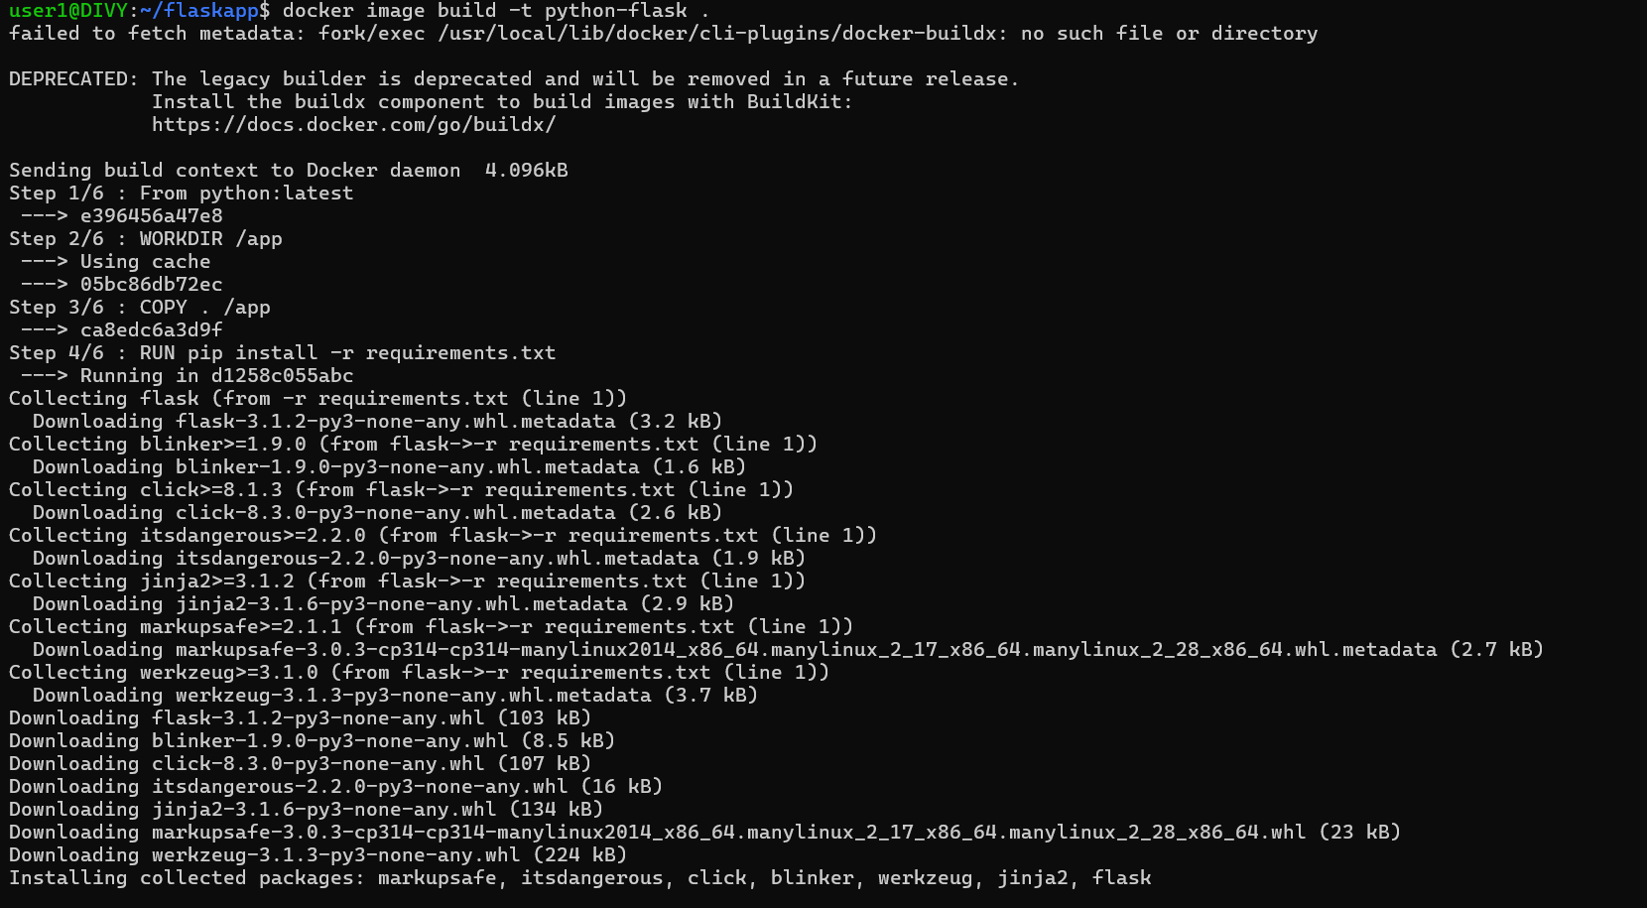
• Run the container and check the response in a browser.
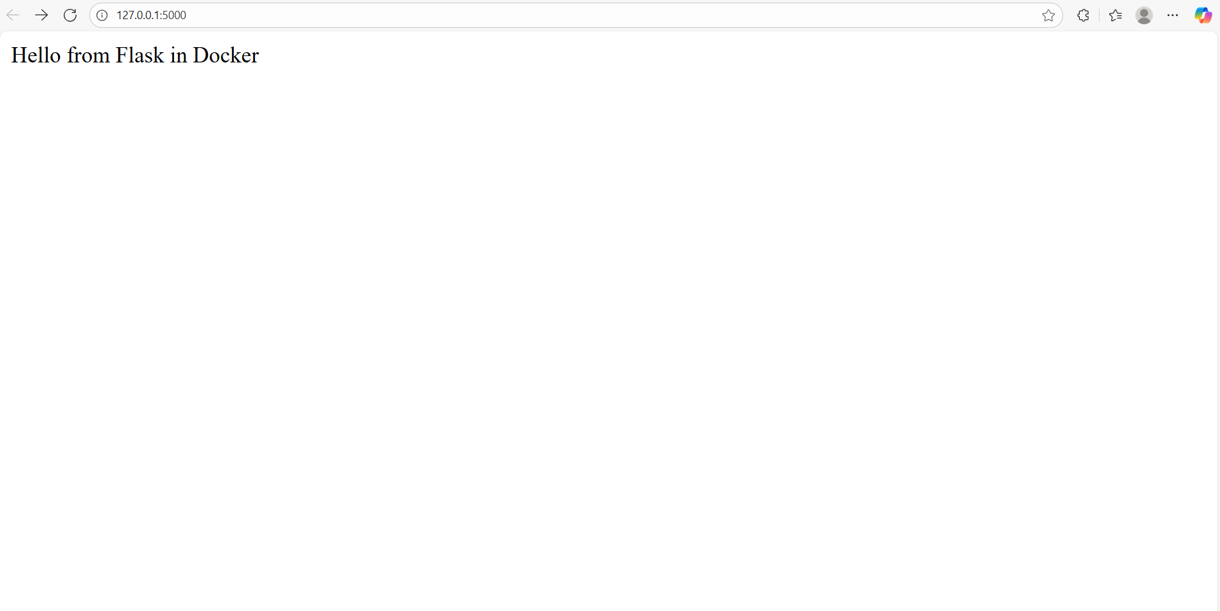

Q5. Create a Custom Nginx Image
• Create a simple index.html file with your name.
Index.html:
<!DOCTYPE html>
<html lang="en">
<head>
<meta charset="UTF-8">
<meta name="viewport" content="width=device-width, initial-scale=1.0">
<title>Document</title>
</head>
<body>
<h1>Hello from nginx server present in Docker made by Divy Jain</h1>
</body>
</html>

• Use nginx:alpine as base image.
• Copy your HTML file into the container.

Dockerfile:
FROM nginx:alpine

# Copy your static website files to the nginx web directory
COPY index.html /usr/share/nginx/html/

# Expose port 80 for HTTP traffic
EXPOSE 80

• Build and run the custom image.
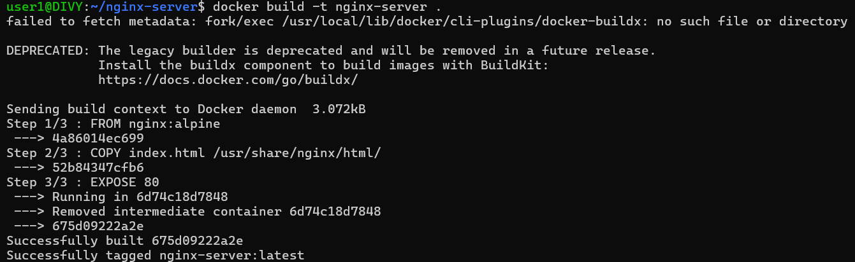
• Open in browser to confirm your page loads.
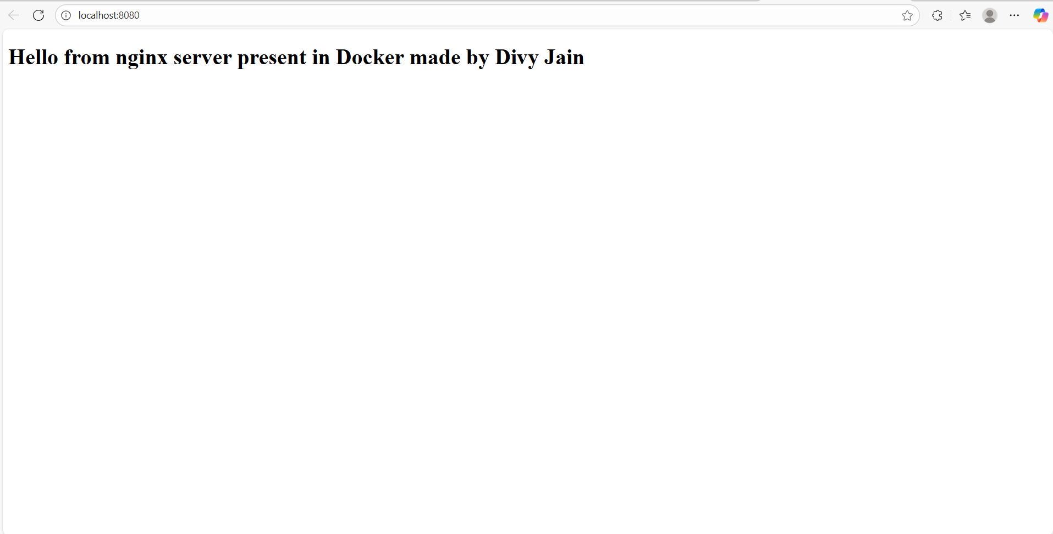

3. Volumes – Persisting Data
Q6. WordPress with Persistent MySQL
• Run a mysql:8 container with a named volume for /var/lib/mysql.
• Run a wordpress container connected to the database.
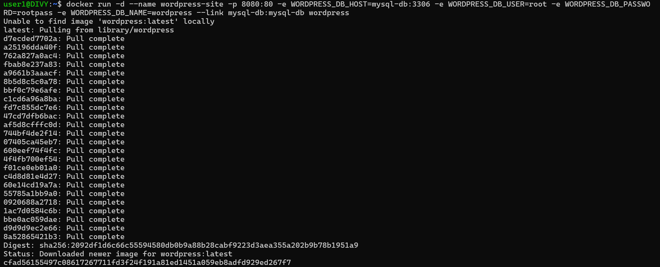
• Stop and remove the containers.
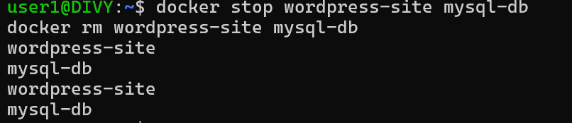
• Restart them and confirm WordPress still remembers your data.
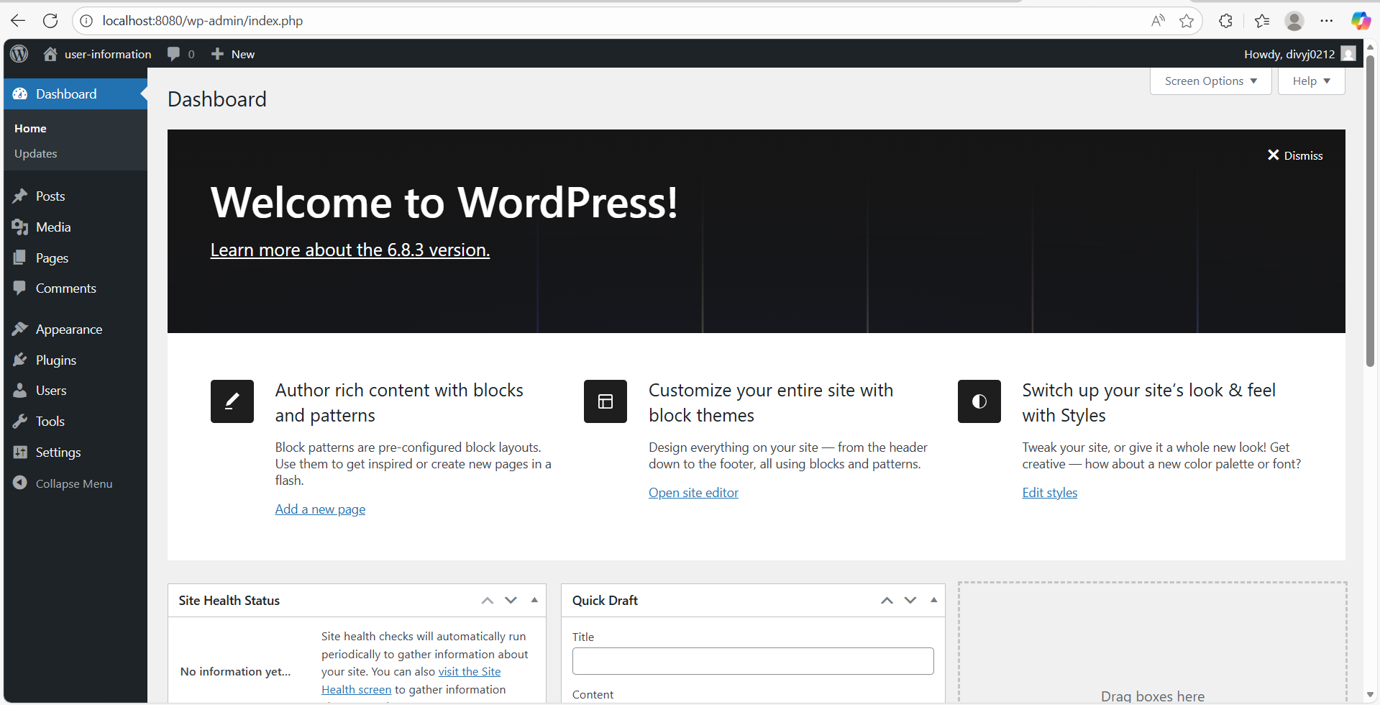

Q7. Flask with Bind Mount
• Create or modify your Flask app locally.
from flask import Flask
app = Flask(__name__)
@app.route("/")
def index():
return "Hello from Flask - Initial Version"
if __name__=="__main__":
app.run(host="0.0.0.0",debug=True)

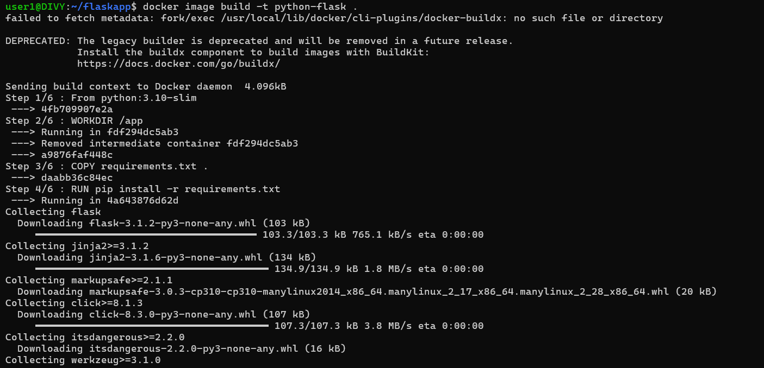
• Run the app container with a bind mount mapping your project folder.
• Edit code on the host machine.
from flask import Flask
app = Flask(__name__)
@app.route("/")
def index():
return "Hello from Flask - Final Version"
if __name__=="__main__":
app.run(host="0.0.0.0",debug=True)

• Check if changes reflect without rebuilding the image.
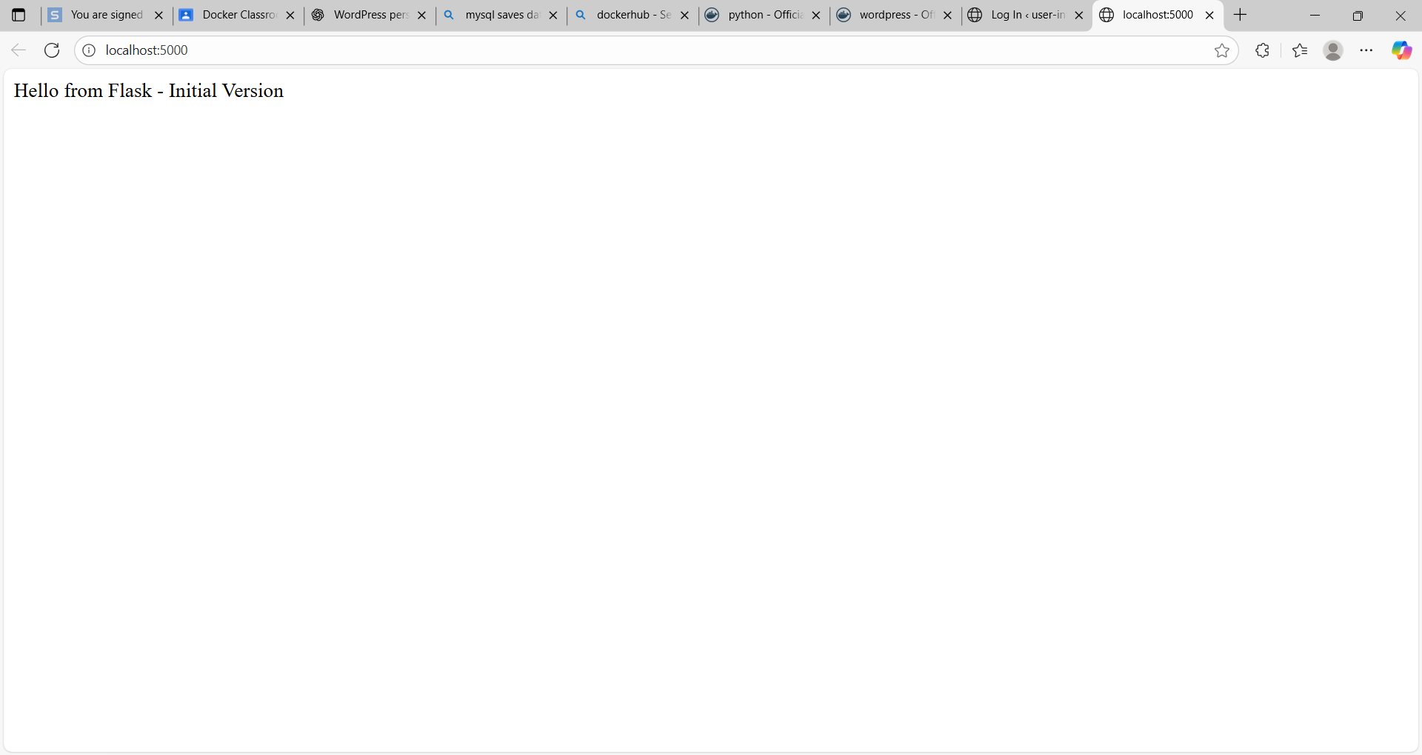
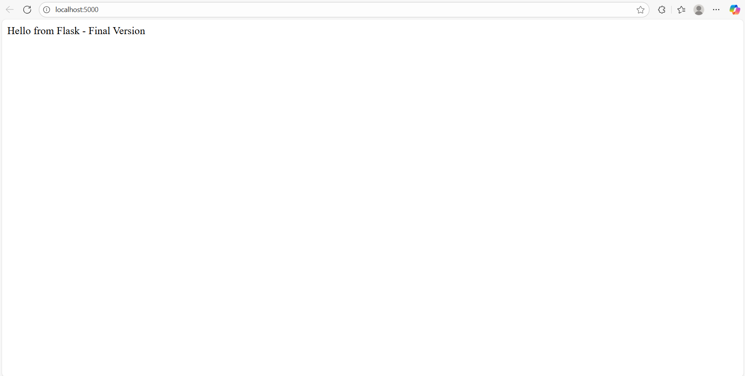

4. Networks – Multi-Container Applications
Q8. Flask + Redis Counter App
• Write a Flask app that connects to Redis to store a counter.
app.py:
from flask import Flask
import redis
app = Flask(__name__)
@app.route('/')
def index():
r = redis.Redis(host='redis',port=6379,decode_responses=True)
count = r.incr('counter')
return f'Hello! This page has been visited {count} times.'
if __name__=="__main__":
app.run(host='0.0.0.0',port=5000,debug=True)
• Create a user-defined Docker network.
• Run a Redis container in the network.
• Run your Flask container in the same network.
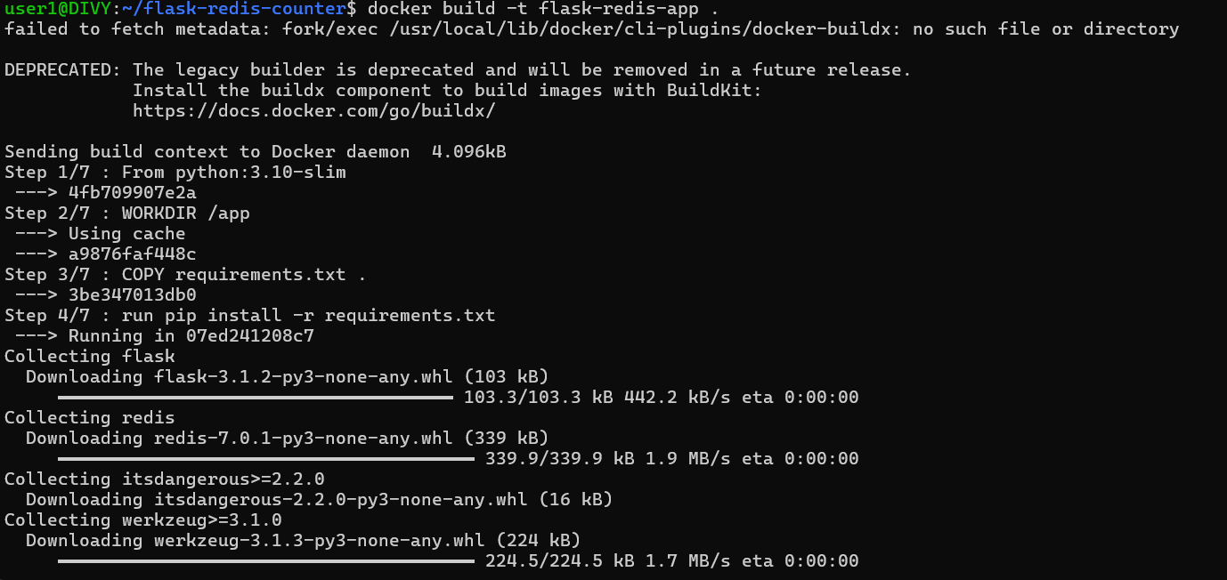
• Refresh the app page multiple times and confirm the counter increments.
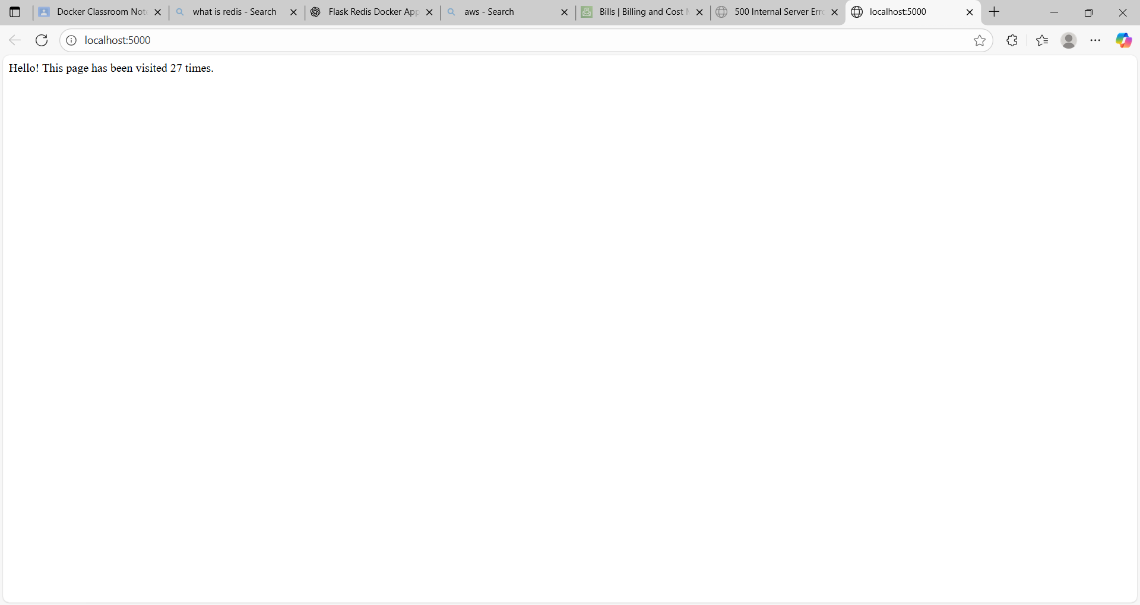

Q9. MySQL + WordPress Blogging App
• Create a custom Docker network.
• Run a MySQL container with environment variables for root password and database.
• Run a WordPress container connected to the same network.
• Complete WordPress setup in the browser.
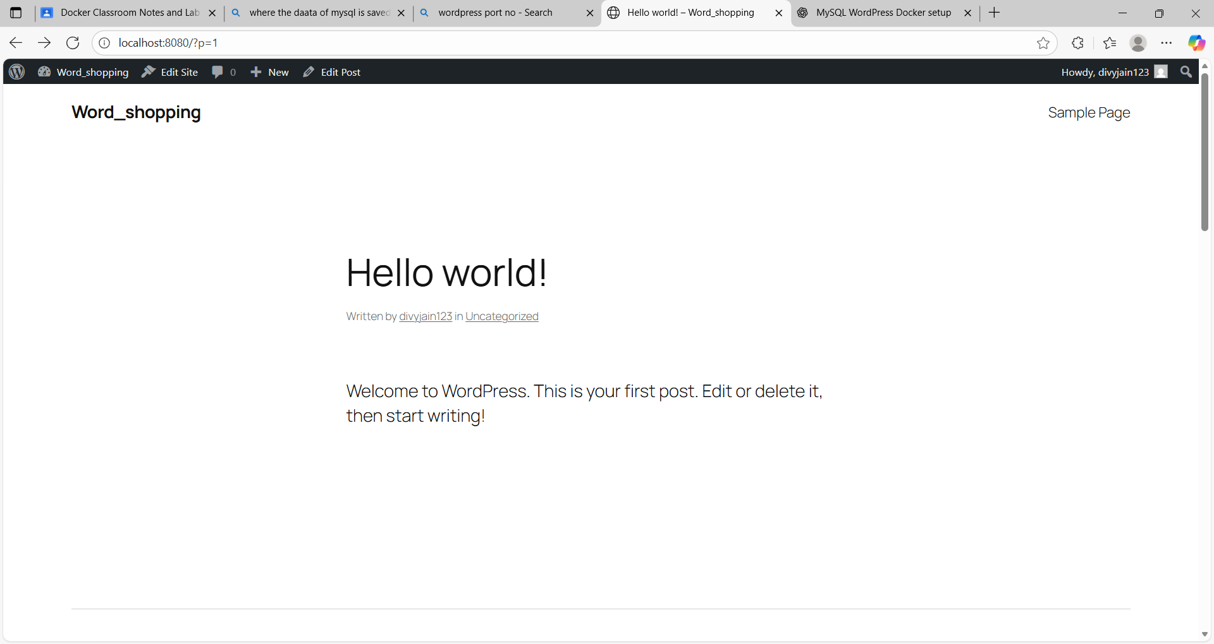

Docker Compose
Q10. Convert Flask + Redis App into Docker Compose
• Write a docker-compose.yml file to define Flask and Redis services.
version: "3.9"
services:
redis:
image: redis:latest
container_name: redis
ports:
- "6379:6379"
networks:
- flask-redis-net
flask-app:
build: .
container_name: flask-app
ports:
- "5000:5000"
environment:
- REDIS_HOST=redis
- REDIS_PORT=6379
depends_on:
- redis
networks:
- flask-redis-net
networks:
flask-redis-net :

• Bring up the stack using docker-compose up.
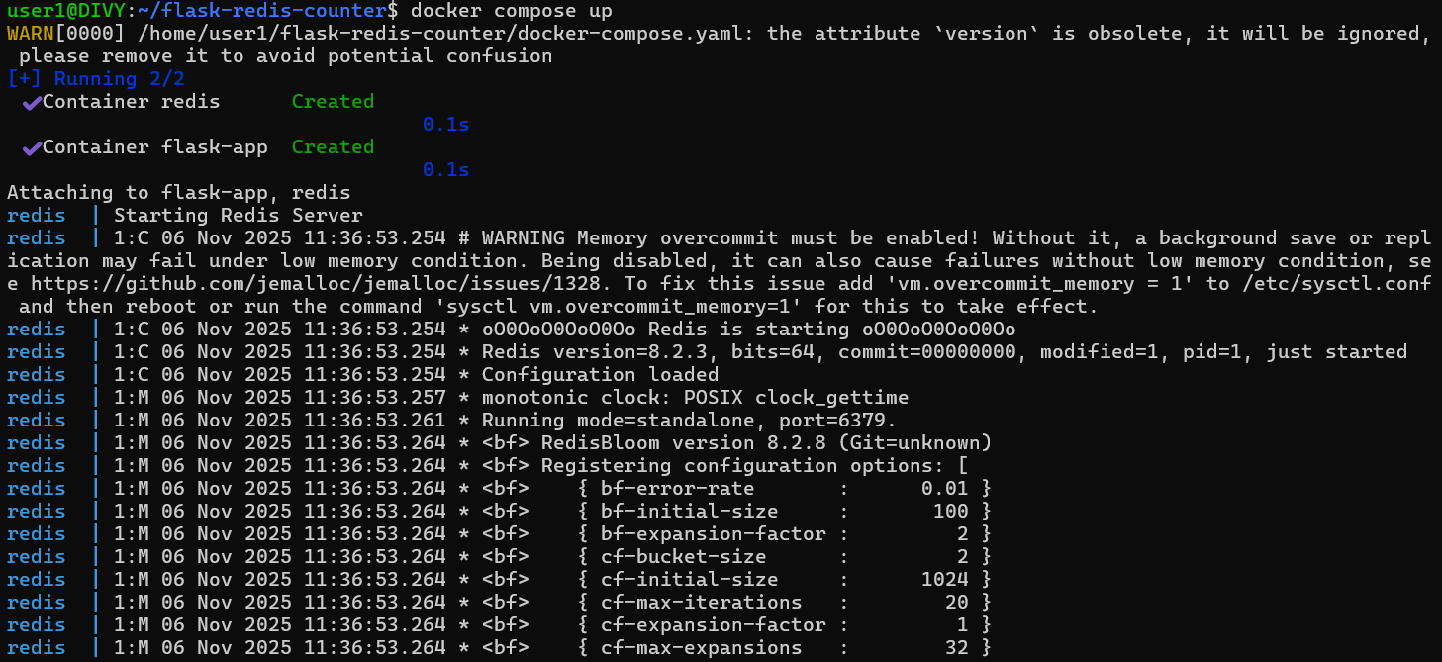
• Verify application works as expected.
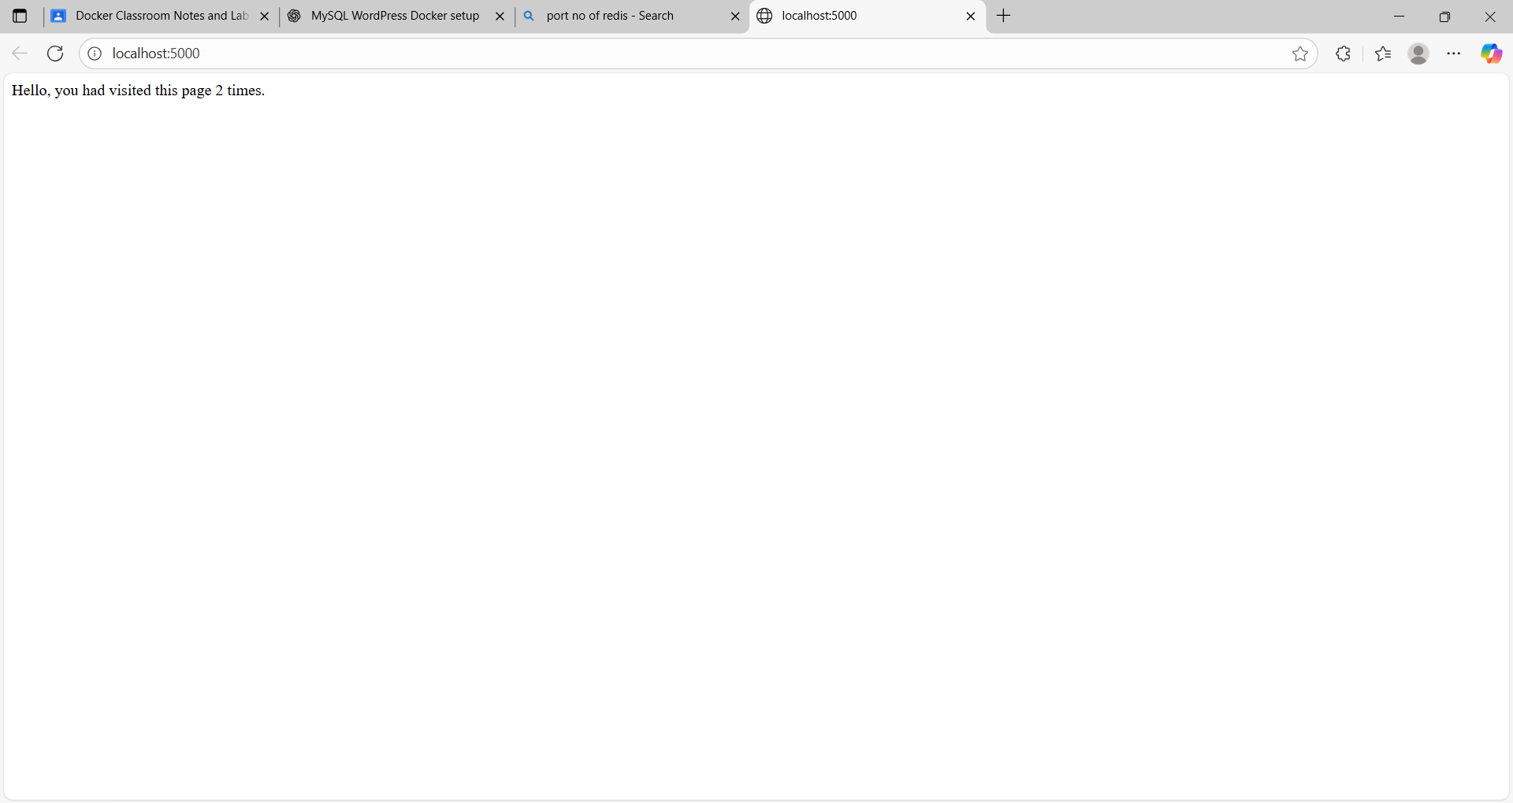

Q11. Node.js + MongoDB Full Stack Setup
• Write a simple Node.js app that saves data to MongoDB.
const express = require("express");
const { MongoClient } = require("mongodb");
const fs = require("fs");
const app = express();
app.use(express.json());

const mongoUrl = "mongodb://mongo:27017";
const client = new MongoClient(mongoUrl);
app.get("/", (req, res) => {
res.send("Node.js + MongoDB is working ✅");
});
app.post("/save", async (req, res) => {
const logStream = fs.createWriteStream("/logs/app.log", { flags: "a" });
try {
const data = req.body;
await client.connect();
const db = client.db("testdb");
const collection = db.collection("records");
await collection.insertOne(data);
logStream.write(`Saved data: ${JSON.stringify(data)}\n`);
res.send({ message: "Data saved to MongoDB", data });
} catch (err) {
logStream.write(`Error: ${err.message}\n`);
res.status(500).send({ error: err.message });
} finally {
logStream.end();
}
});
app.listen(3000, () => console.log("Node.js app running on port 3000"));
• Create a custom image for the Node.js app.
• Store application logs in a volume.
• Connect Node.js and MongoDB containers via a custom network.
docker-compose.yml:
version: "3.9"
services:
mongo:
image: mongo
container_name: mongo-db
ports:
- "27017:27017"
volumes:
- mongo_data:/data/db
networks:
- app-net

node-app:
build: .
container_name: node-backend
ports:
- "3000:3000"
depends_on:
- mongo
volumes:
- logs:/logs
networks:
- app-net
volumes:
mongo_data:
logs:
networks:
app-net:

• Test end-to-end data flow.
